# Muhammad Haaris 21F-9060

# Section: 6E

Web Assignment  
  
  
Task 1  
Code:  
<!DOCTYPE html>

<html>

<head>

<style>

body {

background-color: #000;

color: #fff;

font-family: Arial, sans-serif;

padding: 50px;

}

h1, p, button {

text-align: left;

}

button {

background-color: #4CAF50;

border: none;

color: white;

padding: 15px 32px;

text-decoration: none;

display: inline-block;

font-size: 16px;

margin: 4px 2px;

cursor: pointer;

}

</style>

</head>

<body>

<h1> Start CSS Exercises</h1>

<p>Good luck!</p>

<button>Start CSS Exercises > </button>

</body>

</html>

Output:  
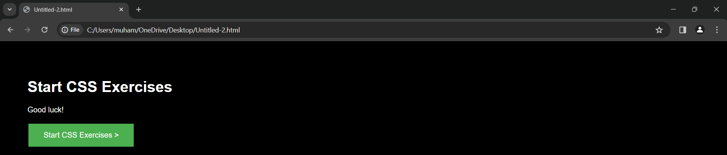

Task 2

Code:  
  
<!DOCTYPE html>

<html>

<head>

<style>

body {

background-color: lightblue; /* Changed from blue to lightblue */

}

form {

width: 300px;

margin: 0 auto;

}

input[type=text], input[type=password], input[type=email], input[type=number] {

width: 100%;

padding: 12px 20px;

margin: 8px 0;

display: inline-block;

border: 1px solid #ccc;

box-sizing: border-box;

}

button {

background-color: red;

color: white;

padding: 14px 20px;

margin: 8px 0;

border: none;

cursor: pointer;

width: 100%;

}

</style>

</head>

<body>

<h2>Registration Form</h2>

<form>

<label for="name">Name*</label><br>

<input type="text" id="name" name="name" required><br>

<label for="username">Username*</label><br>

<input type="text" id="username" name="username" required><br>

<label for="password">Password*</label><br>

<input type="password" id="password" name="password" required><br>

<label for="number">Number*</label><br>

<input type="number" id="number" name="number" required><br>

<label for="email">Email Id*</label><br>

<input type="email" id="email" name="email" required><br>

<button type="submit">Register</button>

</form>

</body>

</html>

Output:  
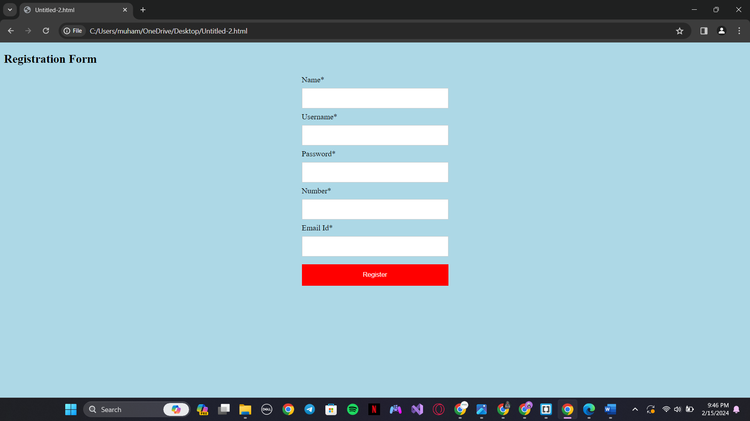

Task 3

Code:  
<!DOCTYPE html>

<html>

<head>

<style>

.card {

box-shadow: 0 4px 8px 0 rgba(0,0,0,0.2);

transition: 0.3s;

width: 40%;

border-radius: 5px;

background-color: white;

padding: 20px;

margin: auto;

text-align: center;

}

.card:hover {

box-shadow: 0 8px 16px 0 rgba(0,0,0,0.2);

}

.container {

padding: 2px 16px;

}

</style>

</head>

<body>

<h2>Card Design</h2>

<div class="card">

<img src="C:\Users\muham\OneDrive\Desktop\download.jpg" style="width:100%">

<div class="container">

<h4><b>PSL-9 Trophy</b></h4>

</div>

</div>

</body>

</html>

Output:  
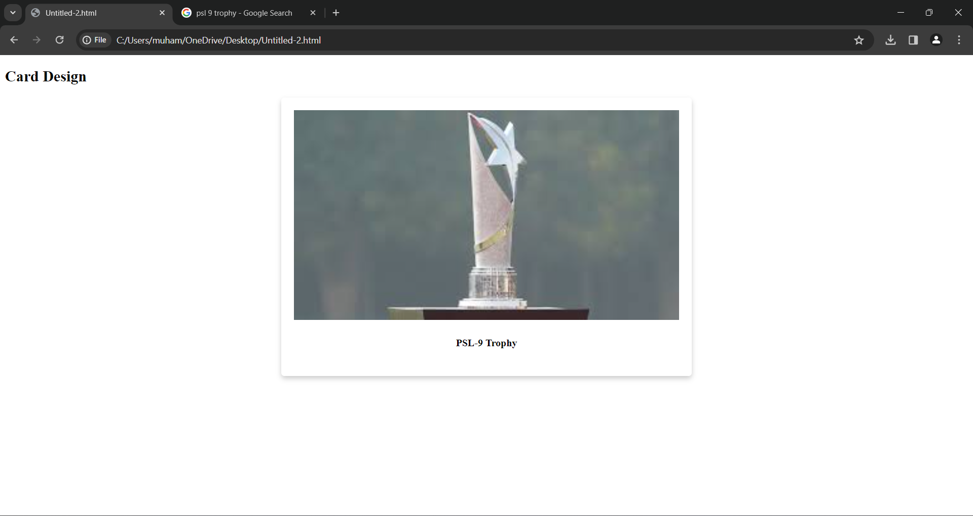

Task 4

Code:  
<!DOCTYPE html>

<html>

<head>

<style>

.card {

box-shadow: 0 4px 8px 0 rgba(0,0,0,0.2);

transition: 0.3s;

width: 40%;

border-radius: 5px;

background-color: white;

padding: 20px;

margin: auto;

text-align: center;

animation: slideRight 5s linear;

}

.card:hover {

box-shadow: 0 8px 16px 0 rgba(0,0,0,0.2);

}

.container {

padding: 2px 16px;

}

@keyframes slideRight {

from {

margin-left: -100%;

opacity: 0;

}

to {

margin-left: 0%;

opacity: 1;

}

}

</style>

</head>

<body>

<h2>Card Design</h2>

<div class="card">

<img src="C:\Users\muham\OneDrive\Desktop\download.jpg" style="width:100%">

<div class="container">

<h4><b>PSL-9 Trophy</b></h4>

</div>

</div>

</body>

</html>

Output:  
Can’t paste a video of the animation