# Muhammad Haaris

# 21F-9060

# Section: 6E

Task 1

**Html** Comments:   
<!-- This is an HTML comment -->

**CSS** comments:  
/* This is a CSS comment */  
  
**JavaScript** comments:  
// This is a single-line comment

/* This is a multi-line comment */

Task 2

Code:  
<!DOCTYPE html>

<html>

<head>

<script src="https://ajax.googleapis.com/ajax/libs/jquery/3.5.1/jquery.min.js"></script>

<script>

$(document).ready(function(){

alert("Welcome to jQuery");

});

</script>

</head>

<body>

</body>

</html>

Output:  
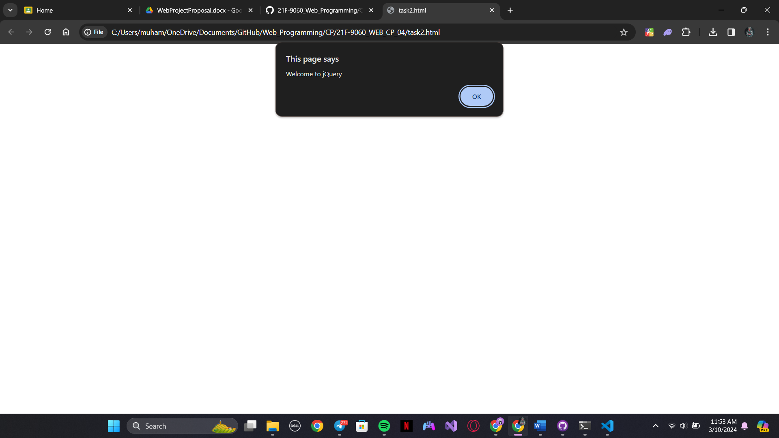

Task 3

Code:

<!DOCTYPE html>

<html>

<head>

<script src="https://ajax.googleapis.com/ajax/libs/jquery/3.5.1/jquery.min.js"></script>

<script>

$(document).ready(function(){

    $("button").click(function(){

        $("img").toggle();

        var text = $(this).text() == 'Hide' ? 'Show' : 'Hide';

        $(this).text(text);

    });

});

</script>

</head>

<body>

<img src="C:\Users\muham\OneDrive\Pictures\Screenshots\Screenshot 2024-03-10 113041.png">

<button>Hide</button>

</body>

</html>

Output:  
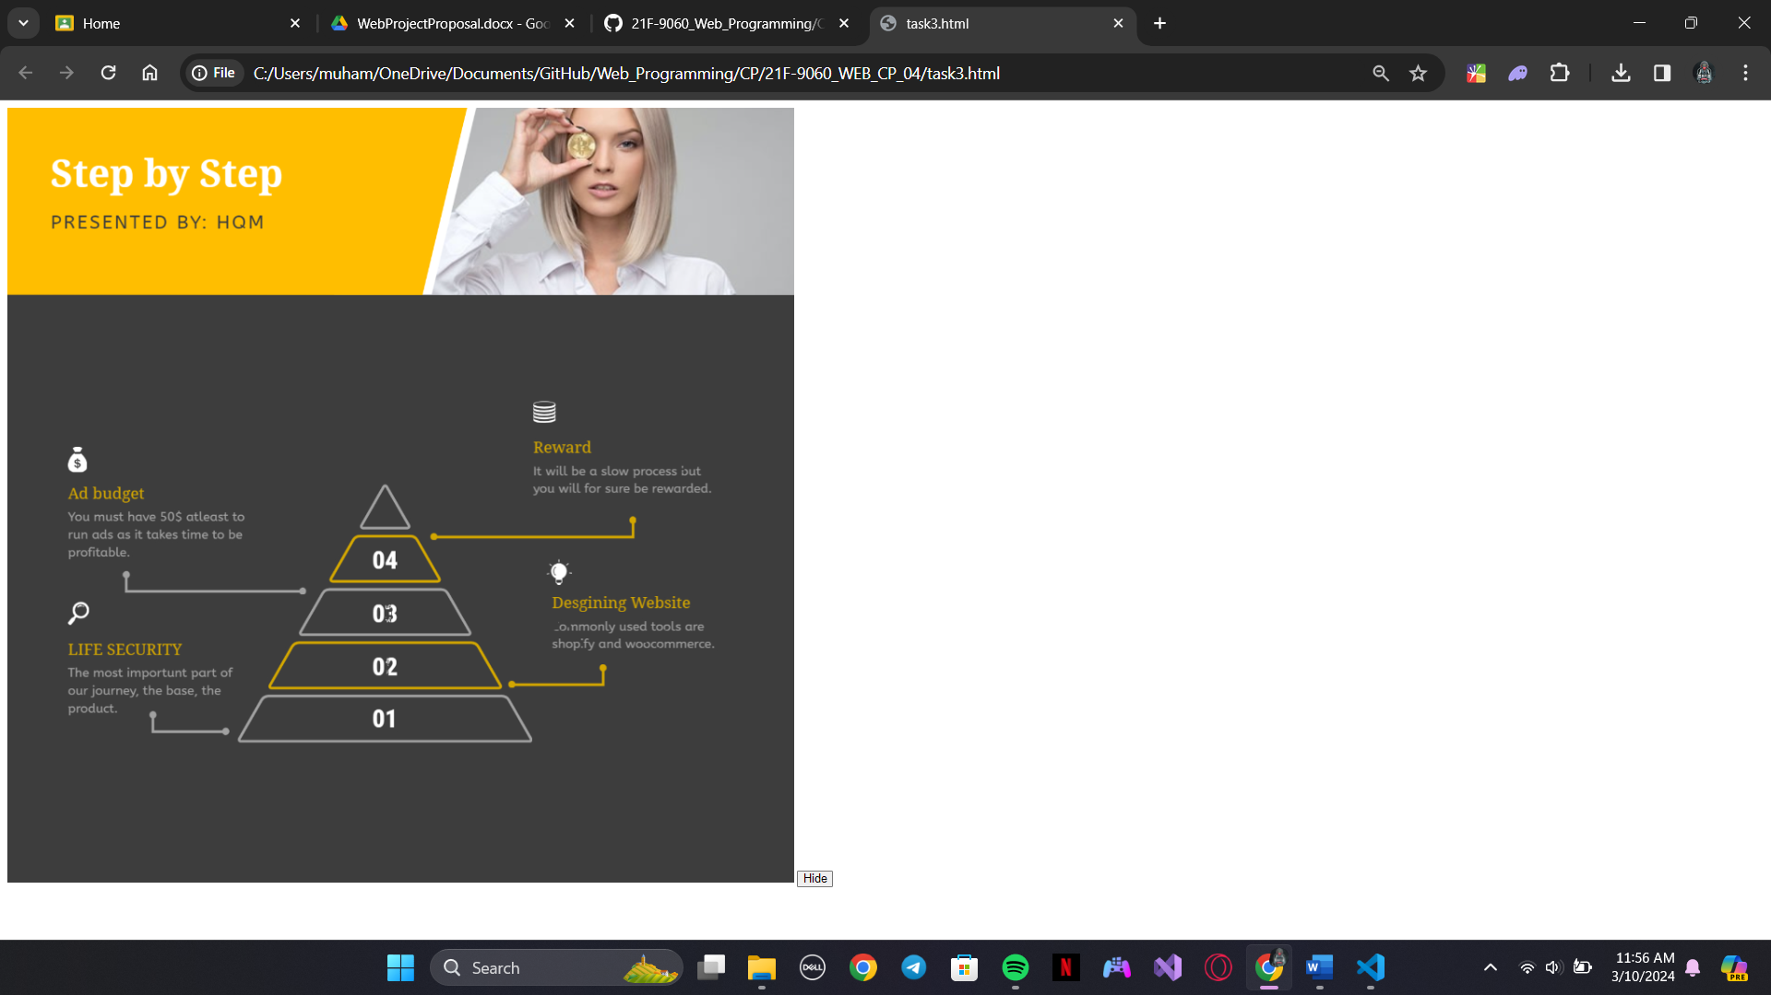

Task 4

Code:  
<!DOCTYPE html>

<html>

<head>

    <style>

        table {

            border-collapse: collapse;

        }

        table, th, td {

            border: 1px solid black;

        }

        tr:hover {

            background-color: #f5f5f5;

        }

    </style>

    <script src="https://ajax.googleapis.com/ajax/libs/jquery/3.5.1/jquery.min.js"></script>

    <script>

        $(document).ready(function(){

            $("table tr").click(function(){

                $(this).remove();

            });

        });

    </script>

</head>

<body>

<table id="myTable">

  <tr>

    <td>Row 1</td>

  </tr>

  <tr>

    <td>Row 2</td>

  </tr>

</table>

</body>

</html>

Output:  
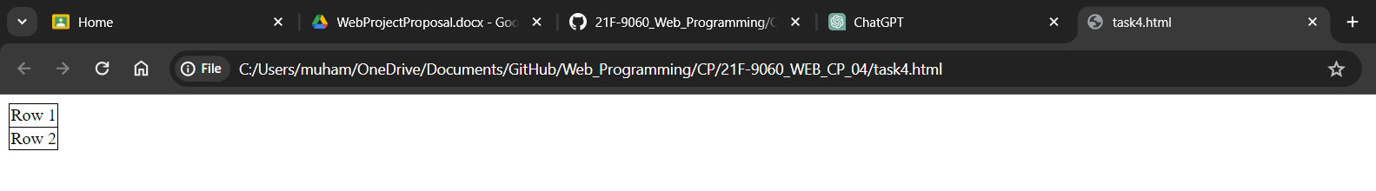

Task 5

Code:

<!DOCTYPE html>

<html>

<head>

<script src="https://ajax.googleapis.com/ajax/libs/jquery/3.5.1/jquery.min.js"></script>

<script>

$(document).ready(function(){

    $("p").click(function(){

        var className = $(this).attr('class');

        var id = $(this).attr('id');

        var text = $(this).text(); // Added this line to retrieve text content

        alert("Class: " + className + ", ID: " + id + ", Text: " + text); // Modified alert message

    });

});

</script>

</head>

<body>

<p class="myClass" id="myId">Click me</p>

</body>

</html>

Output:  
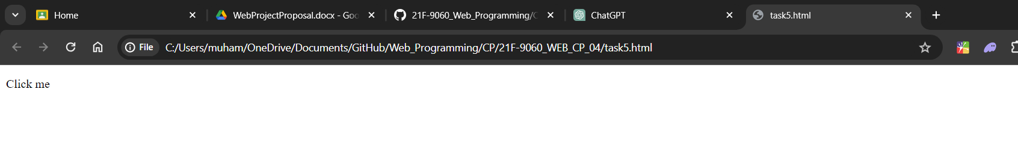

Task 6

Code:

<!DOCTYPE html>

<html>

<head>

<script src="https://code.jquery.com/jquery-git.js"></script>

<meta charset="utf-8">

<meta name="viewport" content="width=device-width">

<title>Find total width of an element (including width, padding and border) in jQuery.</title>

<style>

p {

padding-top: 50px;

padding-right: 30px;

padding-bottom: 50px;

padding-left: 80px;

}

</style>

<script>

$(document).ready(function(){

    var totalWidth = $("#myText").outerWidth();

    alert("Total width: " + totalWidth);

});

</script>

</head>

<body>

<p id="myText">jQuery Exercises, Practice, Solution</p>

</body>

</html>

Output;  
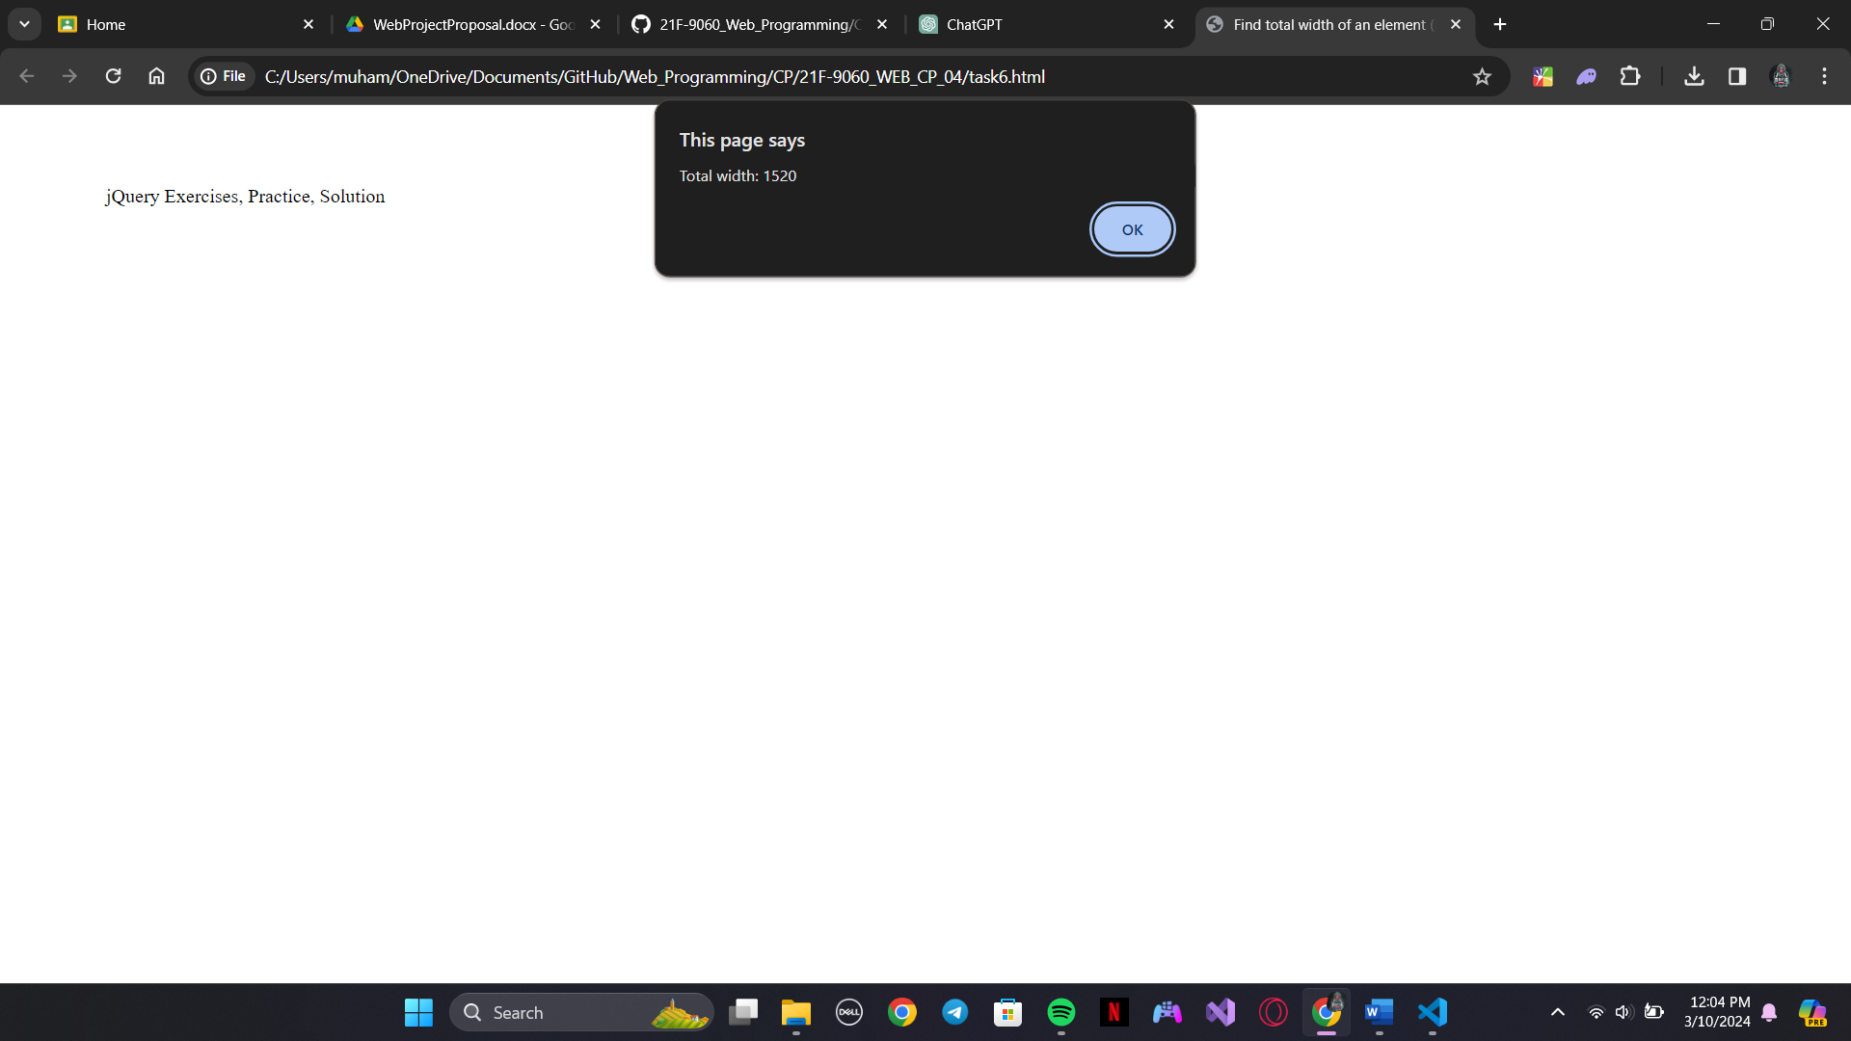

Task 7

Code:

<!DOCTYPE html>

<html>

<head>

<script src="https://code.jquery.com/jquery-git.js"></script>

<meta charset="utf-8">

<meta name="viewport" content="width=device-width">

<title>Counting Child Elements with jQuery</title>

<script>

$(document).ready(function(){

var paragraphCount = $("#selectedParagraphs p").length; // Renamed variable and added a more descriptive ID

alert("Number of 'p' elements inside 'selectedParagraphs': " + paragraphCount); // Adjusted alert message

});

</script>

</head>

<body>

<div id="selectedParagraphs"> <!-- Adjusted ID name -->

<p>Red</p>

<p>White</p>

<p>Green</p>

<p>Black</p>

<p>Blue</p>

<p>Orange</p>

</div>

</body>

</html>

Output:

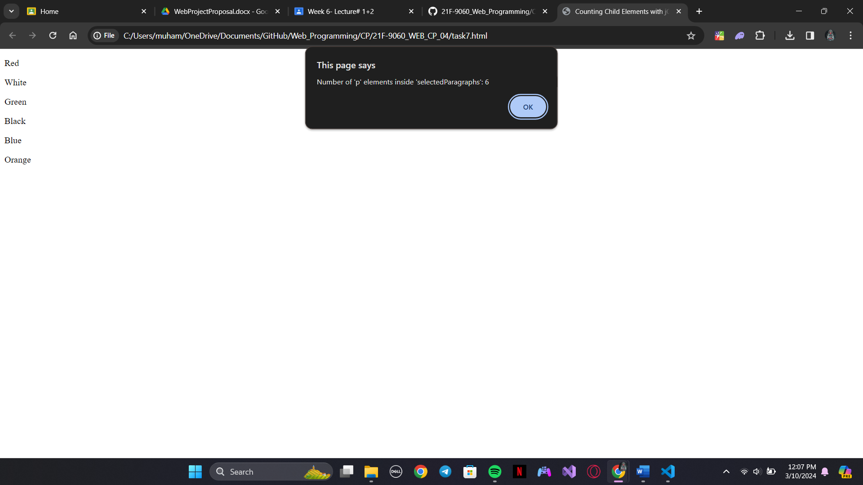

Task 8

Code:

<!DOCTYPE html>

<html>

<head>

<script src="https://ajax.googleapis.com/ajax/libs/jquery/3.5.1/jquery.min.js"></script>

<script>

$(document).ready(function(){

    $("#animatedDiv").animate({left: '250px'}, 8000); // Changed the selector to target an ID

});

</script>

</head>

<body>

<div id="animatedDiv" style="background-color: #98bf21; height: 100px; width: 100px; position: absolute;">Hello</div>

</body>

</html>

Output:



