# Muhammad Haaris

# 21F-9060

# Section: 6E

Task 1

Code:

<!DOCTYPE html>

<html>

<body>

<title>Portfolio</title>

<p style="text-align: center"> <b>Roll Number: </b> 21F-9060 </p>

<h3>Name: </h3> <p> Muhammad Haaris </p>

<h3>Breif: </h3> <tt> I'm a 21 year old computer scientist in making doing my bachelors from FAST university CFD. </tt>

</body>

</html>  
  
Output:  
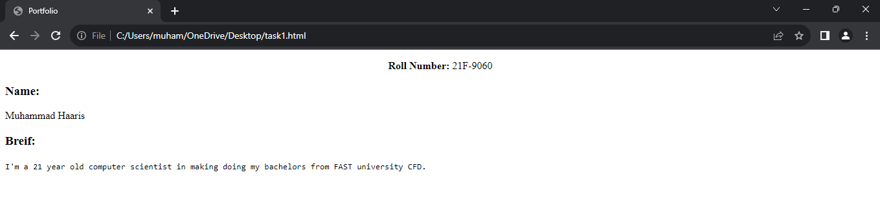

Task 2

Code:  
<!DOCTYPE html>

<html>

<body>

<h2 style="text-align: center; color: Orange;font-size:100% ">

Different Style of texts

</h2>

<h3>This text is bold</h3>

<strong>This text is strong</strong>

<br><br><big>This text is big</big>

<br><br><i>This text is italic</i>

<br><br><em>This text is emphasized</em>

<br><br><tt>This is computer text</tt>

<br><br><p>This is <sub>Subscript</sub> and this is <sup>SuperScript</sup></p>

</body>

</html>

Output:  
  
  
Task 3

Code:  
<!DOCTYPE html>

<html>

<body>

<img src="C:\Users\muham\Downloads\National_University_of_Computer_and_Emerging_Sciences_logo.png"

width="500"

height="500" />

</body>

</html>

Output:

Task 4

Code:  
<!DOCTYPE html>

<html>

<body>

<h1>Link Logo</h1>

<a

href="https://cfd.nu.edu.pk/"

target="blank"

rel="noopener noreferrer"

>

<img src="C:\Users\muham\Downloads\National_University_of_Computer_and_Emerging_Sciences_logo.png"

width="500"

height="500" style="float:left"/>

</a>

</body>

</html>

Output:  


Task 5  
Code:

<!DOCTYPE html>

<html>

<body>

<h1>HTML lists</h1>

<h2>Unordered List</h2>

<p>

We have a variety of languages</p>

<ul>

<li>Oracle</li>

<li>Java</li>

<li>HTML</li>

<li>CSS</li>

</ul>

<p>

These are the following steps to install Java:</p>

<ol>

<li>Download the software</li>

<li>Extract to folder</li>

<li>Double click the executable to run</li>

</ol>

</body>

</html>

Output:  
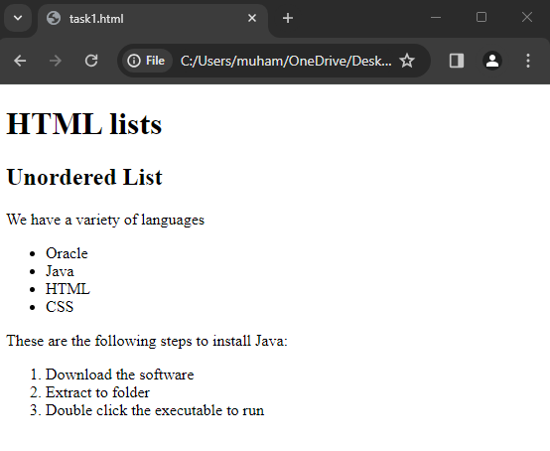

Task 6

Code:  
 <!DOCTYPE html>

<html>

<body>

<table border="2" cellpadding="50">

<tr>

<th>April</th>

<th></th>

<th></th>

</tr>

<tr>

<td></td>

<td></td>

<td></td>

</tr>

<tr>

<td></td>

<td></td>

<td></td>

</tr>

<tr>

<td></td>

<td></td>

<td></td>

</tr>

</table>

</body>

</html>

Output:  
