[Recap] Fill in the blanks to start up a new container for pet microservice so that it will match the diagram.

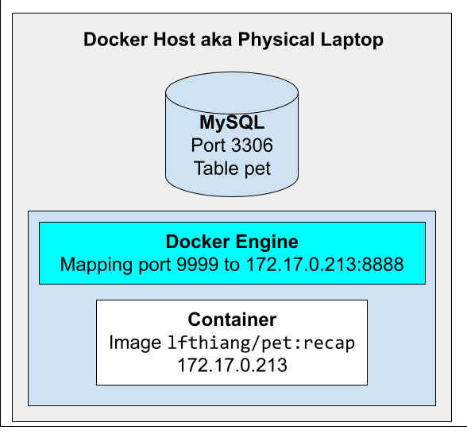

docker **___** -p **___**:**___** -e dbURL=mysql+mysqlconnector://is213@**___**:3306/pet lfthiang/pet:recap

**Answer:**

docker **run** -p **9999**:**8888** -e dbURL=mysql+mysqlconnector://is213@**host.docker.internal**:3306/pet lfthiang/pet:recap

[Recap] Assume compose.yaml is correct. Choose ALL correct statements.

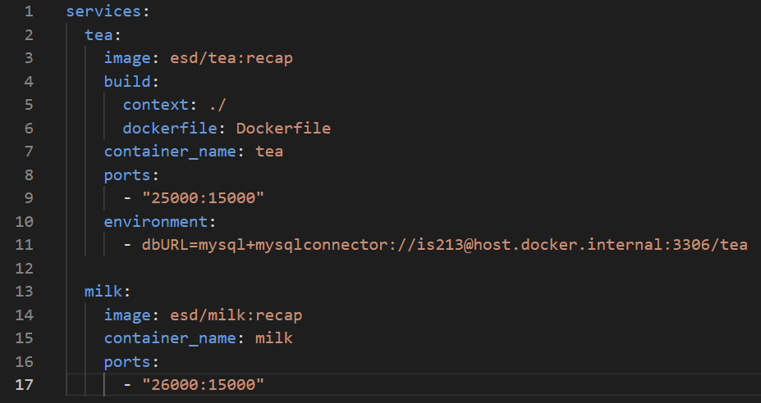

* **When 'docker compose up', it will start 2 containers.**
* **Host port 25000 is mapped to 'tea' container's port 15000**
* There will be a port conflict as both 'tea' container and 'milk' container are listening to port 15000
* **If the esd/tea:recap image is not available locally nor on Docker Hub, docker compose will build the image.**
* The 'milk' service block is missing 'build:' block, thus, docker compose will fail

[Make a guess] Look at the code in the image. Select all CORRECT statements.

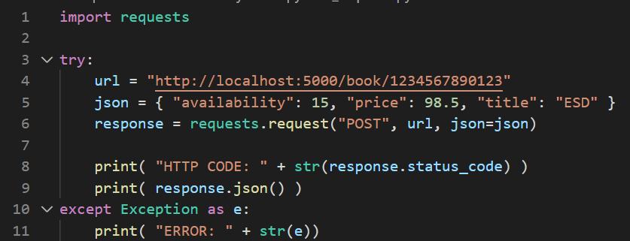

* **There is a python module named "requests".**
* Line 6 sends a HTTP GET to http://localhost:5000/book/1234567890123 and stores the HTTP response in the variable "response"
* Assuming book.py from the previous lab, if there is no book with ISBN 1234567890123, the HTTP status code printed out is 200.
* **Line 9 prints the JSON received in the HTTP response**

*Side note: The lab book.py sends 201 for successful cases.*