Temasek Polytechnic
School of Informatics and IT
Diploma in Big Data & Analytics
AY 2022/2023 Sem

Student Internship Programme Report /

Overseas Student Internship Programme Report

Introduction
CGH is a hospital in the east of Singapore, this place consists of three different buildings, The integrated building, Accident & Emergency building, and the Medical Centre. The office that I am appointed to is located on the 9th floor of the Medical Centre. On the first day, I was brought up to the office and assigned to the table that I will be working at. Then I was introduced to the entire Centre of Performance and Excellence (CPE) department. The CPE department is split into 2 sub-departments Office of Improvement Science (OIS) and Data Management and Information(DMI).
I was attached to CGH for 20 weeks. CGH is under the healthcare industry, they are an award-winning public hospital with over thousands of beds caring for a huge community in the eastern side of Singapore. CGH is a member of the Singhealth Group with a common objective to provide affordable and accessible healthcare that accommodates the needs of every type and every one of the patients. The Internship offer that was offered to me was a role in data management and integration (DMI) under the Centre of Performance Excellence department.

I started my first day of work on the 12th of September, on the very first day it was an introduction to the whole department and showing us the way around CGH. A few hours later, we had a meeting with nary, our department head. We had a discussion on how our internship here was going to go. CGH expected me to take part in certain medium scale projects, to sit in and assist the analysts in charge of their respective projects. Since I have completed my Major Project, I was not expected to take on a project by myself. The sole purpose of this student internship training program is to provide me the opportunity to experience what it is like in the workforce and to absorb as much knowledge on the healthcare domain and to pick up new technical skills and software CGH uses on a daily basis.

On the second day, we met up again to discuss the workload distribution for me and the other intern. I was then told what was expected of me, I was tasked to take on multiple morning reports and 3 different projects on Robotic Process Automation (RPA). These projects will be brought up and discussed with me individually by the analyst in charge of the respective projects. In the meantime, I am to help with minor tasks assigned to me and assist the analysts.

SIP experience
My own expectation from this SIP is to experience what it is like to actually work in an IT industry and how I can apply the skills that were taught in school. Also trying to make an impact in any way during the 20 weeks that I am attached to CGH, doing anything that will help my colleagues ease their burdens to the best of my ability.
As mentioned above I am under the DMI department. What my department mainly does is data extraction. They receive data requests from doctors or nurses who are also known as data requestors. We then use different software like Oracle which is a data warehouse that CGH uses to store their data and also a few other software. Under Oracle, there will be different categories of data for the different departments or medical units under CGH. Under each category there are different headers that you can drag into a “plan” where you can filter data by dates or by selected variables and many more.
We will then export this data as a CSV excel file and structure the data according to what the data requester has requested. The main goal of this whole process is to structure data for analytics for improvements of performance using Excel and Python. On top of doing data requests, we take on projects where we use analysis tools to submit reports on a daily, weekly or monthly basis according to the requestor to help them keep track of data. I will be explaining the different projects that I have taken part in and my experience with them down below.

Automation of CGH 4x/5x
The hospital’s Radiology team, they were doing a weekly report to keep track of the patient's condition. There are 5 different severities from 1x to 5x, patients that are categorised under 4x and 5x are in severe conditions and every one of these data will be tagged as either acknowledged or unacknowledged by a doctor. The reason for their approach is due to the weekly report that they are doing is too time consuming and they want us to speed up the process for them with automation. For this project I was tasked to use a new coding language R script to merge columns and filter the data by 4x and 5x only. Some images of my codes using the platform RStudio will be shown below.
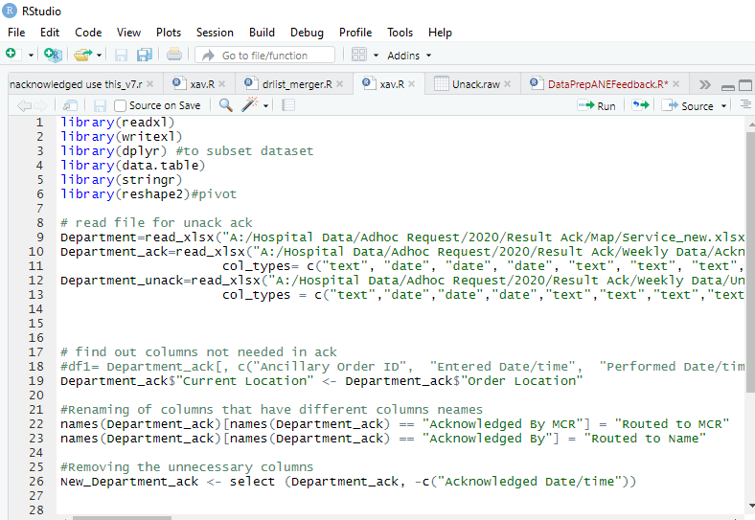
As shown above, these are the codes that I came up with. The codes executed are to read in two different files that one acknowledged and one unacknowledged. After reading in both files, I merged the two files and exported it into an Excel file.
After merging the two files I then used excel to filter the data according to what the end-user requested. It was tough completing this script, it could have taken less than a day. Since I am new to the language R-script, I spent most of the time researching online on what syntax and variables to use. However, I am glad that with time I pulled through and was of help to my colleague.

Automation of Email attachment download
In this next project I was tasked by one of the analysts to automate the process of downloading TXT files from outlook, merging them and exporting them as an excel file for a weekly report submission. I was told that I could use any software available. Therefore, I decided to use Python to code out this process.
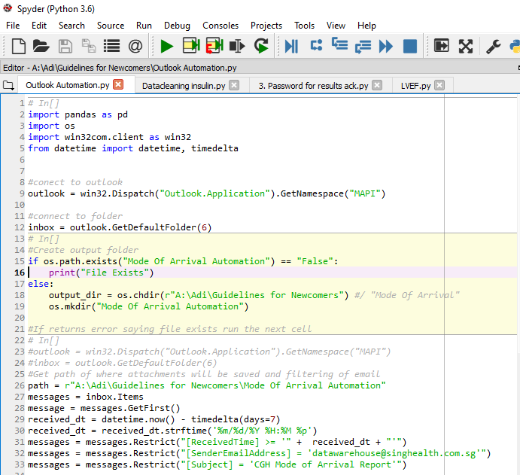
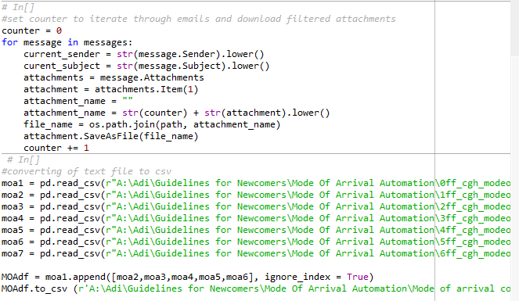
As shown in the two screenshots above, I used a code where it would connect Spyder, the platform I am using to code, to outlook and create a folder in the computer drive to store the downloaded data. Using time delta library I filtered emails that have been received only from 7 days before the current day up until the current date. From there I filtered out the specific email header of the email that has the attached TXT file. After filtering the necessary variables out, I downloaded the TXT files and appended the data for all 7 days. This report will then be sent to MOH weekly.
This project took me quite some time to finish, although it is done in Python, I was not provided with any specific platform to use. I had the choice to use any platform I desire. At the beginning I used Sikuli, a cursor movement automation platform. However, I realised that it was inefficient for this particular task as Sikuli uses screen capture to recognise the location of where you want to click. However, the headers of the emails are the same, therefore it gets an error. So, I decided to use Python. I had trouble starting on the project as it was a new library, and I did not know how to work my way around it. It took me some time but using some basic knowledge I learnt from school and google, I managed to complete the project.
Automation for Data extraction
I had two different tasks needed to be done where I am required to use cursor movement automation for extraction of data and to save it in a particular folder. Both are data extractions but on different data warehouse platforms. For this data extraction, I just need to automate the extraction of data from an E-hints plan and export the file as csv into a folder all using a software called Sikuli. This software is a simplified version of JavaScript, where you input simple codes and Sikuli will convert them into a JavaScript code. By using simple codes like “type” and “click” the software will convert it into a JavaScript that will move the mouse cursor to type or click on your screen without touching your device. Another feature of Sikuli is that you can take screenshots of the screen that your device will be on and the screen capture AI will locate the position on your screen and run the code. Below is a part of the script that I typed out using Sikuli.
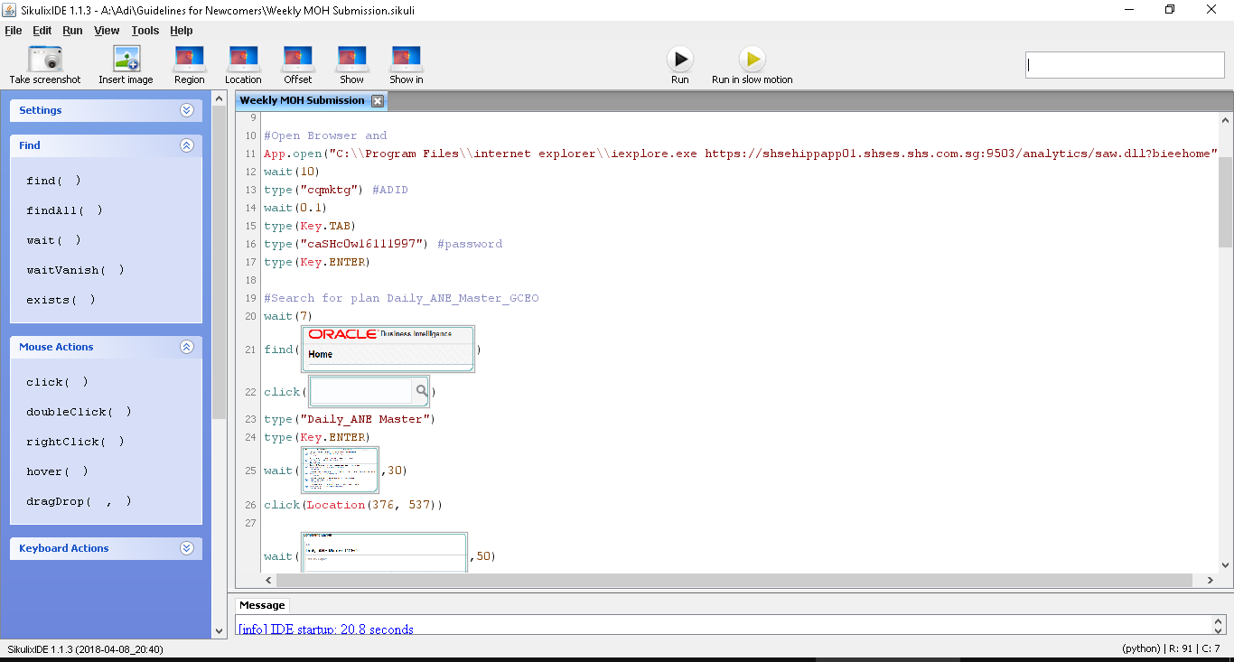
As you can see from the screenshot above there are no complicated codes, but very short syntaxes and screenshots to run the script. This is how the program will run, it will minimise Sikuli and it will start from the current state of your computer. The program will then start to move accordingly and execute the script.
The next task is basically the same steps and process. However, instead of extraction of data using E-hints, this task requires me to use SAP. Below Is a screenshot of the script I typed. I had some troubles trying to figure out the syntax as this software is not well known, with very little sources online to solve my problems. Since it was a simplified version of JavaScript it was manageable on my own.
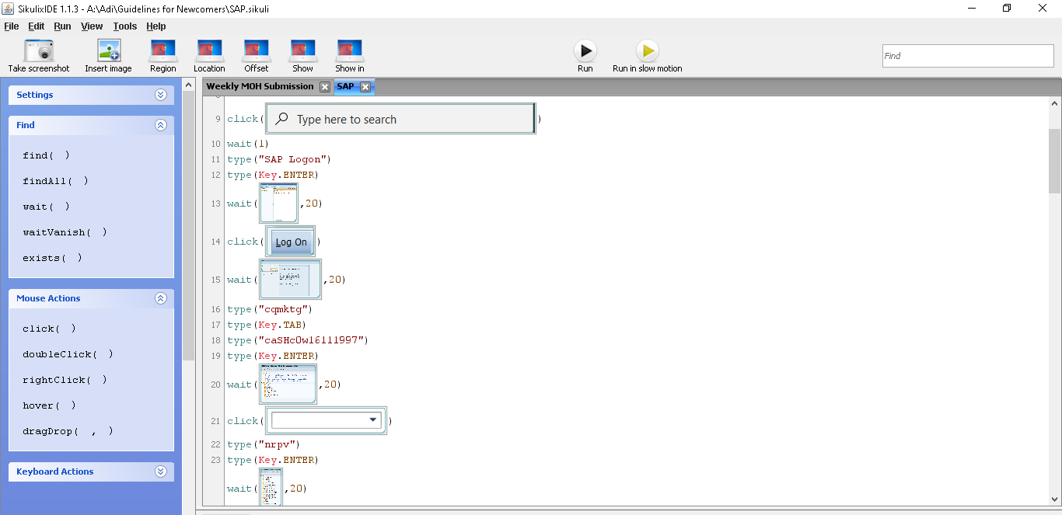

Data Request for A&E Doctor
This project is known as a data request, where there will be a data requester that provides us with a list of data and variables that he requires in a word document. We then need to find a way to find the data, extract it into an excel file and structure the data into a table where it will be easy for the requester to analyse and filter the data. When doing a data request we are supposed to keep contact with the requestor to fulfil their needs to the best of our potential. To complete this data request I had to go through a long list of variables in a word document. Below will be a step by step process on how I went about doing this task as it took me about 1 month to finalise the project.

- Problem Statement
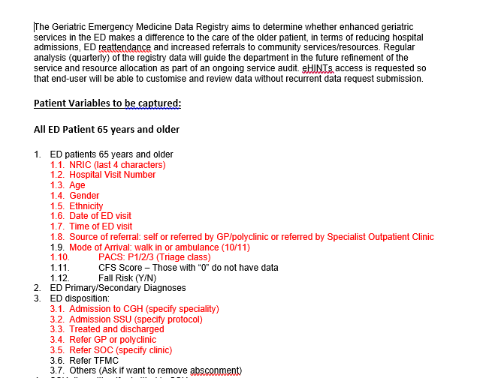
Above is a part of the word document that is provided by the requestor. Objective is to find out if the team is doing well with enhanced geriatric services in the Emergency Department, In terms of Hospital re-attendance and other factors.

- E-hints
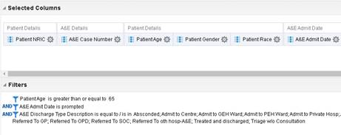
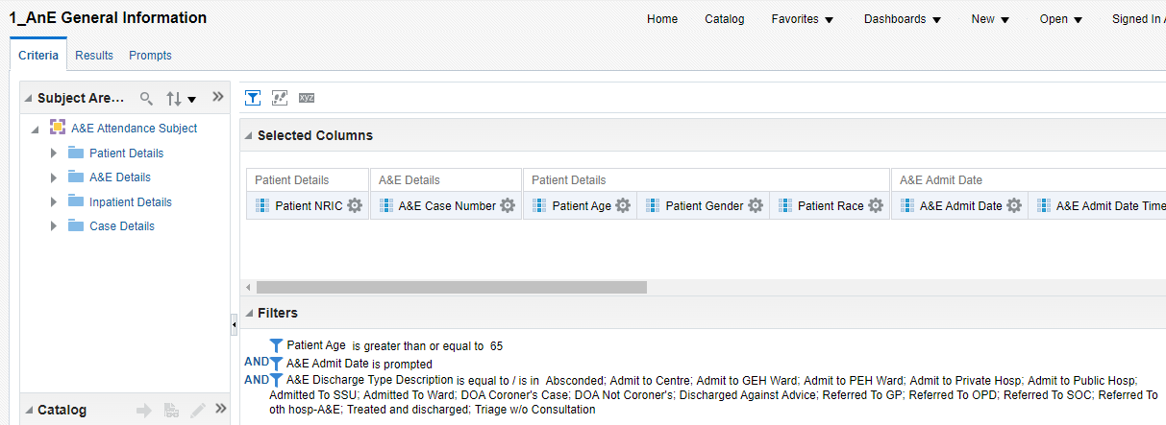
- This is how an E-hints plan looks like, on the side there will be column headers or variables that contain different data for the specific subject area that you choose to use. On every variable there is a setting logo where you can adjust and filter the data accordingly. The filters will then appear at the bottom of the page for edits of the filters.
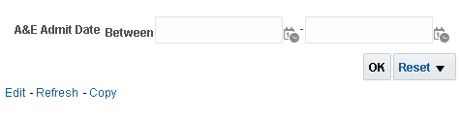
- I then imputed this filter called “Prompted”. This will open up a page like shown above when the data requestor click into the plan created by me. They will not be able to edit the formula, but they will be able to input the variable that I allow them to input, like data range or Patient NRIC number.

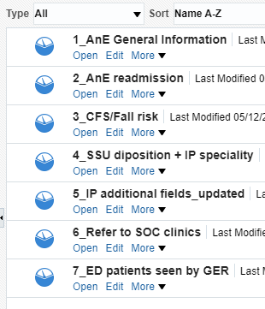
- In total this data request required me to create 7 plans in total to provide that requester with sufficient data to proceed with the requester’s performance audit.

- Excel
Next, I put all the extracted data into one excel table with different excel sheets, using formulas like Vlookup and mathematical formula to calculate variables and connect the different excel sheets and plot all the necessary variables into a general excel sheet where most of the information will be displayed after extracting data into the other excel sheet. The screenshot below will show you a part of the excel file.
I had the most challenges while doing this data request. It is my first time doing a data request, there were a lot of variables that needed to be included. Furthermore, it was also my first time using E-hints to create plans with their data warehouse software. I needed to learn the different subject areas and to find relevant data due to the lack of domain knowledge. The part that I had the most trouble with was the creation of the excel workbook. I did not know how to do the different formulas to piece the data together to meet the requirements. Under the guidance of my colleague, we managed to finish the request before the deadline.

Conclusion
All in all, I personally feel that this internship has given me a broader and clearer perspective on how the course that I am taking now can be somewhat relevant in the working industry. Technical skills like excel formulas and tableau are used to solve real life problems. Or tracking the performance levels of employees to better improve services provided to the customers. Overall, I believe that I have fulfilled my company’s expectations during this program as I ended the internship leaving with domain knowledge and new technical and application skills that were not taught in school. Taking responsibility and providing my fullest to the tasks assigned to me.
Some recommendations that I will give for the tasks and events that I underwent is, in the future, I need to do my homework on whatever field I am stepping into. Be it Sales or IT or Design, I need to have some sort of understanding of what I am doing to excel and be efficient. Secondly, I should take notes of the things that I learnt. Technical skills and application skills are important in the workforce where things are at a high pace, efficiency is key, having broader knowledge and experiences lead to higher efficiency.
Something I would change during this internship program is having more exposure to other departments. Maybe having half the internship in another department to experience a different set of skills.

January reflection:
My plan for the last month of my internship was to extract as much knowledge from my colleagues as much as possible, getting feedback on how I can improve my attitude and skills in the office. Allowing myself to grow and learn from this experience and bring it over to my future endeavours.
I did a data request that required me to extract data from different areas and formulate plans on how to extract data from their data warehouse. After the extraction of data I was tasked to use excel to do up multiple sheets in an excel workbook to connect the data and structure it so it is easy to the eye.
This project tested my monitoring and tracking of my work. It was loads of data that needed to be extracted and presented to the doctor. However, using my past experiences I took my time, not rushing the process and managed to finish it before the deadline. Used Microsoft Word to highlight those variables that have been extracted.
I did quite well going through all the data step by step and persevering through to double and triple check my work to make sure all data is in place and present. Even after completing, I learnt that, especially for the field I am working in, checking your work multiple times is a must. The amount of data is too massive to not make a mistake. Overall, I did pretty well but I need to be more open-minded and find other ways to elevate the structure of my data, to provide simplicity for the end-user.

