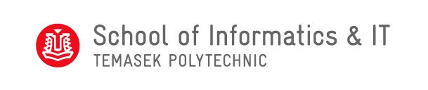

Temasek Polytechnic

School of Informatics and IT
Diploma in Big Data & Analytics
AY 2022/2023 Sem

Student Internship Programme Report /

Overseas Student Internship Programme Report

GUIDELINES ON YOUR WRITTEN REPORT

Based on the given format below, write a report of about 2500 words / 8-10 pages including the use of tables/diagrams.

* Students are required to complete the student SIP subject survey - screenshot the completion of student SIP subject survey and attach in the appendix of the SIP report.
** Students are also required to include the SIP Mentorship Record as well as learning outcome form in the appendix of the SIP report.

I LANGUAGE
Since this is a personal account of:
- what you did
- what was expected of you
- what you expected from the company you worked for
- the benefits you received
- the difficulties you may have encountered,

It is all right to be personal and to use “I” in the introduction/analysis /conclusion and recommendations section of your report.

Your report should not be written in the form of brief notes. It should be in continuous prose using such techniques for layout as tables, bullets, flow-charts, etc. where appropriate. Pay particular attention to tenses - think carefully about whether something that happened in the past or not.

II FORMAT OF WRITTEN REPORT
Your report should contain the following in this order:
- COVER PAGE
- TABLE OF CONTENTS
- CONTENT
- ACKNOWLEDGEMENTS

III CONTENT
1) INTRODUCTION
This section comprises:
- a short description of the company.
- information on the company’s services, products and designs.
- the purpose of your training programme.
- the company’s expectation of you.

2) WORK IN THE COMPANY
This section should form the main part of your report. It comprises two main sections:
- The Work Environment
- write a description of the work environment, its organisational structure and employees.
- write a description of the nature of the business (include the main services and/or products).

- Job Description
- give a technical description of your job (tasks) with the company.
- describe the methods and techniques used in carrying out your duties.
- describe the types of equipment or facilities used.
- describe the safety aspects of your tasks.
- relate any problems or difficulties you have encountered and what you did to solve them (the problems may be work- or people-related).
- include any relevant flow charts, drawings and diagrams at the appropriate sections of your report and make references or inferences, as you have been taught in Communication Skills.

3) ANALYSIS OF THE SIP EXPERIENCE
In this section:
- discuss the purpose of your training programme.
- discuss the company’s expectation of you.
- discuss the benefits you have received from this SIP.
- discuss the difficulties encountered.
- discuss your own expectations of this SIP.

4) CONCLUSION
- Comment on the relevance of your training to your course of study
- Have expectations (the company’s as well as your own) been fulfilled? Analyse and provide an explanation for your answer.

5) RECOMMENDATIONS
Make recommendations on the following:
- improvements to your work.
- improvements to the training programme in order to enhance learning for other student.

6) APPENDICES
a) Students to attach the screenshot on the completion of student SIP survey here.
b) SIP Mentorship Record
c) Students to attach the Learning Outcome Form

IV ASSESSMENT OF REPORT (Total 30%)
Your written report will be assessed based on the following criteria:
- content (20%)
- language and format (10%)

Table of contents

Introduction

Work in company
  - Working environment
  - Job description
    - GES Survey analysis
    - Employer survey analysis
    - UPOP modules
    - Ad-hoc duties

Analysis of SIP experience
  - Purpose of your training programme and company’s expectation
  - Benefits received from this SIP
  - Difficulties encountered
  - Personal expectations of this SIP

Conclusion

Recommendation

Monthly reflection: January - February

Appendices

Appendix A1 (Screenshot of student survey)

Appendix A2 (SIP Mentorship)

Appendix A3 (Learning outcome form)

Introduction
SUTD (Singapore University of Technology and Design) is one of the six autonomous universities in Singapore. The department I had the great opportunity to work in is CDC (Career Development Center) in SUTD, which consists of employees hosting career events, providing career consultation to SUTD students, managing internship matters and maintaining positive relationships with other companies and employers that hires SUTD students as for internships or full time offers, all to make sure that SUTD students have a stable career for their future.

Every year, CDC would collect data from company employers about their experience with SUTD interns and fresh graduates. This data is then presented to the head of department to gain insights about how SUTD students perform in the working world and see which areas that require the most improvement for SUTD students.

My role as a data analyst is to create a Microsoft survey for my colleagues to collect employer responses. I will then analyze the collected responses using power BI by creating visuals about the data, collate all the visuals and put it into PowerPoint to present to the department head.

However, since the employer survey was only collected in October while my internship starts in September, I have taken up various ad-hoc tasks such as helping with events, participating in UPOP and analyzing GES survey responses using power BI.

Work in Company
Working Environment
CDC cultivates unity amongst the colleagues by having lunch together and working closely with one another since all the roles in the department are connected one way or another.

Despite myself being just an intern in the department, everyone was very friendly and welcoming when I first came in, we had lunch together and everyone was so keen on knowing about myself and my interest. This helped me feel comfortable approaching and working with them and I did not dread going to work because of how friendly they were towards me, it felt like I was part of a family in the department.

CDC also cultivates WFH (work from home) for 2 of 5 working days since covid began and they have been continuing the WFH culture ever since, thus I get the comfort of working at my own home for some days and going to office does not benefit my work much because I only need to work from a computer screen which can be done either at home or in the office.

For the physical environment of the office, I sit at a desk next to one of my colleagues and there is also a pantry for SUTD alumni which my department is allowed to use. Apart from the office, the school campus has many facilities such as a running track, swimming pool and gym. There are also quite a variety of food choices around the school campus such as a canteen and 3 other food outlets.

Job Description
Tasks completed:
- GES Survey analysis
- Employer survey analysis
- UPOP sessions:
  - LinkedIng up
  - Art of communication
  - Brand you
  - Showcasing your skills: Resume & Technical Portfolio
- Ad-hoc duties:
  - Industry Night (event)
  - Pulling excel data (VLOOKUP)
  - Internship presentation banners

GES Survey analysis
The GES survey is conducted annually to survey the employment outcomes of the graduates from institutes in Singapore. Like all other institutes, SUTD also conducts such surveys to understand if they were successful in helping their graduates find full-time jobs and finding out how they are faring in their field of work.

For the survey data, CDC has decided to use Power BI as their choice of analysis tool. My job is to analyze the data using their choice of analysis tool which is power BI and show statistics of the survey results such as return offers, FTP (full-time permanent offers), pillars and salaries.

At first, I was not very familiar with the Power BI, and it took me a while to get used to creating the visuals, but I researched on how to use power BI through online videos and articles, and managed to learn to generate simple charts relevant to what the department wants to find out from the survey. No data transformation and cleaning was required since another colleague had already done so prior to my internship.

Charts generated:
- Return offer by pillar
- GPA by return offer,
- GPA by FTP
- FTP by pillar
- GPA by salary
- Pillar by salary
- UAS by salary
- Return offer by internship term.
I am only able to show charts highlighted above, due to sensitive data regarding GPA and salary.
This chart shows the number of return offer by each respective pillar. As you can see from the bar plots, ISTD has much more return offers as compared to other pillars. However, there are still a significant number of students who did not get a return offer.
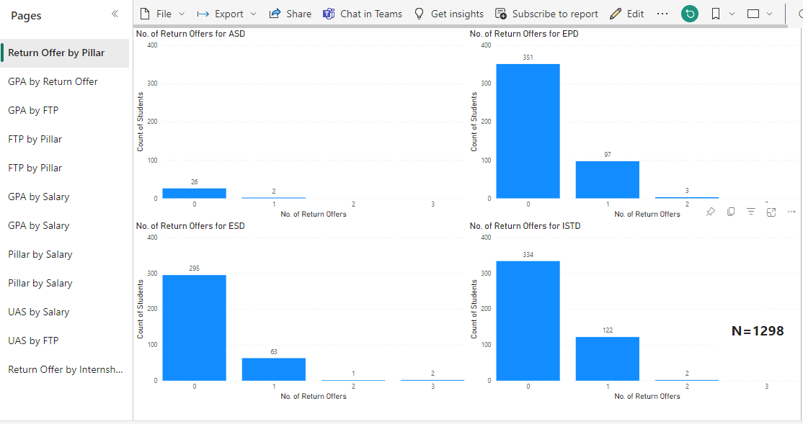

This chart shows the number of return offer by which internship term they were from. As you can see, most the student's return offers are from companies they interned at on the fifth internship term. This is probably because interns on their fifth term would be closer to graduating and thus the company would be able to leave an offer for them until they graduate. Whereas those who interned on the third internship term would still have around a year before they start working. Moreover, students who interned during the fifth internship period would have more experience prior to their internship.
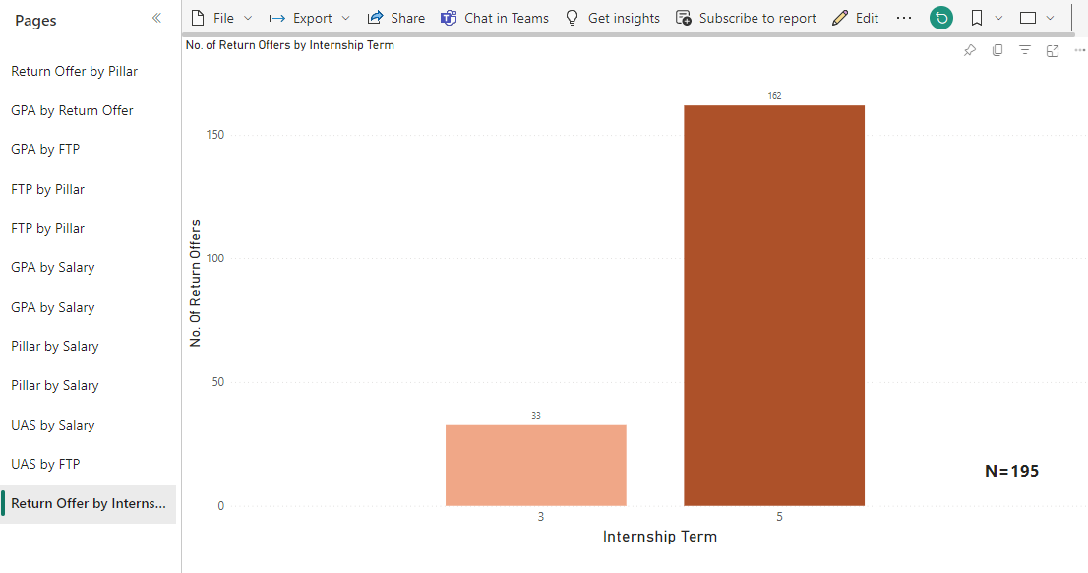

Employer survey analysis
The employer survey is sent out to companies with SUTD interns or fresh graduates to understand from the company’s perspective if SUTD has trained their students well enough for the working world. During the student’s internship, CDC would send representatives from the department to catch up with supervisors and students to ensure that their internship is going smoothly. At the same time after the visits, they will ask the supervisors to fill up the survey. The CDC employer relations team will also send the survey link to employers who hired fresh graduates from SUTD.
The survey consists of the same set of questions for both the different sections, ‘interns’ and ‘fresh graduates’. Survey questions include student’s proficient skills, positive contributions, areas of improvement, etc.
All the responses are collated over the span of 3 months then I will use the responses to conduct analysis for the department on how SUTD interns and fresh graduates fair in their companies.

The first thing I had to do is to create the survey. My supervisor has sent me the questions they wanted me to include in the form and I had to set it up from scratch using Microsoft forms. The screenshot is an example of how the survey looks like.
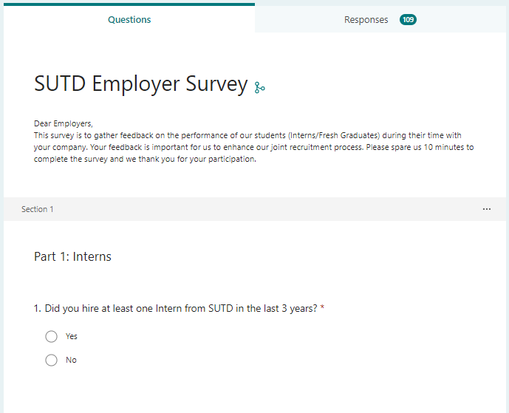

Once I collated all the responses, I downloaded the responses as an excel file and put it into power BI to conduct data cleaning and data transformation and created visuals for multiple choice questions.
For this first visual, I created a donut chart to calculate whether the company has hired an intern for the past 3 years.
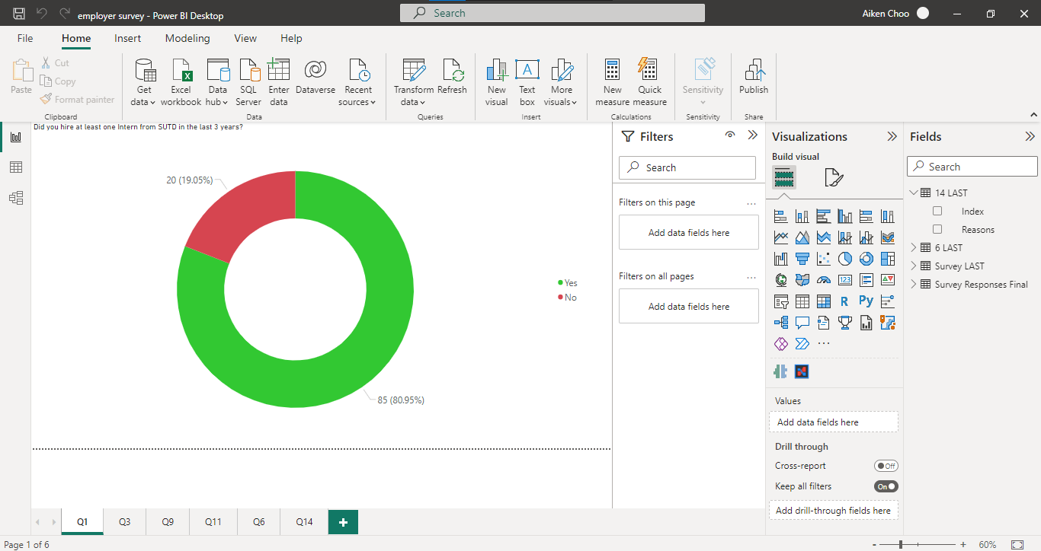

For the next bar chart, I had to analyze a multiple answer question, thus I had to transform the data for the question.
First step is to add the column as a new query.
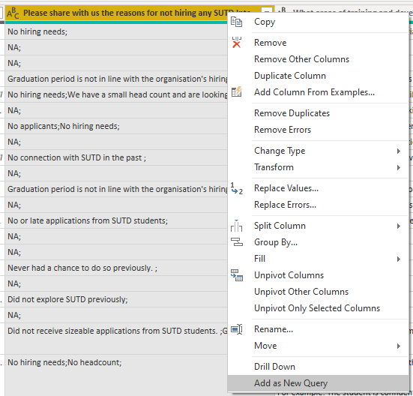

The next step is to convert the query as a table, add an index row as a common column factor with the main dataset, then splitting the multiple answers by delimiter.
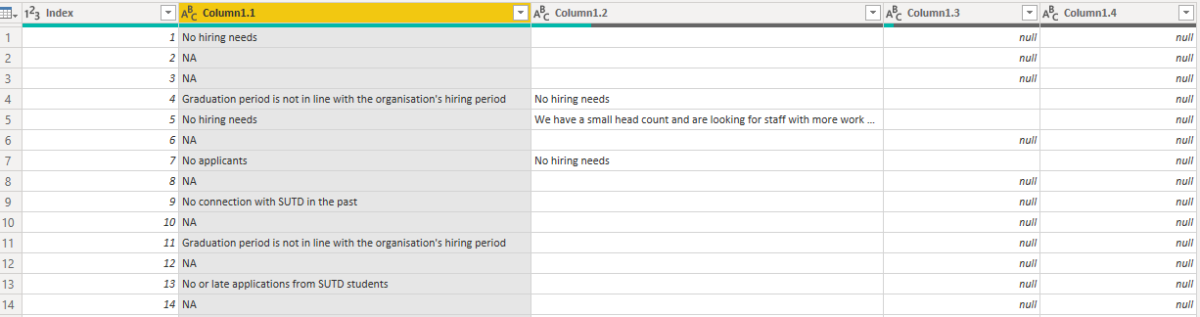

After that, I selected the index column and unpivoted the other columns, then deleted the attribute column. Now the responses will all be in one column but label by the index column they were originally from.
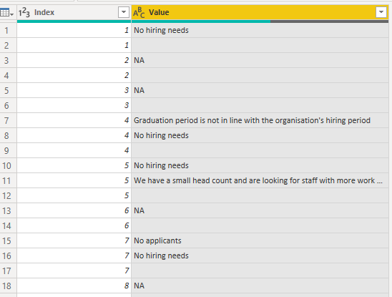

After that, I removed the blank entries generated by the extra semicolon, then created a relationship between the index field of the table with the main dataset.
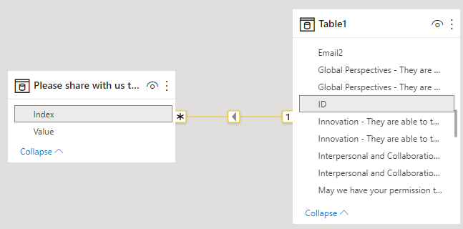
The last step of data transformation is to set the cross-filter direction from single to both. This allows the main dataset to call all the values from the table created.
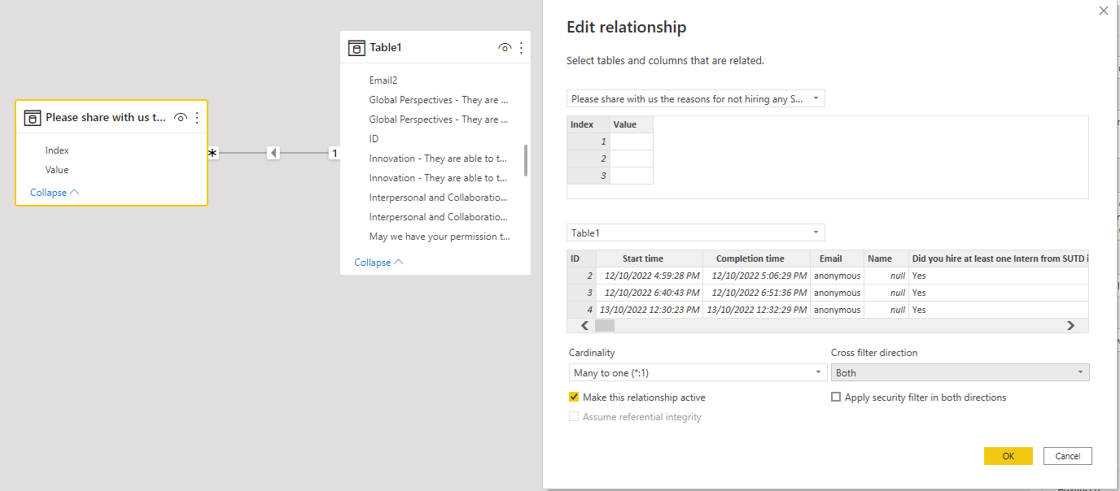

Now when I create the bar plot by using the table created as the X-axis and count of ID as the Y-axis. My supervisor preferred the view as percentage thus I changed the values to percentages. As you can tell, there are many employers who did not hire SUTD interns in the past due to the lack of headcount and the lack of hiring needs.
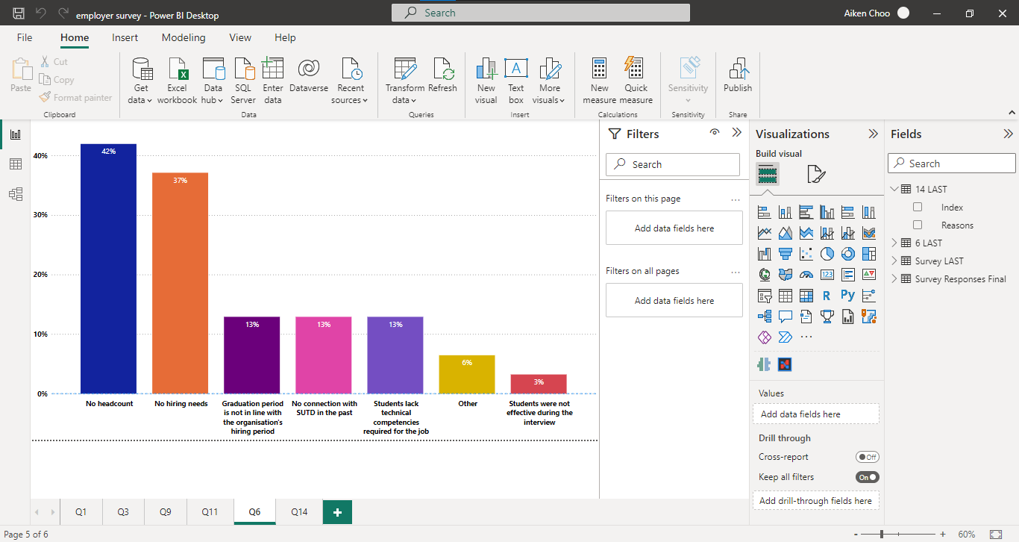
For this slide I used the Microsoft survey’s tornado chart and pointed out the top and bottom areas SUTD interns fare better as compared to other universities. As you can tell, SUTD interns excel in digital literacy, personal values and professional ethics, and curiosity and independent learning, as compared to other universities. Whereas SUTD interns are worse in responsibility to the community, nation and the world, domain expertise, and global perspective, as compared to other universities.
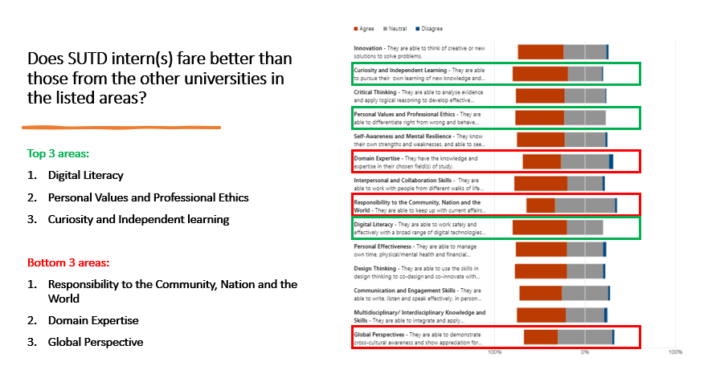
For the rest of the slides I created for data analysis are created on PowerPoint, because the data is in open ended text format. Data transformation for text will be done manually, as power BI was not able to analyze text responses very well.
For the next survey response, employers are required to write training and development they think that SUTD interns should be equipped with. There were a lot of short responses as shown below.
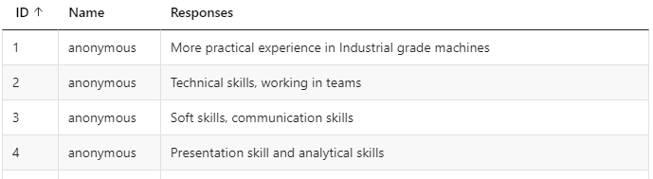

I went through the comments manually and listed out the number of occurrences of each area on improvement, then I put it in descending order. Most of the employers think SUTD interns should be prepared with technical skills and communication skills.
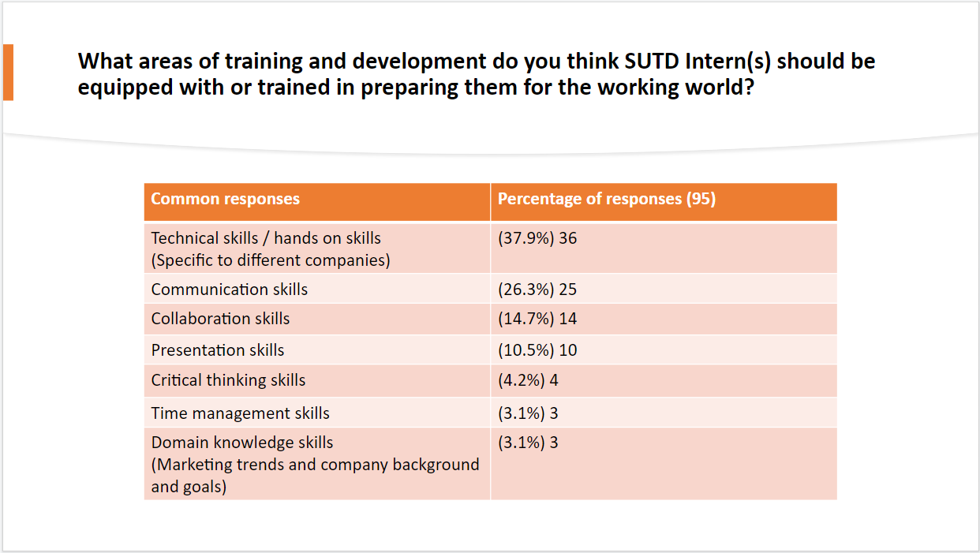

For the comments that are longer and important, I listed the comments, summarized it and listed the company name with a table format. Also in the header, it says which SUTD pillar the company hired their interns from. This will help my department to understand what areas of training are required for each pillar.
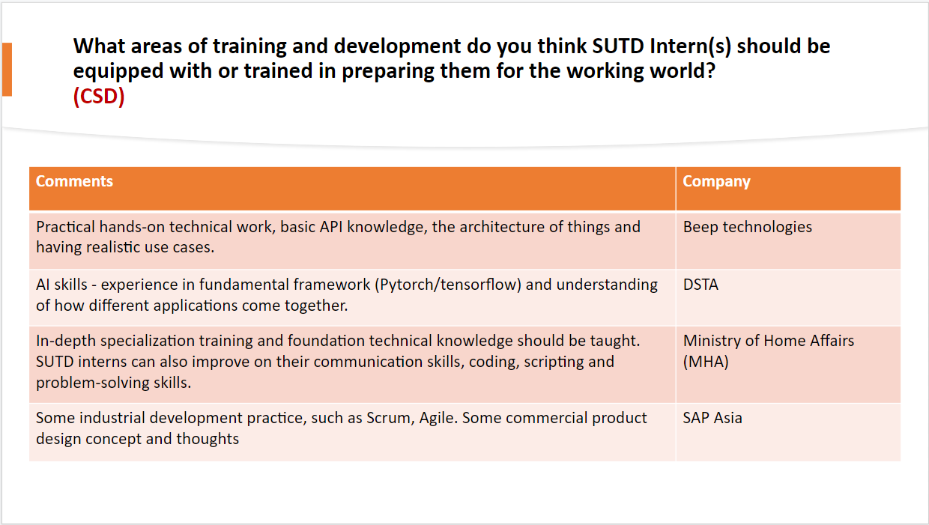

For the rest of the analysis that I did up were the same format, for multiple choice questions, I used a donut chart. For open ended questions, I used the table format on power point. Here are some more screenshots of the survey analysis. Notice the headers will label for SUTD fresh graduates as well, thus the questions are not duplicated.
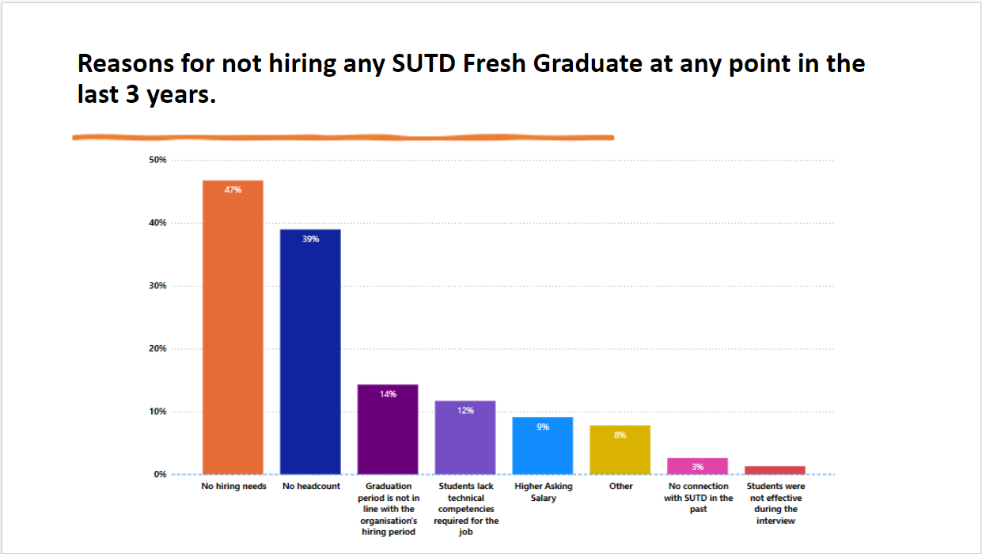
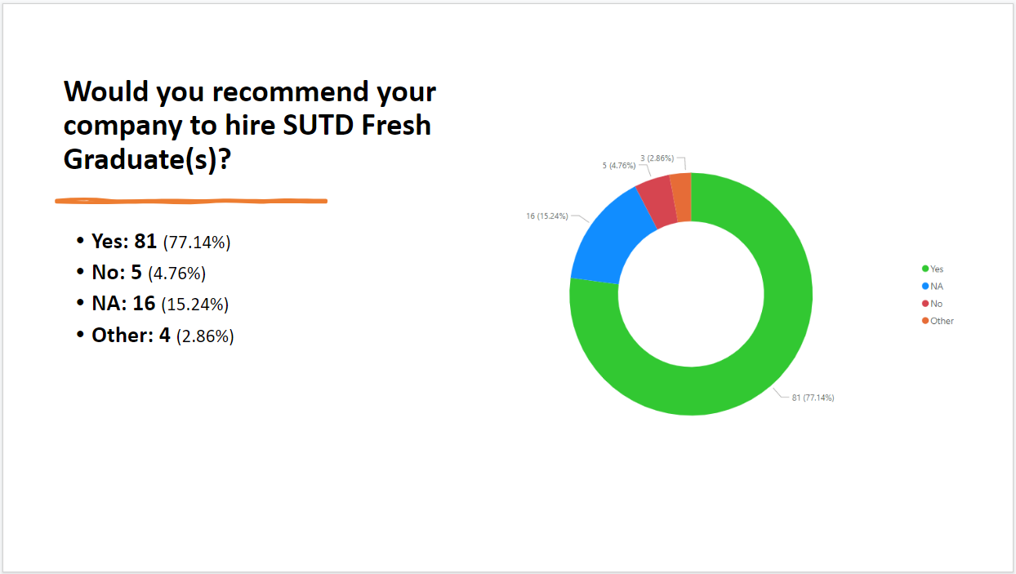
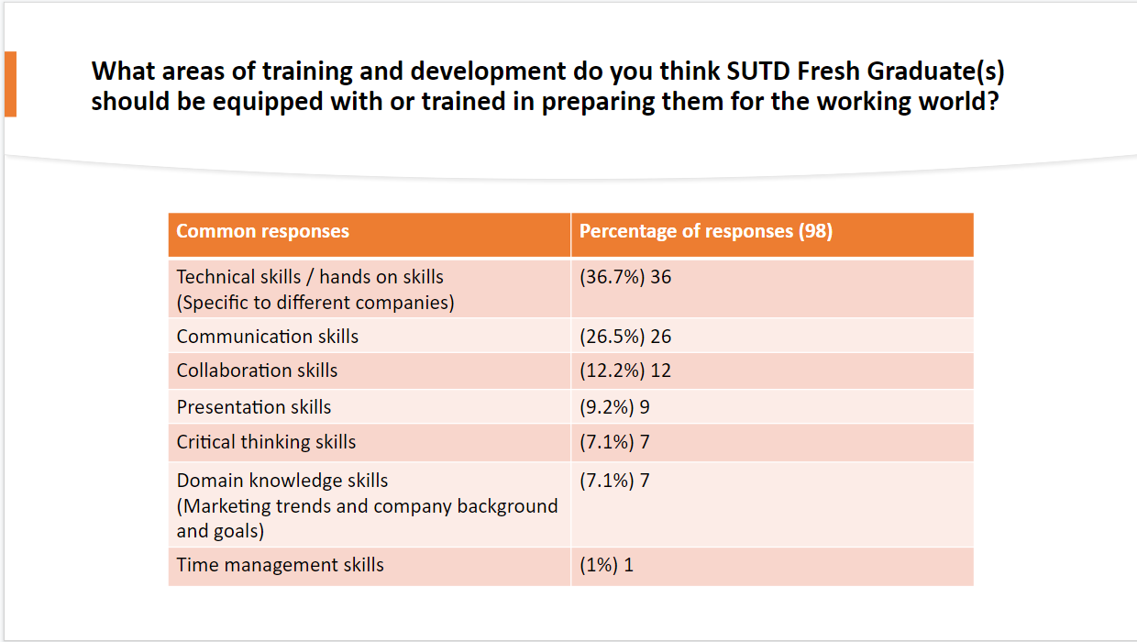
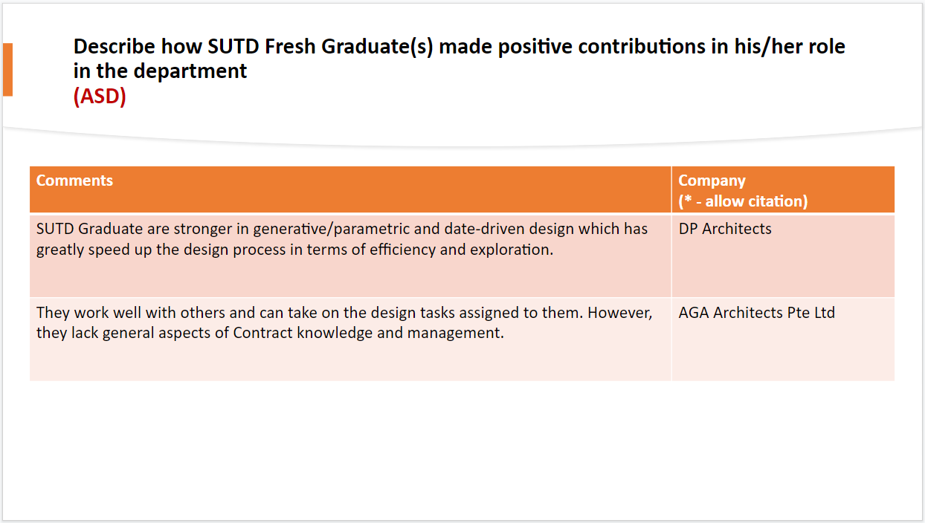

UPOP Modules attended:
- LinkedIng up
- Art of Communication
- Brand you
- Showcasing your skills: Resume & Technical Portfolio

About UPOP
UPOP, also known as Under-Graduates Practice Opportunities Program, is designed to develop career readiness among SUTD undergraduates. With a wide range of practical and experimental sessions, taught by Career Advisors and Professional Consultants, students acquire the relevant career skills they need to navigate the job market upon graduation.

UPOP Module: LinkedIng up
In this UPOP session: linkedIng up, I learnt about the advantages of having a linkedIn account and how to make use of that advantage by bringing it into my work life.

Advantages such as finding opportunities, connecting with various companies and individuals, using it as an E-portfolio and most importantly keeping an updated record of my education, work experiences and skills. With a linkedIn account, I can showcase it to potential job employers and partners.

UPOP Module: Art of Communication
In this UPOP session: art of communication, I learnt how to communicate verbally and non-verbally and why they are both essential in communication.

In verbal communication, what you say can be insignificant if the tone of your voice does not coincide, for instance if you have something very important to say, but you say it in a soft or neutral tone, the listener may not pick up the importance of what you are saying.

In non-verbal communication, hand gestures and body movements can influence firstly, how the readers understand the things you say and secondly how they perceive your enthusiasm and passion in your words. An example for the first instance is, if you nod your head while explaining something, people tend to nod back and have the idea of agreeing with what you are saying. An example for the second instance is, if you keep your hands in front and move it slightly with what you are saying, you show the passion in your words and makes listening to you more interesting as opposed to talking with your hands behind your back.

UPOP Module: Brand you
In this UPOP session: brand you, I learnt the importance of branding and presenting myself to the audience. I learnt that through presenting my own branding, I can create an impact on others by inspiring them and hopefully create opportunities for myself if I can portray my brand well.

The first thing I learnt about branding is understanding yourself. I defined my special traits that sets myself apart from others, examples of special traits are talents, achievements, strengths, experiences, etc.

The second thing I learnt about branding is: appearance, behavior, and attitude. Appearance stands for wearing formal attire, no accessories and neat hair.

The final thing is using communication for a successful presentation. As stated in the previous module art of communication, there are verbal and non-verbal ways to communicate, this can also be applied to a large audience setting. For non-verbal communication, you can move your eyes around ever so frequently to keep audiences engaged, you can also keep your hands in front and move it with the word you are saying to show more expression. For verbal communication, you can speak with greater tone when you want to emphasize a word or a phrase to grasp the audience’s attention to the word.

UPOP Module: Showcasing your skills: Resume & Technical Portfolio
In this UPOP module showcasing your skills, I learnt that there are many ways to present a record of your past education, accomplishments, work experience and skill sets. These methods include using multiple resumes, different E-portfolios, and CV (curriculum vitae).

When you are applying for jobs, I should modify my resume to cater to the company’s job description for a better chance at me being called for an interview. For instance, if I want to apply for an IT related job, I should include my technical skills related to IT that I learnt in poly such as web development, machine learning and web security. However, if I were to apply for an accounting job, I should include technical skills such as preparing financial statements and posting ledger etc. Thus, you can create multiple resumes and cater each one for the sector you are applying for.

For E-portfolios, there are many ways to do so, however the most common ones are linked-in and personal websites. Some people have created websites specifically to showcase their skills, which is ironically a bonus because it shows how well versed you are in web development and creating visually appealing user interfaces. As for linked-in, you do not have to create a website and it has user-friendly tools to assist you in setting up your profile by including everything you need in a resume such as skill sets, work experiences, bio, education and so much more.

Finally for CV, it is the first time I heard of this, and I am shocked that some companies only accept CVs and not resumes. CV is a comprehensive document that shows employers your academic and professional record in detail. It should contain details of work experiences, academic history, skills and awards that make you stand out from other candidates. CV allows employers to assess your professional and educational track record to determine your suitability for their role.

Ad-hoc duties
- Industry Night (event)
- Pulling excel data
- Internship presentation banners

Industry Night (event)
For the first week of my work, I had the opportunity to help out in the Industry Night event that happens once a year. It is the first time in 3 years since SUTD has hosted this event due to covid and many people were still skeptical on joining events due to the high number of people participating the event, thus manpower was an issue.

Some tasks I did to help prepare for the event were putting up banners, labeling the seats in the auditorium, setting up the main area with tables and chairs and setting up the registration booth and equipment. On the day itself, I was stationed at the registration booth for employers and students and helped guide employers when they needed to move to another venue.

Overall, it was a great experience to help out in such an event and I got to see some of the companies who are hiring students studying in the IT field similar to mine.

Pulling excel data
My colleagues often run into issues where they have two different excel sheets, one with the company list they want to email the employer survey to and one with the collated list of all the companies SUTD has had connections with in the past and their contact person’s email.

They have requested that I find a way to pull data of the contact person from the collated list into the list of specific companies they want to email to. Since there were thousands of rows in the excel sheets, I had to find an excel function to pull data using the company name as the common factor. I have decided to use VLOOKUP as the method I am using. Here are the steps I took to pull the data:

First, I put both the excel file into a single excel sheet.
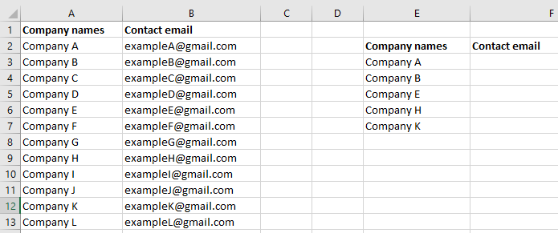

I then keyed in the VLOOKUP formula by lookup value, table array, column index and range look up (by exact match true or false)
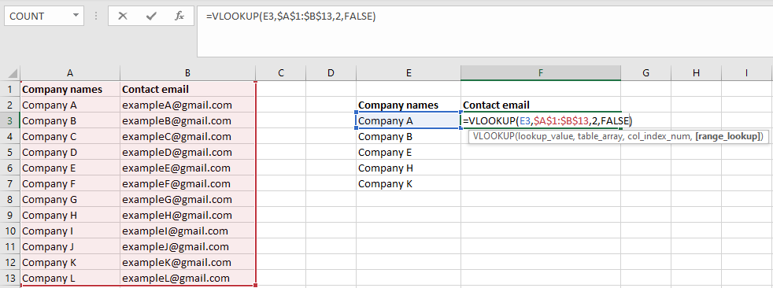

I then applied it to all the rows and this is the final result.
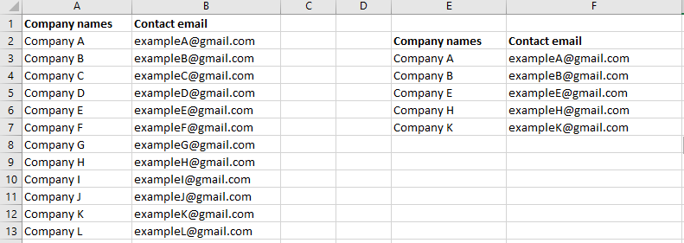

However, when you apply false as the range lookup, the company name has to be exactly the same including capital letters and spacing, thus it took much longer than the steps shown because I had to manually filter the names and edit it to match one another for the data with NA values.
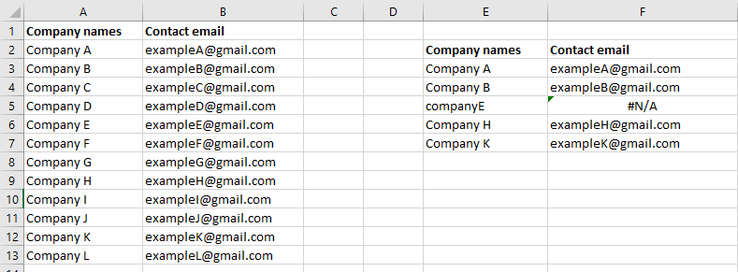

Internship presentation banners
In SUTD internship, students are required to put up a banner of their summarized internship project. The most convenient method to do so is by using Adobe Illustrator, thus I had to google and watch tutorial videos to learn Adobe Illustrator functions and create a banner design for the header and footer of the banner.

Analysis of the SIP experience
Purpose of your training programme and company’s expectation
As a Data Analyst Intern, I am required to assist by providing insights to support the team in making informed decisions relating to internships and employability.

Job Description:
- Utilize data to build reporting dashboards.
- Use of Excel/Access/Qlik to perform collection, analysis and profiling of data.
- Any ad-hoc duties as assigned.
Requirements:
- Currently pursuing a Diploma, preferably major in Analytics, Mathematics, Statistics, Engineering, Computer Science or related field.
- Ability to manage data meticulously.
- Experience in data analysis and data collection required.

Benefits you have received from this SIP
SUTD does not provide any physical benefits normal staff have (days off, MC and transportation), but on certain days the whole campus would have days off (30 dec and eat with family day). They also provided me with a working laptop for me to work with. My department also has their own welfare such as ‘lohei’ during CNY.

Apart from physical benefits, I feel a benefit I received was learning from a group of career coaches. I have always been a quiet person, especially during polytechnic because of covid, I did not have much opportunity to talk to my classmates and socialize. However, the career coaches taught me how to express myself and showed me the importance of communication. This pushed me past my comfort zone and now I feel that I have much more confidence when speaking in front of an audience or during an interview.

Difficulties encountered.
Some difficulties I faced were communicating with employees and using power BI.

As mentioned, I was a very quiet person, thus for the first few weeks, it was difficult for me to ask for help or ask for other things to do during events. But slowly as I got to know my colleagues, I started to feel comfortable around them, especially my supervisor. I gained the confidence to ask for help when I needed guidance which helped me speed up my progress while doing tasks.

Power BI was a program I used for only 1 term in my polytechnic programs. Thus, I was not that familiar with the program and had to use online materials to do my own research on how to transform data and format visuals. It took around 1 to 2 weeks for me to get used to the program and started to create more appealing charts and format it the way my supervisor wants me to.

For the employer survey analysis, I was not sure how I wanted to format the open-ended responses and how to put it into the slides. At first, I just copied and pasted all the comments and company names into the slides and it looked very messy with very lengthy comments. Until my supervisor suggested a way which is to put it into table format so that it looked neater and summarize all the lengthy comments so that when presenting, it does not have too many words to read.

My own expectations of this SIP
My expectations were a bit higher than what I experienced from the internship. I was ready to take on tougher tasks such as machine learning, predictive analysis, and AI, especially since I was in SUTD which is a university of technology. Although I was a little disappointed in knowing that my tasks were much simpler, it was interesting for me to apply my knowledge of data analysis into the real world, especially knowing what I did influenced the company to make an informed decision to make certain positive changes.

On top of that, I learnt much more working skills than I was expecting. When I entered the IT field, I expected to just sit behind a laptop and work all day, however in this department, I learnt that there were a lot of other opportunities to develop my work life skills such as learning communication, exploring different job opportunities and picking up different skills.

Conclusion
In conclusion, this internship has given me a lot of work-life skills such as working with colleagues, communicating with different people in my company, exposing myself to various ways I can jump start my future career through UPOP modules, and applying what I learnt in school into the working world.

I learnt a lot on how to analyze data using power BI and how to properly format open-ended responses into presentation slides. Although the tasks handed to me were not too time consuming, my supervisor and company was able to keep me occupied with many ad-hoc duties and attending modules SUTD provided for their students for free.

Recommendations

Overall, I think the workload was a little under whelming since there was not so much data analysis required in CDC, which I can completely understand. However, I would still recommend an intern to CDC due to the friendliness and healthy work environment, and also the amount of work experience I gained by talking to my colleagues that are professional career coaches and have been in the field for many years.
An improvement can be for the company to consider taking up more data related projects or heavier amounts of data so that other methods of data analysis can be used such as machine learning. This way a data analyst would be much more beneficial in the department because there is much more technical work.

Monthly reflection: January - February
Plan - This month, my plan is to complete all my tasks before the end of my internship so that when I leave the company, I do not leave any tasks half done. I plan to pick up new skills before I leave so that I can bring it into my future work life. I also plan to leave a positive impression with my colleagues before I leave.
Perform - I managed to complete my employer survey slides, which consists of 60 slides of consolidated and filtered data from the employer survey. I made sure that the data was easily understandable and made sure to point out key areas that need to be focused on in the future. I have also participated in UPOP modules, which helped taught me skills on communication and self-branding which I felt was very applicable in the future when I enter the working world and even in my current field of study.
Monitor - I monitored my performance by being proactive in my workplace and focusing on my tasks that need to be done. I updated my supervisor frequently on the tasks and sent my work to the department head for perusal. I also planned my time so that I can complete my task and participate in the UPOP sessions provided by SUTD.
Reflection - This month I felt I was the most productive because I managed to get all my work done, pick up new skills and my colleagues were very happy with my presence in the office. I felt closure in the internship by completing all my work and learnt a lot during my internship.

