

Temasek Polytechnic

School of Informatics and IT
Diploma in Big Data & Analytics
AY 2022/2023 Sem

Student Internship Programme Report /

Overseas Student Internship Programme Report

1) INTRODUCTION:
a short description of the company
- Changi General Hospital (CGH) is an academic medical institution with over 1,000 beds serving a community of more than 1 million people in Singapore. With a wide range of medical specialties and services, it is helmed by an experienced and skilled team of healthcare professionals who consistently deliver positive health outcomes and care for patients.
- CGH is a member of the SingHealth cluster of healthcare institutions.
information on the company’s services, products and designs
- CGH is focused on promoting holistic, patient-centered care for the communities it cares for, providing services that extend beyond the hospital boundaries to help communities return to health and enable them to remain healthy
the purpose of my training program/internship
- The purpose of this training program is to provide me with hands-on experience in the workplace and to be able to apply what I have learned from school to a real-world setting. This internship program not only allows me to enhance my resume, which I know is crucial in the job search process in the future but it also offers a valuable opportunity to gain practical insights into the job application process, including the interview process and receiving job offers. Through this process, I hope to gain a deeper understanding of the industry and the skills necessary to succeed in my future career.
the company's expectations of me
- The company holds high expectations of the intern they are looking to hire. During the interview with me, they mentioned their need for an intern that can come up with methods to streamline some of their daily processes. They also require the intern to help with ongoing projects to ease their workload. To fulfill these expectations, the intern is required to have technical skills in coding/programming languages like Python and/or R, as well as being proficient in software such as Tableau to create graphs. Additionally, the intern may be required to assist with ad-hoc tasks assigned to the department, such as designing posters and setting up booths for events hosted by CGH to showcase the department’s latest projects.

2) WORK IN THE COMPANY:
The Work Environment and nature of the business
- CGH is a highly acclaimed public hospital situated in the eastern region of Singapore, providing healthcare services to over one million residents of the city-state. With a capacity of 1,000 beds, it is part of SingHealth, a leading government healthcare group in Singapore.
- As an intern, I will be serving in the department of Data Management & Informatics (DMI). This department is a crucial component of the Centre for Performance Excellence (CPE), playing an important role in furthering its mission and objectives.
- The DMI team is comprised of several senior analysts, as well as a few other employees who have been on board for the past six months. The total number of staff in this department is ten people, including myself and another intern. We are in a small section of a larger office building, and everyone on the team is very pleasant and friendly. Everyone interacts with each other casually like friends, which is quite different from other departments in the company. I have heard that in some other departments, the environment is more strictly professional and can, at times, be intimidating.
Job Description:
give a technical description of your job (tasks) with the company as well as the methods and techniques used
- As an intern in Data Management & Informatics (DMI), my role is to provide support for the daily tasks that the department must carry out regularly, thereby enabling them to allocate their time and resources towards more crucial matters such as projects. One such task I have been assigned involves updating the daily list for the A&E Department. This dataset, updated daily, helps the A&E Department to monitor and track patients who have been admitted into the A&E unit but have yet to receive a referral. By performing this task efficiently, I can make a meaningful impact by alleviating some of the department's workload, enabling them to concentrate on prioritized projects and tasks.
- I was assigned the responsibility of improving the department's processes to minimize the time spent on routine tasks and ease the daily workload. One of my colleagues brought to my attention a laborious process involving the download, cleaning, and combination of multiple Excel datasets. I leveraged my knowledge of Python programming to automate the process. As a result, my colleague experienced a significant decrease in the time spent on the daily task and was able to increase his productivity, with the only requirement being the downloading of the necessary datasets, followed by using the Python script that I created. During my final presentation at CGH, my work was recognized as a significant contribution to CGH's initiative to enhance productivity and efficiency. This was acknowledged by a senior analyst, who praised my efforts. [Fig 1, Fig 2, Fig 3]
- I am frequently tasked with ad-hoc duties, including downloading multiple datasets via the SingHealth-IHiS Electronic Health Intelligence System (EHints). EHints serves as the Enterprise Analytic Platform for the analysis and reporting needs of the Business, Finance and Clinical departments within SingHealth. In my role, I use EHints regularly to obtain datasets necessary for my colleagues' projects. [Fig 4]
- Once the datasets are downloaded, I may also be required to combine them. Depending on the size of the datasets and the number of files, I sometimes use manual methods such as Excel to combine them. However, in instances where the data sets are too large, I leverage my Python coding skills to combine them by repurposing scripts I have created for my colleagues. By assisting with these tasks, I can lighten my colleagues' workload, allowing them to focus on more critical aspects of their projects. [Fig 5]
- From time to time, I am tasked with the responsibility of collecting and processing data. This involves several steps. Starting from researching the data required from the SingHealth-IHiS Electronic Health Intelligence System (EHints), downloading the necessary information, cleaning and combining the data using a python script, and finally extracting and merging it with an existing database in Excel. The complexity of this process lies in navigating the massive EHints database to select the right data, which can be a challenge, especially for me as I am not familiar with the system. However, through careful research and precise execution, as well as having colleagues who guided me throughout the process, I can complete these tasks and provide the necessary information needed for the project [Fig 6]
describe the types of equipment or facilities used
- In conducting my data analysis work, I require only a notebook computer with an internet connection and coding software named Spyder. This software provides me with the necessary tools and features to perform my analysis efficiently and effectively. The combination of these two tools has proven to be a highly effective solution for me in executing my data analysis work.
- I am also given access to use EHints, which is a data warehouse that captures all the data.
describe the safety aspects of my tasks
- In light of successful malicious attacks on healthcare organizations in Singapore, it is critical for me to uphold the strictest standards of privacy and data protection. As an intern handling sensitive patient information, I am responsible for adhering to the regulations set forth by the Personal Data Protection Act (PDPA). This requires me to exercise caution and maintain the confidentiality of patient information at all times. For example, I am prohibited from capturing images that may contain confidential information and it is a requirement that I must password protect all Excel files containing confidential information. By adhering to the PDPA laws, I am not only fulfilling my ethical and legal obligations, but I am also helping to safeguard the privacy and personal data of patients, ensuring that their information is handled with the highest level of confidentiality.
relate any problems or difficulties you have encountered and what you did to solve them (the problems may be work- or people-related)
- The first difficulty I face is coding. My coding skills are one of my weaker areas and it’s like my Achilles heel. This often leads to challenges and frustration when attempting to troubleshoot issues and create functional code. In the past, I would frequently rely on a simple Google search to find solutions, but I would often be met with answers that were not applicable or relevant to my specific problem. To overcome this challenge, I have tried to improve my search techniques and query more precise keywords to narrow down the results and find more relevant solutions. Additionally, I am not afraid to seek assistance and ask others for help, as I believe that learning from others and their thought processes is crucial to personal and professional growth.
- The second issue I encountered while working on my projects is that I often complete a portion of my work and then leave the office for the weekends. Upon my return the following Monday, I often find myself struggling to remember exactly where I left off. This not only wastes valuable time but also hinders my productivity as I must spend time reorienting myself with the work I have completed. To mitigate this issue, I started leaving notes in my project folder to remind myself of the progress I have made. This allows me to quickly review the notes written in the project folder and promptly resume my work without having any significant loss in time and productivity.
- The third issue I have faced in my role is making careless mistakes while performing assigned tasks. This is due to my tendency to prioritize speed over accuracy, and my colleagues have pointed this out to me. He mentioned that although completing tasks quickly is desirable, it is important to also take the time to check my work to ensure that it is not only fast but also high quality. This means taking the necessary steps to avoid careless mistakes, such as double-checking my work, in order to produce accurate and reliable results. By taking a more measured approach, I can balance the need for speed with the importance of producing high-quality work.

3) ANALYSIS OF THE SIP EXPERIENCE:
discuss the purpose of your training program
- The purpose of this training program is to offer hands-on experience in the workplace and apply what I have learnt to real-world scenarios. The internship serves as a valuable opportunity to not only bolster my resume but also gain practical insights and experience in the job application process. Through this experience, I aim to have a deeper understanding of the industry and its work culture.
discuss the company's expectations of you
- As an intern in the Data Management & Informatics department, I expected to help support the daily operations and processes. My responsibilities include updating the daily list for the A&E Department, improving departmental processes for time efficiency, downloading and processing data from the SingHealth-IHiS Electronic Health Intelligence System (EHints), and providing support for ad-hoc tasks like setting up events and booths.
discuss the benefits you have received from this SIP
- I was able to gain valuable hands-on experience in the workplace and was able to apply my knowledge into my job. I utilized tools and software like EHints to complete my tasks, providing me with useful skills that will be valuable in future job searches. I also learned the importance of my role in supporting other departments and recognized that every number represented in my dataset corresponded to a real patient case in the hospital. Through daily tasks, I was able to practice my skills and improve upon my existing knowledge.
discuss the difficulties encountered
- I faced challenges such as managing my time efficiently as well as coding. Additionally, I sometimes struggled to understand project requirements due to the presence of medical terminologies in the project specifications. Despite these challenges, I am continuously learning and working to overcome these obstacles.
discuss your own expectations of this SIP
- My internship expectations are to gain hands-on experience, apply what I have learned in school, and evaluate if this type of work and work culture aligns with what I want to do in the future

4) CONCLUSION:
Comment on the relevance of your training to your course of study
- This internship has been highly relevant to my course of study and has provided me with valuable hands-on experience. I have been able to apply the concepts and techniques taught in school to practical situations. Additionally, the use of software such as EHints and Spyder has allowed me to familiarize myself with tools that may be utilized in future employment opportunities. This experience has not only enhanced my skills as a data analyst but has also provided me with new knowledge that I can continue to build upon in the future.
Have expectations (the company’s as well as your own) been fulfilled?
- Both my expectations and the company's have been fully met. I successfully completed all the tasks assigned to me, except for one which was dropped due to technical errors. This Internship also provided me with valuable knowledge and skills that I am confident will benefit me in future endeavours. I was also given the opportunity to tour the hospital and gain insight into its inner workings. This was particularly impactful as I was able to understand the real-life implications of the data I was working with, as each number in the dataset represented an actual case in the hospital.

5) RECOMMENDATIONS:
improvements to my work
- During my internship, I have identified several areas where I can improve on. The first of which is time management. I have noticed that I sometimes take a little too long to complete tasks. Another area to improve on is organization, as I need to better keep track of my tasks and responsibilities, especially after weekends. Additionally, I need to learn how to balance between the speed and quality of my work. Lastly, I recognize the importance of honing my coding skills, as I am not very proficient in it

Feedbacks for this internship
- This internship program has been very fruitful for me and I have learned and picked up skillsets that I will be able to use in the future. I do not have any suggestions to improve this internship.

6) APPENDICES

[Fig 1] this code helps me to open up excel and “turn on” the macros

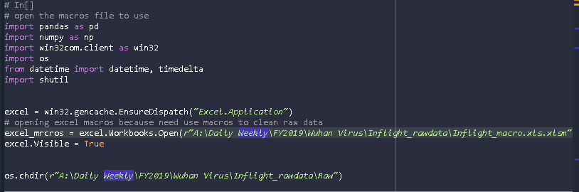

[Fig 2] this code allows me to run the macros on all the excel files opened

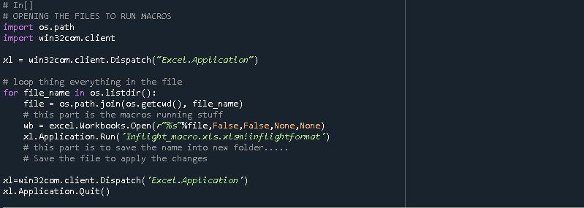

[Fig 3] this code combines all the datasets together, I was able to repurpose this code to help combine other datasets for other projects

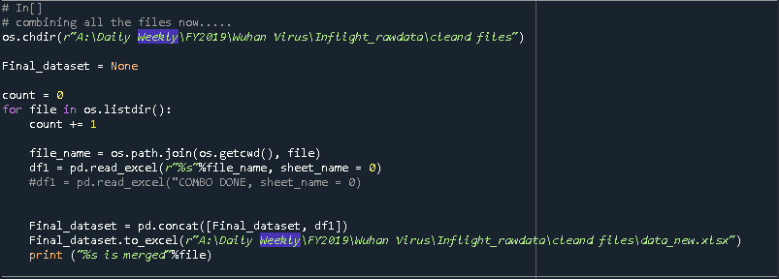

[Fig 4] How EHints look like

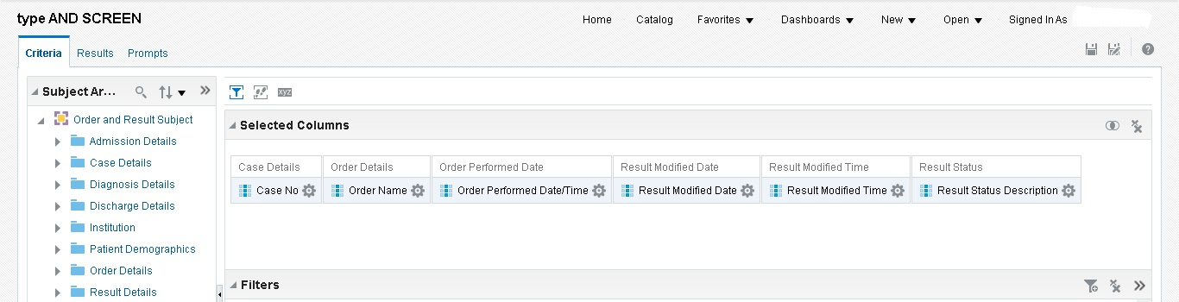

[Fig 5] Another code I used, I repurposed some of my old codes like [Fig 3] into this new code

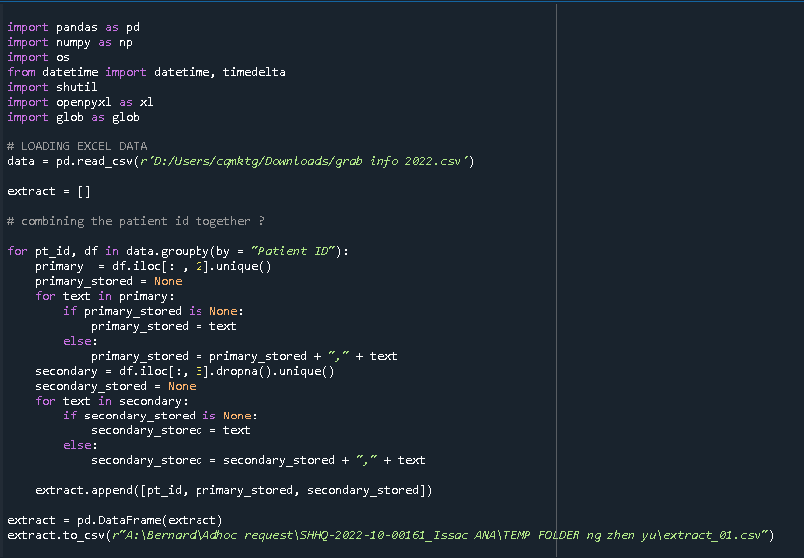

[Fig 6] Mutiple EHints plan created to get the data needed for the project