Software Requirements
Specification
For
InventBox
Version 1.0
Prepared by William Rose
4/13/2026

Table of Contents
1. Project background and descriptions 3
2. Project scope 3
3. High-level requirements 3
4. Entities 3
5. Success Metrics 3
6. Considerations 4
7. Specific Exclusion from Project Scope 5
8. Dependencies and Technologies 6
9. Assumptions 6
10. Designs and Diagrams 7

1. Project background and descriptions
Target Release: 1.0
Status: Rough Draft
Document Owner: William Rose
Designer: William Rose
Tech Lead: William Rose

2. Project scope
InventBox was the inventory management that aims to create, delete, manage, or search the inventory of items or part of the items and display them in an organized way with categories and locations.

3. High-level requirements
InventBox will include the following:
- A login system to store and grab the user information
- An interface to show user interface
- An interface to show the items in an inventory
- A system that search for the items in an inventory
- A system that organize the items by locations and categories
- A system that create, update, or delete the items in an inventory
- A system that scan the bar code to add or grab the items
- A system that calculate the total prices for items that needed
- A system that export and import data for easy transfer
- A system that filter the items by specific information

4. Entities
InventBox will affect the following entities:
- InventBox System – Also known as this system that display the interface to the user on the frontend
- InventBox Backend – The API layer that manage the data on the backend
- User – The user that uses the InventBox
- System Admin – The user that is responsible for managing and maintaining the InventBox

5. Success Metrics
The following metrics can be used to judge the project’s success:

Goal | Metric
User can create items into a inventory via manually or scanning through bar code. | Examine the user’s metadata for the items information
System can organize the items into the locations or categories based on what user is inputted | Items categories or locations displayed with organization matter
System can calculate the total prices of the items to buy. | The items price are displayed
The system is cross platform with self hosting browser, CLI, and mobile | All of relevant information is reachable from all sort of UI
The system fail safety when isolated from the backend systems | The UI is error free when isolated.

6. Considerations
The following requirements were considered of importance for the project.

Requirement | User Story | Status
User can create an account | As a user, I want to create an account to store the information about myself
User can manage their data | As a user, I want to update and delete the account if I want to edit information or delete the information from the system.
User can create an items manually | As a user, I want to create an items that I have with information that I put in into the inventory.
User can manage their items data | As a user, I want to update the item with the new information that I have.
User can delete their items | As a user, I want to delete the items from the inventory.
User can scan the bar code to add items | As a user, I want to scan the bar code from the item so I can add items automatically.
User can search for an item from the query | As a user, I want to search for the items so I can look for specific items in the list.
User can filter through the items with specific information | As a user, I want to filter the items so I can go through the items with certain type of information.
User can scan the bar code to get the item from the list | As a user, I want to scan the bar code so I can yank the items from the inventory.
User can add the items to the shopping list | As a user, I want to add the items to the shopping list so I can look through the list to buy.
System can organize the items into different locations or categories based on what user have put in. | As a system, I want to be able to organize the items into different locations or categories so user can see the items from those information.
System can add the total costs from all of the prices in the shopping lists. | As a system, I want to be able to calculate the total prices so the user can see how much it would cost.
System can add the taxes based on the user’s locations | As a system, I want to be able to look for the taxes based on the user’s locations so user can see the taxes that will be added to the product costs.
Admin can manage the data in the backend | As a system administrator, I want to be able to read and manage the data in the backend using the SQL query
User can export and import the items from or into the inventory. | As a user, I want to be able to export and import the data from the inventory so I can transfer from one device to another.
Admin can self host the backend using the container like Docker. | As a system administrator, I want to be able to self hosting using the container so I can manage the data and users can access the app through browser

7. Specific Exclusion from Project Scope
The following functionality is planned for InventBox but is currently outside of the scope of the project.
- Maintenance functionality like repair logs.
- Multiple inventory management functionality.
- Reporting functionality.
- User sharing functionality for multiple peoples.

8. Dependencies and Technologies
The following technologies and dependencies are required:
- Docker
- SQLite
- Angular
- Bootstrap
- NodeJS
- ASP.NET
- Entity Framework
- ETO.Forms
- Avalonia
- Nunit
- Xunit
- Jasmine
- Vitest

9. Assumptions
InventBox is designed under the assumptions:
- The system will be used to manage the inventory in their home or businesses.
- The user will provide the metadata needed to manage their inventories.
- The metadata collected for the user will be protected with the data protection schemes.
- The user will provide an options to use CLI, Desktop, Mobile, or self hosting.
- The data from the bar code is accurate as technically possible.

10. Designs and Diagrams
InventBox Front Page Mockup
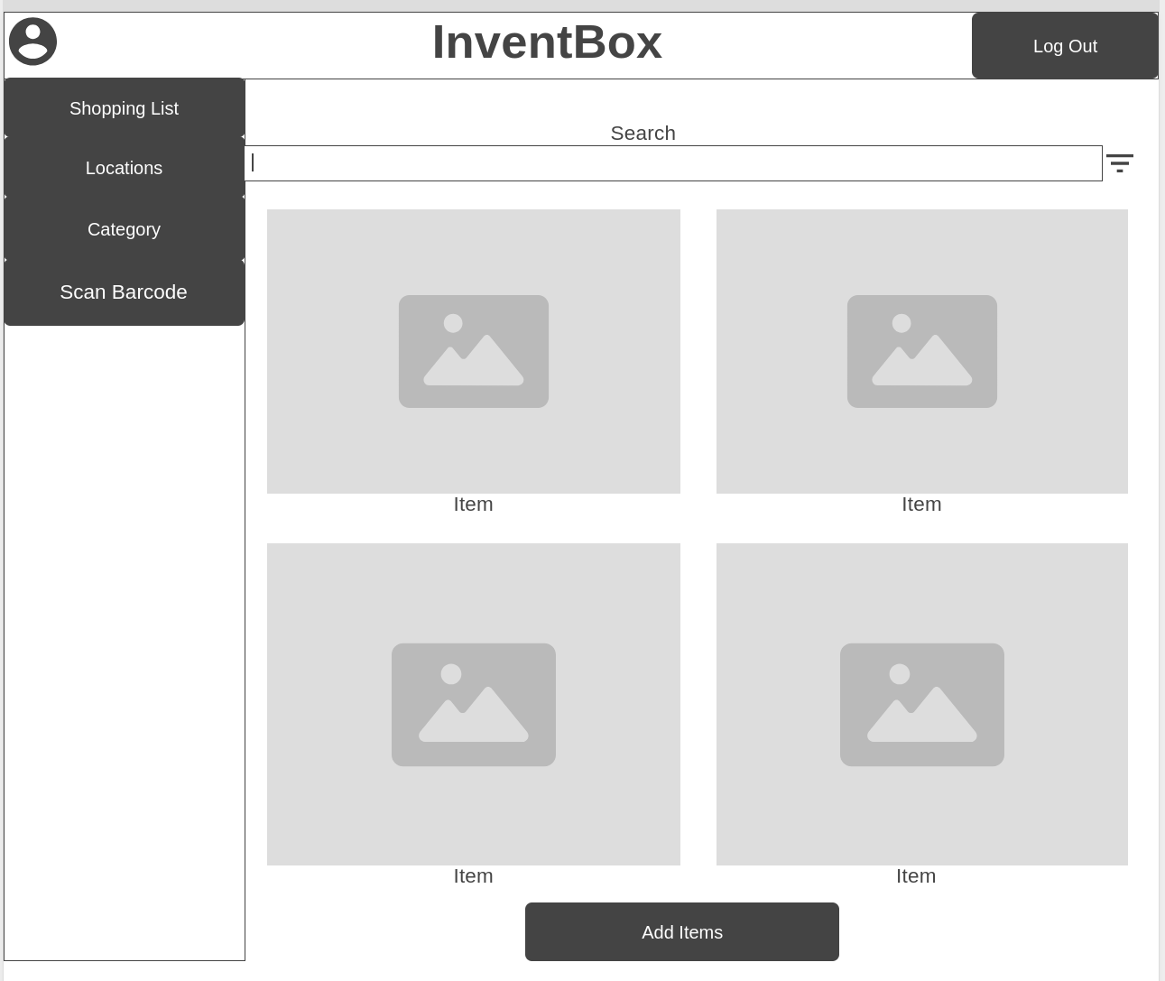
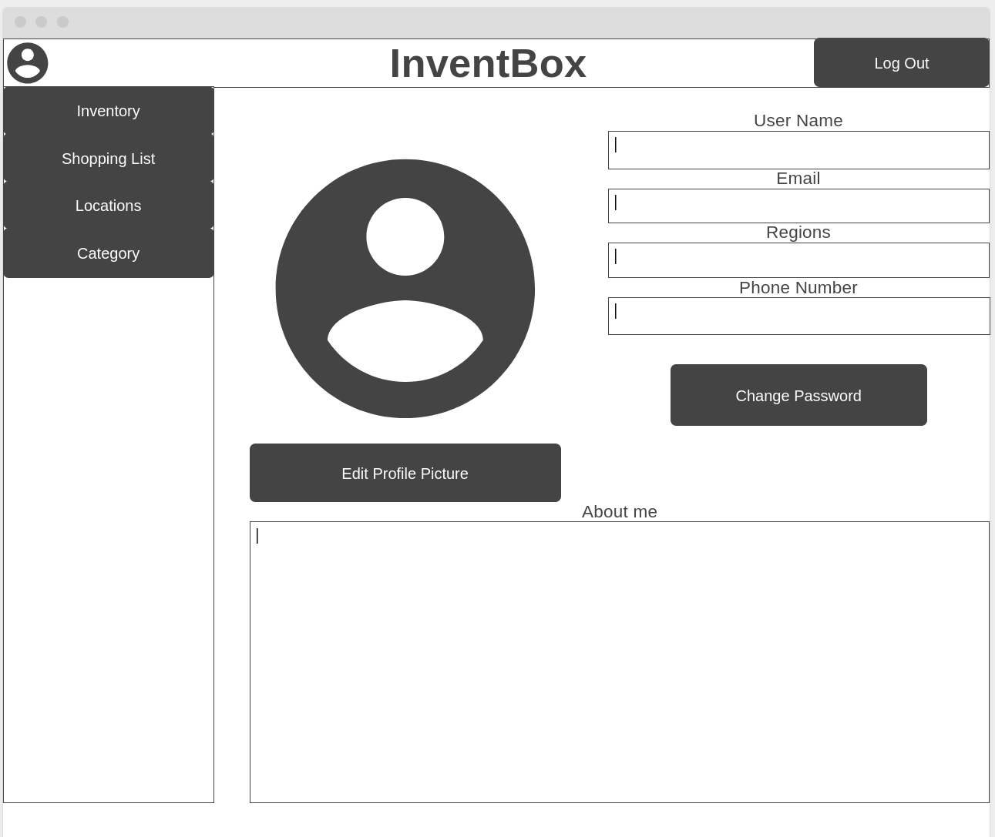

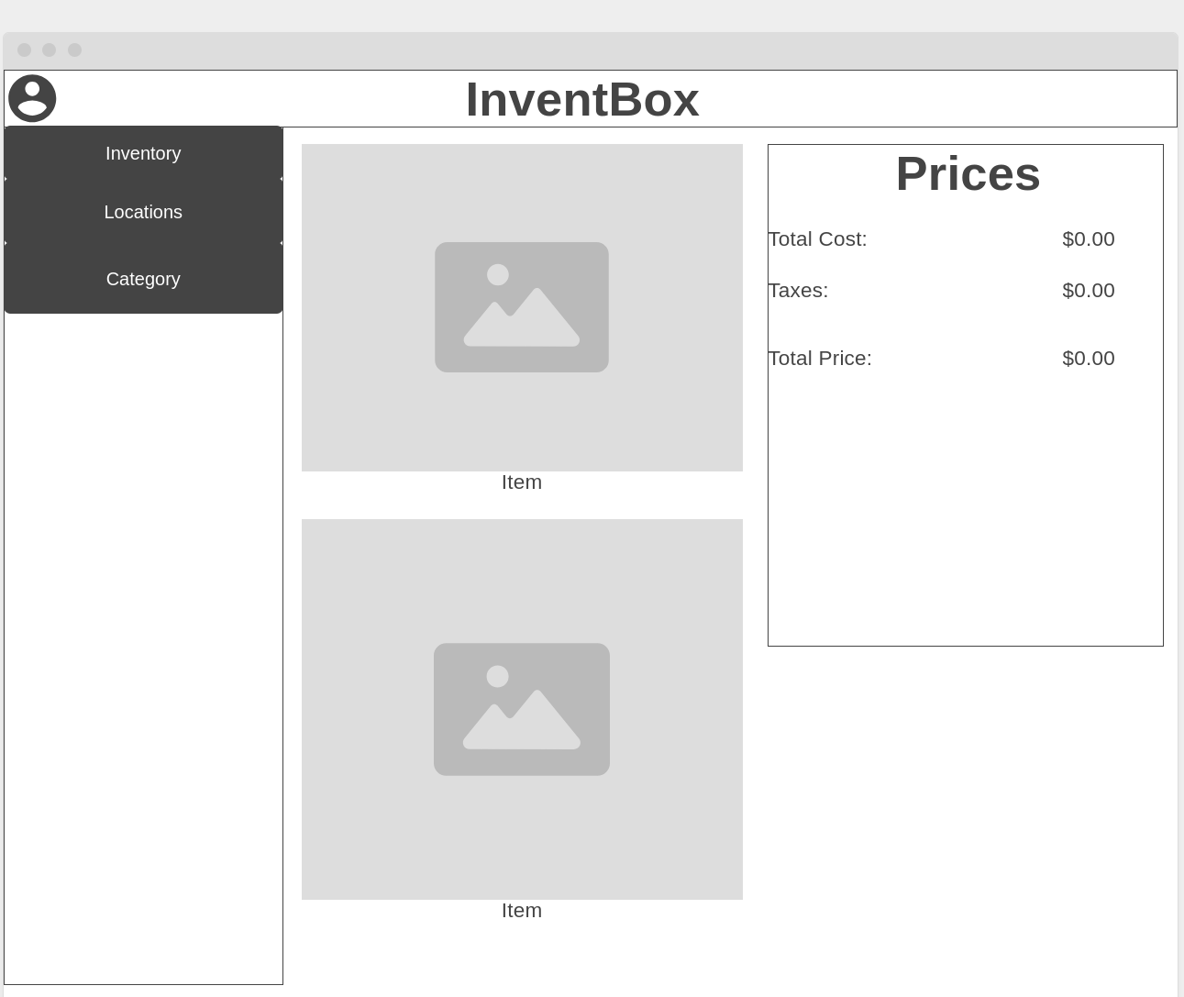
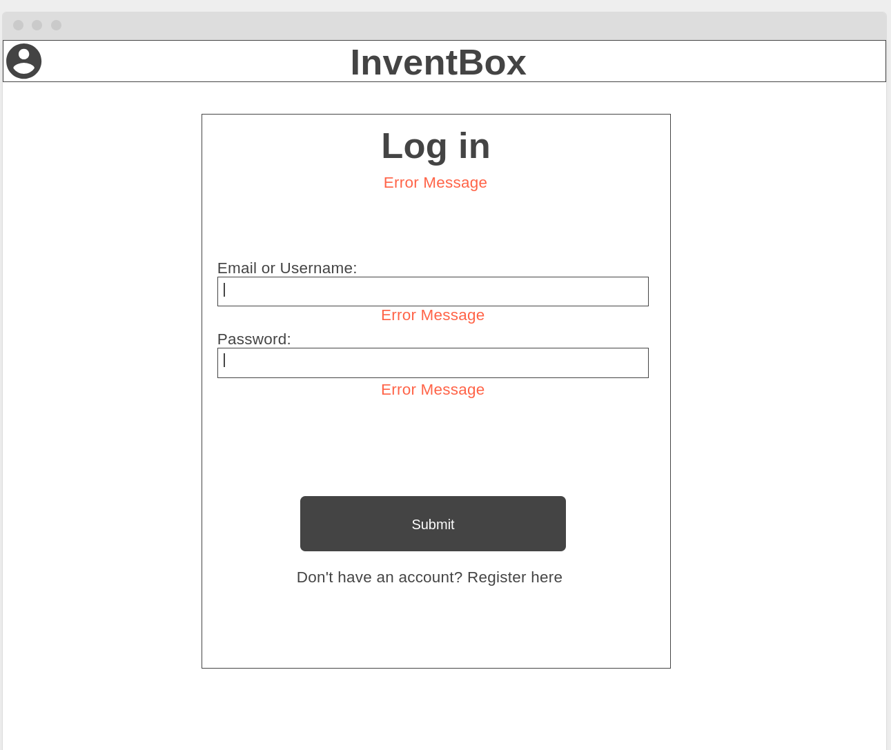
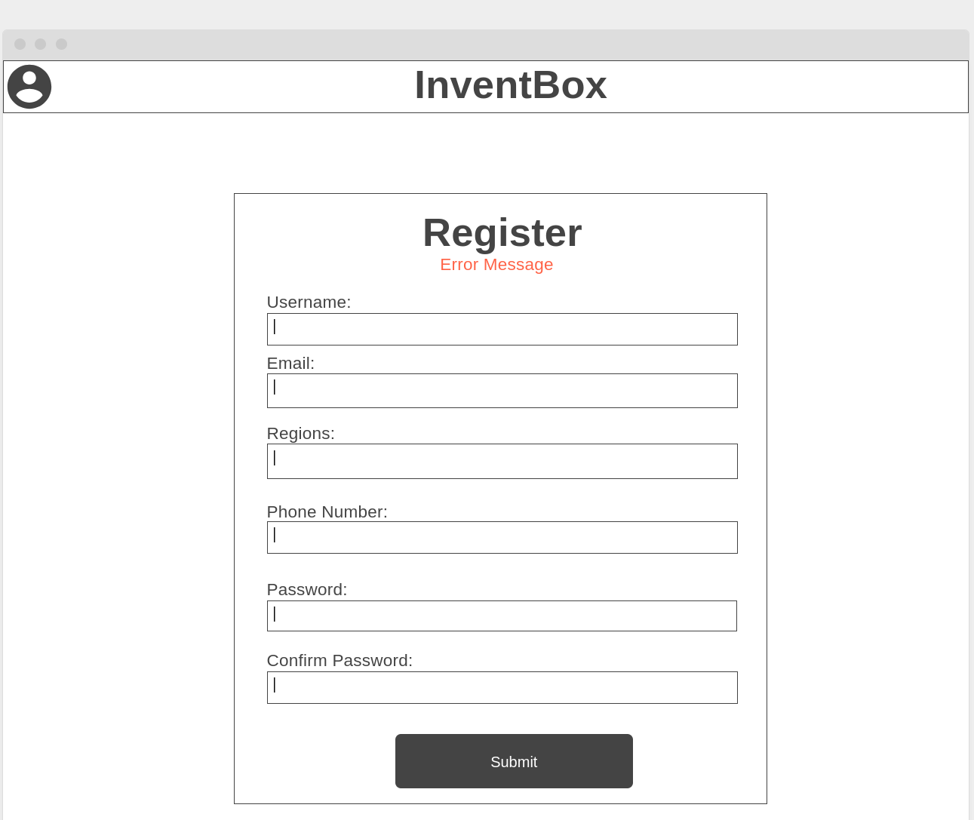
InventBox Entity Relationship Diagram

