**Nama :** Imam Rama Sanjaya

**Nim :** 200320004

**Kelas :** Reguler Pagi

**Jurusan :** Tekhnik Informatika

**PEMROGRAMAN III**

Config.php

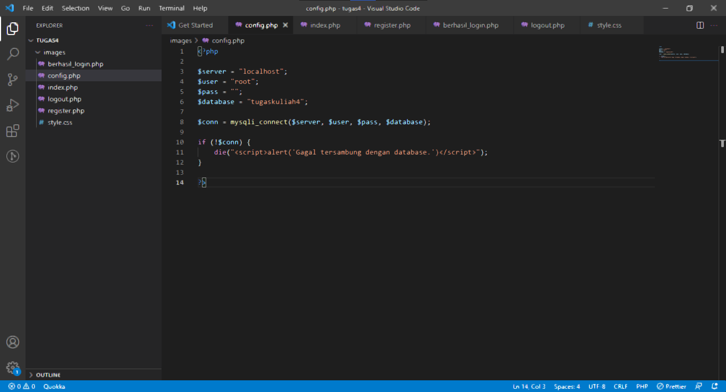

Index.php

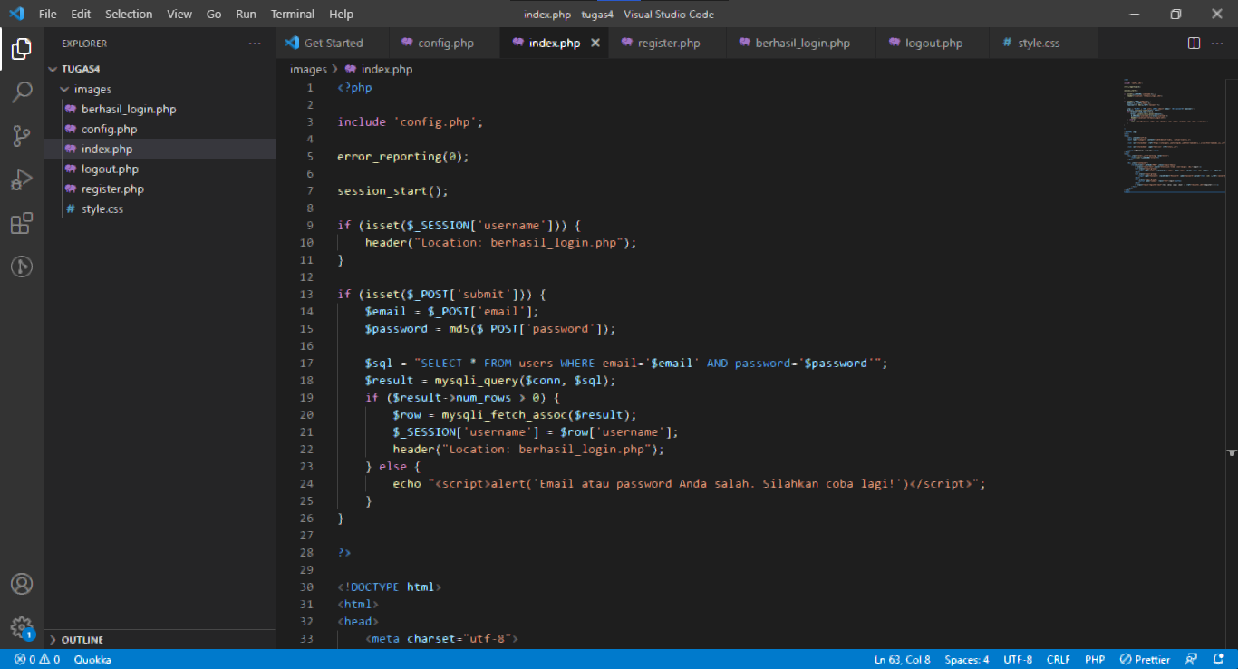

Register.php

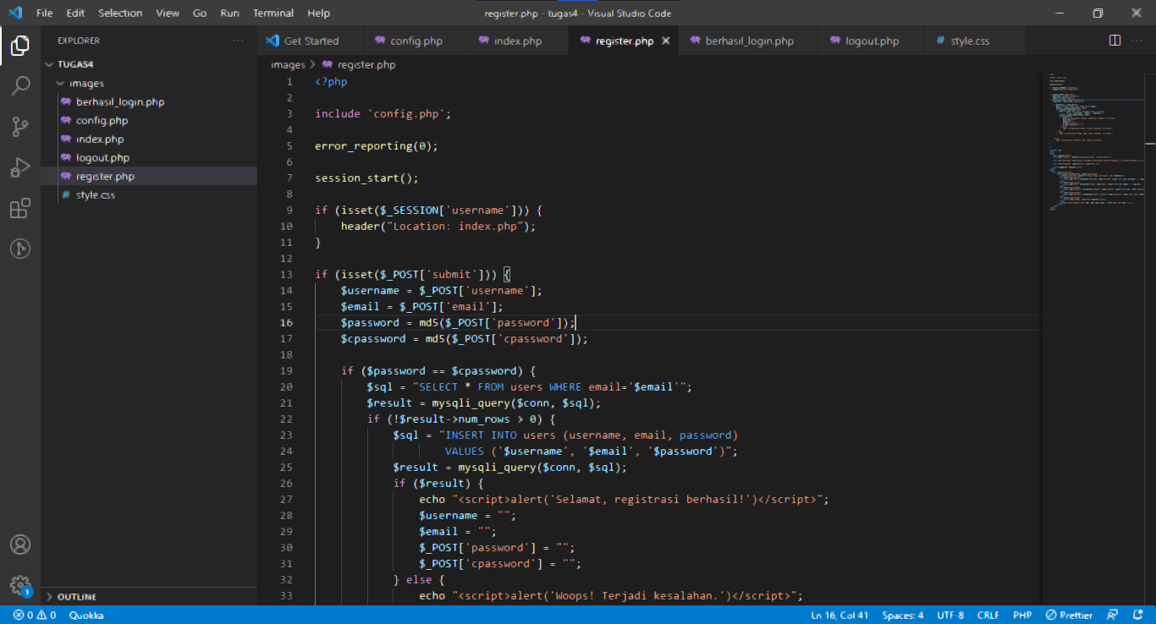

Berhasil_login.php

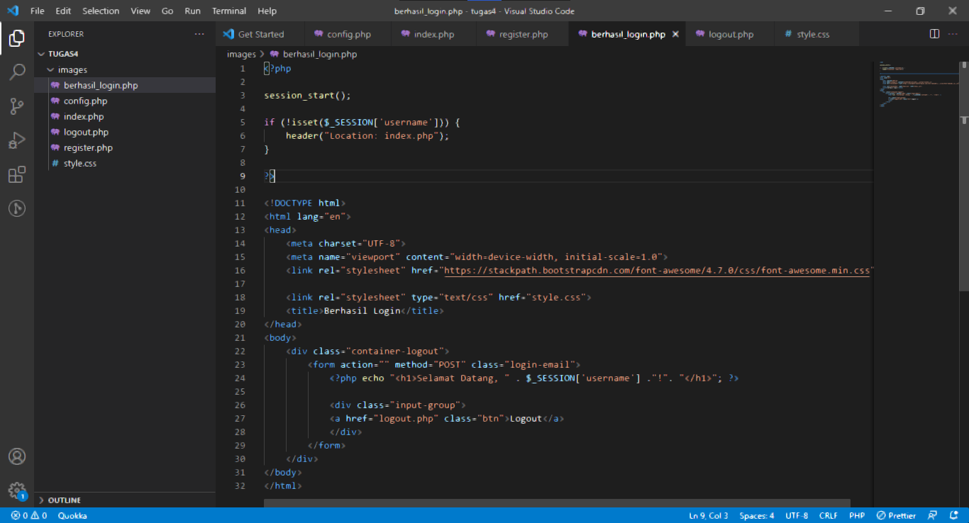

Logout.php

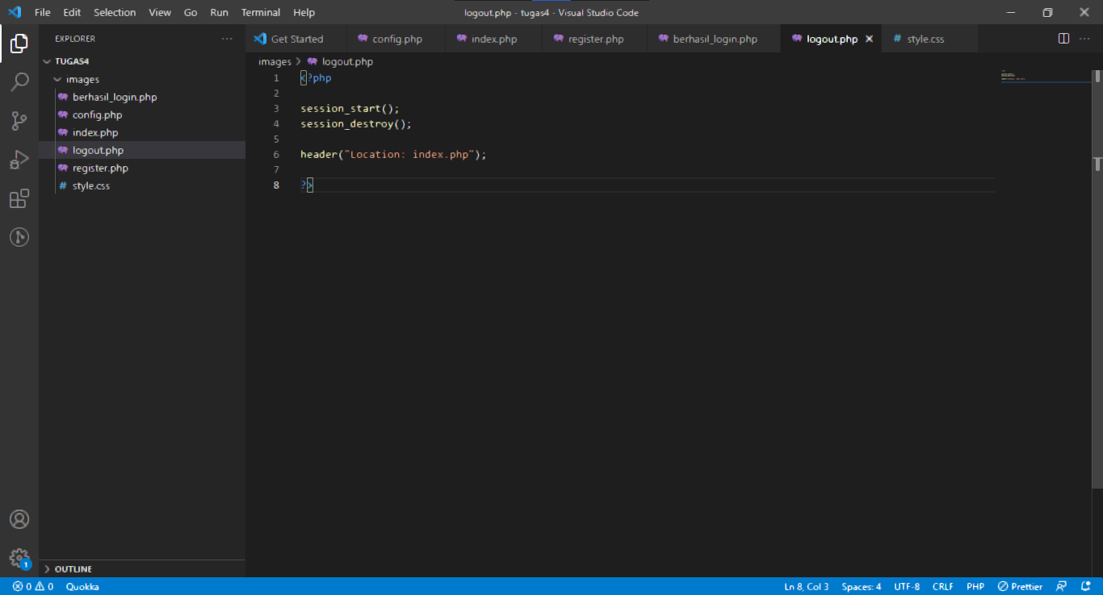

Style.css

