1. Stock market data API:

Input: Date range

Output:

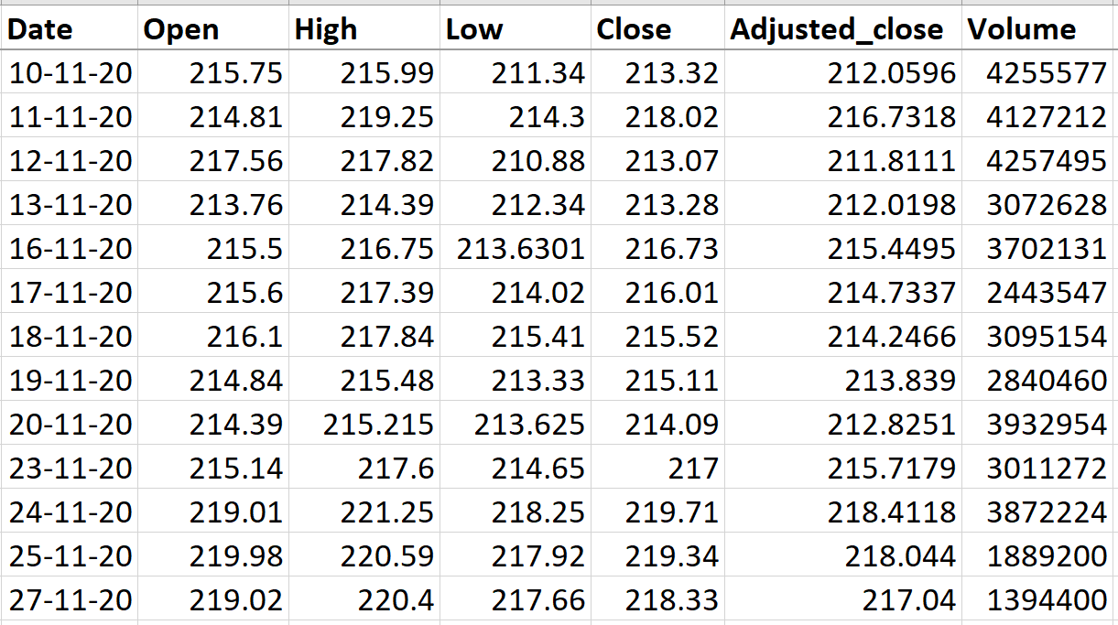

1. Tourist spots API:

Input: Year

Output:

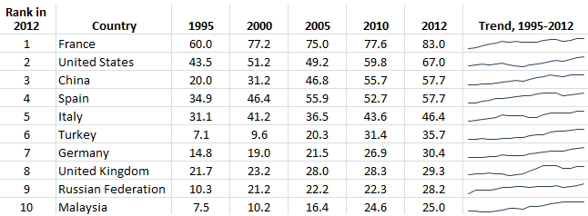

1. University rank API:

Input: Type of university (Engineering or arts and science)

Output:

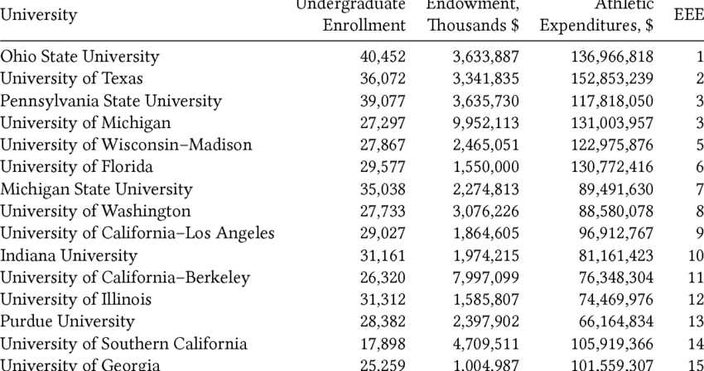

1. Weather predictions API:

Input: Date

Output:

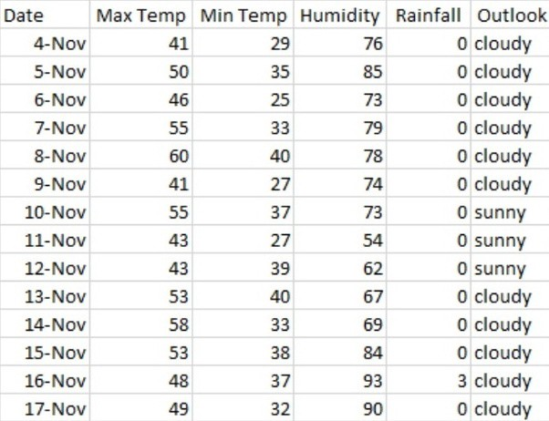

1. Best Job API:

Input: Country Name.

Output:

