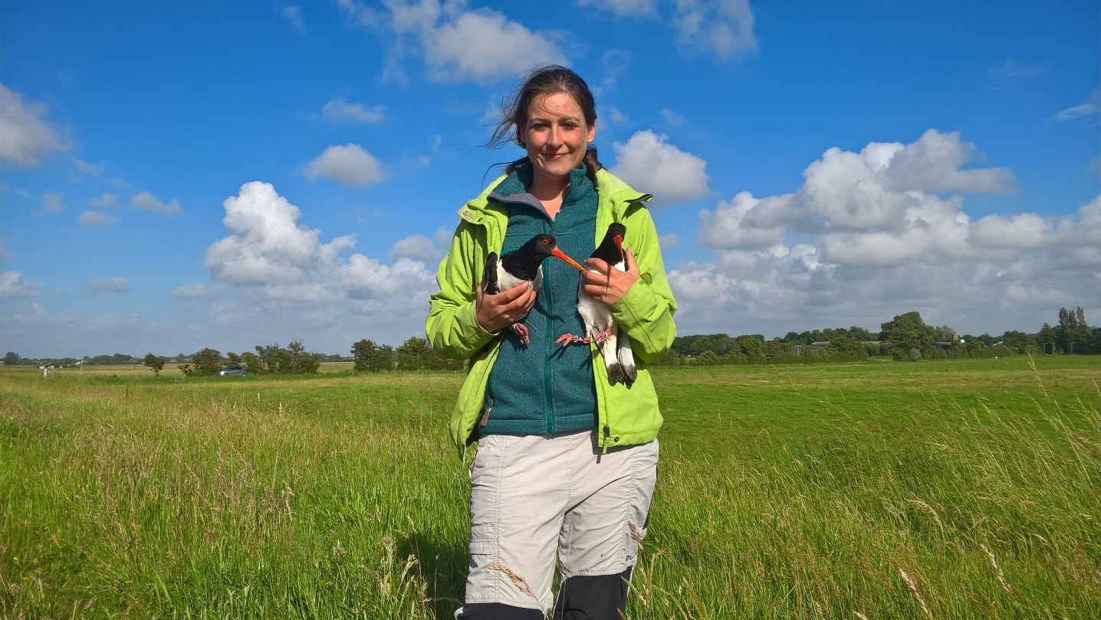
CV – Dr. Ir. Magali Frauendorf
De Meent 9
6871 TR Renkum
The Netherlands
0031 6 85 49 49 25
magalifrauendorf@gmail.com
29-04-1988, Eckernförde, Germany
German and French nationality


Education
2016-2021  2014-2016  2008-2012 | PhD, Department of Animal Ecology, Netherlands Institute of Ecology (NL)  Master of Science in Forest and Nature Conservation, Wageningen University, Wageningen (NL) (cum laude)  Bachelor of Applied Science in Wildlife Management, University of Applied Sciences, Leeuwarden (NL)


research experience
Altenburg & Wymenga ecological research  Ecological researcher  Project & tasks: Fieldwork, student supervision, Project leading, Data analysis, Report writing in project concerning meadowbirds, shorebirds, small mustelids and geese management.  Department of Animal Ecology, Netherlands Institute of Ecology, NL  PhD student  Project: “Causes of spatiotemporal variation in reproductive performance of Eurasian oystercatchers in a human-dominated landscape”  Tasks: Fieldwork (Monitoring breeding success of oystercatchers; catching, ringing, gps tagging of oystercatchers in the Wadden Sea and Delta area; measuring body condition (physiology and morphology); citizen science; data analysis (Structural Equation Modeling, Bayesian Statistiscs, Mark-  Supervision: Martijn van de Pol, Bruno J. Ens, Eelke Jongejans, Hans de Kroon  Institute for Terrestrial and Aquatic Wildlife Research, University of Veterinary Medicine Hannover, Germany  Research assistant  Project: “Space use of red deer in Lower Saxony” and “Investigations on the influence of hunting on geese and crop damages”  Tasks: writing project proposal for financial funding, doing data analysis in GIS and R as well as field work (catching and collaring geese).  Supervisor: Oliver Keuling  Wageningen Environmental Research, Wageningen, NL  Intern (master)  Project: “Investigating the effectiveness of different non-invasive methods (trap cam, video surveillance and track pads) to encounter the usage of crossing structures by ungulates in the National Park Hoge Veluwe.”  Tasks: field work (trap cam and track pad monitoring), statistical analysis, report writing  Supervisor: Sip van Wieren, Edgar van der Grift | Jan 2022-now  Dec 2016-Dec 2021  May 2016-Dec 2016  Nov 2015-March 2016


research experience
Wageningen University, NL & Institute for Terrestrial and Aquatic Wildlife Research, Germany  Thesis (master)  Project: “The influence of environmental factors, physiological factors and hunting on the reproductive success of wild boar in Germany”  Tasks: Statistical analysis of long-term dataset of wild boar reproduction and writing up results in three manuscripts resulting in one published paper.  Supervision: Sip van Wieren, Oliver Keuling  Institute for Terrestrial and Aquatic Wildlife Research, Germany  Research assistant  Project: “Wild boar management in Lower Saxony”  Tasks: telemetry and catching of wild boar & habitat analysis  Supervision: Oliver Keuling  Norwegian Institute for Nature Research (NINA), Norway  Thesis (bachelor)  Project: “Microhabitat characteristics of Eurasian Lynx (Lynx lynx) kill and rest sites in northern Norway“  Tasks: GPS-tracking of lynx, finding kill and rest sites, measuring microhabitat characteristics  Supervisors: Jenny Mattisson, John Linnell, John Odden  Harz National Park (Lynx project), Germany  Intern (bachelor)  Project: “Pilot study on the microhabitat selection of Eurasian lynx (Lynx lynx) concerning hunting sites in the Harz National Park, Germany“  Tasks: catching lynx, following lynx with VHF and GPS tracking, finding kill and rest sites, following tracks in the snow, statistical analysis, report writing.  Supervisor: Ole Anders  Research and education centre „La Tirimbina“, Costa Rica  Intern (bachelor)  Project: “Density estimation of Costa Rican wet tropical forest bird species“  Tasks: GIS-analysis, mist netting bats, bird monitoring.  Supervisor: Melquisedec Gamba-Rios | Feb 2015-July 2015  April 2013-Dec 2013  June 2012-Aug 2012  Sep 2011-Feb 2012  Feb 2010-June2010


Publications
Published:
- Frauendorf, M., Allen, A. M., Jongejans, E., Ens, B. J., Teunissen, W., Kampichler, C., van Turnhout, C. A. M., Bailey, L. D., de Kroon, H., Cremer, J., Kleyheeg, E., Nienhuis, J., & van de Pol, M. (2022). Love thy neighbour?—Spatial variation in density dependence of nest survival in relation to predator community. Diversity and Distributions, 28(4), 624–635. https://doi.org/10.1111/ddi.13457
- Allen, A. M., Jongejans, E., van de Pol, M., Ens, B. J., Frauendorf, M., van der Sluijs, M., & de Kroon, H. (2022). The demographic causes of population change vary across four decades in a long-lived shorebird. Ecology, 103(4), e3615. https://doi.org/10.1002/ecy.3615
- van Irsel, J., Frauendorf, M., Ens, B. J., van de Pol, M., Troost, K., Oosterbeek, K., de Kroon, H., Jongejans, E., & Allen, A. M. (2022). State-dependent environmental sensitivity of reproductive success and survival in a shorebird. Ibis, 164(3), 692–710. https://doi.org/10.1111/ibi.13038
- Frauendorf, M., Allen, A. M., Verhulst, S., Jongejans, E., Ens, B. J., van der Kolk, H.-J., de Kroon, H., Nienhuis, J., & van de Pol, M. (2021). Conceptualizing and quantifying body condition using structural equation modelling: A user guide. Journal of Animal Ecology, 90(11), 2478–2496. https://doi.org/10.1111/1365-2656.13578
- Frauendorf, M., Gethoffer, F., Siebert, U., & Keuling, O. (2016). The influence of environmental and physiological factors on the litter size of wild boar (Sus scrofa) in an agriculture dominated area in Germany. Science of the Total Environment, 541, 877–882. https://doi.org/10.1016/j.scitotenv.2015.09.128
In preparation:
- Frauendorf, M., Allen, A. M., van der Kolk, H.-J., Cubaynes S., Ens, B. J., Verhulst, S., Jongejans, E., de Kroon, H., Oosterbeek, K., Troost, K., van de Pol, M. Body condition mediates carry-over effects of a deteriorating overwintering environment on reproduction in a declining shorebird.
- Frauendorf, M., Ens, B. J., Allen, A. M., Jongejans, E., de Kroon, H., Teunissen, W., Kampichler, C., Kleyheeg, E., Nienhuis, J., Oosterbeek, K., van de Sluijs, M., de Jong, M., de Jong, J., van de Pol, M. The synergistic effects of environmental drivers of declining reproduction of a threatened meadow bird across the Netherlands.


Conference participation
2021  2020  2020  2020  2019  2019  2019  2018  2018  2017  2015 | International Wader Study Group Conference (IWSG). Online.  International Wader Study Group Conference (IWSG). Online. Oral presentation.  III Elvonal Shorebird Conference. Debrecen, Hungary. Oral presentation.  Netherlands Annual Ecology Meeting (NAEM). Lunteren, the Netherlands. Oral presentation.  British Ecological Society Meeting (BES). Belfast, Ireland. Oral presentation.  Netherlands Annual Ecology Meeting (NAEM). Lunteren, the Netherlands. Co-hosted session.  European ornithological Union conference (EOU). Cluj-Napoca, Romania. Oral presentation.  International Wader study group conference (IWSG). Workum, Netherlands. Oral presentation.  International ornithological society conference (IOC). Vancouver, Canada. Oral presentation.  Netherlands Annual Ecology Meeting (NAEM). Lunteren, the Netherlands. Attendance.  Annual Meeting of the German Society for Mammalian Biology (DGS). Hannover, Germany. Oral presentation.


Review experience
- Royal Society Open Science
- Biological Conservation
- Global Change Biology
- Wader study


Supervision/Teaching experience
- Supervision of nine Bachelor and Master students (2017-2020)
- Three guest lectures in course “conservation biology” for bachelor and master students at Wageningen University and Radboud University (2017, 2018)


Skills & competences
Field work  Software  Languages  Other | Catching different species (wild boar, lynx, bats, birds) with different techniques (mist net, cannon net, trap box) ● ringing birds ● monitoring reproductive success ● following animals with gps/telemetry/colour ring/(snow) tracks ● trap cam monitoring ● bat monitoring (bat detector) ● citizen science  ArcGis ● Qgis ● R ● JAGS ● SPSS ● Distance ● Ranges ● Maxent ● Vortex ● Matlab ● Endnote ● Zotero ● Batsound  German: fluent ● English: fluent ● Dutch: fluent ● French: fluent ● Spanish: basic  Valid driving licence class BE (car-trailer, since 2006)


participated Courses
- Structural Equation Modelling
- Integral Projection Models
- Applied Spatial Modelling with R
- Modeling Population Dynamics – Estimating Demographic Parameters for Wildlife Conservation
- Bayesian inference of animal demography
- The Floor is Yours - How to present/pitch your research online
- Make me fly - Stress management during your PhD


Major collaborators
- Dr. Martijn van de Pol, Netherlands Institute of Ecology, Wageningen, NL/ James Cook University, Townsville, AUS
- Prof. Dr. Hans de Kroon, Radboud University, Nijmegen, NL
- Dr. ir. Eelke Jongejans, Radboud University, Nijmegen, NL
- Dr. Bruno Ens, Sovon Dutch centre for field ornithology, Nijmegen, NL
- Dr. Andrew Allen, Netherlands Institute of Ecology, Wageningen, NL
- Prof. Dr. Simon Verhulst, University of Groningen, Groningen, NL
- Dr. Christian Kampichler, Sovon Dutch centre for field ornithology, Nijmegen, NL
- Dr. Wolf Teunissen, Sovon Dutch centre for field ornithology, Nijmegen, NL
- Dr. Liam Bailey, Leibniz Institute for Zoo and Wildlife Research, Berlin, GER
- Dr. rer. nat. Oliver Keuling, Institute for Terrestrial and Aquatic Wildlife Research, Hannover, GER
- Dr. Sarah Cubaynes, Centre for Functional and Evolutionary Ecology, Montpellier, FR


National Societally Relevant outreach activity
- Scholeksters op daken; Natuurlijk Zoey, RTV Utrecht, 2018.
- Pilot broedsucces metingen van de scholekster in Noord-Holland; Jaarboek Boerenlandvogels Noord-Holland; 2018.
- Bedreiging scholekster komt van alle kanten; Artikel in Bionieuws; 2017.
- Interessant en dramatisch broedseizoen voor Nederlandse scholeksters; NatureToday; 2017.
- Scholeksters zoeken-Hoe komt het dat de scholekster zo fel achteruit gaat? Mens&Vogel. 55: 48-57; 2017.
- Interview op Omrop Fryslân; 2017.
- Speur dit voorjaar mee naar scholeksters met kleurringen; NatureToday; 2017.


“Other” employment/experience
2017-2020  2018-present  2018-2021 | Volunteer in the breeding bird monitoring program (BMP); Sovon, Dutch Centre for Field Ornithology.  Collaborator of the Élvonal Shorbird Science project (www.elvonalshorebirds.com)  Assisting in research activities in the citizen science project (‘Scholekster op het dak’) about roof-breeding oystercatchers (www.scholeksterophetdak.nl)


Referees
Dr. Martijn van de Pol  Dr. Bruno Ens | Senior scientist, Department of Animal Ecology, Netherlands Institute of Ecology, m.vandepol@nioo.knaw.nl  Sovon Vogelonderzoek Nederland, bruno.ens@sovon.nl

