R-code for the paper 'Conceptualizing and quantifying body condition using structural equation modelling: A user guide.' (Frauendorf et al.)

Magali Frauendorf

25-08-2021

Abbreviations for the variables in all R-codes. All Statistical analyses were done with R-version 3.5.1.  
ratio: ratio of mass divided by tarsus length  
MS: mass  
TA: tarsus length  
TH: head length  
WL: wing length  
FC: fat reserves  
BCol: bill colour  
LS: bill luminance  
CS: bill chroma  
HS: bill hue  
Comp: composite variable=body condition  
LogitSurvWS: Survival  
Density: Oystercatcher density (number/km2)  
SexN: Sex (numeric variable)  
nBH: standardized bill tip height (mean=0, sd=1)  
nHT: standardized handling time and squared handling time (mean=0, sd=1)  
CortStd: Corticosterone  
U_perVolBlood: Uric acid  
Cho_perVolBlood: Cholesterol  
LogitH: Haematocrit  
LogitB: Buffy coat  
BS: Body size (latent variable)  
Residuals: Residuals of mass (Mass ~ wing length + tarsus length + head length)

Import packages (versions are shown behind the #)

Import data and prepare data for analysis

section 1: latent variables

Energy store

Select relevant variables for this dataset

Code S1: The code shows the code for Figue 2b. The error variance of ratio turns out to be negative (but really close to 0) so that it is acceptable to fix the error variance of the variable ratio to 0. The R-package used for the analysis is lavaan.

lvmod.1 <-'  
ES =~ ratio + Residuals #=~ annotation for defining latent variable Energy store  
Residuals~~0*Residuals  
'  
  
lvmod.1.fit<-cfa(lvmod.1,data=f) #fits the model  
summary(lvmod.1.fit, rsq=T, standardized=T) #gives model output

## lavaan 0.6-8 ended normally after 20 iterations  
##   
## Estimator ML  
## Optimization method NLMINB  
## Number of model parameters 3  
##   
## Number of observations 1021  
##   
## Model Test User Model:  
##   
## Test statistic 0.000  
## Degrees of freedom 0  
##   
## Parameter Estimates:  
##   
## Standard errors Standard  
## Information Expected  
## Information saturated (h1) model Structured  
##   
## Latent Variables:  
## Estimate Std.Err z-value P(>|z|) Std.lv Std.all  
## ES =~   
## ratio 1.000 0.459 0.932  
## Residuals 0.097 0.001 82.169 0.000 0.045 1.000  
##   
## Variances:  
## Estimate Std.Err z-value P(>|z|) Std.lv Std.all  
## .Residuals 0.000 0.000 0.000  
## .ratio 0.032 0.001 22.594 0.000 0.032 0.131  
## ES 0.211 0.011 19.798 0.000 1.000 1.000  
##   
## R-Square:  
## Estimate  
## Residuals 1.000  
## ratio 0.869

fitMeasures(lvmod.1.fit, c("chisq", "pvalue", "df","cfi", "srmr", "rmsea", "rmsea.ci.lower", "rmsea.ci.upper")) #gives model fit indices

## chisq pvalue df cfi srmr   
## 0 NA 0 1 0   
## rmsea rmsea.ci.lower rmsea.ci.upper   
## 0 0 0

fitMeasures(lvmod.1.fit, c("gfi", "agfi", "cfi", "rni", "srmr", "rmsea", "pvalue", "BIC"))

## gfi agfi cfi rni srmr rmsea pvalue bic   
## 1.000 1.000 1.000 1.000 0.000 0.000 NA -4058.447

Create a PCA of energy stores

Check the correlation between the PC1 and the latent variable for energy stores

Table S4: Loadings from PC1 and PC2 of the fat-reserve-PCA. PCA analyses were conducted with the R-package FactoMineR.

|  |  |  |
| --- | --- | --- |
|  | Dim.1 | Dim.2 |
| Residuals | 0.98 | 0.18 |
| Ratio | 0.98 | -0.18 |

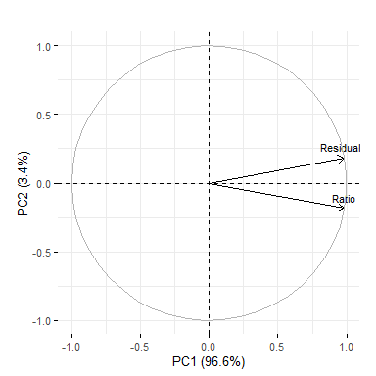

Figure S3: Visualisation of the fat-reserve-PCA. PCA visualization was conducted with the R-package factoextra {(Kassambara, 2020 #1153)}.

Bill colour

Import and prepare data

Code S2: SEM for bill colour analysis (Figure 2a). The error variance of the variable HS (Hue) turns out to be slightly negative (close to 0) so that it is acceptable to fix the error variance of the variable HS to 0. The R-package used for the analysis is lavaan.

f$AgeN<-ifelse(f$Age=="Adult",2,1)  
  
lvmod.2 <-'  
BCol=~LS+HS+CS #define latent variable BCol=Bill colour  
LS~~0*LS #fix error variance of hue to 0  
'  
lvmod.2.fit<-cfa(lvmod.2,data=f, group="Age") #fit model  
summary(lvmod.2.fit, rsq=T, standardized=T) #model output

## lavaan 0.6-8 ended normally after 66 iterations  
##   
## Estimator ML  
## Optimization method NLMINB  
## Number of model parameters 16  
##   
## Number of observations per group:   
## Adult 599  
## Sub-Adult 163  
##   
## Model Test User Model:  
##   
## Test statistic 1141.244  
## Degrees of freedom 2  
## P-value (Chi-square) 0.000  
## Test statistic for each group:  
## Adult 787.835  
## Sub-Adult 353.409  
##   
## Parameter Estimates:  
##   
## Standard errors Standard  
## Information Expected  
## Information saturated (h1) model Structured  
##   
##   
## Group 1 [Adult]:  
##   
## Latent Variables:  
## Estimate Std.Err z-value P(>|z|) Std.lv Std.all  
## BCol =~   
## LS 1.000 3.508 1.000  
## HS 1.456 0.015 94.952 0.000 5.107 0.968  
## CS -0.387 0.015 -25.357 0.000 -1.357 -0.720  
##   
## Intercepts:  
## Estimate Std.Err z-value P(>|z|) Std.lv Std.all  
## .LS 68.892 0.143 480.618 0.000 68.892 19.638  
## .HS 63.320 0.215 293.846 0.000 63.320 12.006  
## .CS 84.494 0.077 1096.179 0.000 84.494 44.789  
## BCol 0.000 0.000 0.000  
##   
## Variances:  
## Estimate Std.Err z-value P(>|z|) Std.lv Std.all  
## .LS 0.000 0.000 0.000  
## .HS 1.733 0.100 17.306 0.000 1.733 0.062  
## .CS 1.716 0.099 17.306 0.000 1.716 0.482  
## BCol 12.307 0.711 17.306 0.000 1.000 1.000  
##   
## R-Square:  
## Estimate  
## LS 1.000  
## HS 0.938  
## CS 0.518  
##   
##   
## Group 2 [Sub-Adult]:  
##   
## Latent Variables:  
## Estimate Std.Err z-value P(>|z|) Std.lv Std.all  
## BCol =~   
## LS 1.000 8.534 1.000  
## HS -0.055 0.035 -1.550 0.121 -0.468 -0.121  
## CS 1.033 0.029 35.923 0.000 8.820 0.942  
##   
## Intercepts:  
## Estimate Std.Err z-value P(>|z|) Std.lv Std.all  
## .LS 53.267 0.668 79.687 0.000 53.267 6.242  
## .HS 65.298 0.304 214.763 0.000 65.298 16.822  
## .CS 67.158 0.733 91.599 0.000 67.158 7.175  
## BCol 0.000 0.000 0.000  
##   
## Variances:  
## Estimate Std.Err z-value P(>|z|) Std.lv Std.all  
## .LS 0.000 0.000 0.000  
## .HS 14.850 1.645 9.028 0.000 14.850 0.985  
## .CS 9.826 1.088 9.028 0.000 9.826 0.112  
## BCol 72.835 8.068 9.028 0.000 1.000 1.000  
##   
## R-Square:  
## Estimate  
## LS 1.000  
## HS 0.015  
## CS 0.888

fitMeasures(lvmod.2.fit, c("chisq", "pvalue", "df","cfi", "srmr", "rmsea", "rmsea.ci.lower", "rmsea.ci.upper"))# model fit indices

## chisq pvalue df cfi srmr   
## 1141.244 0.000 2.000 0.683 0.061   
## rmsea rmsea.ci.lower rmsea.ci.upper   
## 1.223 1.164 1.283

Plot three bill colours per age class (Fig. S6)

Create a PCA of bill colour

Check correlation PCA and CFA (bill colour)

Plot supplement Fig. S8

Table S5

Table S5: Loadings from the PC1, PC2 and PC3 of the adult bill colour. PCA analyses were conducted with the R-package FactoMineR.

|  |  |  |  |
| --- | --- | --- | --- |
|  | Dim.1 | Dim.2 | Dim.3 |
| Hue | 0.99 | 0.10 | 0.08 |
| Luminance | 0.95 | 0.31 | -0.06 |
| Chroma | -0.90 | 0.44 | 0.02 |

Table S6

Table S6: Loadings from the PC1, PC2 and PC3 of the sub-adult bill colour. PCA analyses were conducted with the R-package FactoMineR.

|  |  |  |  |
| --- | --- | --- | --- |
|  | Dim.1 | Dim.2 | Dim.3 |
| Hue | -0.49 | 0.87 | 0.02 |
| Luminance | 0.92 | 0.39 | -0.05 |
| Chroma | 1.00 | 0.07 | 0.06 |

Fig. S4 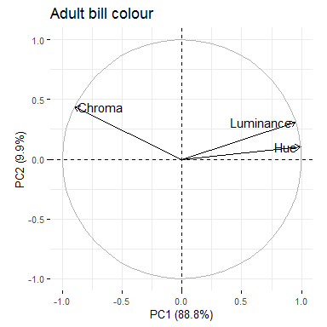

Fig. S5 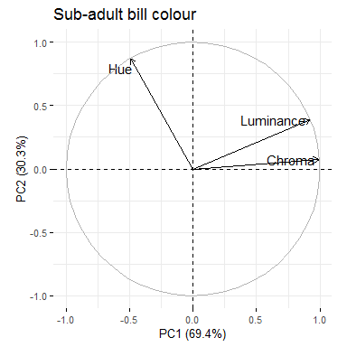

section 2: composite variable

Prepare data for analysis

Code S3: Code for the composite variable model (Figure 5). Note that in this example the model fit index (CFI) indicates poor fit. However, remember that this simply serves as a simple illustration for running a composite variable in SEM and is not yet biologically correct e.g. missing confounding variables. The first variable (determining the composite variable) should always be multiplied by 1 to set the scale (for other variables). We multiplied the first variable "ratio" by -1 because it has a negative effect on the condition. If we multiply it by 1 we get a negative effect of condition on survival wich makes interpretation more difficult. All absolute values of the coefficients stay the same (when multiplyinh by 1 or -1). The R-package used for the analysis is lavaan.

# Variable scaling  
d1$MSK<-d1$MS/1000  
d1$Dens<-d1$Density/1000  
d1$TA100<-d1$TA/100  
d1$TH100<-d1$TH/100  
d1$WL100<-d1$WL/100  
d1$Cho10<-d1$Cho_perVolBlood/10  
  
Cmod.1 <- '  
Comp <~ -1*lMS+CortStd+U_perVolBlood+Cho10+LogitH+LogitB # define the composite variable  
lMS =~ MSK # create latent variable of mass  
lMS~WL100+TA100+TH100 # regress structural sizes on latent mass  
LogitSurvWS~Comp # regress the composite on survival  
Comp~Dens # regress the denisty on the composite variable  
'   
Cmod.1.fit<-sem(Cmod.1,data=d1) # fit the model  
summary(Cmod.1.fit, rsq=T, standardized=T)# get the output of the sem

## lavaan 0.6-8 ended normally after 68 iterations  
##   
## Estimator ML  
## Optimization method NLMINB  
## Number of model parameters 12  
##   
## Number of observations 447  
##   
## Model Test User Model:  
##   
## Test statistic 77.832  
## Degrees of freedom 9  
## P-value (Chi-square) 0.000  
##   
## Parameter Estimates:  
##   
## Standard errors Standard  
## Information Expected  
## Information saturated (h1) model Structured  
##   
## Latent Variables:  
## Estimate Std.Err z-value P(>|z|) Std.lv Std.all  
## lMS =~   
## MSK 1.000 0.050 1.000  
##   
## Composites:  
## Estimate Std.Err z-value P(>|z|) Std.lv Std.all  
## Comp <~   
## lMS -1.000 -0.744 -0.744  
## CortStd -0.028 0.009 -3.160 0.002 -0.412 -0.373  
## U_perVolBlood -0.017 0.011 -1.561 0.119 -0.256 -0.185  
## Cho10 -0.028 0.033 -0.833 0.405 -0.412 -0.110  
## LogitH 0.044 0.077 0.568 0.570 0.654 0.076  
## LogitB 0.028 0.027 1.029 0.304 0.420 0.112  
##   
## Regressions:  
## Estimate Std.Err z-value P(>|z|) Std.lv Std.all  
## lMS ~   
## WL100 0.230 0.032 7.272 0.000 4.610 0.330  
## TA100 0.337 0.071 4.770 0.000 6.762 0.213  
## TH100 0.117 0.033 3.528 0.000 2.357 0.153  
## LogitSurvWS ~   
## Comp 2.887 0.410 7.040 0.000 0.193 0.412  
## Comp ~   
## Dens -0.553 0.132 -4.183 0.000 -8.246 -0.571  
##   
## Variances:  
## Estimate Std.Err z-value P(>|z|) Std.lv Std.all  
## .MSK 0.000 0.000 0.000  
## .LogitSurvWS 0.183 0.012 14.950 0.000 0.183 0.830  
## .Comp 0.000 0.000 0.000  
## .lMS 0.002 0.000 14.950 0.000 0.707 0.707  
##   
## R-Square:  
## Estimate  
## MSK 1.000  
## LogitSurvWS 0.170  
## Comp 1.000  
## lMS 0.293

fitMeasures(Cmod.1.fit, c("chisq", "pvalue", "df","cfi", "srmr", "rmsea", "rmsea.ci.lower", "rmsea.ci.upper")) #get the model fit indices

## chisq pvalue df cfi srmr   
## 77.832 0.000 9.000 0.780 0.049   
## rmsea rmsea.ci.lower rmsea.ci.upper   
## 0.131 0.105 0.158

Code S4: Model with squared mass

# squared mass  
d1$ResidualsSc<-d1$Residuals/100  
d1$ResidualsSc2<-d1$ResidualsSc*d1$ResidualsSc  
d1$Cho10<-d1$Cho_perVolBlood/10 #scaled cholesterol  
  
Cmod.2 <- '  
Comp <~ -1*ResidualsSc+ResidualsSc2+CortStd+U_perVolBlood+Cho10+LogitH+LogitB # define the composite variable  
LogitSurvWS~Comp #regress the composite on survival  
Comp~Dens #regress the denisty on the composite variable  
ResidualsSc~~ResidualsSc2  
'   
Cmod.2.fit<-sem(Cmod.2,data=d1, fixed.x=F) # fit the model  
summary(Cmod.2.fit, rsq=T, standardized=T)# get the output of the sem

## lavaan 0.6-8 ended normally after 140 iterations  
##   
## Estimator ML  
## Optimization method NLMINB  
## Number of model parameters 33  
##   
## Number of observations 447  
##   
## Model Test User Model:  
##   
## Test statistic 77.188  
## Degrees of freedom 12  
## P-value (Chi-square) 0.000  
##   
## Parameter Estimates:  
##   
## Standard errors Standard  
## Information Expected  
## Information saturated (h1) model Structured  
##   
## Composites:  
## Estimate Std.Err z-value P(>|z|) Std.lv Std.all  
## Comp <~   
## ResidualsSc -1.000 -1.908 -0.799  
## ResidualsSc2 0.390 0.215 1.818 0.069 0.745 0.197  
## CortStd -0.201 0.070 -2.863 0.004 -0.383 -0.346  
## U_perVolBlood -0.121 0.088 -1.375 0.169 -0.230 -0.166  
## Cho10 -0.327 0.267 -1.224 0.221 -0.624 -0.166  
## LogitH 0.802 0.624 1.285 0.199 1.530 0.178  
## LogitB 0.298 0.221 1.347 0.178 0.569 0.152  
##   
## Regressions:  
## Estimate Std.Err z-value P(>|z|) Std.lv Std.all  
## LogitSurvWS ~   
## Comp 0.359 0.051 7.100 0.000 0.188 0.401  
## Comp ~   
## Dens -3.675 1.036 -3.549 0.000 -7.014 -0.486  
##   
## Covariances:  
## Estimate Std.Err z-value P(>|z|) Std.lv Std.all  
## ResidualsSc ~~   
## ResidualsSc2 0.031 0.005 5.693 0.000 0.031 0.280  
## CortStd ~~   
## U_perVolBlood 0.096 0.031 3.087 0.002 0.096 0.148  
## Cho10 0.002 0.011 0.179 0.858 0.002 0.008  
## LogitH 0.009 0.005 1.822 0.068 0.009 0.086  
## LogitB 0.032 0.012 2.799 0.005 0.032 0.134  
## Dens -0.003 0.003 -1.167 0.243 -0.003 -0.055  
## U_perVolBlood ~~   
## Cho10 0.013 0.009 1.407 0.159 0.013 0.067  
## LogitH 0.025 0.004 5.997 0.000 0.025 0.296  
## LogitB -0.019 0.009 -2.026 0.043 -0.019 -0.096  
## Dens -0.007 0.002 -3.102 0.002 -0.007 -0.148  
## Cho10 ~~   
## LogitH 0.017 0.002 10.051 0.000 0.017 0.540  
## LogitB -0.004 0.003 -1.227 0.220 -0.004 -0.058  
## Dens 0.006 0.001 6.739 0.000 0.006 0.336  
## LogitH ~~   
## LogitB -0.000 0.001 -0.329 0.742 -0.000 -0.016  
## Dens 0.002 0.000 4.598 0.000 0.002 0.223  
## LogitB ~~   
## Dens -0.002 0.001 -2.399 0.016 -0.002 -0.114  
##   
## Variances:  
## Estimate Std.Err z-value P(>|z|) Std.lv Std.all  
## .LogitSurvWS 0.185 0.012 14.950 0.000 0.185 0.839  
## ResidualsSc 0.175 0.012 14.950 0.000 0.175 1.000  
## ResidualsSc2 0.070 0.005 14.950 0.000 0.070 1.000  
## .Comp 0.000 0.000 0.000  
## CortStd 0.818 0.055 14.950 0.000 0.818 1.000  
## U_perVolBlood 0.519 0.035 14.950 0.000 0.519 1.000  
## Cho10 0.071 0.005 14.950 0.000 0.071 1.000  
## LogitH 0.014 0.001 14.950 0.000 0.014 1.000  
## LogitB 0.071 0.005 14.950 0.000 0.071 1.000  
## Dens 0.005 0.000 14.950 0.000 0.005 1.000  
##   
## R-Square:  
## Estimate  
## LogitSurvWS 0.161  
## Comp 1.000

varTable(Cmod.2.fit)

## name idx nobs type exo user mean var nlev lnam  
## 1 LogitSurvWS 7 447 numeric 0 0 2.061 0.229 0   
## 2 ResidualsSc 25 447 numeric 0 0 0.000 0.176 0   
## 3 ResidualsSc2 26 447 numeric 0 0 0.175 0.070 0   
## 4 CortStd 4 447 numeric 0 0 -0.029 0.820 0   
## 5 U_perVolBlood 1 447 numeric 0 0 1.202 0.520 0   
## 6 Cho10 24 447 numeric 0 0 1.322 0.071 0   
## 7 LogitH 6 447 numeric 0 0 -0.181 0.014 0   
## 8 LogitB 5 447 numeric 0 0 -5.118 0.072 0   
## 9 Dens 20 447 numeric 0 0 0.135 0.005 0

Fig. S9 and Fig. S10

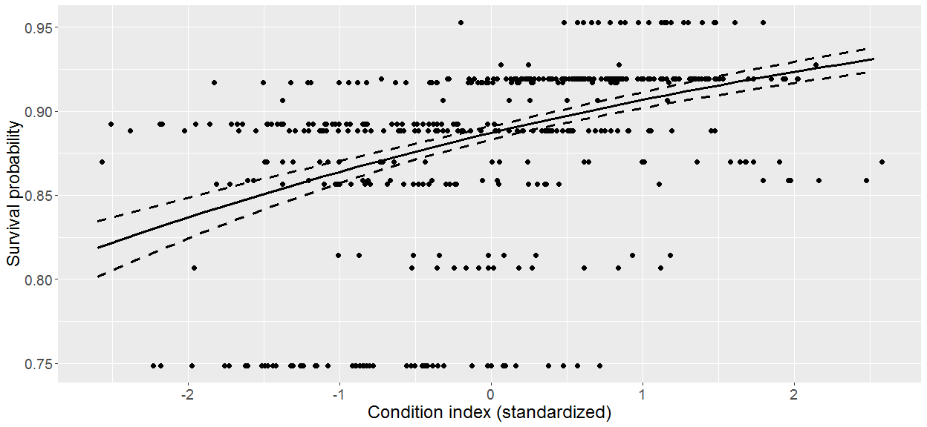

Figure S9: Relationship between the standardized condition and the survival probablity

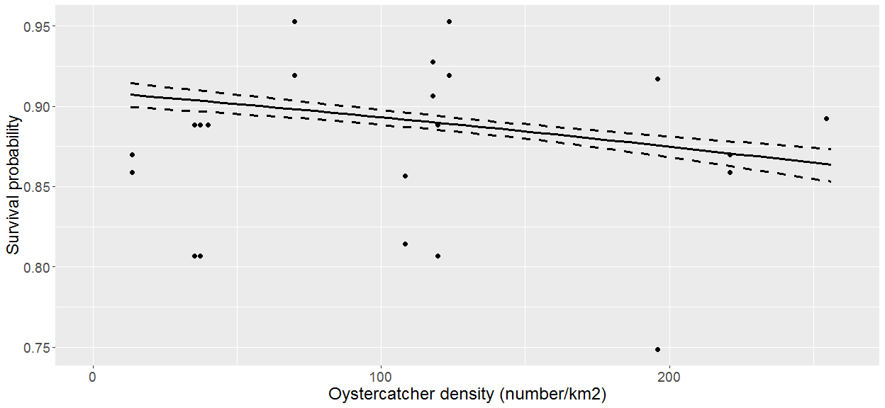

Figure S10: The effect of density on survival probablity

Section 3

Select relevant variables for the analysis

Code S5: R-code of the final model including latent variables (bill colour and energy store) and a composite variable (body condition). See Code S4 for explanation of the -1 infront of CortStd (composite variable). Covariance structure was defined in the model because it is expected that the error term handling time and squared handling time are correlated. Similarly we expect the error term of haematocrit and cholesterol to be correlate because cholesterol is determined in mmol/l blood which means that is is related to the proportion of haematocrit in the blood. The R-package used for the analysis is lavaan.

Cmod.3 <- '  
#Bill colour  
BCol =~ HS  
  
#Energy store  
ES =~ lMS+ratio   
lMS =~ MSK  
lMS ~ TA + TH +WL   
lMS~~0*lMS  
  
#cond variables: regress confounding and individual variables on the different condition measures  
lCho =~ Cho_perVolBlood  
lH =~ LogitH   
lB =~ LogitB  
lU =~ U_perVolBlood  
lCort =~ CortStd10  
lB + lH + lCho + ES + lU ~ AgeN+SexN+nBH10+nHT10   
lCort + BCol ~ AgeN+SexN+nBH10  
  
#composite  
Comp <~ -1*ES+lCort+BCol+lH+lB+lCho+lU #define the composite variable with the condition variables  
LogitSurvWS ~ Comp   
Comp ~ Density   
  
#add covariance structure  
lCho~~lH  
lU~~lH   
'  
  
Cmod.3.fit<-sem(Cmod.3,data=f) #fit the model  
summary(Cmod.3.fit, rsq=T, standardized=T) #get model output

## lavaan 0.6-8 ended normally after 211 iterations  
##   
## Estimator ML  
## Optimization method NLMINB  
## Number of model parameters 49  
##   
## Number of observations 427  
##   
## Model Test User Model:  
##   
## Test statistic 363.725  
## Degrees of freedom 68  
## P-value (Chi-square) 0.000  
##   
## Parameter Estimates:  
##   
## Standard errors Standard  
## Information Expected  
## Information saturated (h1) model Structured  
##   
## Latent Variables:  
## Estimate Std.Err z-value P(>|z|) Std.lv Std.all  
## BCol =~   
## HS 1.000 0.049 1.000  
## ES =~   
## lMS 1.000 0.928 0.928  
## ratio 10.313 0.016 637.548 0.000 0.476 0.999  
## lMS =~   
## MSK 1.000 0.050 1.000  
## lCho =~   
## Cho_perVolBlod 1.000 0.261 1.000  
## lH =~   
## LogitH 1.000 0.116 1.000  
## lB =~   
## LogitB 1.000 0.270 1.000  
## lU =~   
## U_perVolBlood 1.000 0.714 1.000  
## lCort =~   
## CortStd10 1.000 0.100 1.000  
##   
## Composites:  
## Estimate Std.Err z-value P(>|z|) Std.lv Std.all  
## Comp <~   
## ES -1.000 -0.760 -0.760  
## lCort -0.229 0.071 -3.234 0.001 -0.376 -0.376  
## BCol 0.121 0.135 0.902 0.367 0.097 0.097  
## lH 0.050 0.069 0.718 0.473 0.094 0.094  
## lB 0.013 0.024 0.543 0.587 0.059 0.059  
## lCho -0.027 0.030 -0.921 0.357 -0.118 -0.118  
## lU -0.013 0.010 -1.367 0.172 -0.156 -0.156  
##   
## Regressions:  
## Estimate Std.Err z-value P(>|z|) Std.lv Std.all  
## lMS ~   
## TA 0.577 0.003 225.302 0.000 11.610 0.363  
## TH -0.000 0.001 -0.340 0.734 -0.008 -0.001  
## WL -0.001 0.001 -0.499 0.618 -0.011 -0.001  
## lB ~   
## AgeN -0.182 0.031 -5.907 0.000 -0.673 -0.276  
## SexN 0.016 0.031 0.532 0.595 0.061 0.030  
## nBH10 0.282 0.150 1.876 0.061 1.043 0.104  
## nHT10 -0.219 0.128 -1.712 0.087 -0.811 -0.081  
## lH ~   
## AgeN -0.051 0.014 -3.764 0.000 -0.441 -0.181  
## SexN -0.005 0.014 -0.369 0.712 -0.043 -0.021  
## nBH10 -0.089 0.066 -1.343 0.179 -0.768 -0.077  
## nHT10 -0.038 0.056 -0.672 0.502 -0.327 -0.033  
## lCho ~   
## AgeN 0.052 0.031 1.689 0.091 0.198 0.081  
## SexN -0.034 0.030 -1.131 0.258 -0.132 -0.065  
## nBH10 0.188 0.149 1.264 0.206 0.722 0.072  
## nHT10 0.468 0.127 3.690 0.000 1.795 0.179  
## ES ~   
## AgeN 0.028 0.005 5.320 0.000 0.600 0.246  
## SexN -0.014 0.005 -2.761 0.006 -0.311 -0.152  
## nBH10 0.009 0.025 0.373 0.709 0.205 0.020  
## nHT10 -0.079 0.022 -3.647 0.000 -1.708 -0.171  
## lU ~   
## AgeN -0.051 0.084 -0.600 0.549 -0.071 -0.029  
## SexN -0.119 0.084 -1.420 0.156 -0.167 -0.082  
## nBH10 -0.437 0.411 -1.063 0.288 -0.612 -0.061  
## nHT10 -0.742 0.350 -2.120 0.034 -1.040 -0.104  
## lCort ~   
## AgeN -0.049 0.011 -4.276 0.000 -0.493 -0.202  
## SexN 0.008 0.011 0.674 0.500 0.077 0.038  
## nBH10 0.098 0.056 1.749 0.080 0.981 0.098  
## BCol ~   
## AgeN -0.026 0.005 -4.728 0.000 -0.530 -0.217  
## SexN -0.025 0.005 -4.528 0.000 -0.504 -0.247  
## nBH10 0.108 0.027 4.064 0.000 2.218 0.222  
## LogitSurvWS ~   
## Comp 3.222 0.453 7.119 0.000 0.196 0.415  
## Comp ~   
## Density -0.046 0.011 -4.100 0.000 -0.757 -0.526  
##   
## Covariances:  
## Estimate Std.Err z-value P(>|z|) Std.lv Std.all  
## .lCho ~~   
## .lH 0.016 0.002 10.329 0.000 0.561 0.561  
## .lH ~~   
## .lU 0.019 0.003 5.575 0.000 0.232 0.232  
##   
## Variances:  
## Estimate Std.Err z-value P(>|z|) Std.lv Std.all  
## .lMS 0.000 0.000 0.000  
## .HS 0.000 0.000 0.000  
## .ratio 0.000 0.000 14.612 0.000 0.000 0.001  
## .MSK 0.000 0.000 0.000  
## .Cho_perVolBlod 0.000 0.000 0.000  
## .LogitH 0.000 0.000 0.000  
## .LogitB 0.000 0.000 0.000  
## .U_perVolBlood 0.000 0.000 0.000  
## .CortStd10 0.000 0.000 0.000  
## .LogitSurvWS 0.184 0.013 14.612 0.000 0.184 0.828  
## .BCol 0.002 0.000 14.612 0.000 0.893 0.893  
## .ES 0.002 0.000 14.612 0.000 0.887 0.887  
## .lCho 0.065 0.004 14.612 0.000 0.958 0.958  
## .lH 0.013 0.001 14.866 0.000 0.961 0.961  
## .lB 0.066 0.005 14.612 0.000 0.907 0.907  
## .lU 0.496 0.034 14.612 0.000 0.974 0.974  
## .lCort 0.009 0.001 14.612 0.000 0.943 0.943  
## .Comp 0.000 0.000 0.000  
##   
## R-Square:  
## Estimate  
## lMS 1.000  
## HS 1.000  
## ratio 0.999  
## MSK 1.000  
## Cho_perVolBlod 1.000  
## LogitH 1.000  
## LogitB 1.000  
## U_perVolBlood 1.000  
## CortStd10 1.000  
## LogitSurvWS 0.172  
## BCol 0.107  
## ES 0.113  
## lCho 0.042  
## lH 0.039  
## lB 0.093  
## lU 0.026  
## lCort 0.057  
## Comp 1.000

fitMeasures(Cmod.3.fit, c("chisq", "pvalue", "df","cfi", "srmr", "rmsea", "rmsea.ci.lower", "rmsea.ci.upper")) #get model fit indices

## chisq pvalue df cfi srmr   
## 363.725 0.000 68.000 0.922 0.077   
## rmsea rmsea.ci.lower rmsea.ci.upper   
## 0.101 0.091 0.111

Code S6: The full model (Fig. 5) with only one size structure (tarsus length) and an added direct effect of body size on survival. For model results in a figure see Fig. S13. The R-package used for the analysis is lavaan.

Cmod.4 <- '  
BCol =~ HS  
  
ES =~ MSK+ratio   
MSK ~ TA  
MSK~~0*MSK  
  
#cond variables: regress confounding and individual variables on the different condition measures  
lCho =~ Cho_perVolBlood  
lH =~ LogitH   
lB =~ LogitB  
lU =~ U_perVolBlood  
lCort =~ CortStd10  
lB + lH + lCho + ES + lU ~ AgeN+SexN+nBH10+nHT10  
lCort + BCol ~ AgeN+SexN+nBH10  
  
#composite  
Comp <~ -1*ES+lCort+BCol+lH+lB+lCho+lU   
LogitSurvWS ~ Comp + TA   
Comp~ Density   
  
#add covariance structure  
lCho~~lH  
lU~~lH   
'  
Cmod.4.fit<-sem(Cmod.4,data=f)  
summary(Cmod.4.fit, standardized=T, rsq=T)

## lavaan 0.6-8 ended normally after 171 iterations  
##   
## Estimator ML  
## Optimization method NLMINB  
## Number of model parameters 48  
##   
## Number of observations 427  
##   
## Model Test User Model:  
##   
## Test statistic 276.972  
## Degrees of freedom 51  
## P-value (Chi-square) 0.000  
##   
## Parameter Estimates:  
##   
## Standard errors Standard  
## Information Expected  
## Information saturated (h1) model Structured  
##   
## Latent Variables:  
## Estimate Std.Err z-value P(>|z|) Std.lv Std.all  
## BCol =~   
## HS 1.000 0.049 1.000  
## ES =~   
## MSK 1.000 0.046 0.928  
## ratio 10.317 0.016 645.740 0.000 0.476 0.999  
## lCho =~   
## Cho_perVolBlod 1.000 0.261 1.000  
## lH =~   
## LogitH 1.000 0.116 1.000  
## lB =~   
## LogitB 1.000 0.270 1.000  
## lU =~   
## U_perVolBlood 1.000 0.714 1.000  
## lCort =~   
## CortStd10 1.000 0.100 1.000  
##   
## Composites:  
## Estimate Std.Err z-value P(>|z|) Std.lv Std.all  
## Comp <~   
## ES -1.000 -0.755 -0.755  
## lCort -0.228 0.071 -3.188 0.001 -0.372 -0.372  
## BCol 0.130 0.136 0.957 0.339 0.104 0.104  
## lH 0.043 0.070 0.620 0.535 0.082 0.082  
## lB 0.014 0.024 0.562 0.574 0.061 0.061  
## lCho -0.027 0.030 -0.894 0.371 -0.115 -0.115  
## lU -0.014 0.010 -1.429 0.153 -0.164 -0.164  
##   
## Regressions:  
## Estimate Std.Err z-value P(>|z|) Std.lv Std.all  
## MSK ~   
## TA 0.576 0.002 252.687 0.000 0.576 0.363  
## lB ~   
## AgeN -0.182 0.031 -5.907 0.000 -0.673 -0.276  
## SexN 0.016 0.031 0.532 0.595 0.061 0.030  
## nBH10 0.282 0.150 1.876 0.061 1.043 0.104  
## nHT10 -0.219 0.128 -1.712 0.087 -0.811 -0.081  
## lH ~   
## AgeN -0.051 0.014 -3.764 0.000 -0.441 -0.181  
## SexN -0.005 0.014 -0.370 0.712 -0.043 -0.021  
## nBH10 -0.089 0.066 -1.343 0.179 -0.768 -0.077  
## nHT10 -0.038 0.056 -0.672 0.502 -0.327 -0.033  
## lCho ~   
## AgeN 0.052 0.031 1.689 0.091 0.198 0.081  
## SexN -0.034 0.030 -1.131 0.258 -0.132 -0.065  
## nBH10 0.188 0.149 1.264 0.206 0.722 0.072  
## nHT10 0.468 0.127 3.690 0.000 1.795 0.179  
## ES ~   
## AgeN 0.028 0.005 5.313 0.000 0.599 0.245  
## SexN -0.014 0.005 -2.752 0.006 -0.310 -0.151  
## nBH10 0.009 0.025 0.373 0.709 0.205 0.020  
## nHT10 -0.079 0.022 -3.648 0.000 -1.708 -0.171  
## lU ~   
## AgeN -0.051 0.084 -0.600 0.549 -0.071 -0.029  
## SexN -0.119 0.084 -1.420 0.156 -0.167 -0.082  
## nBH10 -0.437 0.411 -1.063 0.288 -0.612 -0.061  
## nHT10 -0.742 0.350 -2.120 0.034 -1.040 -0.104  
## lCort ~   
## AgeN -0.049 0.011 -4.276 0.000 -0.493 -0.202  
## SexN 0.008 0.011 0.674 0.500 0.077 0.038  
## nBH10 0.098 0.056 1.749 0.080 0.981 0.098  
## BCol ~   
## AgeN -0.026 0.005 -4.728 0.000 -0.530 -0.217  
## SexN -0.025 0.005 -4.528 0.000 -0.504 -0.247  
## nBH10 0.108 0.027 4.064 0.000 2.218 0.222  
## LogitSurvWS ~   
## Comp 3.185 0.452 7.040 0.000 0.194 0.413  
## TA -0.552 0.664 -0.832 0.406 -0.552 -0.037  
## Comp ~   
## Density -0.047 0.011 -4.095 0.000 -0.764 -0.531  
##   
## Covariances:  
## Estimate Std.Err z-value P(>|z|) Std.lv Std.all  
## .lCho ~~   
## .lH 0.016 0.002 10.329 0.000 0.561 0.561  
## .lH ~~   
## .lU 0.019 0.003 5.575 0.000 0.232 0.232  
##   
## Variances:  
## Estimate Std.Err z-value P(>|z|) Std.lv Std.all  
## .MSK 0.000 0.000 0.000  
## .HS 0.000 0.000 0.000  
## .ratio 0.000 0.000 14.612 0.000 0.000 0.001  
## .Cho_perVolBlod 0.000 0.000 0.000  
## .LogitH 0.000 0.000 0.000  
## .LogitB 0.000 0.000 0.000  
## .U_perVolBlood 0.000 0.000 0.000  
## .CortStd10 0.000 0.000 0.000  
## .LogitSurvWS 0.183 0.013 14.612 0.000 0.183 0.828  
## .BCol 0.002 0.000 14.612 0.000 0.893 0.893  
## .ES 0.002 0.000 14.612 0.000 0.888 0.888  
## .lCho 0.065 0.004 14.612 0.000 0.958 0.958  
## .lH 0.013 0.001 14.866 0.000 0.961 0.961  
## .lB 0.066 0.005 14.612 0.000 0.907 0.907  
## .lU 0.496 0.034 14.612 0.000 0.974 0.974  
## .lCort 0.009 0.001 14.612 0.000 0.943 0.943  
## .Comp 0.000 0.000 0.000  
##   
## R-Square:  
## Estimate  
## MSK 1.000  
## HS 1.000  
## ratio 0.999  
## Cho_perVolBlod 1.000  
## LogitH 1.000  
## LogitB 1.000  
## U_perVolBlood 1.000  
## CortStd10 1.000  
## LogitSurvWS 0.172  
## BCol 0.107  
## ES 0.112  
## lCho 0.042  
## lH 0.039  
## lB 0.093  
## lU 0.026  
## lCort 0.057  
## Comp 1.000

fitMeasures(Cmod.4.fit,   
 c("chisq", "pvalue", "df","cfi", "nfi","srmr", "rmsea", "rmsea.ci.lower",   
 "rmsea.ci.upper", "AIC", "rmsea.pvalue"))

## chisq pvalue df cfi nfi   
## 276.972 0.000 51.000 0.939 0.927   
## srmr rmsea rmsea.ci.lower rmsea.ci.upper aic   
## 0.079 0.102 0.090 0.114 -5278.346   
## rmsea.pvalue   
## 0.000

Code S7: The full model (Fig. 5) with only one size structure (tarsus length) and only an indirect effect of body size on survival. For model results in a figure see Fig. S13. The R-package used for the analysis is lavaan.

Cmod.5 <- '  
BCol =~ HS  
  
ES =~ MSK+ratio   
MSK ~ TA  
MSK~~0*MSK  
  
#cond variables: regress confounding and individual variables on the different condition measures  
lCho =~ Cho_perVolBlood  
lH =~ LogitH   
lB =~ LogitB  
lU =~ U_perVolBlood  
lCort =~ CortStd10  
lB + lH + lCho + ES + lU ~ AgeN+SexN+nBH10+nHT10 #+nDS  
lCort + BCol ~ AgeN+SexN+nBH10  
  
#composite  
Comp <~ -1*ES+lCort+BCol+lH+lB+lCho+lU #lCho+lB+lH+ #define the composite variable with the condition variables  
LogitSurvWS ~ Comp   
Comp~ Density   
  
#add covariance structure  
lCho~~lH  
lU~~lH   
'  
Cmod.5.fit<-sem(Cmod.5,data=f)  
summary(Cmod.5.fit, standardized=T, rsq=T)

## lavaan 0.6-8 ended normally after 163 iterations  
##   
## Estimator ML  
## Optimization method NLMINB  
## Number of model parameters 47  
##   
## Number of observations 427  
##   
## Model Test User Model:  
##   
## Test statistic 277.638  
## Degrees of freedom 52  
## P-value (Chi-square) 0.000  
##   
## Parameter Estimates:  
##   
## Standard errors Standard  
## Information Expected  
## Information saturated (h1) model Structured  
##   
## Latent Variables:  
## Estimate Std.Err z-value P(>|z|) Std.lv Std.all  
## BCol =~   
## HS 1.000 0.049 1.000  
## ES =~   
## MSK 1.000 0.046 0.928  
## ratio 10.317 0.016 645.740 0.000 0.476 0.999  
## lCho =~   
## Cho_perVolBlod 1.000 0.261 1.000  
## lH =~   
## LogitH 1.000 0.116 1.000  
## lB =~   
## LogitB 1.000 0.270 1.000  
## lU =~   
## U_perVolBlood 1.000 0.714 1.000  
## lCort =~   
## CortStd10 1.000 0.100 1.000  
##   
## Composites:  
## Estimate Std.Err z-value P(>|z|) Std.lv Std.all  
## Comp <~   
## ES -1.000 -0.760 -0.760  
## lCort -0.229 0.071 -3.233 0.001 -0.376 -0.376  
## BCol 0.121 0.135 0.901 0.368 0.097 0.097  
## lH 0.050 0.069 0.719 0.472 0.095 0.095  
## lB 0.013 0.024 0.544 0.586 0.059 0.059  
## lCho -0.027 0.030 -0.922 0.356 -0.118 -0.118  
## lU -0.013 0.010 -1.367 0.172 -0.156 -0.156  
##   
## Regressions:  
## Estimate Std.Err z-value P(>|z|) Std.lv Std.all  
## MSK ~   
## TA 0.576 0.002 252.694 0.000 0.576 0.363  
## lB ~   
## AgeN -0.182 0.031 -5.907 0.000 -0.673 -0.276  
## SexN 0.016 0.031 0.532 0.595 0.061 0.030  
## nBH10 0.282 0.150 1.876 0.061 1.043 0.104  
## nHT10 -0.219 0.128 -1.712 0.087 -0.811 -0.081  
## lH ~   
## AgeN -0.051 0.014 -3.764 0.000 -0.441 -0.181  
## SexN -0.005 0.014 -0.370 0.712 -0.043 -0.021  
## nBH10 -0.089 0.066 -1.343 0.179 -0.768 -0.077  
## nHT10 -0.038 0.056 -0.672 0.502 -0.327 -0.033  
## lCho ~   
## AgeN 0.052 0.031 1.689 0.091 0.198 0.081  
## SexN -0.034 0.030 -1.131 0.258 -0.132 -0.065  
## nBH10 0.188 0.149 1.265 0.206 0.722 0.072  
## nHT10 0.468 0.127 3.690 0.000 1.795 0.179  
## ES ~   
## AgeN 0.028 0.005 5.313 0.000 0.599 0.245  
## SexN -0.014 0.005 -2.752 0.006 -0.310 -0.151  
## nBH10 0.009 0.025 0.373 0.709 0.205 0.020  
## nHT10 -0.079 0.022 -3.648 0.000 -1.708 -0.171  
## lU ~   
## AgeN -0.051 0.084 -0.600 0.549 -0.071 -0.029  
## SexN -0.119 0.084 -1.420 0.156 -0.167 -0.082  
## nBH10 -0.437 0.411 -1.063 0.288 -0.612 -0.061  
## nHT10 -0.742 0.350 -2.120 0.034 -1.040 -0.104  
## lCort ~   
## AgeN -0.049 0.011 -4.276 0.000 -0.493 -0.202  
## SexN 0.008 0.011 0.674 0.500 0.077 0.038  
## nBH10 0.098 0.056 1.749 0.080 0.981 0.098  
## BCol ~   
## AgeN -0.026 0.005 -4.728 0.000 -0.530 -0.217  
## SexN -0.025 0.005 -4.528 0.000 -0.504 -0.247  
## nBH10 0.108 0.027 4.064 0.000 2.218 0.222  
## LogitSurvWS ~   
## Comp 3.224 0.453 7.120 0.000 0.196 0.415  
## Comp ~   
## Density -0.046 0.011 -4.099 0.000 -0.756 -0.526  
##   
## Covariances:  
## Estimate Std.Err z-value P(>|z|) Std.lv Std.all  
## .lCho ~~   
## .lH 0.016 0.002 10.329 0.000 0.561 0.561  
## .lH ~~   
## .lU 0.019 0.003 5.575 0.000 0.232 0.232  
##   
## Variances:  
## Estimate Std.Err z-value P(>|z|) Std.lv Std.all  
## .MSK 0.000 0.000 0.000  
## .HS 0.000 0.000 0.000  
## .ratio 0.000 0.000 14.612 0.000 0.000 0.001  
## .Cho_perVolBlod 0.000 0.000 0.000  
## .LogitH 0.000 0.000 0.000  
## .LogitB 0.000 0.000 0.000  
## .U_perVolBlood 0.000 0.000 0.000  
## .CortStd10 0.000 0.000 0.000  
## .LogitSurvWS 0.184 0.013 14.612 0.000 0.184 0.828  
## .BCol 0.002 0.000 14.612 0.000 0.893 0.893  
## .ES 0.002 0.000 14.612 0.000 0.888 0.888  
## .lCho 0.065 0.004 14.612 0.000 0.958 0.958  
## .lH 0.013 0.001 14.866 0.000 0.961 0.961  
## .lB 0.066 0.005 14.612 0.000 0.907 0.907  
## .lU 0.496 0.034 14.612 0.000 0.974 0.974  
## .lCort 0.009 0.001 14.612 0.000 0.943 0.943  
## .Comp 0.000 0.000 0.000  
##   
## R-Square:  
## Estimate  
## MSK 1.000  
## HS 1.000  
## ratio 0.999  
## Cho_perVolBlod 1.000  
## LogitH 1.000  
## LogitB 1.000  
## U_perVolBlood 1.000  
## CortStd10 1.000  
## LogitSurvWS 0.172  
## BCol 0.107  
## ES 0.112  
## lCho 0.042  
## lH 0.039  
## lB 0.093  
## lU 0.026  
## lCort 0.057  
## Comp 1.000

fitMeasures(Cmod.5.fit,   
 c("chisq", "pvalue", "df","cfi", "nfi","srmr", "rmsea", "rmsea.ci.lower",   
 "rmsea.ci.upper", "AIC", "rmsea.pvalue"))

## chisq pvalue df cfi nfi   
## 277.638 0.000 52.000 0.939 0.927   
## srmr rmsea rmsea.ci.lower rmsea.ci.upper aic   
## 0.079 0.101 0.089 0.113 -5279.679   
## rmsea.pvalue   
## 0.000

Table S8: Comparison of the two full models (Fig. S13). Cmod.5.fit indicating the model without a direct effect of body size, Cmod.4.fit indicating the model with a direct effect of body size on survival.

## Chi-Squared Difference Test  
##   
## Df AIC BIC Chisq Chisq diff Df diff Pr(>Chisq)  
## Cmod.4.fit 51 -5278.3 -5083.6 276.97   
## Cmod.5.fit 52 -5279.7 -5089.0 277.64 0.66635 1 0.4143

Code S8: SEM Model for comparing performance (without competitior density in the model)

lvmod.6 <- '  
#Bill colour  
BCol =~ HS  
  
#Energy store  
ES =~ lMS+ratio   
lMS =~ MSK  
lMS ~ TA + TH +WL   
lMS~~0*lMS  
  
#cond variables: regress confounding and individual variables on the different condition measures  
lCho =~ Cho_perVolBlood  
lH =~ LogitH   
lB =~ LogitB  
lU =~ U_perVolBlood  
lCort =~ CortStd10  
lB + lH + lCho + ES + lU ~ AgeN+SexN+nBH10+nHT10   
lCort + BCol ~ AgeN+SexN+nBH10  
  
#composite  
Comp <~ -1*ES+lCort+BCol+lH+lB+lCho+lU #lCho+lB+lH+ #define the composite variable with the condition variables  
LogitSurvWS ~ Comp   
#Comp ~ Density   
  
#add covariance structure  
lCho~~lH  
lU~~lH   
'  
lvmod.6.fit<-sem(lvmod.6,data=f) #fit the model  
summary(lvmod.6.fit, rsq=T, standardized=T) #get model output

## lavaan 0.6-8 ended normally after 186 iterations  
##   
## Estimator ML  
## Optimization method NLMINB  
## Number of model parameters 48  
##   
## Number of observations 427  
##   
## Model Test User Model:  
##   
## Test statistic 246.143  
## Degrees of freedom 60  
## P-value (Chi-square) 0.000  
##   
## Parameter Estimates:  
##   
## Standard errors Standard  
## Information Expected  
## Information saturated (h1) model Structured  
##   
## Latent Variables:  
## Estimate Std.Err z-value P(>|z|) Std.lv Std.all  
## BCol =~   
## HS 1.000 0.049 1.000  
## ES =~   
## lMS 1.000 0.928 0.928  
## ratio 10.313 0.016 637.546 0.000 0.476 0.999  
## lMS =~   
## MSK 1.000 0.050 1.000  
## lCho =~   
## Cho_perVolBlod 1.000 0.261 1.000  
## lH =~   
## LogitH 1.000 0.116 1.000  
## lB =~   
## LogitB 1.000 0.270 1.000  
## lU =~   
## U_perVolBlood 1.000 0.714 1.000  
## lCort =~   
## CortStd10 1.000 0.100 1.000  
##   
## Composites:  
## Estimate Std.Err z-value P(>|z|) Std.lv Std.all  
## Comp <~   
## ES -1.000 -0.873 -0.873  
## lCort -0.219 0.066 -3.299 0.001 -0.413 -0.413  
## BCol 0.171 0.128 1.327 0.184 0.157 0.157  
## lH 0.012 0.065 0.187 0.852 0.027 0.027  
## lB 0.024 0.023 1.028 0.304 0.121 0.121  
## lCho -0.053 0.029 -1.842 0.065 -0.261 -0.261  
## lU -0.002 0.009 -0.274 0.784 -0.033 -0.033  
##   
## Regressions:  
## Estimate Std.Err z-value P(>|z|) Std.lv Std.all  
## lMS ~   
## TA 0.577 0.003 225.300 0.000 11.610 0.363  
## TH -0.000 0.001 -0.333 0.739 -0.008 -0.001  
## WL -0.001 0.001 -0.492 0.623 -0.011 -0.001  
## lB ~   
## AgeN -0.182 0.031 -5.907 0.000 -0.673 -0.276  
## SexN 0.016 0.031 0.532 0.595 0.061 0.030  
## nBH10 0.282 0.150 1.876 0.061 1.043 0.104  
## nHT10 -0.219 0.128 -1.712 0.087 -0.811 -0.081  
## lH ~   
## AgeN -0.051 0.014 -3.764 0.000 -0.441 -0.181  
## SexN -0.005 0.014 -0.369 0.712 -0.043 -0.021  
## nBH10 -0.089 0.066 -1.343 0.179 -0.768 -0.077  
## nHT10 -0.038 0.056 -0.672 0.502 -0.327 -0.033  
## lCho ~   
## AgeN 0.052 0.031 1.689 0.091 0.198 0.081  
## SexN -0.034 0.030 -1.131 0.258 -0.132 -0.065  
## nBH10 0.188 0.149 1.264 0.206 0.722 0.072  
## nHT10 0.468 0.127 3.690 0.000 1.795 0.179  
## ES ~   
## AgeN 0.028 0.005 5.320 0.000 0.600 0.246  
## SexN -0.014 0.005 -2.761 0.006 -0.311 -0.152  
## nBH10 0.009 0.025 0.373 0.709 0.205 0.020  
## nHT10 -0.079 0.022 -3.647 0.000 -1.708 -0.171  
## lU ~   
## AgeN -0.051 0.084 -0.600 0.549 -0.071 -0.029  
## SexN -0.119 0.084 -1.420 0.156 -0.167 -0.082  
## nBH10 -0.437 0.411 -1.063 0.288 -0.612 -0.061  
## nHT10 -0.742 0.350 -2.120 0.034 -1.040 -0.104  
## lCort ~   
## AgeN -0.049 0.011 -4.276 0.000 -0.493 -0.202  
## SexN 0.008 0.011 0.674 0.500 0.077 0.038  
## nBH10 0.098 0.056 1.749 0.080 0.981 0.098  
## BCol ~   
## AgeN -0.026 0.005 -4.728 0.000 -0.530 -0.217  
## SexN -0.025 0.005 -4.528 0.000 -0.504 -0.247  
## nBH10 0.108 0.027 4.064 0.000 2.218 0.222  
## LogitSurvWS ~   
## Comp 3.489 0.463 7.536 0.000 0.184 0.388  
##   
## Covariances:  
## Estimate Std.Err z-value P(>|z|) Std.lv Std.all  
## .lCho ~~   
## .lH 0.016 0.002 10.329 0.000 0.561 0.561  
## .lH ~~   
## .lU 0.019 0.003 5.575 0.000 0.232 0.232  
##   
## Variances:  
## Estimate Std.Err z-value P(>|z|) Std.lv Std.all  
## .lMS 0.000 0.000 0.000  
## .HS 0.000 0.000 0.000  
## .ratio 0.000 0.000 14.612 0.000 0.000 0.001  
## .MSK 0.000 0.000 0.000  
## .Cho_perVolBlod 0.000 0.000 0.000  
## .LogitH 0.000 0.000 0.000  
## .LogitB 0.000 0.000 0.000  
## .U_perVolBlood 0.000 0.000 0.000  
## .CortStd10 0.000 0.000 0.000  
## .LogitSurvWS 0.192 0.013 14.612 0.000 0.192 0.850  
## .BCol 0.002 0.000 14.612 0.000 0.893 0.893  
## .ES 0.002 0.000 14.612 0.000 0.887 0.887  
## .lCho 0.065 0.004 14.612 0.000 0.958 0.958  
## .lH 0.013 0.001 14.866 0.000 0.961 0.961  
## .lB 0.066 0.005 14.612 0.000 0.907 0.907  
## .lU 0.496 0.034 14.612 0.000 0.974 0.974  
## .lCort 0.009 0.001 14.612 0.000 0.943 0.943  
## Comp 0.000 0.000 0.000  
##   
## R-Square:  
## Estimate  
## lMS 1.000  
## HS 1.000  
## ratio 0.999  
## MSK 1.000  
## Cho_perVolBlod 1.000  
## LogitH 1.000  
## LogitB 1.000  
## U_perVolBlood 1.000  
## CortStd10 1.000  
## LogitSurvWS 0.150  
## BCol 0.107  
## ES 0.113  
## lCho 0.042  
## lH 0.039  
## lB 0.093  
## lU 0.026  
## lCort 0.057

fitMeasures(lvmod.6.fit, c("chisq", "pvalue", "df","cfi", "srmr", "rmsea", "rmsea.ci.lower", "rmsea.ci.upper")) #get model fit indices

## chisq pvalue df cfi srmr   
## 246.143 0.000 60.000 0.949 0.066   
## rmsea rmsea.ci.lower rmsea.ci.upper   
## 0.085 0.074 0.096

Predictions SEM

Conventional approach (Fig. 6b)

Code S9: R-code and output of the cross validation for the SEM approach (Figue 6a) and the conventional (regression & PCA) approach (Figure 6b) conducted with the R-package caret.

Supplements: Plot raw data mass on survival (Fig. S12)

Table S7

Table S7

Table S5: Model fit indices of all models. Statistical significance of the chi-square statistic (using alpha = 0.05) indicates that exact fit of the model has to be rejected. With increasing sample sizes, chance of detecting a smaller difference between the hypothesized value and the true value is greater and therefore may lead to rejection of the model. Since we have to deal with relatively high sample sizes (>300), we also document measures of approximate fit: the root mean square error of approximation (RMSEA), standardized root mean square residual (SRMR) and the comparative fit index (CFI).

|  |  |  |  |  |  |  |  |  |
| --- | --- | --- | --- | --- | --- | --- | --- | --- |
|  | Chi-square | p-value | DF | CFI | SRMR | RMSEA | Lower RMSEA | Upper RMSEA |
| Energy store model (Fig. 2a, Code S1) | 1.81366033302766e-12 | 0 | 0 | 0.682995094693035 | 4.38643999110527e-09 | 0 | 0 | 0 |
| Bill colour model (Fig. 2b, Code S2) | 1141.24384008411 | 0 | 2 | 0.682995094693035 | 0.061156329275115 | 1.22273081922325 | 1.16366699426069 | 1.28286668368661 |
| Composite model (Fig. 4, Code S3) | 77.8316641650984 | 4.35207425653061e-13 | 9 | 0.779915397402296 | 0.0489912391954891 | 0.130803425826995 | 0.104941560156755 | 0.158315901145798 |
| Composite model with squared mass (Code S4) | 77.1876937922242 | 1.41504585826624e-11 | 12 | 0.652883307546357 | 0.067163605524985 | 0.110239801823489 | 0.0875210712246657 | 0.134326812541937 |
| Latent+composite model (Fig. 5, Code S5) | 363.724572174324 | 0 | 68 | 0.921882084968808 | 0.0774817818512497 | 0.100919551600493 | 0.090860344674144 | 0.111234546722596 |
| Full model with direct and indirect effect of body size (Fig. S13a, Code S6) | 276.972012224315 | 0 | 51 | 0.939207817695611 | 0.0787906451505614 | 0.101865776694641 | 0.0902862184459697 | 0.113785668188161 |
| Full model with indirect effect of body size (Fig S13b, Code S7) | 277.638364691098 | 0 | 52 | 0.939297577314358 | 0.079103015610449 | 0.100807039931372 | 0.0893257449247818 | 0.112623223510656 |
| Model used for model performance (Fig. 6, Code S8) | 246.143479517584 | 0 | 60 | 0.949107610638136 | 0.0657026022067085 | 0.0852382159305254 | 0.0743198061156126 | 0.0964520516763885 |
| Acceptable threshold levels | Low chi-square relative to degrees of freedom with an insignificant p value (p > 0.05) |  |  | >0.90 | <0.08 | <0.07 |  |  |
| Literature | {Grace, 2006 #1061} |  |  | {Lefcheck, 2019 #1157; Hu, 1999 #321} | {Hu, 1999 #321} | {Steiger, 2007#1162} |  |  |

Descriptive supplementary information (Table S1, Table S2, Fig. S2, Fig. S24)

Table S1: Catching events and their characteristics.

|  |  |  |  |  |  |  |  |  |
| --- | --- | --- | --- | --- | --- | --- | --- | --- |
| Date | Location | Longitude | Latitude | Winter | Catching event ID | Number of 1st CY birds | Number of Sub-Adults | Number of Adults |
| 2-12-2016 | Vlieland, Vliehors Kazerne | 4.95 | 53.24 | 2016_2017 | 66900281 | NA | 1 | 5 |
| 3-12-2016 | Vlieland, Vliehors Kazerne | 4.95 | 53.24 | 2016_2017 | 66900282 | 4 | 1 | NA |
| 4-12-2016 | Vlieland, Vliehors Kazerne | 4.95 | 53.24 | 2016_2017 | 66900283 | 2 | NA | NA |
| 5-12-2016 | Vlieland, Vliehors Kazerne | 4.95 | 53.24 | 2016_2017 | 66900284 | NA | 1 | NA |
| 18-12-2016 | Vlieland, Vliehors hoek Posthuiswad | 4.97 | 53.25 | 2016_2017 | 66900285 | 1 | 3 | 2 |
| 18-12-2016 | Vlieland, Vliehors hoek Posthuiswad | 4.97 | 53.25 | 2016_2017 | 66900286 | 6 | 5 | 2 |
| 18-12-2016 | Vlieland, Vliehors hoek Posthuiswad | 4.97 | 53.25 | 2016_2017 | 66900287 | 1 | NA | NA |
| 19-12-2016 | Vlieland, Vliehors hoek Posthuiswad | 4.97 | 53.25 | 2016_2017 | 66900288 | 1 | NA | NA |
| 16-1-2017 | Vlieland, Vliehors hoek Posthuiswad | 4.95 | 53.24 | 2016_2017 | 66900332 | NA | 1 | 1 |
| 17-1-2017 | Vliehors, Kazerne-oost | 4.95 | 53.24 | 2016_2017 | 66900333 | NA | 45 | 30 |
| 18-1-2017 | Vliehors, Kazerne-oost | 4.95 | 53.24 | 2016_2017 | 66900334 | NA | 5 | 5 |
| 25-1-2017 | Schiermonnikoog 2e slenk | 6.23 | 53.48 | 2016_2017 | 66900335 | NA | 34 | 14 |
| 20-2-2017 | Balgzand Normerven | 4.94 | 52.91 | 2016_2017 | 66900349 | NA | 37 | 30 |
| 24-2-2017 | Eemshaven | 6.78 | 53.46 | 2016_2017 | 66900364 | NA | 14 | 4 |
| 28-2-2017 | Molenkolk Texel | 4.80 | 53.02 | 2016_2017 | 66900365 | NA | 49 | 8 |
| 15-12-2017 | Vlieland, Vliehors, Kwelder ten zuiden van Kroonpolders | 4.96 | 53.25 | 2017_2018 | 66902231 | 1 | 24 | 11 |
| 18-12-2017 | Vlieland, Vliehors, Kwelder ten zuiden van Kroonpolders | 4.96 | 53.25 | 2017_2018 | 66902233 | 12 | 16 | 12 |
| 19-12-2017 | Vlieland, Vliehors, Kwelder ten zuiden van Kroonpolders | 4.96 | 53.25 | 2017_2018 | 66902235 | NA | 11 | 5 |
| 19-12-2017 | Vlieland, Vliehors, Tankdoelen Waddenkant | 4.92 | 53.23 | 2017_2018 | 66902236 | NA | 32 | 8 |
| 6-2-2018 | Oosterend, Terschelling | 5.39 | 53.40 | 2017_2018 | 66902246 | NA | 3 | NA |
| 26-1-2018 | Balgzand, 't Kuitje, Den Helder | 4.79 | 52.93 | 2017_2018 | 66902247 | NA | 69 | 6 |
| 19-1-2018 | Prunjepolder, Oosterschelde | 3.85 | 51.69 | 2017_2018 | 66902248 | NA | 108 | 21 |
| 21-1-2018 | Ameland, Vogelpolle | 5.67 | 53.42 | 2017_2018 | 66902249 | NA | 77 | 25 |
| 16-2-2018 | Striep, Terschelling | 5.30 | 53.38 | 2017_2018 | 66902250 | NA | 17 | 1 |
| 17-2-2018 | Sehael, Terschelling | 5.32 | 53.38 | 2017_2018 | 66902251 | NA | 45 | 5 |
| 30-1-2018 | Schor Wilhelminapolder, Zeeland | 3.90 | 51.54 | 2017_2018 | 66902257 | NA | 106 | 16 |
| 19-2-2018 | Schiermonnikoog, 2e Slenk | 6.23 | 53.48 | 2017_2018 | 66902259 | NA | 48 | 36 |
| 20-2-2018 | Schiermonnikoog, 2e Slenk | 6.23 | 53.48 | 2017_2018 | 66902260 | NA | 22 | 12 |

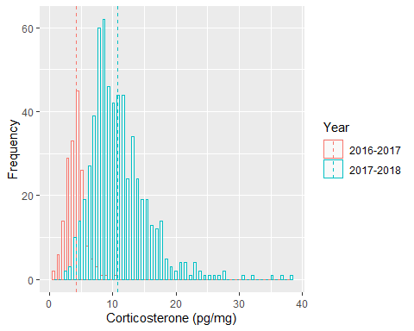

Figure S24: Corticosterone (pg/mg) measurements for the two different years of extraction (2016-2017 & 2017-2018)

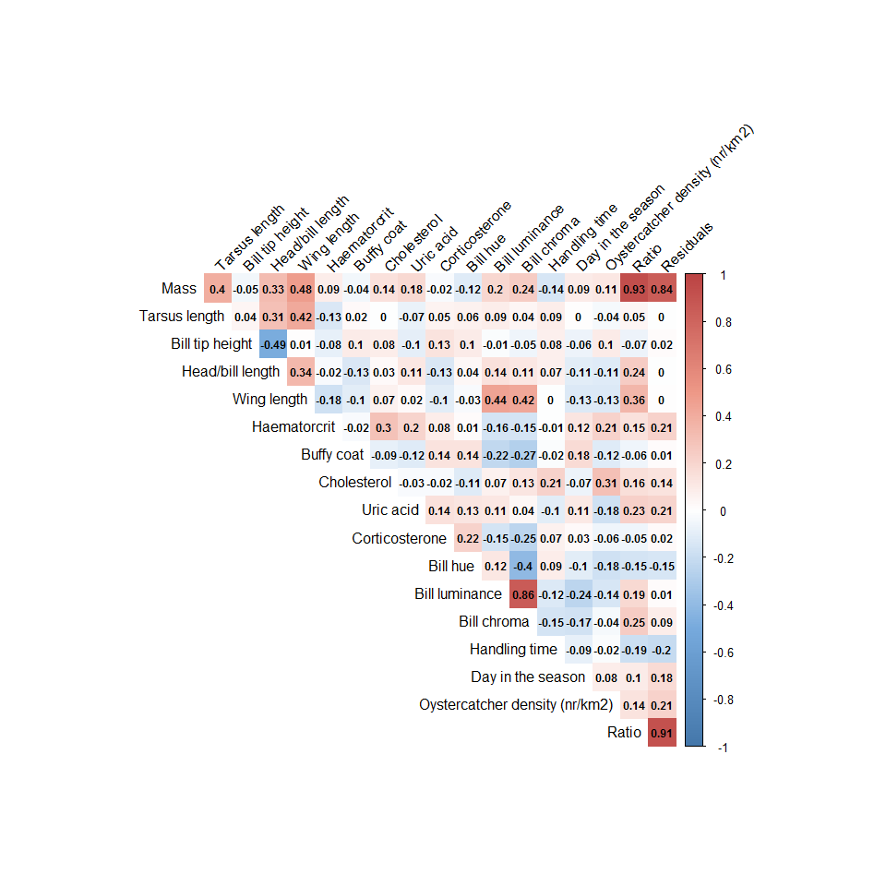

Figure S2: Correlation matrix of all variables in the dataset.

Code S10: Example r-code to account for a measurement error (in a regression analysis; mass as response variable and three structural size measures as independent variables) by using latent variables in SEM. We assume a reapatability of 0.3 of the strctural size measures TA, TH and WL. We add three latent variables lTA, lTH, lWL to the model. Instead of regressing the strucural size measures directly on mass, we regress the latent variables of the structural size measures on mass (lTA, lWL, lTH). By adding the latent variables to the model, we can distinguish between the error variance due to unexplained variation and due to measurement error. In the output of this model, we find the unexplained variation for each structural size variable (without any influence of measurement error). The R-package used for the analysis is lavaan. See chapter 4 in for more information about accounting for measurement errors in SEM.

lvmod.3 <-'  
lTA=~TA # define the latent variable lTA   
lWL=~WL # define the latent variable lWL   
lTH=~TH # define the latent variable lTH   
TA~~0.7*TA # add error variance on TA  
TH~~0.7*TH # add error variance on TH  
WL~~0.7*WL # add error variance on WL  
MS~lTA+lTH+lWL # regress the three latent variables on mass  
'  
lvmod.3.fit<-sem(lvmod.3,data=d) #fit the model  
summary(lvmod.3.fit, rsq=T, standardized=T) #get model output

## lavaan 0.6-8 ended normally after 62 iterations  
##   
## Estimator ML  
## Optimization method NLMINB  
## Number of model parameters 10  
##   
## Used Total  
## Number of observations 1021 1033  
##   
## Model Test User Model:  
##   
## Test statistic 0.000  
## Degrees of freedom 0  
##   
## Parameter Estimates:  
##   
## Standard errors Standard  
## Information Expected  
## Information saturated (h1) model Structured  
##   
## Latent Variables:  
## Estimate Std.Err z-value P(>|z|) Std.lv Std.all  
## lTA =~   
## TA 1.000 2.914 0.961  
## lWL =~   
## WL 1.000 6.917 0.993  
## lTH =~   
## TH 1.000 6.396 0.992  
##   
## Regressions:  
## Estimate Std.Err z-value P(>|z|) Std.lv Std.all  
## MS ~   
## lTA 4.199 0.562 7.474 0.000 12.234 0.238  
## lTH 1.352 0.246 5.502 0.000 8.645 0.168  
## lWL 1.983 0.222 8.918 0.000 13.714 0.266  
##   
## Covariances:  
## Estimate Std.Err z-value P(>|z|) Std.lv Std.all  
## lTA ~~   
## lWL 6.834 0.695 9.837 0.000 0.339 0.339  
## lTH 7.135 0.651 10.954 0.000 0.383 0.383  
## lWL ~~   
## lTH 14.303 1.476 9.691 0.000 0.323 0.323  
##   
## Variances:  
## Estimate Std.Err z-value P(>|z|) Std.lv Std.all  
## .TA 0.700 0.700 0.076  
## .TH 0.700 0.700 0.017  
## .WL 0.700 0.700 0.014  
## .MS 1965.561 87.719 22.408 0.000 1965.561 0.742  
## lTA 8.489 0.407 20.873 0.000 1.000 1.000  
## lWL 47.850 2.149 22.268 0.000 1.000 1.000  
## lTH 40.903 1.841 22.214 0.000 1.000 1.000  
##   
## R-Square:  
## Estimate  
## TA 0.924  
## TH 0.983  
## WL 0.986  
## MS 0.258

Import and prepare data for the binomial model (Code S11)

Code S11: Example r-code for a model with binomial response variable. In this example we defined a bird that was seen in the subsequent year (after catching) as 1 and otherwise as 0. We show here an example of a simple composite model (similar to Figure 5) without any confounding variables. The R-package used for the analysis is lavaan.

d$Seen1<-ordered(d$Seen) #define the numeric binomial response variable "Seen" (1/0) to be ordered  
  
Cmod.6 <- '  
 Comp <~ 1*MS+Cho_perVolBlood+LogitB+LogitH+U_perVolBlood+Cort #define the composite variable  
 MS~TA # regress tarsus length on mass to correct for size effect on mass  
 Seen1~Comp # use Seen1 as binomial response variable  
'  
  
Cmod.6.fit<-sem(Cmod.6,data=d, ordered ="Seen1", estimator="WLSMV") #estimator WLSMV needs to be used when dealing with binomial response variables, define ordered="Seen1" to tell the model that the response variable is binomial  
summary(Cmod.6.fit, rsq=T, standardized=T) #get model output

## lavaan 0.6-8 ended normally after 115 iterations  
##   
## Estimator DWLS  
## Optimization method NLMINB  
## Number of model parameters 10  
##   
## Used Total  
## Number of observations 110 214  
##   
## Model Test User Model:  
## Standard Robust  
## Test Statistic 4.603 4.645  
## Degrees of freedom 6 6  
## P-value (Chi-square) 0.596 0.590  
## Scaling correction factor 1.096  
## Shift parameter 0.445  
## simple second-order correction   
##   
## Parameter Estimates:  
##   
## Standard errors Robust.sem  
## Information Expected  
## Information saturated (h1) model Unstructured  
##   
## Composites:  
## Estimate Std.Err z-value P(>|z|) Std.lv Std.all  
## Comp <~   
## MS 1.000 0.017 0.607  
## Cho_perVolBlod -5.295 8.020 -0.660 0.509 -0.092 -0.228  
## LogitB 88.799 76.314 1.164 0.245 1.541 0.416  
## LogitH 123.789 207.183 0.597 0.550 2.148 0.219  
## U_perVolBlood 0.819 41.349 0.020 0.984 0.014 0.006  
## Cort -14.552 9.206 -1.581 0.114 -0.252 -0.778  
##   
## Regressions:  
## Estimate Std.Err z-value P(>|z|) Std.lv Std.all  
## MS ~   
## TA 4.639 1.075 4.316 0.000 4.639 0.407  
## Seen1 ~   
## Comp 0.008 0.003 2.387 0.017 0.441 0.414  
##   
## Intercepts:  
## Estimate Std.Err z-value P(>|z|) Std.lv Std.all  
## .MS 143.753 134.311 1.070 0.284 143.753 4.111  
## .Seen1 0.000 0.000 0.000  
## Comp 0.000 0.000 0.000  
##   
## Thresholds:  
## Estimate Std.Err z-value P(>|z|) Std.lv Std.all  
## Seen1|t1 2.651 5.553 0.477 0.633 2.651 2.489  
##   
## Variances:  
## Estimate Std.Err z-value P(>|z|) Std.lv Std.all  
## .MS 1019.968 144.232 7.072 0.000 1019.968 0.834  
## .Seen1 0.940 0.940 0.829  
## Comp 0.000 0.000 0.000  
##   
## Scales y*:  
## Estimate Std.Err z-value P(>|z|) Std.lv Std.all  
## Seen1 1.000 1.000 1.000  
##   
## R-Square:  
## Estimate  
## MS 0.166  
## Seen1 0.171

fitmeasures(Cmod.6.fit, c("chisq", "pvalue", "df","cfi", "srmr", "rmsea", "rmsea.ci.lower", "rmsea.ci.upper")) #get model fit indices

## chisq pvalue df cfi srmr   
## 4.603 0.596 6.000 1.000 0.018   
## rmsea rmsea.ci.lower rmsea.ci.upper   
## 0.000 0.000 0.107