1. Introduction
In this project, I am working on a sample e-commerce database using MySQL. The main aim is to learn how to write better SQL queries and design a database properly.
The database has four tables: Customers, Products, Orders, and OrderDetails. These tables store information about customers, products, orders, and the items purchased by customers.
In this project, I will practice SQL queries, check query performance, understand execution plans, and learn how to improve database design.

2. Environment and Dataset
- Database: MySQL
- Database Name: ecommerce
- Tables: Customers, Products, Orders, OrderDetails
- Tools Used: MySQL Workbench and Microsoft Word
- Dataset: Sample e-commerce data created for practice
I will check the number of records in each table after creating the database and inserting the sample data
select productid, productname, category, price
from products;
Purpose: This query displays the product ID, product name, category, and price of all products in the database.
Analysis: I have selected only the columns I need instead of using select *. This makes the query easier to understand. Since I want to display all products, MySQL may read the entire table.
Optimization: For this query, a full table scan is acceptable because I need all product records. I will check the execution plan before deciding whether any changes or indexes are needed.

Query 2: Find Products by Category and Price
SQL Query
select productid, productname, category, price
from products
where category = 'Electronics'
and price > 1000;
Objective: To find all Electronics products that cost more than ₹1,000.
Optimization: I created a composite index on category and price to check whether it helps MySQL find the required products faster.
create index idx_products_category_price
on products (category, price);
Analysis: This index may help because the query filters products by category and price. However, the result depends on the amount of data and how many products match the conditions.
Conclusion: I will compare the execution plan before and after creating the index using EXPLAIN. I will record the results to check whether the index improves query performance. An index also uses extra storage and can affect insert, update, and delete operations.

5. JOIN Query Optimization
Objective: Combine customer and order information to support order reporting.
Optimization approach:
- Use explicit INNER JOIN syntax instead of implicit joins.
- Join tables using their primary key and foreign key relationships.
- Select only the columns required for the report.
- Evaluate the execution plan using EXPLAIN.
- Consider indexes on join columns when query workload and execution-plan evidence justify them.
Aggregation: The order-total query joins Customers, Orders, and OrderDetails. It calculates each order's value using SUM(Quantity * UnitPrice).
Evaluation: The correctness of the output should be verified, and the execution plan should be examined before recommending additional indexes. Primary keys are indexed automatically in MySQL, while foreign-key indexing behavior depends on the table definition and existing indexes.

6. Aggregation and GROUP BY Optimization

SELECT

SUM(Quantity * UnitPrice) AS TotalRevenue

FROM OrderDetails;
Objective: Calculate sales revenue by product category.
Original approach: Join Products with OrderDetails, calculate each line item's value using Quantity multiplied by UnitPrice, and aggregate the results by category.
Optimization considerations:
- Select only the columns required for the report.
- Avoid unnecessary joins when the required information is available in one table.
- Use GROUP BY only when grouped results are needed.
- Check the execution plan for temporary tables, sorting, and estimated rows.
- Avoid claiming performance improvements without comparing execution plans or measurements.
Finding: The category-sales query requires the Products join because the category is stored in Products. A total-revenue query can use OrderDetails alone, reducing unnecessary work when category breakdowns are not required.

7. Index Analysis and Performance Testing

SHOW INDEX FROM Customers;

SHOW INDEX FROM Products;

SHOW INDEX FROM Orders;

SHOW INDEX FROM OrderDetails;
Objective: Identify indexes that may improve filtering and JOIN operations.
Method: Existing indexes were inspected using SHOW INDEX. The execution plan for a query filtering Orders by CustomerID was examined using EXPLAIN.
Optimization tested: An index on Orders(CustomerID) was considered because CustomerID is used to find a customer's orders and join Orders with Customers.
Evaluation criteria: Compare the access type, selected index, estimated rows examined, and execution time before and after the change. Avoid duplicate indexes and consider the additional storage and write costs associated with indexes.
Limitation: The sample dataset is small. Execution plans and timing measurements on larger representative data are needed to assess real-world performance.
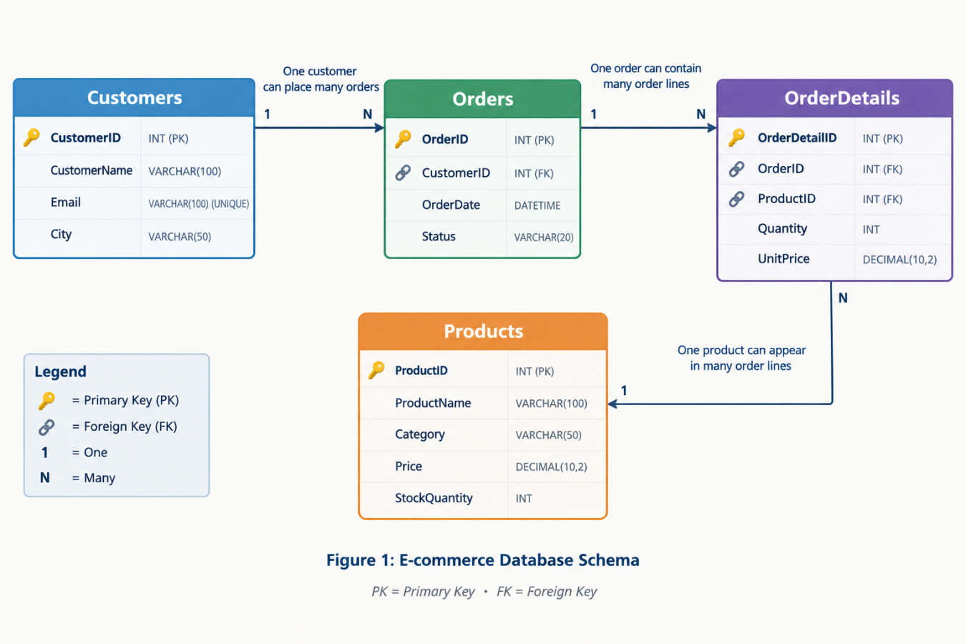
Figure 1: E-commerce Database Schema showing Customers, Orders, OrderDetails, and Products with primary keys, foreign keys, and one-to-many relationships.
Note: The diagram is illustrative. Your current SQL schema uses DATE for OrderDate, so ensure the final diagram matches your actual table definitions before submitting.

Schema Improvements and Data Integrity

Objective
In this step, I want to make sure that product prices and stock quantities are not negative.

Changes Made
I can use check constraints in the Products table to prevent invalid values.
alter table products
add constraint chk_product_price
check (price >= 0);

alter table products
add constraint chk_product_stock
check (stockquantity >= 0);

Benefits
These constraints help keep the data correct. For example, a product cannot have a price of -500 or a stock quantity of -10 when the constraints are enforced.

Testing
I will test the constraints by inserting or updating products with valid and invalid values. Negative values should be rejected if the constraints are enforced by MySQL.

Conclusion
Using check constraints is a simple way to improve data quality and maintain consistency in the database. Before applying them, I will check my MySQL version and make sure the existing data meets these conditions.

10. Research and References

Research Methodology
Official MySQL documentation was reviewed to understand SQL query optimization, execution plans, indexing strategies, and relational database constraints. These resources provide the technical foundation for analyzing the e-commerce database.

Key Findings
- Query optimization: SQL queries should be evaluated according to their purpose, execution plan, and data volume.
- Execution plans: The EXPLAIN statement helps identify access methods, index usage, and estimated rows examined.
- Indexing: Appropriate indexes can improve data retrieval, but unnecessary indexes increase storage requirements and the cost of data modifications.
- Data integrity: Primary keys, unique constraints, and foreign keys help maintain reliable relationships between tables.

