import pandas as pd
import numpy as np
import matplotlib.pyplot as plt
import seaborn as sns
print("Data Science Environment Ready!")
print("Pandas version:", pd.__version__)
print("NumPy version:", np.__version__)
Data Science Environment Ready!
Pandas version: 2.3.3
NumPy version: 2.3.5
data = {
"Product": ["Laptop", "Mouse", "Keyboard", "Monitor",
"Laptop", "Mouse", "Monitor", "Keyboard"],
"Category": ["Electronics", "Accessories", "Accessories",
"Electronics", "Electronics", "Accessories",
"Electronics", "Accessories"],
"Quantity": [2, 10, 5, 3, 1, 8, 2, 4],
"Price": [50000, 500, 1500, 12000, 50000, 500, 12000, 1500],
"Region": ["West", "North", "South", "West",
"North", "South", "East", "East"]
}
df = pd.DataFrame(data)
df["Sales"] = df["Quantity"] * df["Price"]
df.to_csv("retail_sales.csv", index=False)df.to_csv("retail_sales.csv", index=False)
df
df
Product Category Quantity Price Region Sales
0 Laptop Electronics 2 50000 West 100000
1 Mouse Accessories 10 500 North 5000
2 Keyboard Accessories 5 1500 South 7500
3 Monitor Electronics 3 12000 West 36000
4 Laptop Electronics 1 50000 North 50000
5 Mouse Accessories 8 500 South 4000
6 Monitor Electronics 2 12000 East 24000
7 Keyboard Accessories 4 1500 East 6000
print("First five rows:")
print(df.head())
print("\nDataset information:")
df.info()
print("\nDataset shape:")
print(df.shape)
First five rows:
Product Category Quantity Price Region Sales
0 Laptop Electronics 2 50000 West 100000
1 Mouse Accessories 10 500 North 5000
2 Keyboard Accessories 5 1500 South 7500
3 Monitor Electronics 3 12000 West 36000
4 Laptop Electronics 1 50000 North 50000
Dataset information:
<class 'pandas.core.frame.DataFrame'>
RangeIndex: 8 entries, 0 to 7
Data columns (total 6 columns):
# Column Non-Null Count Dtype
--- ------ -------------- -----
0 Product 8 non-null object
1 Category 8 non-null object
2 Quantity 8 non-null int64
3 Price 8 non-null int64
4 Region 8 non-null object
5 Sales 8 non-null int64
dtypes: int64(3), object(3)
memory usage: 516.0+ bytes
Dataset shape:
(8, 6)
print("\nColumn names:")
print(df.columns)
print("\nStatistical summary:")
print(df.describe())
Column names:
Index(['Product', 'Category', 'Quantity', 'Price', 'Region', 'Sales'], dtype='object')
Statistical summary:
Quantity Price Sales
count 8.000000 8.000000 8.000000
mean 4.375000 16000.000000 29062.500000
std 3.159453 21530.708966 33269.932264
min 1.000000 500.000000 4000.000000
25% 2.000000 1250.000000 5750.000000
50% 3.500000 6750.000000 15750.000000
75% 5.750000 21500.000000 39500.000000
max 10.000000 50000.000000 100000.000000
print("Missing values:")
print(df.isnull().sum())
print("Duplicate rows:")
print(df.duplicated().sum())
Missing values:
Product 0
Category 0
Quantity 0
Price 0
Region 0
Sales 0
dtype: int64
Duplicate rows:
0
clean_df = df.copy()
clean_df = clean_df.drop_duplicates()
clean_df["Product"] = clean_df["Product"].str.strip()
clean_df["Sales"] = clean_df["Quantity"] * clean_df["Price"]
print(clean_df)
Product Category Quantity Price Region Sales
0 Laptop Electronics 2 50000 West 100000
1 Mouse Accessories 10 500 North 5000
2 Keyboard Accessories 5 1500 South 7500
3 Monitor Electronics 3 12000 West 36000
4 Laptop Electronics 1 50000 North 50000
5 Mouse Accessories 8 500 South 4000
6 Monitor Electronics 2 12000 East 24000
7 Keyboard Accessories 4 1500 East 6000
# Select specific columns
print(clean_df[["Product", "Sales"]])
# Find sales greater than ₹10,000
print(clean_df[clean_df["Sales"] > 10000])
# Sort from highest to lowest sales
print(clean_df.sort_values("Sales", ascending=False))
# Select only electronics
print(clean_df[clean_df["Category"] == "Electronics"])
Product Sales
0 Laptop 100000
1 Mouse 5000
2 Keyboard 7500
3 Monitor 36000
4 Laptop 50000
5 Mouse 4000
6 Monitor 24000
7 Keyboard 6000
Product Category Quantity Price Region Sales
0 Laptop Electronics 2 50000 West 100000
3 Monitor Electronics 3 12000 West 36000
4 Laptop Electronics 1 50000 North 50000
6 Monitor Electronics 2 12000 East 24000
Product Category Quantity Price Region Sales
0 Laptop Electronics 2 50000 West 100000
4 Laptop Electronics 1 50000 North 50000
3 Monitor Electronics 3 12000 West 36000
6 Monitor Electronics 2 12000 East 24000
2 Keyboard Accessories 5 1500 South 7500
7 Keyboard Accessories 4 1500 East 6000
1 Mouse Accessories 10 500 North 5000
5 Mouse Accessories 8 500 South 4000
Product Category Quantity Price Region Sales
0 Laptop Electronics 2 50000 West 100000
3 Monitor Electronics 3 12000 West 36000
4 Laptop Electronics 1 50000 North 50000
6 Monitor Electronics 2 12000 East 24000

Exercise 5: Perform basic data analysis
total_sales = clean_df["Sales"].sum()
total_quantity = clean_df["Quantity"].sum()
average_sales = clean_df["Sales"].mean()
highest_sale = clean_df["Sales"].max()
print("Total Sales: ₹", total_sales)
print("Total Quantity Sold:", total_quantity)
print("Average Sales per Row: ₹", round(average_sales, 2))
print("Highest Sale: ₹", highest_sale)
Total Sales: ₹ 232500
Total Quantity Sold: 35
Average Sales per Row: ₹ 29062.5
Highest Sale: ₹ 100000
# Find sales by region:
region_sales = clean_df.groupby("Region")["Sales"].sum()
print(region_sales)
Region
East 30000
North 55000
South 11500
West 136000
Name: Sales, dtype: int64
# Find sales by category:
category_sales = clean_df.groupby("Category")["Sales"].sum()
print(category_sales)
Category
Accessories 22500
Electronics 210000
Name: Sales, dtype: int64

Bar chart — Sales by product
clean_df.plot(kind="bar")
plt.title("Sales by Product")
plt.xlabel("Product")
plt.ylabel("Sales (₹)")
plt.xticks(rotation=45)
plt.tight_layout()
plt.show()
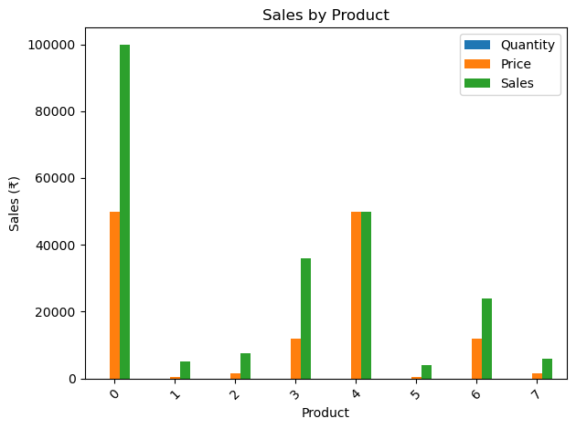
category_sales.plot(
kind="pie",
autopct="%1.1f%%"
)
plt.title("Sales by Category")
plt.ylabel("")
plt.show()
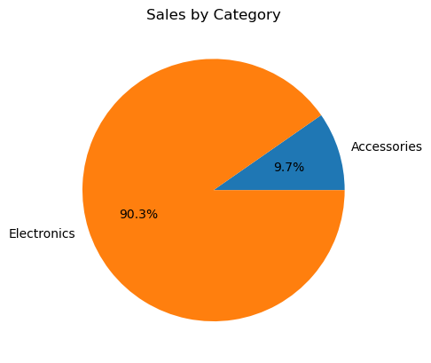

Correlation analysis
numeric_df = clean_df[
["Quantity", "Price", "Sales"]
]
correlation = numeric_df.corr()
sns.heatmap(
correlation,
annot=True,
cmap="coolwarm",
fmt=".2f"
)
plt.title("Correlation Between Numerical Variables")
plt.show()
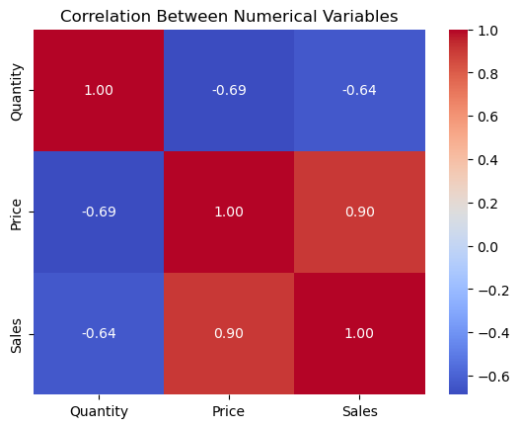

Save the cleaned dataset
clean_df.to_csv("cleaned_retail_sales.csv", index=False)
print("Cleaned dataset saved successfully!")
Cleaned dataset saved successfully!
check_df = pd.read_csv("cleaned_retail_sales.csv")
print(check_df.head())
print("Rows and columns:", check_df.shape)
Product Category Quantity Price Region Sales
0 Laptop Electronics 2 50000 West 100000
1 Mouse Accessories 10 500 North 5000
2 Keyboard Accessories 5 1500 South 7500
3 Monitor Electronics 3 12000 West 36000
4 Laptop Electronics 1 50000 North 50000
Rows and columns: (8, 6)

