**CAMPUS-MANAGED INTERNET ACCESS SYSTEM**

A Research Study Presented to

The faculty of the College of Information Technology of

Northern Mindanao Colleges, Inc.

City of Cabadbaran

In Partial Fulfillment

Of The Requirements For The Degree

BACHELOR OF SCIENCE IN INFORMATION TECHNOLOGY

By:

REGINAL CACO

FEBY KEIR MAGATAO

NINO MORIT

JAY CADIRAO

**CHAPTER I**

**INTRODUCTION**

**Situation Analysis**

Students, especially in college, need and use the Internet almost every day, whether for communication, entertainment & recreation, or education research and other related purposes. Though a stable and reliable Internet connection is getting more common nowadays, it comes with a monthly subscription fee or on a prepaid basis such as in mobile networks and devices. The need for students to have an internet connection in school is not a luxury anymore but important. In the event of upcoming quizzes, exams, projects, and other curricular requirements, students don’t always depend on their notes or library resources. Most of the time, they search on the Internet for additional references to their lessons, tutorial videos, e-books, pictures, and other digital supplements.

In the pre-pandemic NORMI, students can only access the Internet inside the Internet Lab which has a very limited number of computers – 12 to 15 units only for more or less 2,000 college students. Aside from the monthly subscription fee, the school administration has to shoulder the expenses for the maintenance of the laboratory as well as the monthly salary of the Lab Attendant – although the expenses are taken from the students’ Internet Lab Fees.

Now that the school is gearing up towards face-to-face classes, the classrooms and laboratories must still be utilized while observing social distancing, thus minimizing the number of students that can be accommodated inside the Internet laboratory at one time. Not all computers in the Internet Laboratory can be utilized. This means that the number of students who can access the laboratory is further minimized as compared to the pre-pandemic time.

**Purpose and Description of the Project**

The proposed system is entitled/named “This system is a stand-alone application that will allow the students to use high-speed and managed internet access. The main purpose of the project is to give all the students Internet access while they are in school but, this would be for limited hours or data only.

Students can connect easily by using their voucher code or username and password. In addition, students can only access their voucher code or username and password on just one device. Using multiple devices would require users (students) to secure another account subscription. Only the system administrator can make changes in the setting and configurations of the system.

A voucher code with equivalent specific hours or data of internet access is given to the students after they are officially enrolled. Students can now have the convenience of accessing the Internet for their research works and others in the classroom, quadrangle, library, corridors, and other areas of the campus they find comfortable. This voucher code would be charged to their account cards and it does not expire. The remaining unused hours for the current semester can still be used for the next semester.

**Project Framework**

**Input Throughput Output**

System generated voucher code.

User’s device will receive a notification “You are now logged in”.

Verifying voucher code validity.

­­

**Figure 1.0 Schematic Diagram showing the different variables of the Study**

**Conceptual Framework**

The managed Internet access system only requires users a valid voucher code to be logged in to the system portal. The system validates the voucher code and determines its remaining number of consumable hours or data. After the validation, the system notifies the user that his/her device has successfully logged in to the system and can now access the internet until the remaining consumable hours or data run out.

**Statement of Objectives**

Access to the Internet is fundamental to achieving this vision for the future. It can improve the quality of education in many ways. It opens doorways to a wealth of information, knowledge, and educational resources, increasing opportunities for learning in and beyond. For the past two years, the Education System in the Philippines has encountered different forms of transition or adjustment due to the pandemic that occurred and effect into the whole world. This situation has changed a lot in the forms of the Education System that’s why this research, as a student, helps us to identify the importance of Internet Administration for Students.

**Scope and Limitations**

**Scope**

Allow users (students) to access the managed internet connection within the campus premises through a web portal. Allow each user to use one device only with a corresponding voucher code. Additional device(s) should be provided each with its voucher code generated by the administrator. Voucher codes can be acquired by paying first the prescribed amount to the school cashier and then the official receipt should be presented to the system administrator. Voucher codes with remaining unused hours or data can still be used in the following semester either by the same or other users.

Each voucher code generated has its corresponding number of hours or data consumable and can be used all at once or on several occasions. One voucher code can also be used on other devices one at a time, not simultaneously. Internet access has a decent but limited bandwidth allocation for each device currently logged in into the system.

It also has a load-balancing feature so the bandwidth for each device should be similar to each other even during peak hours. Internet access is also filtered. Inappropriate sites that contain pornography, gambling, and violence are blocked. (This feature requires an update from time to time regarding the restricted sites that are still accessible by the users.) Users' personal information such as student name, student ID, and the receipt is logged in into the system every time he/she purchases a voucher code. The system can print out a voucher code.

**Limitations**

The system does not recognize the identity of the actual user of the voucher code. Voucher codes can either be given or borrowed as per permission or the prerogative of the user who acquired them. It does not also indicate the amount paid by the user at the cashier to acquire the voucher code. The system does not generate reports regarding the voucher codes being generated at the end of the semester together with the student name, student ID, and the receipt of the student.

**Significance of the Study**

The proposed system should be implemented with its significance and advantages to its stockholders and beneficiaries.

**School Administration** - The school administration can implement separate and managed Internet access for students with a return on investment. The students can, by no means, make any unauthorized access to the school’s local network through the Internet as they are on a separate physical network.

**Students** - Students can have a more reliable and stable internet connection with the campus premises as compared to the mobile data connection. The system administers and distributes at least two high-speed fiber Internet connections which are suitable for research, browsing, downloading educational resources, social media, and online LMS (Learning Management System) such as Google Classroom and Google Meet.

**Definition of Terms**

For clarification, some important terms used in the study have been defined.

**Access code/Voucher code** - refers to a random sequence of letters and numbers used to access the system through a portal.

**Local network** - a type of network composed of computers, smartphones, tablets, routers, and switches without Internet access.

**Web-based application** - refers to applications that can be accessed by a web browser.

**Wi-Fi (**Wireless Fidelity) - a term given to the type of radio signal that is used by wireless network devices such as modems, routers, and access points.

**CHAPTER II**

**REVIEW OF THE RELATED LITERATURE**

This chapter includes a review of related literature, conceptual framework/research paradigm, theoretical framework, research hypothesis, and definition of terms.

For the local context, in the Philippines, several studies showed some contrasting sentiments concerning internet connectivity and the use of gadgets or devices for online learning. In a study by Fabito et al., (2020) the group revealed that one of the three barriers and challenges that students encountered in online learning Was a good internet connection. Another related concept from Castellano (2019) indicated that only a minimum of the students have internet access thus impeding them to access the e-learning platform. In another study, poor students do not own laptops and desktop computers and have limited internet connections (Cleofas & Rocha, 2021).

However, in the findings of Jin and Sabio (2018), the use of mobile devices has the potential to be used and adapted for learning. Another study showed that the greater number of device types owned by a student, the greater the level of learning readiness (Estira, 2020). In addition, from another state university in the country, a study revealed the students' readiness for online classes however, the burden of computer and internet rentals in cafes exists (Yra et al., 2020).

In this regard, the objective of this study is to assess the internet connection capability and learning device availability of students for the possibility of an online or flexible type of learning. The result of the study will provide the school administration with a glimpse of how students and faculty will adjust their teaching-learning processes. At the same time, the result will also become a basis for institutionalizing a flexible learning approach for the time to come.

Another related matter in this study is the availability of learning tools or devices that is equally important. Although we are in an era where technological instruments and apparatuses are within reach, there are still some who do not have one. For example, in a particular country in South Asin, a study showed that respondents have at home and the university, computers, and internet facilities (Siddiquah and Salim, 2017). In another study, students possessed various types and brands of mobile phones especially smartphones (Essel et al., 2018). This is possible because the market of mobile phones became in demand and the prices are very competitive for consumers.

Some studies showed the dependency of students on smartphones, for online learning and internet access (Apuke & Ivendo, 2018; Muthuprasad et al., 2021).

But Gezgin (2017) indicated no significant difference in the duration of smartphone ownership and the occurrence of nomophobia in university students.

However, another study stated that mobile learning devices have a positive effect on students' perceived efficiency of working (Chase et al., 2018). But the most pressing issue here is the unwillingness of students towards the blended-online learning approach (Baloran, 2020).

Internet The internet is a globally connected network system that uses TCP/IP to transmit data via various types of media. The internet is a network of global exchanges – including private, public, business, academic, and government networks – connected by guided, wireless and fiber-optic technologies. The terms Internet and World Wide Web are often used interchangeably, but they are not the same thing; the internet refers to the global communication system, including hardware and infrastructure, while the web is one of the services communicated over the internet.

<https://www.techopedia.com/definition/2419/internet>

Preston Gralla, Que Publishing, 1998. Have you ever wanted to know how data travels from computer to computer, around the world? Have you ever wondered how websites can track users or how newsgroups work? How the Internet Works not only tells the reader how it works but shows them with easy-to-follow, four-color visual spreads tracking the path data flows and the hardware involved. Now entering its fourth year, How the Internet Works helps you understand the latest in Internet and networking technology from cookies and data tracking to web sound and video. Its intelligent visual approach demystifies the technology in a format that appeals to readers of all levels. Content includes explanations of digital certificates, extranets, Interact telephony, meta-searches, and scripting languages such as XML and dynamic HTML.

Janet Abbate, MIT Press, 2000. Janet Abbate recounts the key players and technologies that allowed the Internet to develop, but her main focus is always on the social and cultural factors that influenced the Internet's design and use. Since the late 1960s, the Internet has grown from a single experimental network serving a dozen sites in the United States to a network of networks linking millions of computers worldwide. In Inventing the Internet, Janet Abbate recounts the key players and technologies that allowed the Internet to develop; but her main focus is always on the social and cultural factors that influenced the Internet's design and use. The story she unfolds is an often twisting tale of collaboration and conflict among a remarkable variety of players, including government and military agencies, computer scientists in academia and industry, graduate students, telecommunications companies, standards organizations, and network users. The story starts with the early networking breakthroughs formulated in Cold War think tanks and realized in the Defense Department's creation of the ARPANET. It ends with the emergence of the Internet and its rapid and seemingly chaotic growth. Abbate looks at how academic and military influences and attitudes shaped both networks; how the usual lines between producer and user of technology were crossed with interesting and unique results; and how later users invented their own very successful applications, such as electronic mail and the World Wide Web. She concludes that such applications continue the trend of decentralized, user-driven development that has characterized the Internet's entire history and that the key to the Internet's success has been a commitment to flexibility and diversity, both in technical design and in organizational culture.

Norman H Nie, Lutz Erbring, IT & Society 1 (1), 275-283, 2002. The major questions of interest are shown in Appendix A and the frequency of responses is shown in Appendix B. Some 65 percent of American households have at least one computer (of that, 19 percent report a multicomputer household); 43 percent of American households are connected to the Internet.

Hendrik Schulze, Klaus Mochalski, Ipoque Report 37, 351-362, 2009. This study uses the same methodology as the 2007 Internet Study 1 to classify network traffic according to protocol and protocol class. Several of ipoque’s ISP and university customers agreed to provide anonymized traffic statistics collected by PRX Traffic Managers installed in their networks. Protocols and applications are detected with a combination of layer-7 deep packet inspection (DPI) and behavioral traffic analysis. All classified network flows are then accounted for per subscriber providing the raw data for this study. All comparisons and trend analyses, if not noted otherwise, refer to the 2007 study. It is important to note that the results are not statistically representative. The monitoring sites were picked based on accessibility and may not be typical for their region. For instance, we could have picked the only cable ISP in a country, where all other ISPs only offer DSL access.

Jurgen Schonwalder, Aiko Pras, J-P Martin-Flatin, IEEE Communications Magazine 41 (10), 90-97, 2003. As the Internet continues to grow, it becomes more and more apparent that existing Internet management technologies need to be improved, extended, or replaced to extend functionality and reduce development time and operational costs. Within the IETF, IRTF, and IAB, several new approaches are currently under discussion. Evolutionary approaches aim at improving currently used technologies, whereas revolutionary approaches try to replace existing management-specific technologies with standard distributed systems technologies. This article surveys the research and development work underway to develop future Internet management technologies.

Shengwei Wang, Junlong Xie, Automation in Construction 11 (6), 707-715, 2002. Recently, it is of great interest to adopt the Internet/Intranet to develop Building Management Systems (BMS) and Facilities Management Systems (FMS). This paper addresses two technical issues: Web-based access (including database integration) and the integration of BMS and FMS. These should be addressed for accessing BMS remotely via the Internet, integrating control networks using the Internet protocols and infrastructures, and using the Internet/Intranet for building facilities management.

An experimental Internet-enabled system that integrates Building and Facilities Management Systems has been developed and tested. This system integrated open control networks with the Internet and is developed utilizing the embedded Web server, the PC Web server, and the Distributed Component Object Model (DCOM) software development technology on the platform of an open control network. Three strategies for interconnecting BMS local networks via the Internet/Intranet are presented and analyzed.

Allan Leinwand, Karen Fang, Addison-Wesley Longman Publishing Co., Inc., 1993. Aimed at network engineers, this book introduces them to the ISOOSI categories of network management: fault management, configuration management, performance management, security management, and accounting management. The approach is to advance concepts of simple, complex, and more complex (called “advanced” by the authors)“tools”(meaning programs) that fulfill some or all of the needs in a particular ISOOSI network management area. A small warning is given in the introduction that “some of these tools might not exist today” More on this later. The book consists of nine chapters: Overview of Network Management Fault Management Configuration Management Security Management Performance Management Accounting Management Network Management Protocols A Look at RFC [Request for Comments] 1213 Productivity Tools. Two appendices, “Obtaining RFCs” and “Obtaining Technical Standards,” complete the book. It has a decent index, a glossary of terms and acronyms, and references to literature (mostly RFCs) for each chapter. Each chapter begins by defining its major topic. Generally, this definition is followed by examples of the kinds of problems the network management technique is supposed to solve. Next, the authors discuss the tools that can be used in dealing with the problem. The discussions are generally clear and well-illustrated with diagrams and examples. In general, this book says, “it could happen this way,” but lacks discussion of any tools that a network engineer or manager can buy or borrow. The tools discussed are programs that could be written as the authors describe, not anything real or tangible that one could obtain from a friendly UNIX or C shop. In this regard, the book is misleading. It is a collection of designs that could be realized as described—but do not look for product information. An extensive section on the simple network management protocol (SNMP) management information base (MIB) outlines its content and what one might do with the MIB data. That the section describes an RFC rather than an accepted standard leaves one wondering where the word “practical” in the title comes from. The book would be better described as ideas for inclusion in network tools the reader might be called upon to design. The pluses of the book are its clarity and the generally informative illustrations as well as careful use of standards and almost standards where they exist. The negative aspect is that the authors talk of “tools” as though they were products when at best they are suggestions for handling one or more network management problems. On balance, the book could be useful for a new entrant into the world of network management, and I recommend it for that purpose.

Kwang-Hui Lee, 1994 IEEE GLOBECOM. Communications: The Global Bridge, 548-552, 1994. This paper presents a distributed network management system that provides a means to manage communication networks for distributed systems. For efficient network management, the multi-level domain approach has been used. Management function (Configuration, Fault, Performance management) is distributed in each management domain. The management system was composed of several elements. Some of those were previously implemented in the project of the single-level multi-domain network management system. The integration of different networks which have different network management schemes can also be achieved with the distributed network management system. The object-oriented distributed database was chosen for the management information base (MIB). We finished the design of the system and are in the middle of its implementation in the environment of distributed campus network (CNUNet).

The internet is being created to serve as a platform for a variety of activities for people of all ages in society (Akin Adaemola, 2014). Internet connectivity has greatly increased over the previous few decades and is now available everywhere, including homes, workplaces, travel, and schools (Ellore, 2014). Today, actual research (Akende, 2015) shows that students' academic performance may be influenced by access to information.

The internet is nearly ubiquitous; most students have internet access on their cell phones (Ellore, 2014). This allows students to widen their academic information, research, and assignments by gaining access to material from across the world, and it also facilitates simple collaboration with the academic community (Siraj, 2015).

According to recent data, the internet allows users to access information sites as well as other sites such as social media sites, internet games, and many more (Siraj, 2015). According to research conducted by (Ellore, 2014) on the impact of internet use on academic performance and face-to-face contact, most students have access to the internet on their smartphones as a result of the availability of the internet. This allows students to enhance their academic knowledge (Siraj, 2015). According to (Bamise, 2017), computer use and access to internet resources are significantly crucial to students. Yesilyurt et al. (2014) showed that having a home computer and an internet connection improves students' academic performance as well as their self-learning abilities. According to Siraj et al. (2015), students regard the internet as a complement to learning, which correlates to greater academic achievement.

Ruth and Adedotun (2015) proposed in a similar study that the source and availability of information might impact college students' academic performance.

Chatting was found to be the most popular activity among secondary school students, followed by downloading, watching videos online, surfing the web, using the internet to study for school work, looking for other websites such as sports websites, reading news online, games websites, and finally online shopping.

According to research, the usage of the internet has a favorable influence depending on the type and how it is utilized (Torres-Diaz et al., 2016). According to Kakkar (2014), internet use may be advantageous 9 to students in their academic settings and may not create possible harm to their mental health if utilized moderately. Because the internet has become such a vital aspect of modern life, Singh et al. (2013) concluded that it should be utilized as a tool for communication and information acquisition rather than as a habit-forming addiction. Colleges and colleges are asked to educate students about the potentially harmful effects of a high percentage of recreational internet use on academic progress (Bragdon and Dowler, 2016).

Torres-Diaz et al., 2016) also agreed that internet use improves academic performance. They believe that students who utilize the internet for instructional materials are less likely to fail their exams. As a result, the disadvantages of not having access to the internet outweigh the benefits. People who engage in interactive activities with classmates and professors, or who use a variety of online resources for coursework, tend to perform better academically (Torres-Diaz et al., 2016).

Furthermore, students must be taught how to use computer resources to get the reliable material for their academic work (Mami and Hatami-Zad, 2014; Aitokhuehi et al., 2014).

Akande, S. O. and Bamise, O. F. (2017). The Role of School Library in Academic Motivation of Secondary School Students in Osun State, Nigeria. International Journal of Library Science. Scientific & Academic Publishing. Vol. 6(1): pp. 18-27.DOI: 10.5923/j.library.20170601.03. http://journal.sapub.org/library.

Akin-Adaramola, O. S. (2014). Ashesi University College the Internet Usage among Secondary School Students: A Case Study on Labone Secondary School. Ashesi University College.

Bragdon, R. A. and Dowler, K. (2016). College Student Technology Use and Academic

Performance. Center for Promoting Ideas, USA, International Journal of Humanities and Social Science. Vol. 6(1), pp. 12-22, ISSN 2220-8488 (Print), 2221-0989 (Online),

[www.ijhssnet.com](http://www.ijhssnet.com)

Ellore, S. B. 2014. The influence of internet usage on academic performance and face-to-face communication. Journal of psychology and behavioral science. 2(2): 163-186.

Kakkar, N. Ahuja, J. and Dahiya, P. (2014). Influence of Internet Addiction on the Academic Performance and Mental Health of College Students. An international peer reviews and referred. Scholarly research journal for interdisciplinary studies. Vol-3/21.

Mami, S. and Hatami-Zad, A. (2014). Investigating the effect of Internet Addiction on Social Skills and in High School Students' Achievement. International J. Soc. Sci. & Education. Vol.4 (Special Issue), pp; 56-61. ISSN: 2223-4934 E and 2227-393X Print.

Rabiu, H., Muhammed, A. I, Umaru, Y. and Ahmed, H. T. (2016). Impact Of Mobile Phone

Usage Of Academic Performance Among Secondary School Students In Taraba State,

Nigeria. European Scientific Journal. Vol.12(1); ISSN: 1857 – 7881 (Print) e - ISSN

1857- 7431. doi: 10.19044/esj.2016.v12n1p466

<URL:http://dx.doi.org/10.19044/esj.2016.v12n1p466>

Ruth A. A. and Adedotun, A. (2015). Perceived Influence of Information Sources Availability and Use on the Academic Performance of Secondary School Students in a Nigerian Metropolitan City. American Journal of Educational Research, Vol. 3(11), pp; 1346-1349. <http://pubs.sciepub.com/education/3/11/2>. Science and Education Publishing. DOI:10.12691/education-3-11-2.

Siraj, H. H., Salam, A., Hasan, N. A., Jin, T. H., Roslan, R. B. and Othman, M. N. B. (2015).Internet Usage and Academic Performance: A Study in a Malaysian Public University.Japan Health Sciences University & Japan International Cultural Exchange Foundation.30 International Medical Journal. Vol. 22(2), pp. 83 – 86. <https://www.researchgate.net/publication/275833912>

Torres-Díaz, J., Duart, J. M., Gómez-Alvarado, H. F., Marín-Gutiérrez, I. and Segarra-Faggioni, V. (2016). Internet Use and Academic Success in University Students. Media Education Research Journal | pp. 61-70 ISSN: 1134-3478; e-ISSN: 1988-3293.www.comunicarjournal.com. DOI <http://dx.doi.org/10.3916/C48-2016-06>.

Yesilyurt, E., Basturk, R., Yesilyurt and Kara, I. (2014). The Effect of Technological Devices on Student’s Academic Success: Evidence from Denizli. Journal of Internet and Application Management. Vol. 5(1), pp; 39-47.

**CHAPTER III**

**METHODOLOGY**

**Requirements Analysis**

The Campus-Managed Internet Access System refers to a network setup where the Internet service and access are controlled by the Administrator. The purpose of this system is to provide secure and controlled access to the Internet for students.

This system can include features such as:

**User authentication** - ensures that only authorized users can access the network.

**Bandwidth management** - to ensure fair usage of resources.

**Content filtering** - blocks access to inappropriate websites or restricts access to certain sites.

**Monitoring and logging** - to track usage and identify potential security issues.

The benefits of a campus-managed Internet access system include improved security, controlled access to the Internet, and increased efficiency for IT support. However, it also requires a significant investment in hardware, software, and personnel.

**Stakeholder’s Identification**

The stakeholders in a campus-managed internet access system are students. They are the primary users of the system and rely on it for academic and personal use.

The administrator will be the one who will register the student for their voucher code to connect to the internet. Additionally, the administrator will be authorized to access the system and manage it.

The system developers will be the ones who will fix if the system has errors, bugs, and glitches the system.

**Requirement Lists**

**Strengths and Weaknesses**

This shows what is the Strength and Weaknesses of the system of our study and what will be the possible solutions of the study.

**Strengths**

**Secure access** - The system provides secure and controlled access to the Internet for authorized users.

**Efficient resource utilization** - The system ensures fair usage of resources by managing bandwidth and prioritizing traffic.

**Content filtering** - The system blocks access to inappropriate websites or restricts access to certain sites, ensuring a safe and appropriate online environment for users.

**User authentication** - The system requires user authentication, ensuring that only authorized users can access the network.

**Monitoring and logging** - The system tracks usage and logs activities.

**Centralized management** - The system provides a centralized point of control, making it easier for the administrator to manage and maintain the network.

**Weaknesses**

**High cost** - The system requires a significant investment in hardware, software, and personnel, making it a costly solution.

**Content Restrictions** - The content filtering and restriction features of the system can limit access to certain websites or information, potentially impacting academic and research activities.

**Maintenance and support** - The system requires ongoing maintenance and support to ensure its proper functioning and security.

Overall, while a Campus-Managed Internet Access System provides many benefits, it also has its limitations and weaknesses that must be carefully considered and addressed.

**Measurable Goals**

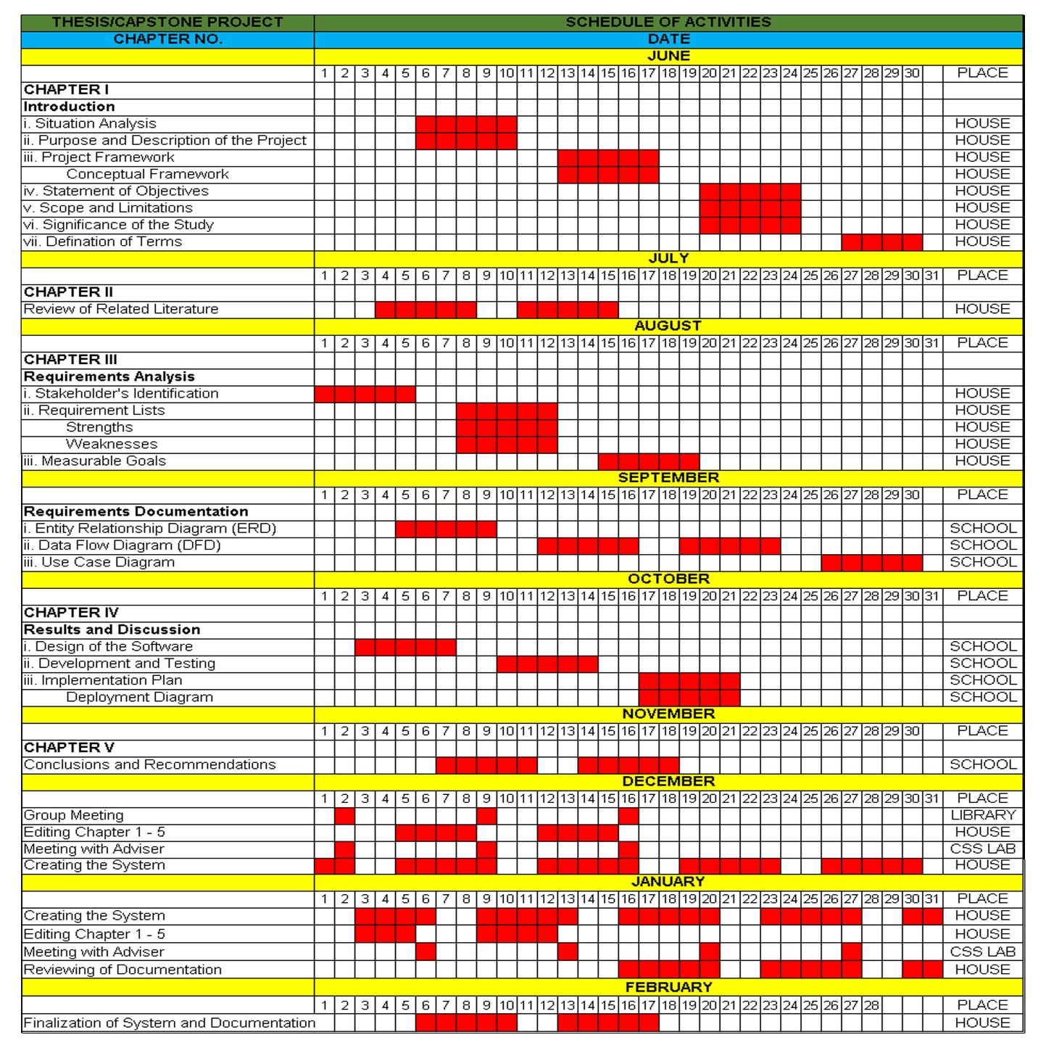

**Figure 2.0 Gantt Chart**

A Gantt Chart is a presentation of the project management to visually represent the project schedule over time. This Gantt Chart shows the start and finish dates of different required elements of a project.

**Entity Relationship Diagram**

User

user_id

server_id

voucher_id

name

uptime

action

pk

fk

fk

Admin

server_id

user_id

voucher_id

profile_id

device_id

name

interface

address_pool

profile

pk

fk

fk

fk

fk

fk

admin_id

device_id

server_id

user_id

voucher_id

profile_id

pk

fk

fk

fk

fk

Server

Voucher

pk

fk

fk

voucher_id

server_id

profile_id

name

password

voucher_type

code_length

voucher_count

limit_uptime

limit_bytes_total

pk

fk

fk

fk

fk

fk

device_id

server_id

user_id

voucher_id

profile_id

admin_id

uuid

name

password

host

port

action

Device

Profile

pk

fk

fk

profile_id

server_id

voucher_id

profile_name

share_user

keepalive_timeout

status_auto_refresh

rate_limit

**Data Flow Diagram**

**Contextual Diagram**

Login

Login

0

Campus-Managed Internet Access System

Student

Admin

Admin Login Form

User Login Form

**Figure 4.0 Contextual Diagram DFD for Campus-Managed Internet Access System**

The contextual data flow diagram shows the general process of the system. There are two entities in this system, namely: admin and student. Admin can be logged in to the system and the system shows the login interface the same as the student.

System

1.1

Voucher Code/Username and Password

Voucher Code/Username and Password

Validation

Student name, ID and Receipt

Student name, ID and Receipt

Student

Admin

System

1.2

Internet Management Services

Student name, ID and Receipt

Generated Voucher Code/Username and Password

**Figure 5.0 Level 0 DFD**

Level 0 DFD of the Campus-Managed Internet Access System shows the detailed sub-process which is “Validation”. The student shows their student name, student ID, and receipt. The admin will input the information into the system to generate a voucher code, then the generated voucher code will send to the student.

Voucher Code/Username and Password Login

Voucher Code/Username and Password

System

1.3

Internet Service Login

db_records

D1

Student

Internet Access

System

1.4

Grant Internet Access

System

Internet Usage Report

1.5

Admin

Internet Usage and Internet Traffic

**Figure 6.0 Level 1 DFD**

Level 1 DFD of the Campus-Managed Internet Access System shows the detailed sub-process which is “Student Login”. The student will input their voucher code/username and password to the system and it will be restored into the database. The student will have access to the internet and the admin will be got the internet usage and traffic report.





Admin

User

**Figure 7.0 Use Case Diagram**

A use case diagram shows the flow of activities by accessing the system with the User and the System Administrator.

**CHAPTER IV**

**RESULTS AND DISCUSSION**

This chapter tackles the result and discussion of the project, which contains the following: Description of the project, Design of the software, Development and testing, and Implementation plan.

Our system entitled “Campus-Managed Internet Access System” is the main purpose of our project is to give internet access to all the college students of Northern Mindanao Colleges Inc., while they are on campus but this internet access is limited only.

This system is a stand-alone application that will allow the student to use high-speed and managed internet.

There are several key components to a Campus-Managed Internet Access System:

**Network infrastructure** - This includes routers, switches, firewalls, and other networking equipment that provide physical connectivity to the Internet.

**Access control** - This component is responsible for authenticating users and controlling their access to the Internet based on policies set by the system.

**Content filtering** - This component is used to block access to malicious websites or content.

**Usage monitoring** - This component tracks usage patterns on how much data is used by every user.

**Requirement of the Project**

**Hardware Specifications**

* Mikrotik hEX
* Switch Hub
* Router
* UTP Cable
* RJ 45
* Laptop/Desktop
* Printer

**Software Specifications**

* Front End - ReactJS
* Back End - Laravel

**Design of the Software**

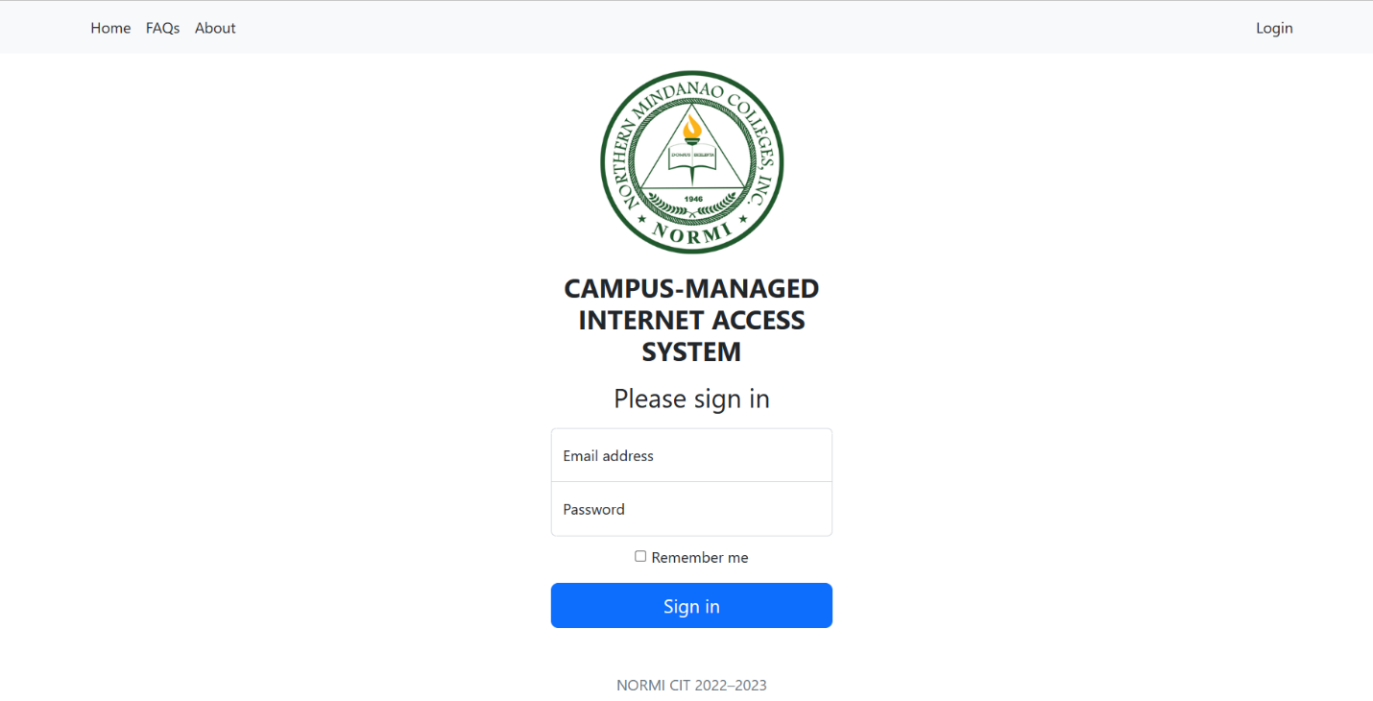

**Figure 8.0 Admin Login Form**

This is the login form where only the administrator can gain access to the system by typing their unique email address and password.

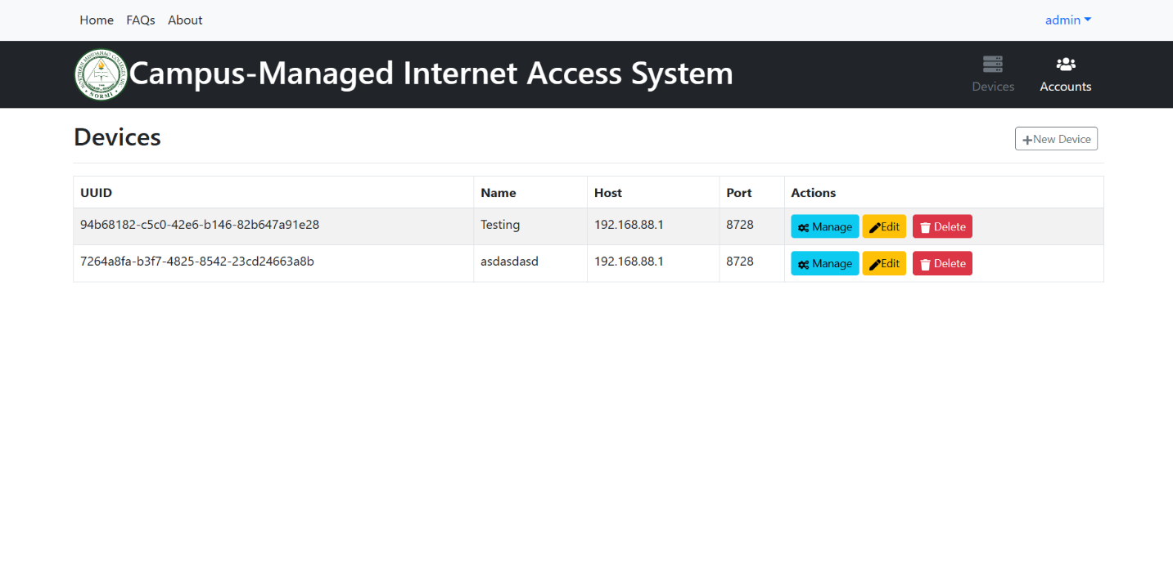

**Figure 9.0 Devices**

This is the figure where the administrator can add a device and then connect it to the device that uses via IP address.

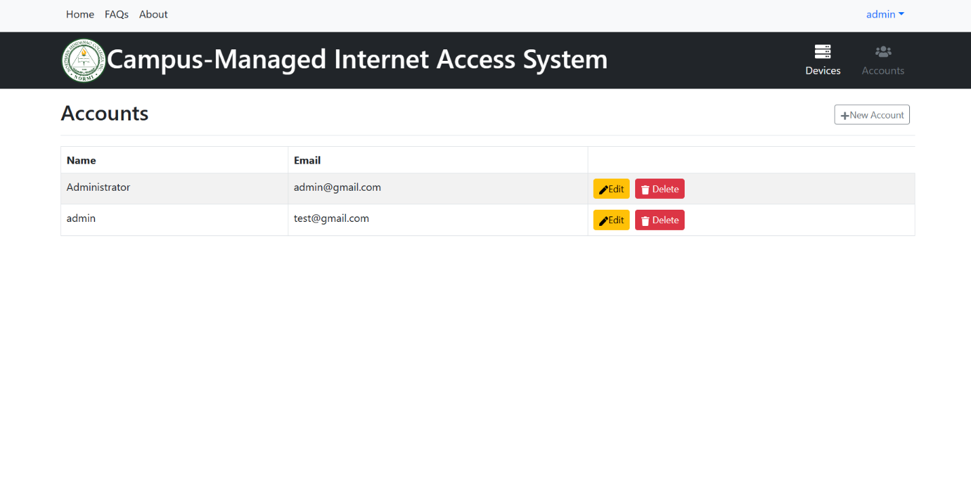

**Figure 10.0 Accounts**

This is the figure where the administrator can add an account to login into the system.

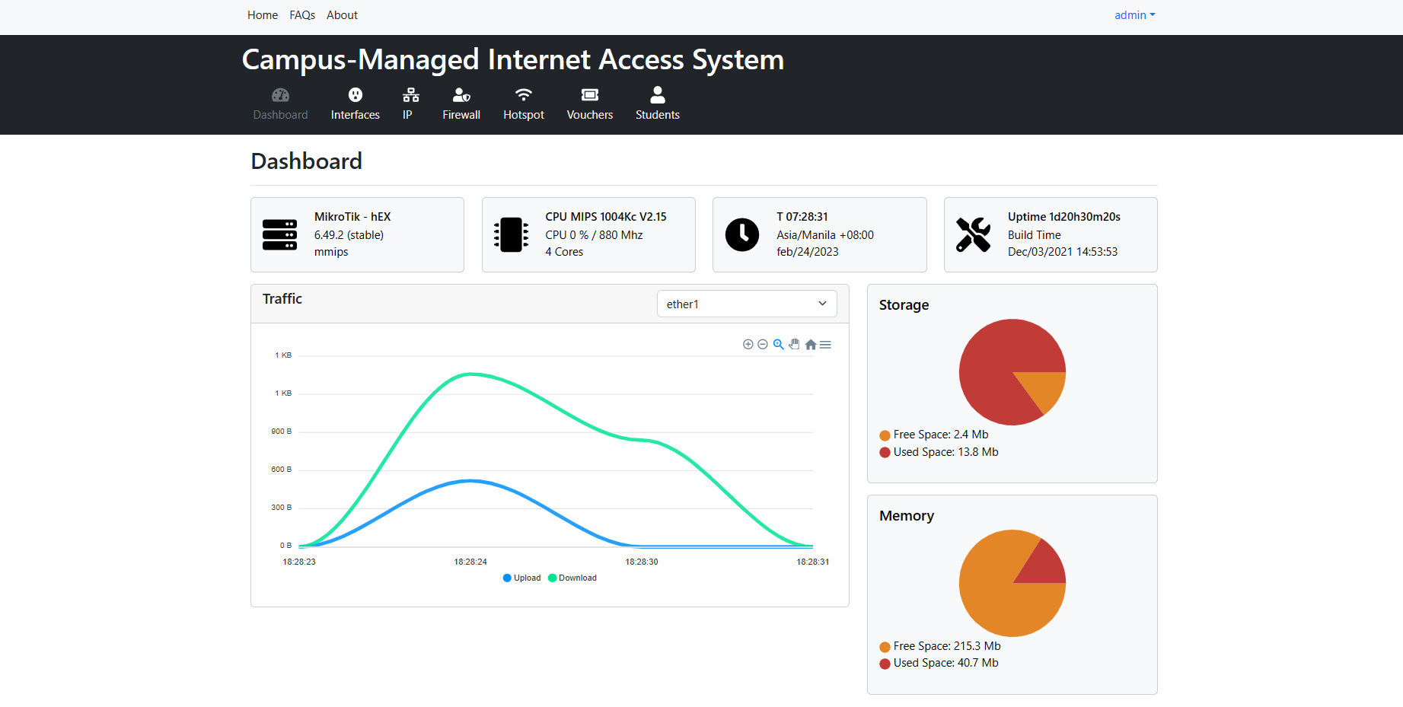

**Figure 11.0 Dashboard**

This is the figure where the administrator can see the storage, memory, and internet traffic of the device.

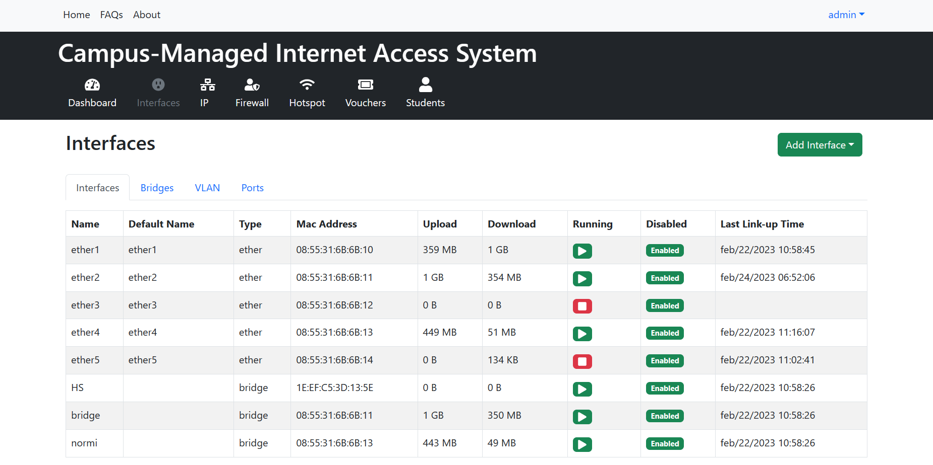

**Figure 12.0 Interfaces**

This is the figure where the administrator can add bridges and assign ports to the device to expand the network.

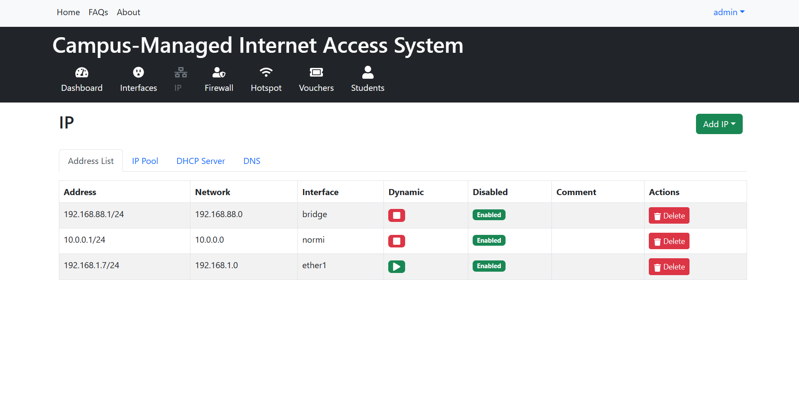

**Figure 13.0 IP**

This is the figure where the administrator can add IP ranges of the network and IP addresses.

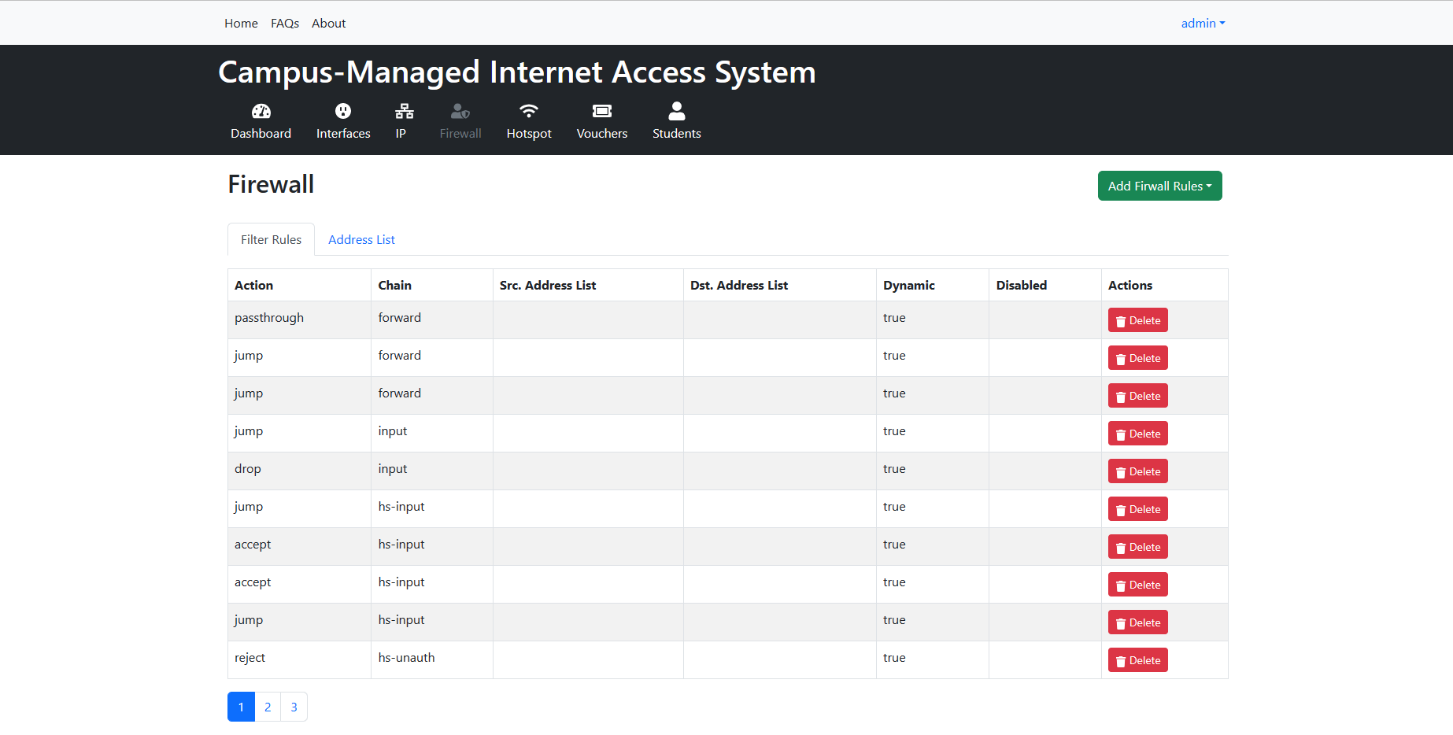

**Figure 14.0 Firewall**

This is the figure where the administrator can filter an inappropriate website.

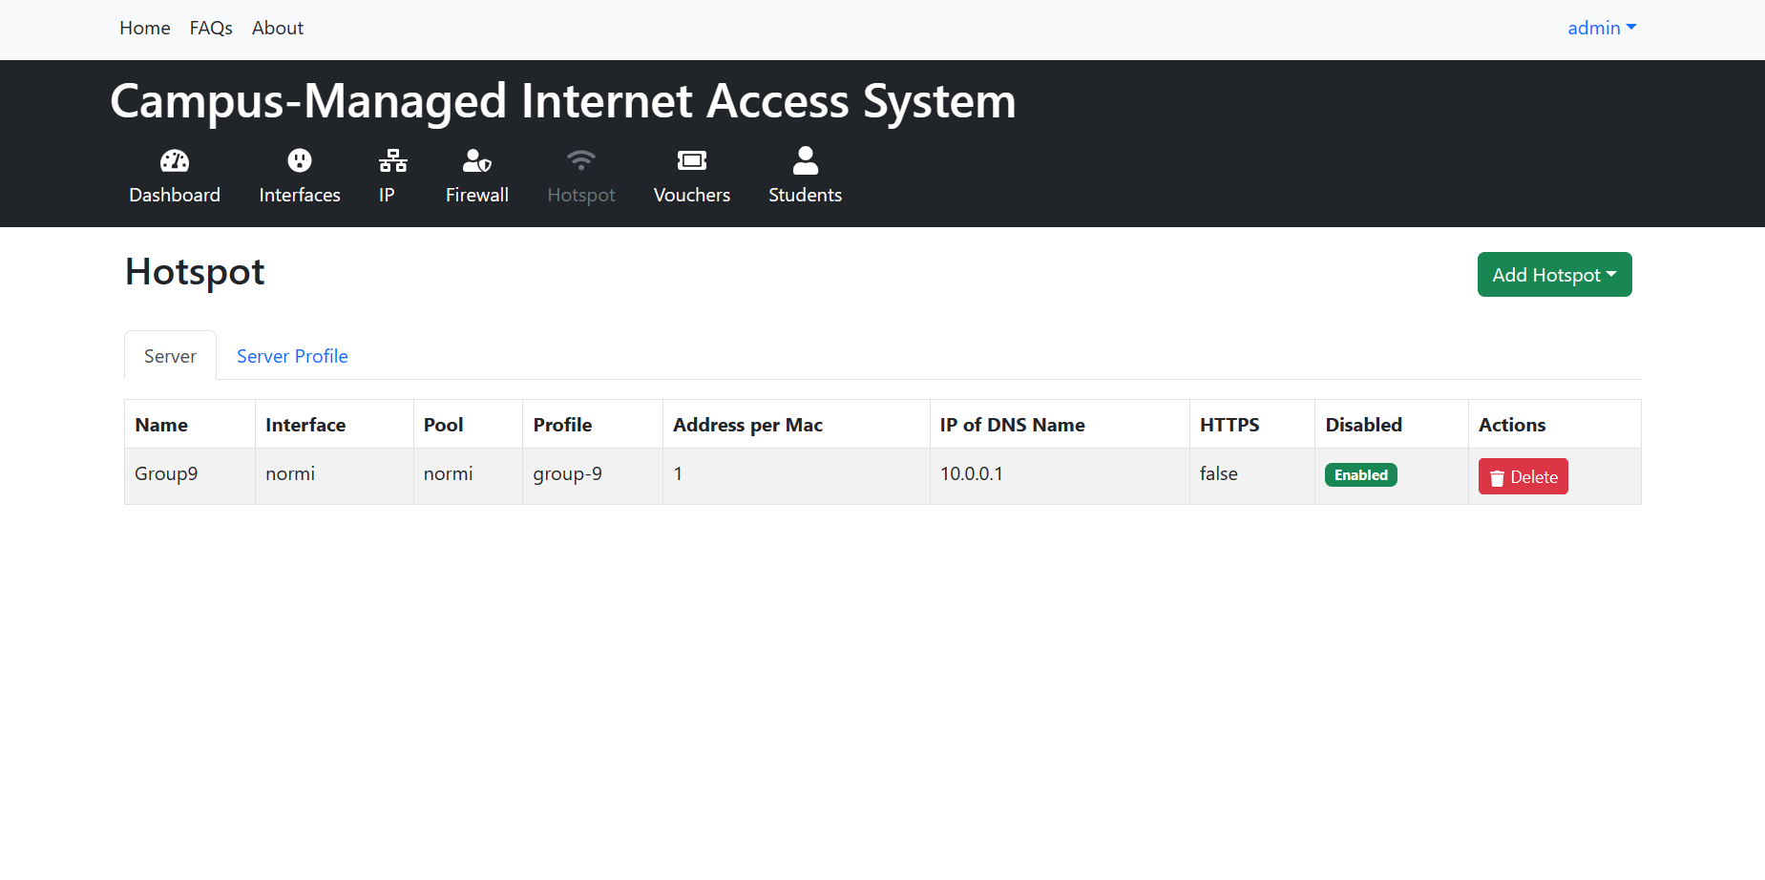

**Figure 15.0 Hotspot**

This is the figure where the administrator can add a hotspot for the network.

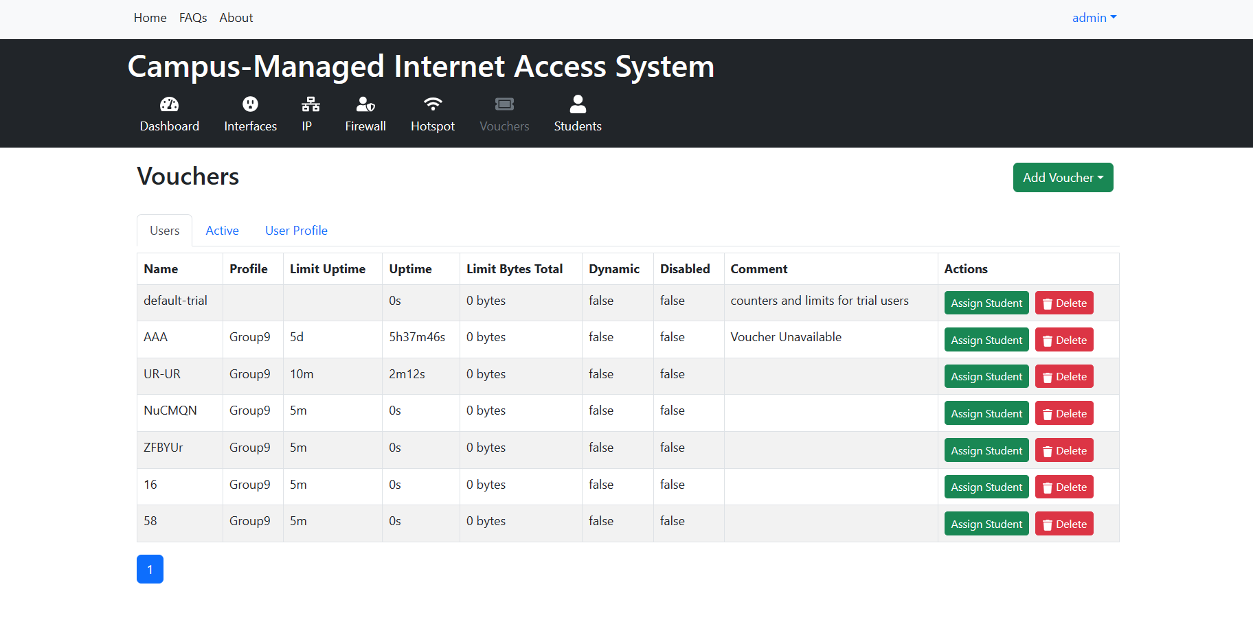

**Figure 16.0 Vouchers**

This is the figure where the administrator can generate a voucher code and see the active users.

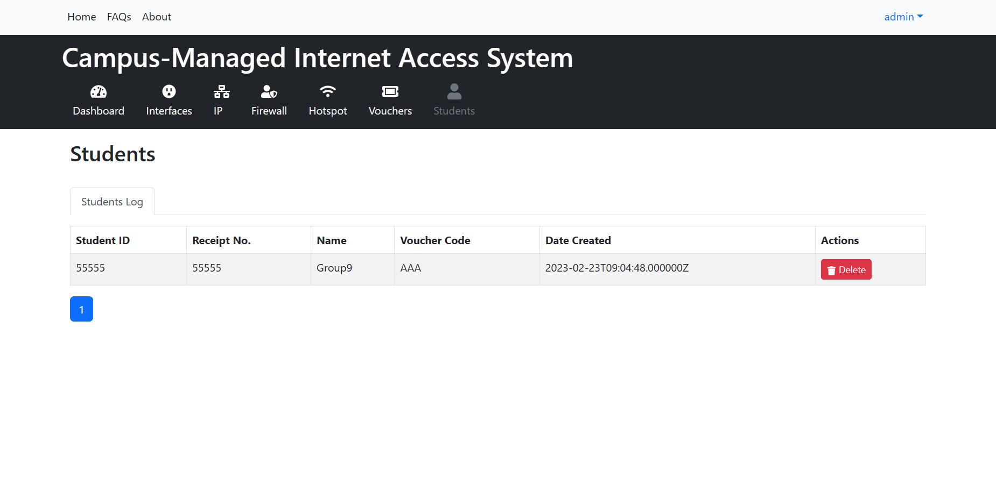

**Figure 17.0 Students**

This is the figure where the administrator can see the list of vouchers that are assigned to each user.

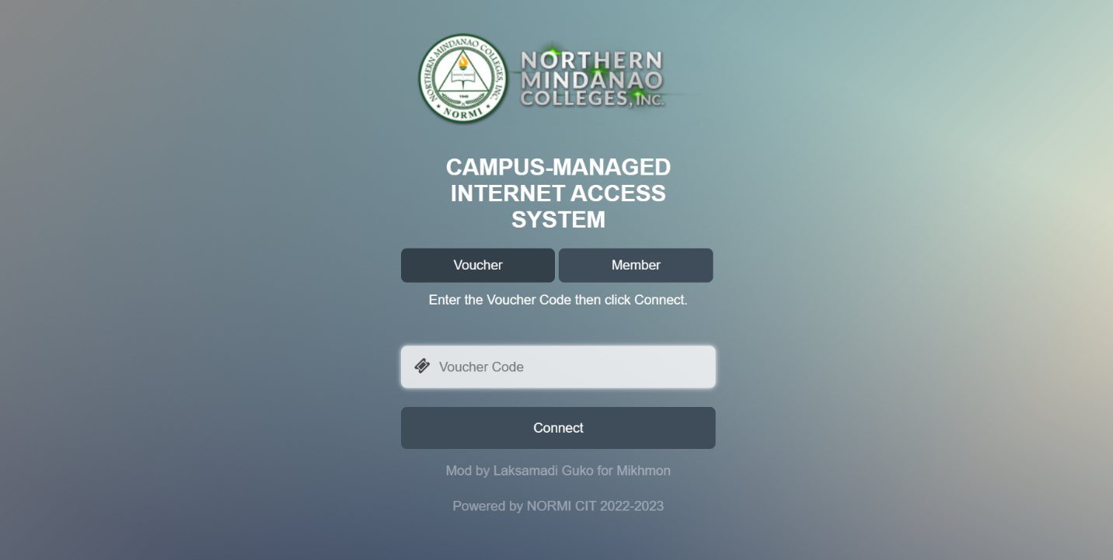

**Figure 18.0 User Login Form**

This is the login form where only the users can gain access to the internet by typing their voucher code or unique username and password.

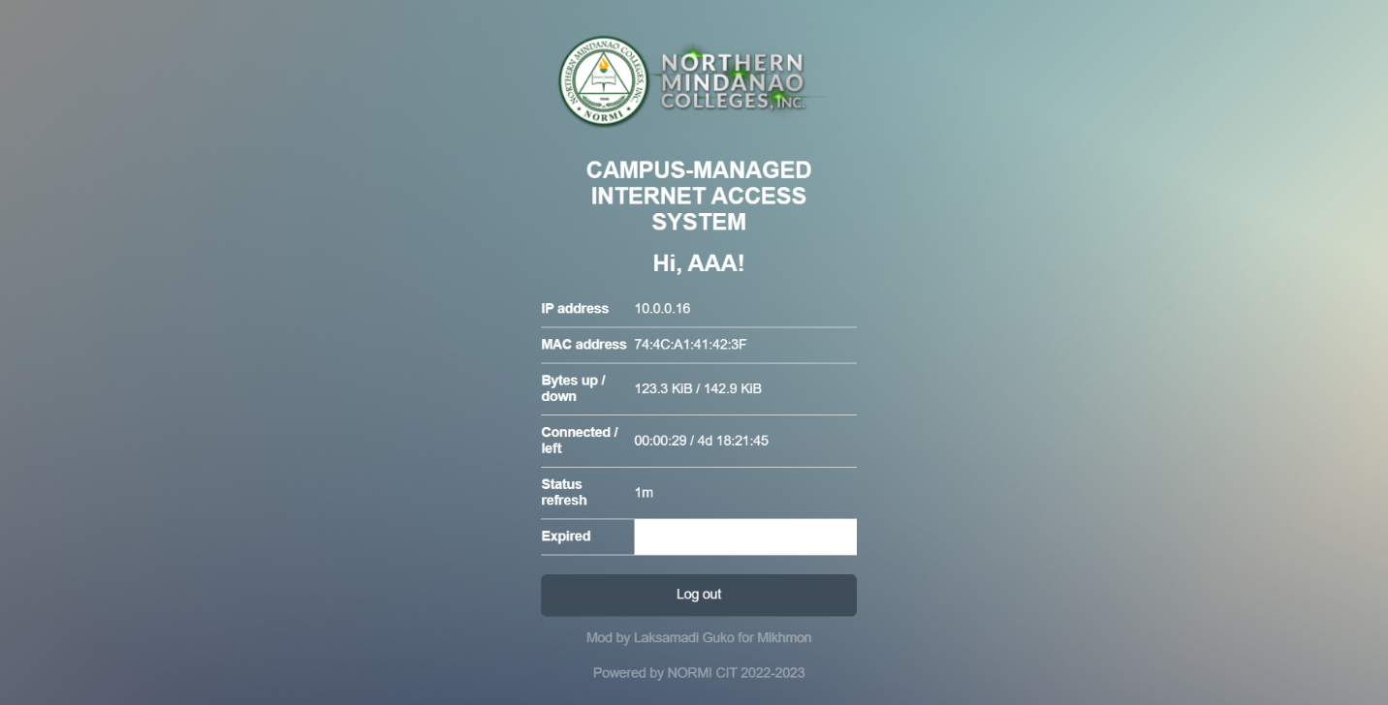

**Figure 19.0 User Logout Form**

This is the form where only the users can see their status and logged out their voucher code.

**Development and Testing**

During our initial Trial and Error Testing, Our system entitled "Campus-Managed Internet Access System" both had advantages and disadvantages during the system operation.

**Advantages**

* The administrator has easy to access the system within less than 10 seconds by typing in their unique email address and password.
* The students have easy to access the internet within less than 10 seconds by typing in their voucher code or unique username and password.
* The system did not experience any lag or technical issues from the data input for the student validation.
* The system featured a user-friendly interface that made it easy and convenient to login into the internet by typing in their voucher code or unique username and password.
* The system has easy to generate a voucher code for Internet users and it is easy to expand the network.

**Disadvantage**

* The system is dependent on the speed of the Internet source. It means if the Internet source is poor the Internet of the system will be poor too or logged. If the Internet source is stable the internet of the system is faster and more stable.

**Implementation Plan**



LIBRARY

QUADRANGLE

FRONT LOBBY

ADMINISTRATOR

ENTRANCE







**CHAPTER V**

**RECOMMENDATION, CONCLUSION, AND SUMMARY**

**Recommendations**

The researchers would like to recommend the Campus-Managed Internet Access System to give Internet access to the students of Northern Mindanao Colleges Inc.

To the School Administration, the system serves as Internet management for the students of Northern Mindanao Colleges Inc. Additionally, the Campus-Managed Internet Access System can give profit to the school.

To the Student of Northern Mindanao Colleges Inc., the system will become their assistance and will become a perfect tool to use especially for research or educational purposes. The system will also make their work convenient and fewer errors.

The system delivers both safety and reliability in data input and output. That is why it is a perfect tool to use for the school administration for Internet management.

**Conclusion**

The Campus-Managed Internet Access System can provide several benefits for educational purposes. It allows for greater control and security over network access and ensures that only authorized users can connect to the network and access resources. It can also help to prevent unauthorized access to sensitive data.

Moreover, the Campus-Managed Internet Access System can provide more reliable and consistent Internet access for students. This can be particularly important in today's digital age, where Internet connectivity is critical for learning and educational research.

**Summary**

The Campus-Managed Internet Access System is a network infrastructure that provides controlled and secure access to the Internet for students of Northern Mindanao Colleges Inc. The system can offer several benefits, such as better control and security over network access, protection against inappropriate sites, and reliable and consistent Internet connectivity.

Implementing a Campus-Managed Internet Access System can ensure that only authorized users can access the network and its resources and prevent unauthorized access. Additionally, the system can provide better Internet connectivity, which is critical for learning and research in today's digital age.

However, it is important to ensure that the system is designed and implemented correctly to achieve the desired results and minimize potential issues. Overall, the Campus-Managed Internet Access System can be a wise investment for a school looking to improve network security and reliability.