Instytut Sterowania i Systemów Informatycznych
Uniwersytet Zielonogórski
Integracja systemów
Laboratorium 9
Prowadzący: Marek Kowal
(M.Kowal@issi.uz.zgora.pl)

Handling Bad Data with the Fuzzy Lookup
More often than not, when you are working in the real world, data is not going to be perfect like it is in the AdventureWorks2014 database. Real-world situations call for cleansing dirty data or data that has abnormalities like misspellings or truncation.
Imagine you are attempting to retrieve a foreign key from a dimension table, but, strangely, you find rows without a match. Upon investigation, you find bad data is being supplied to you. One technique might be to divert these rows without matches to a table to be dealt with later; another might be to just add the bad data regardless of misspellings and other mishaps that occur during data entry.

The Fuzzy Lookup Transform, and the Fuzzy Grouping Transform gives other alternatives to dealing with dirty data while reducing your number of unmatched rows. The Fuzzy Lookup Transform matches input records with data that has already been cleansed in a reference table. It returns the match and can also indicate the quality of the match. This way you know the likelihood of the match being correct.

NOTE: A best practice tip is to use the Fuzzy Lookup Transform only after trying a regular lookup on the field first. The Fuzzy Lookup Transform is a very expensive operation that builds specialized indexes of the input stream and the reference data for comparison purposes. Therefore, it is recommended to first use a regular Lookup Transform and then divert only those rows not matching to the Fuzzy Lookup Transform.
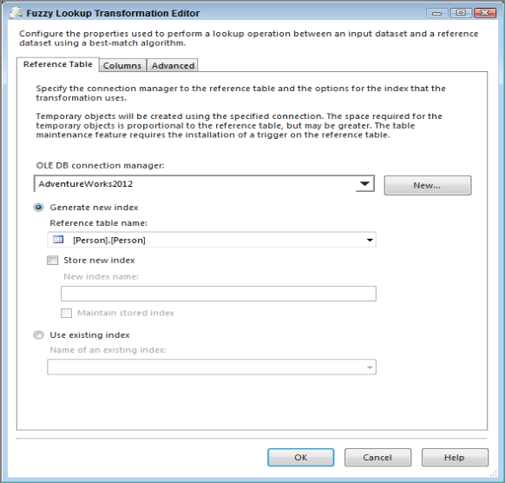
Fig. 1
Using the Fuzzy Lookup Transform requires at least one field to be a string, either a DT_WSTR or DT_STR data type. On the Columns tab in the editor, you need to map at least one text field from the input to the reference table for comparison.

The Advanced tab contains the settings that control the fuzzy logic algorithms. You can set the maximum number of matches to output per incoming row. The default is set to 1, which pulls only the best record out of the reference table that meets the similarity threshold. Incrementing this setting higher than the default might generate more results that you’ll have to sift through, but it might be required if you have too many closely matching strings in your data. A slider controls the similarity threshold. When you are experimenting, a good strategy is to start this setting at 0.5 and move up or down as you review the results. This setting is normally decided based on a businessperson’s review of the data, not the developer’s review. If a row cannot be found that’s similar enough, the columns that you checked in the Columns tab will be set to NULL. The token delimiters can also be set if, for example, you don’t want the comparison process to break up incoming strings with a period (.) or spaces. The default for this setting is all common delimiters. See Fig. 2 for an example of an Advanced tab.

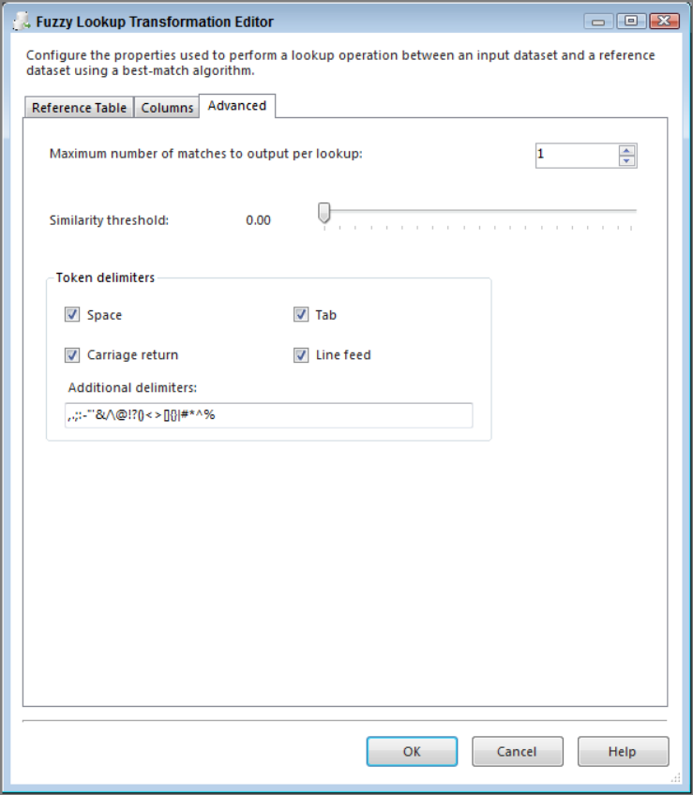
Fig. 2

The transform creates several output columns that you may or may not decide are useful to store in a table. Either way, they are important to understand:

- Input and Pass-Through Field Names and Values—This column contains the name and value of the text input provided to the Fuzzy Lookup Transform or passed through during the lookup.

- Reference Field Name and Value—This column contains the name and value(s) of the matched results from the reference table.

- Similarity—This column contains a number between 0 and 1 representing similarity. Similarity is a threshold calculated by comparing one word with another; you set this when configuring the Fuzzy Lookup Transform. The closer this number is to 1, the closer the two text fields match. A similarity of 1 would indicate an exact match.

- Confidence—This column contains a number between 0 and 1 representing confidence of the match relative to the set of matched results. Confidence is different from similarity; it is not calculated by comparing just one string against another, but rather by comparing the chosen string match against all the other possible matches. Confidence gets better the more accurately your reference data represents your subject domain, and it can change based on the sample of the data coming into the ETL process.

You may not want to use each of these fields, but it is important to appreciate the value they could provide.

- Cel ćwiczenia
You use the Fuzzy Lookup Transform to attempt to correct some bad data that you receive in a flat file. After this lesson, you should have an idea of how useful the Fuzzy Lookup Transform can be in cleansing your data.

- Przebieg ćwiczenia
- Create a new package

- Drag a Data Flow Task onto your designer and name it DFT - Fuzzy Lookup.

- Create a new Flat File Connection Manager name it New Employee, and point it to FuzzyExample.txt. Check the Column names in the first data row option. The editor should look like Fig. 3.

- In the Data Flow, bring a new Flat File Source over and name it New Employee Load. Open the editor and make the connection manager the newly created New Employee.

- On the Columns tab, change the name of the output columns to LastName, FirstName, and OccupationLabel.

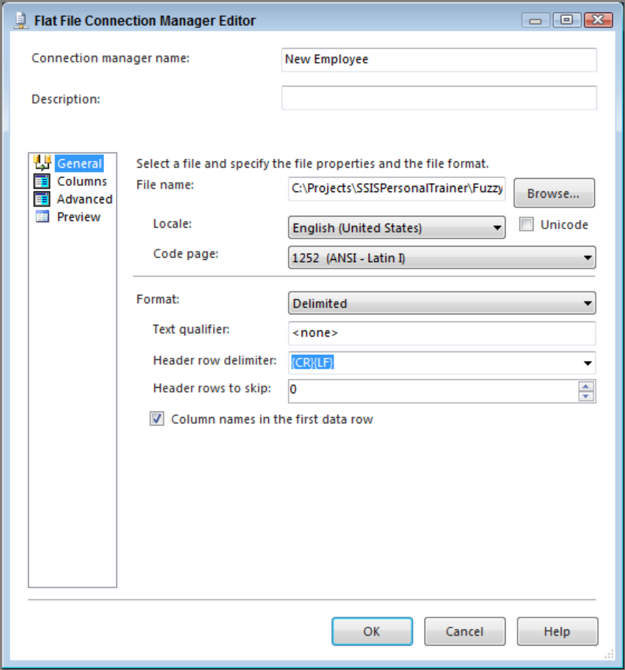
Fig. 3

- Open Management Studio and run the following query to create a new table called Occupation.
CREATE TABLE [dbo].[Occupation](
[OccupationID] [smallint] IDENTITY(1,1) NOT NULL,
[OccupationLabel] [varchar](50) NOT NULL,
CONSTRAINT [PK_Occupation_OccupationID] PRIMARY KEY CLUSTERED
(
[OccupationID] ASC
) ON [PRIMARY]
) ON [PRIMARY]
GO
INSERT INTO [dbo].[Occupation] Select ‘CUSTOMER SERVICE REPRESENTATIVE’
INSERT INTO [dbo].[Occupation] Select ‘SHIFT LEADER’
INSERT INTO [dbo].[Occupation] Select ‘ASSISTANT MANAGER’
INSERT INTO [dbo].[Occupation] Select ‘STORE MANAGER’
INSERT INTO [dbo].[Occupation] Select ‘DISTRICT MANAGER’
INSERT INTO [dbo].[Occupation] Select ‘REGIONAL MANAGER’

- Next, create another connection manager, this time an OLE DB Connection Manager, using the AdventureWorks2014 database.
- Drag a Lookup Transform on the design surface and use the new [dbo].[Occupation] table to select the OccupationID based on the OccupationLabel that exists in both the source and the reference table. Fig. 4 shows what your mapping should look like. Lastly, before closing the editor, make sure to specify in the General tab that non-matching entries should redirect rows to no match output.
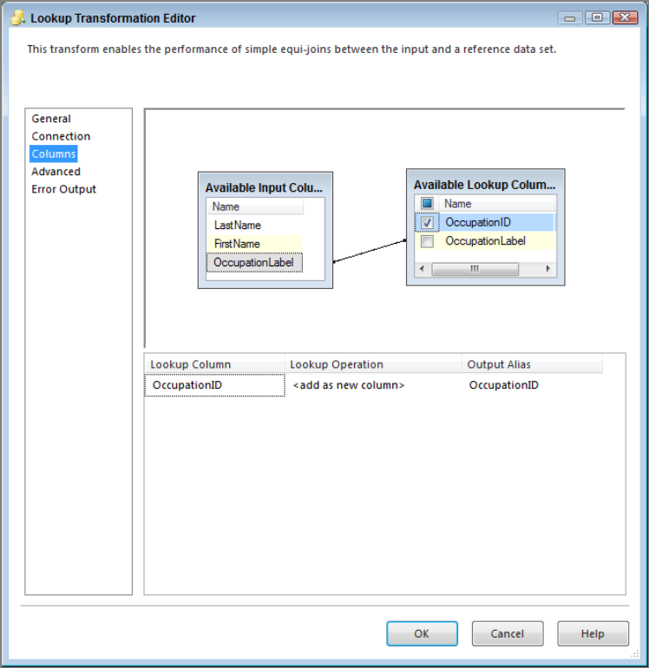
Fig. 4
- You already know from the lesson description that the source data is dirty, so now you’re going to use a Fuzzy Lookup Transform to catch all the bad data the regular Lookup doesn’t recognize. Drag a new Fuzzy Lookup Transform in the Data Flow and connect the blue no match output arrow from the Lookup Transform to it.

- Open the Fuzzy Lookup and select [dbo].[Occupation] for the Reference table name property. Fig. 5 shows the Fuzzy Lookup Transformation Editor using the Occupation table as the reference table.

- The Columns tab should be joined by OccupationLabel as shown in Fig. 6. It should also return the OccupationID and OccupationLabel from the reference table, which you can ensure by checking the boxes in the Available Lookup Columns box. The OccupationLabel from the reference table should replace the same column from the input stream to correct bad data. To do this, uncheck the OccupationLabel column from the Available Input Columns

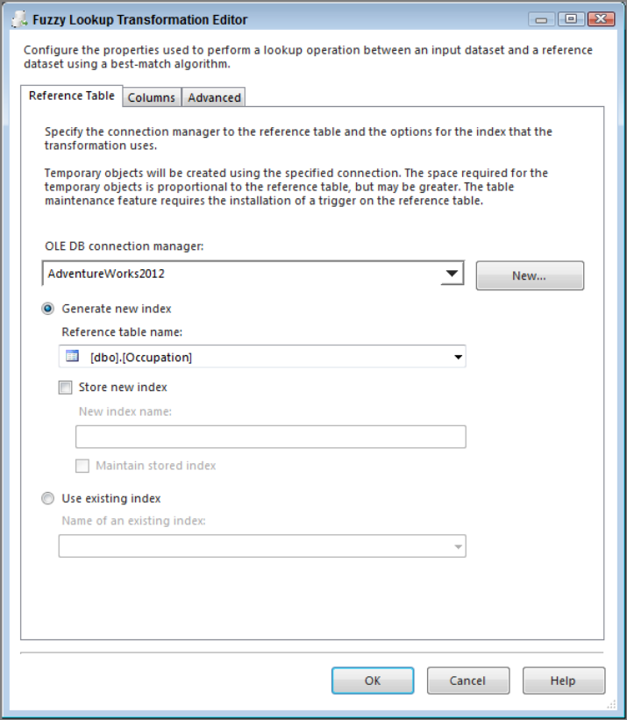
Fig. 5

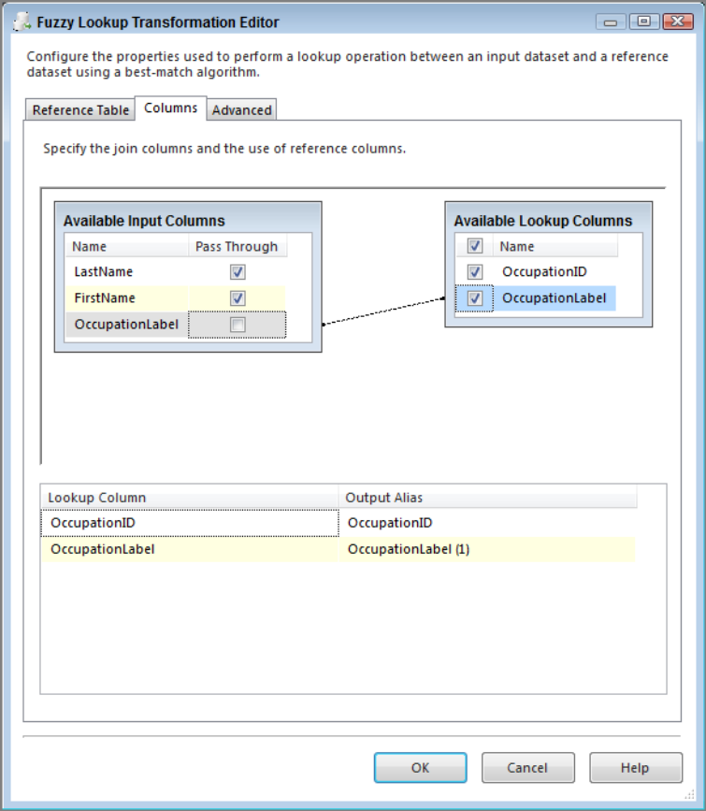
Fig. 6

- Next, in the Advanced tab, leave the Similarity threshold at the default setting and change the token delimiters to use only a period in the Additional delimiters box, as reflected in Fig. 7. Also, modify the Similarity threshold to 0.50 and then click OK.

- To bring together the data from both lookup transforms, drag a Union All over and connect the two lookups to it. First, connect the blue arrow from the Fuzzy Lookup Transform and then connect the blue arrow from the regular Lookup Transform. Then open the Union All Transformation Editor and delete the unneeded columns by right-clicking and selecting Delete on the columns that are not pictured in Fig. 8. You may also need to rename the output of OccupationLabel to not include (1) in the name.

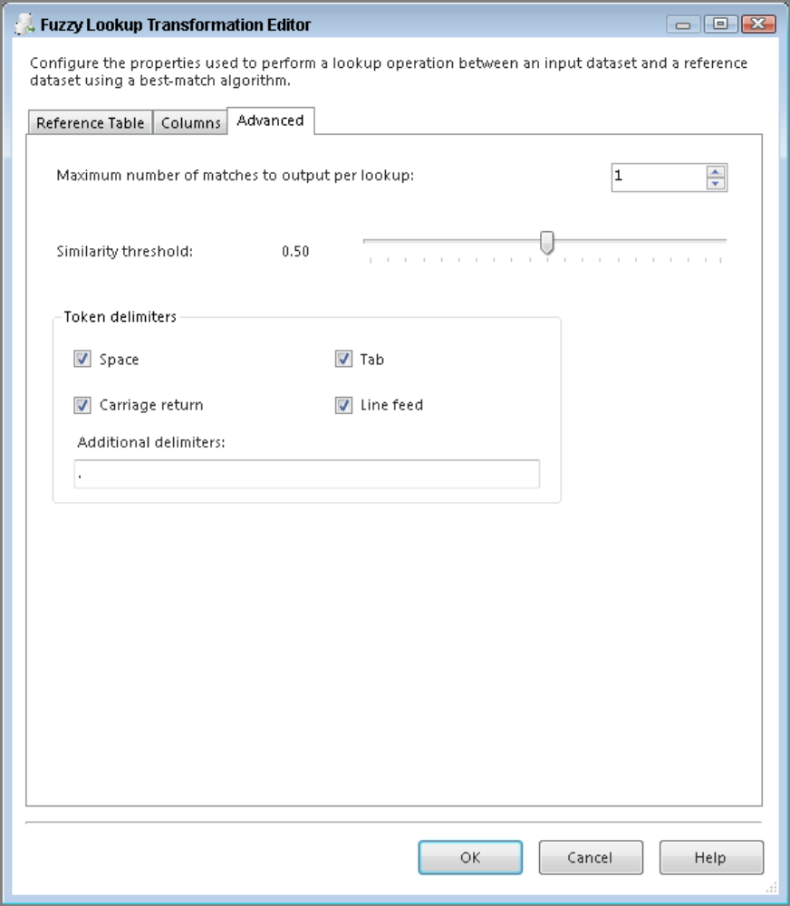
Fig. 7

- To finish off this package you need to load the results into a new table. Bring an OLE DB Destination onto the design surface, and from within the editor, select New to create a new table. Use the following code to create the EmployeeRoster table:
CREATE TABLE [EmployeeRoster] (
[EmployeeID] [smallint] IDENTITY(1,1) NOT NULL,
[LastName] varchar(50),
[FirstName] varchar(50),
[OccupationID] smallint,
[OccupationLabel] varchar(50)
)

- Once the mapping has been set in the destination, click OK and your package is complete. A successful run of this package should look like Fig. 9. Compare the EmployeeRoster table to the original flat file you started with, and you will see the Fuzzy Lookup using the reference table corrected 10 rows of dirty data.

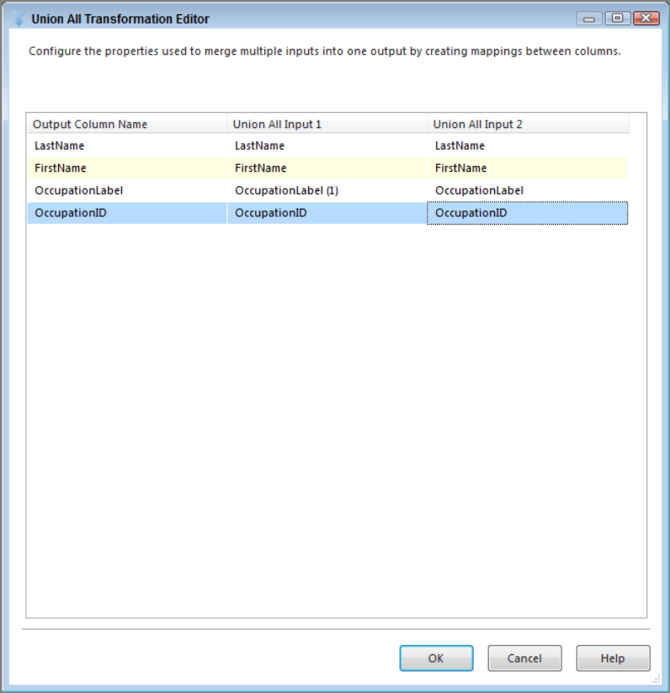
Fig. 8

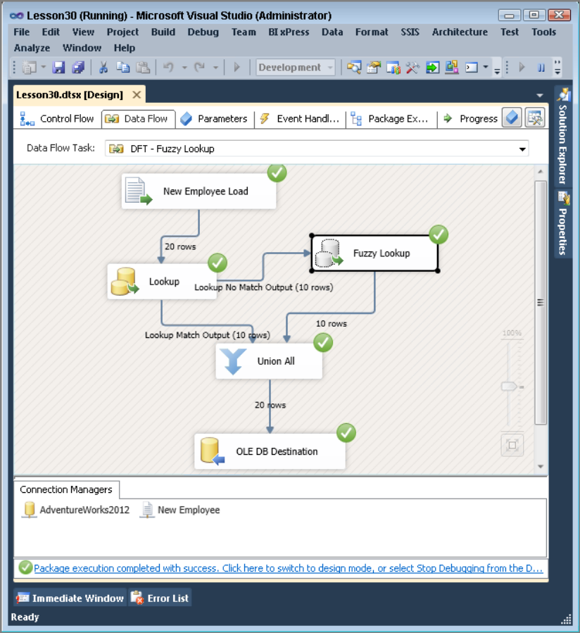
Fig. 9

Removing Duplicates with the Fuzzy Grouping Transform

In the previous exercise, you saw how to use the Fuzzy Lookup Transform to prevent bad data from being loaded in your dimension tables, but what if the bad data is already in your table or if you are just beginning to build your data warehouse?.

In these circumstances, you can use the Fuzzy Grouping Transform to examine the contents of suspect fields and provide groupings of similar words. You can use the matching information provided by this transform to clean up the table and eliminate redundancy.

The Fuzzy Grouping Transform uses the same logic as the Fuzzy Lookup Transform, and therefore requires many of the same things. It must have a connection to an OLE DB Connection Manager to generate temporary tables that the transform uses in its algorithm. At development time, the Connection Manager tab is where you make this setting.

Also, just as was the case with the Fuzzy Lookup Transform, this transform expects an input stream with a string, either DT_WSTR or DT_STR data type. The Columns tab of the Fuzzy Grouping Transformation Editor (which you open by double-clicking the transform), shown in Fig, 10, is where you select the string field that you want to be analyzed and grouped into logical matches. Notice in the top part of the Columns tab that you can also check Pass Through on each column, which means the data is not analyzed, but is accessible in the output stream. If you move down to the bottom part of the Columns tab, you see a table of options for each input column. You can choose the names of any of the output columns: Group Output Alias, Output Alias, and Similarity Output Alias. Often the only column you want from this group is the Group Output Alias. If you select more than one column to be analyzed, the minimum similarity evaluation is configurable at the column level.

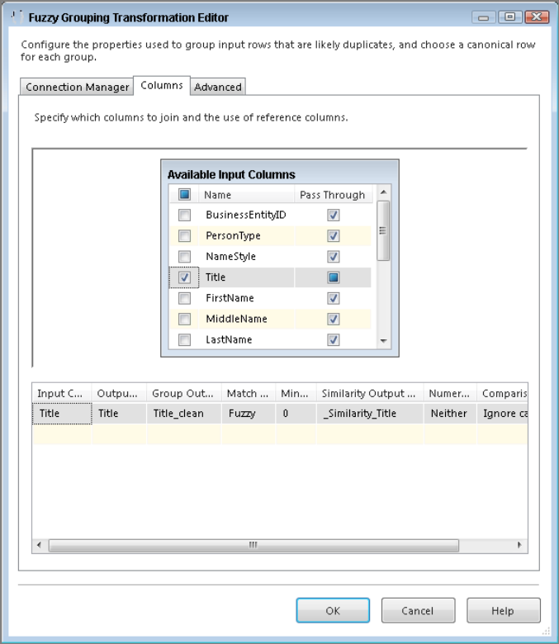
Fig. 10
The Numerals option enables you to configure the numbers in the input stream when grouping text logically. This may be necessary when comparing an address field, because, more than likely, it will have leading numerals; for example, the address “834 West Elm Street” has the leading numerals “834.”
Comparison flags provide the options to ignore or pay attention to case, kana type (Japanese characters), nonspacing characters, character width, symbols, and punctuation.

The Advanced tab is where you see some of the familiar configurations you saw in the Fuzzy Lookup Transform that control the logic algorithm used for finding matches. A slider controls the similarity threshold. It is recommended you start this at 0.5 to test and move the slider up or down until you get the results you are looking for. This setting is normally decided based on a businessperson’s review of the data, not the developer’s review. The token delimiters can also be set if, for example, you don’t want the comparison process to break up incoming strings with a period (.) or spaces. Fig. 11 shows the default settings for the Advanced tab.

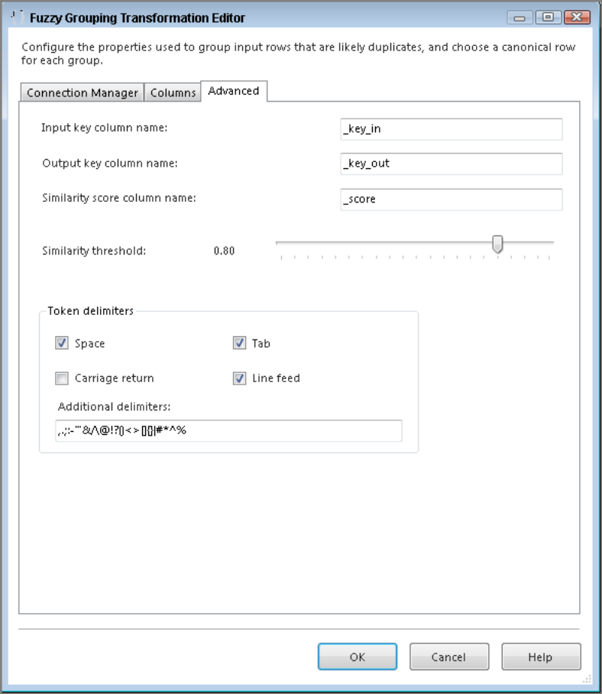
Fig. 11

One feature that was not in the Fuzzy Lookup Transform is the ability to set the names of the three additional fields that are added automatically to the output of this transform. By default, these fields are named _key_in, _key_out, and _score. These new outputs that will be added to the data stream are important to understand:

- _key_in—This column uniquely identifies each row in the stream.
- _key_out—This column identifies a group of duplicate rows. Any rows that have the same _key_out value are rows that are in the same group.
- _score—This column indicates the similarity of the row with a value between 0 and 1. A similarity of 1 would be an exact match.

- Cel ćwiczenia
In this lab, you create a new dimension table and populate it with occupations for your company. The import file contains several different versions of the same occupation, and you need to determine which will be the best fit. After this lesson, you will have an understanding of how to use the Fuzzy Grouping Transform to remove duplicates.

- Przebieg ćwiczenia

- Create a new package.

- Drag a Data Flow Task onto your designer and name it DFT - Fuzzy Grouping.

- Create a new Flat File Connection Manager, name it Occupations, and point it to FuzzyExample.txt. Also, check the Column names in the first data row option. The editor should look like Fig. 12.

- In the Data Flow, bring a new Flat File Source over and name it Occupation Load. Open the editor and make the connection manager the newly created Occupations.

- On the Columns tab, select only the TITLE column to return, change the name of the output column to OccupationLabel, then click OK.

- Next, create another connection manager, this time an OLE DB Connection Manager, using the AdventureWorks2014 database.

- Bring a Fuzzy Grouping Transform in the Data Flow, connect it to your Flat File Source, and open the editor. Set the OLE DB Connection Manager to AdventureWorks2014.

- On the Columns tab, there is only one column to bring back, so check the OccupationLabel Fig. 13 shows what the Columns tab should look like now.

- Next, in the Advanced tab, change the Similarity threshold to 0.50 and change the Token delimiters to reflect Fig. 14. Then click OK.

- If you ran this now and loaded a table, you would have 20 rows of the clean data, but you would also have several duplicate records. Remember, you are trying to create a dimension table, so to prevent duplicates in this package add a Conditional Split Transform with an Output Name of Best Match and a Condition of _key_in == _key_out. If these two values match, the grouped value is the best representative candidate for the natural key in a dimension table. All other rows are not needed, so you can name the Default Output Name Delete. Fig. 15 shows how your Conditional Split Transform should be configured.
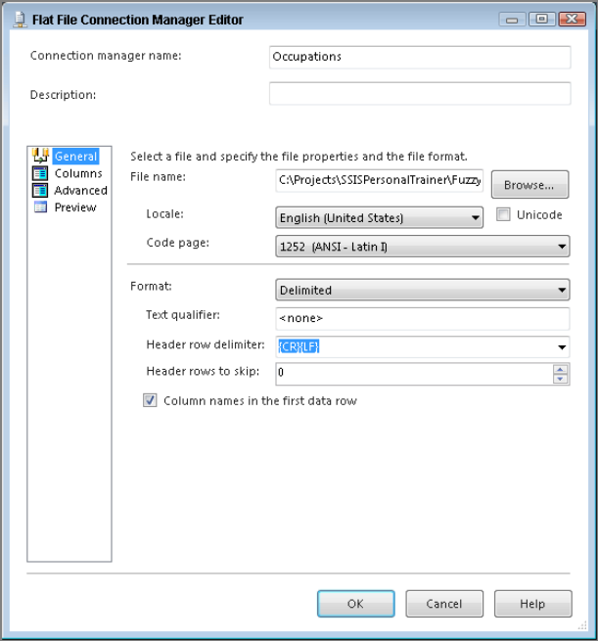
Fig. 12
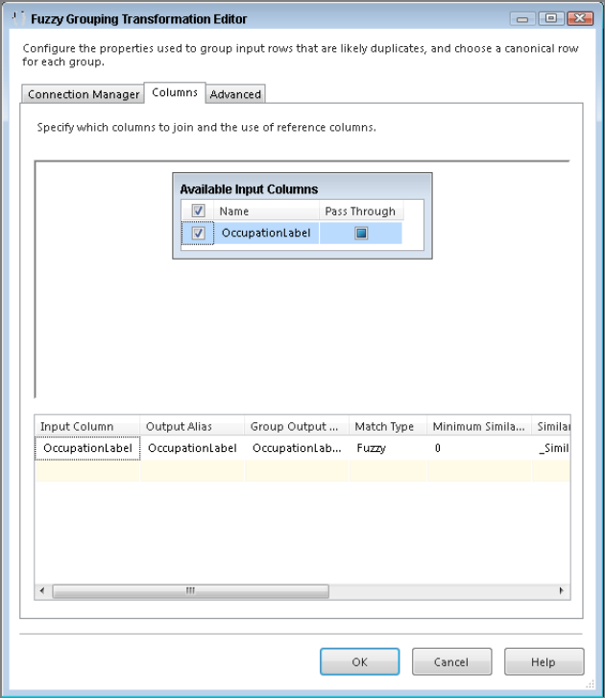
Fig. 13

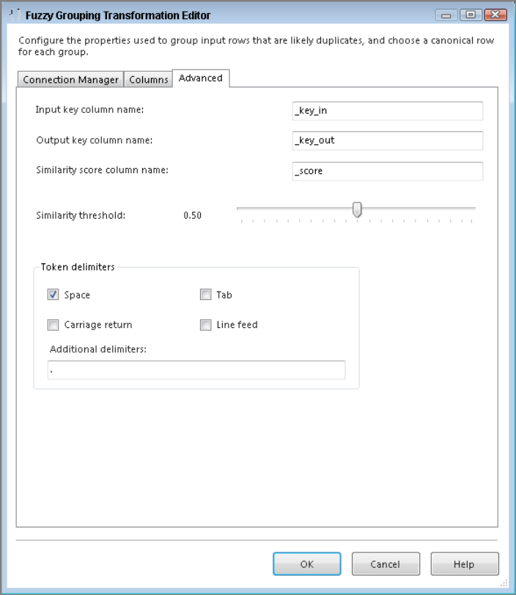
Fig. 14

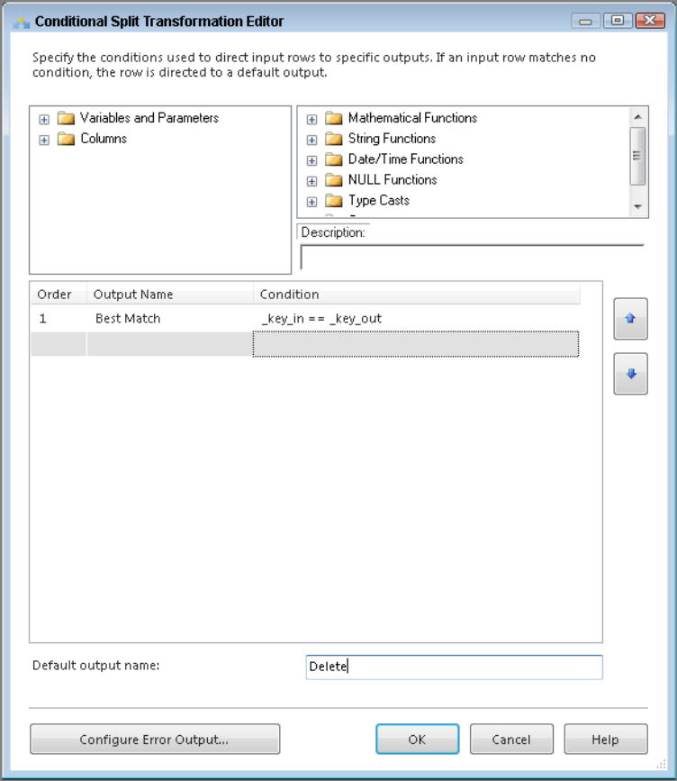
Fig. 15

- To finish off this package, you need to load the results into a new table. Bring an OLE DB Destination onto the design surface and from within the editor select New next to Name of the table or name of the view to create a new table. Use the following code to create the Occupation_FuzzyGrouping table:

CREATE TABLE [dbo].[Occupation_FuzzyGrouping](
[OccupationID] [smallint] IDENTITY(1,1) NOT NULL,
[OccupationLabel] [varchar](50) NOT NULL
)

- Remember from the beginning of this lesson that the Fuzzy Grouping Transform provides several output columns. These columns include a Group Output Alias column that you now use in the Mappings tab. Set OccupationLabel_clean to map to the OccupationLabel column in the destination. Once your Mappings tab looks like Fig. 16, click OK.

- A successful run of this package should look like Fig. 17.

- Fig. 18 shows the results in the Occupation_FuzzyGrouping table you just populated. If you completed previous lab, you might notice that you just created essentially the same table (aside from the order) that was used as a reference table in the previous lab.
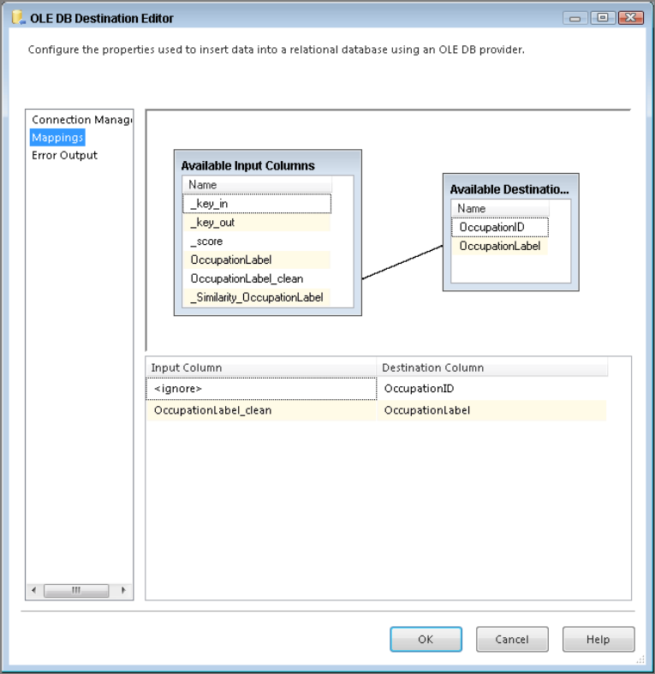
Fig. 16

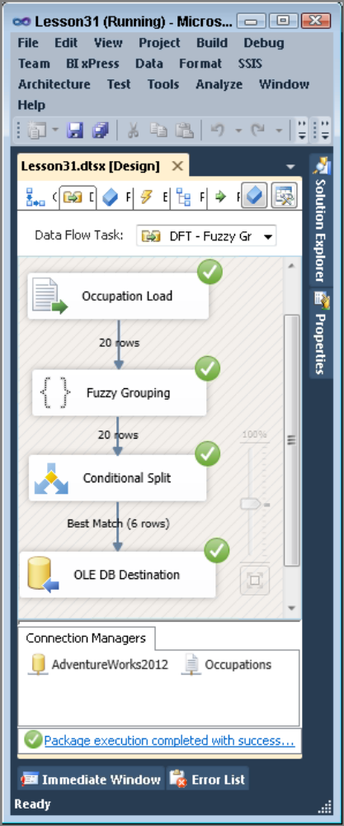
Fig. 17
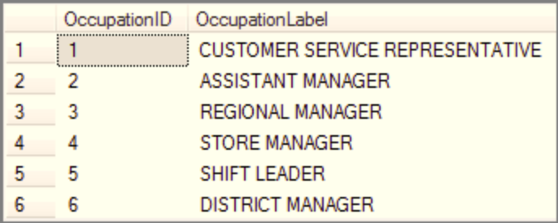
Fig. 18

Bibliografia
- Knight B., Knight D., Davis M, Snyder W. (2013): Knight’s Microsoft® SQL Server® 2012 Integration Services 24-Hour Trainer, John Wiley & Sons.
- Knight B., Veerman E., Moss J.M., Davis M., Rock C. (2012): PROFESSIONAL Microsoft® SQL Server® 2012 Integration Services, John Wiley & Sons.
- http://www.wrox.com/WileyCDA/Section/id-814197.html
- https://msdn.microsoft.com/library/ms169917(SQL.120).aspx
- Tok W-H., Parida R. Masson M. Ding X. Sivashanmugam (2012): Microsoft SQL Server 2012 Integration Services, Promise (tłumaczenie j. polski).
- Kimball R. (2004): The Data Warehouse ETL Toolkit. John Wiley & Sons

