FitBit Fitness Tracker data analysis

Author: Magdalena Praselek

Introduction

The business case of this analisys is to determine the trends in usage of FitBit Fitness Tracker and also determine the main benefits for users.

This kind of analysis will be valuable for product owners, product designers and marketing department of the company as it may help make decisions about new functionalities and marketing strategy.

The data used for this analysis is open-source FitBit Fitness Tracker Data available at Kaggle [1]. The data were collected between March, 12 2016 and May, 12 2016. Thirty three users parcitipated in this survey. Unfortunately we don’t know anything about participants demografic characteristics such as age, sex, earnings, and domicile. This kind of data could be very useful in market segmentation.

The data is divided into 18 csv files. Each file contains different data such as daily or hourly activity, number of steps, time of sleep, heart rate. Each user has its own ID.

The analysis was performer with Python programming language, using Pandas, Matplotlib and Seaborn packages.

What are the trends in usage of FitBit fitness data tracker?

First of all let’s take a look at descriptive statistics. The daily descriptive statistics shows table below:

|  |  |  |  |  |  |
| --- | --- | --- | --- | --- | --- |
|  | Steps | Sleep minutes | Sedentary minutes | Calories | Total active minutes |
| Standard deviation | 5087.15 | 118.64 | 301.26 | 718.17 | 121.78 |
| min | 0.00 | 58.00 | 0.00 | 0.0 | 0.00 |
| mean | 7637.91 | 419.17 | 991.21 | 2303.61 | 227.54 |
| max | 36019.00 | 796.00 | 1440.00 | 4900.00 | 552.00 |
| count | 940.00 | 410.00 | 940.00 | 940.00 | 940.00 |
| 75% | 10727.00 | 490.00 | 1229.50 | 2793.25 | 317.25 |
| 50% | 7405.50 | 432.50 | 1057.50 | 2134.00 | 247.00 |
| 25% | 3789.75 | 361 | 729.75 | 1828.5 | 146.75 |

There were 940 daily and 22099 hourly activity logs but only 410 daily sleep logs. Only 24 participants from 33 performed sleep logs. That leads to conclusion that users prefer to use FitBit device during activity than sleep.

Let’s look at activity distribution:

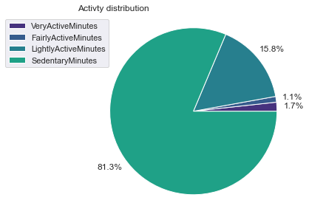

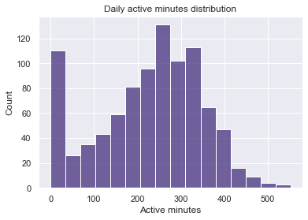

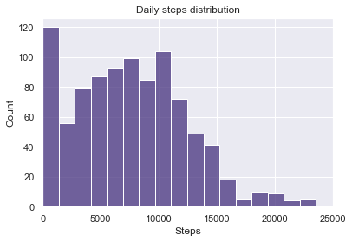

Surprisingly users spent most of the time seating. The most popular kind of activity was light activity. What is more, many logs showed 0 steps and 0 activity.

Let’s look at weekly distribution of activity and sleep:

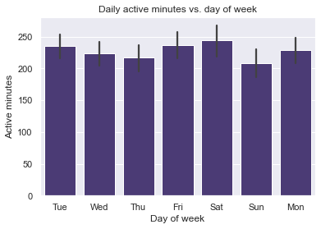

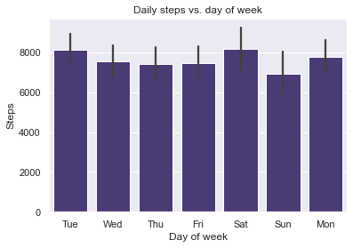

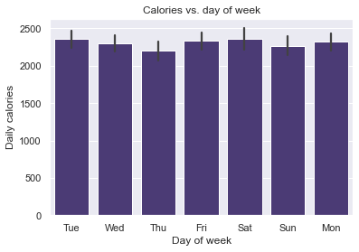

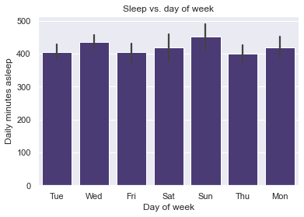

The most active day of week was Saturday and the least was Sunday both in total activity minutes and steps.

On the other hand the day when the participants were asleep the longest was Sunday and the shortest was Thursday.

Daily calories burned reflect these trends.

Let’s look now at the hourly distribution of activity and sleep:

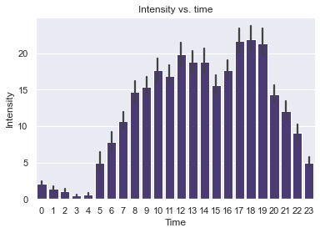

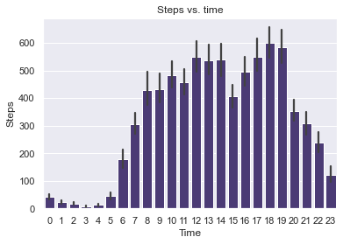

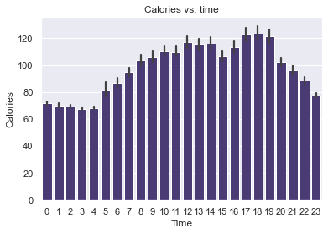

The most intense hours during day were between 5 PM and 7 PM. There was another peak at 12 AM. The least intense hours were from 12 PM to 4 AM. The most polular hours for making steps were from 12 AM to 2 PM and from 5 PM to 7 PM – during these hours users made more than 500 steps hourly. Hourly calories burned reflect these trends.

As we can see on the next plots, there is strong linear correlation between calories burned and total activity minutes and between calories and total steps what is not a surprise.

Summary

The most interesting conclusions are:

1. Average of daily active minutes is ~ 227 minutes while average of daily sedentary minutes is ~ 991 min. That is a good score according to WHO recommendations (at least 60 minutes per day of moderate activity[2].
2. Average of sleep is ~419 minutes (~ 7 hours) which is a good score acording to American Academy of Sleep Medicine and Sleep Research Society recommendations (at least 7 hours per day) but it would be perfect if users would intend more time for sleep.
3. What is not a surprise, there is strong correlation between calories burned and steps and between calories burned and activity. This may be beneficial for users who want to loose weight.
4. Users prefer to use tracker during the day than during the night. Because sleep is very significant for human health, it is a valuable from a business perspective thing to encourage users to take advantages of the tracker also during the night.
5. The most active day of the week is Saturday and the least – Sunday. This trend may be useful in marketing strategy.
6. Smart devices as FitBit tracker may be very helpful not only for sport lovers, but also for people caring about their weight and health in general.

Sources

[1] https://www.kaggle.com/datasets/arashnic/fitbit - accessed March 18, 2024

[2] https://www.who.int/europe/publications/i/item/9789240014886 - accessed March 29, 2024

[3] https://www.ncbi.nlm.nih.gov/pmc/articles/PMC4434546/ - accessed March 29, 2024