Salad Story Nutrition Facts Analysis & Visualisation

Author: Magdalena Prasełek

# Introduction

If someone would have asked me If I have favourite fast food restaurant I woud say - yes! - what probably would be a surprise as I don’t like junk food at all. Salad Story is my favourite fast food restaurant beacuse it has healthy and fresh menu, full of vegatables and other healthy ingredients. Every time I eat there, I ask myself a question: is this a really healthy restaurant or just a fast food? Maybe this is the best way to eat fast & healthy out or this is just delusion. I decided to answer this question by analysing and visualising Salad Story nutrition facts.

# Data preparation

First of all I collected data from official Salad Story website [1] to three Excel sheets: „Nutrition Facts” which is facts table and two lookup tables: „Category” and „Menu”.

Then I imported it to Power Bi Desktop and added 13 calculated columns that return more detailed nutrition facts:

*Nutrition per 100 g = nutrition / weight*

*Nutrition RI = nutrient / RI amount of nutrient*

Where RI is Reference Intake [2]

Here you can see what my tables look like:

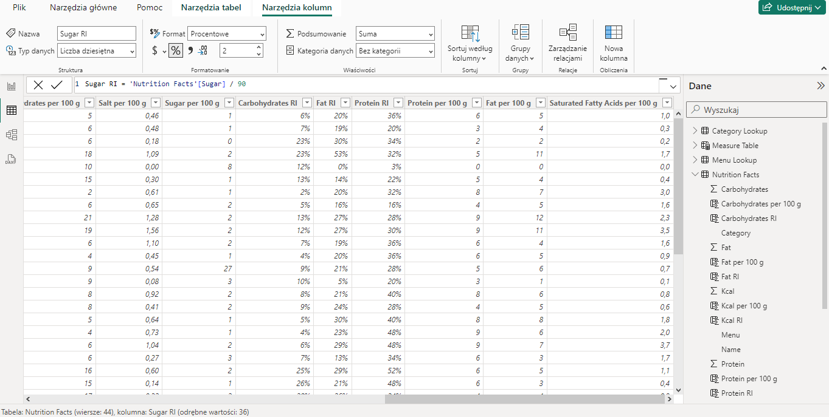

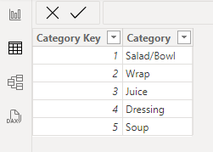

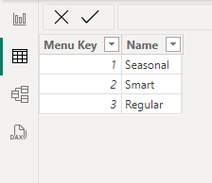

Next I created table relations:

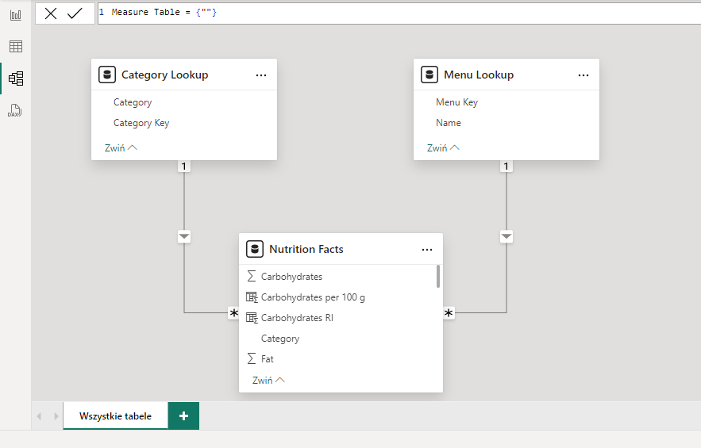

And then I created extra table for measures:

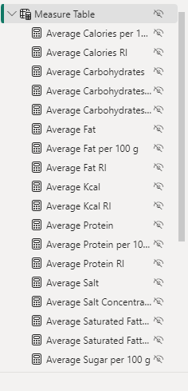

Finally I managed to perform some data visualisations to answer the question: **Is Salad Story really healthy fast food restaurant?**

Each page of visualisation in the left-bottom corner has simple navigation menu where user can jump into previous or next page.

The first page shows overall nutrition facts.

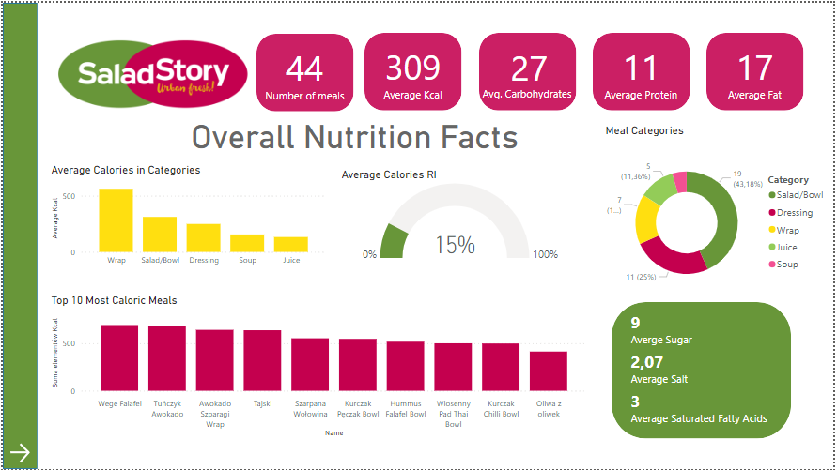

By clicking single category on histogram or doughnut chart I can filter all the data on this page and see each measure calculated only for selected category.

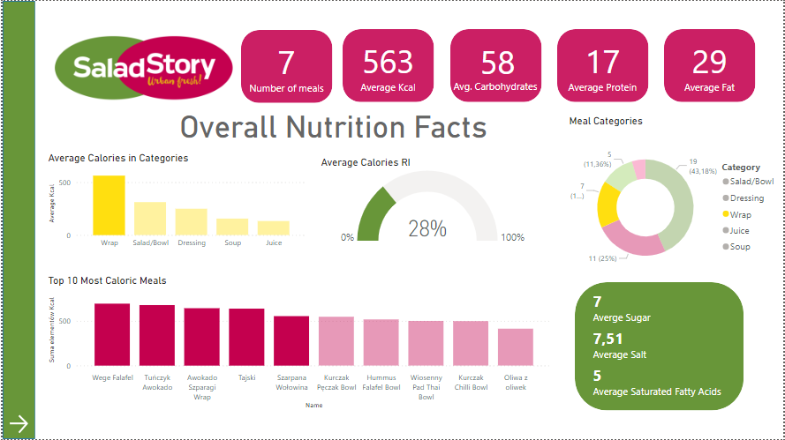

Second page is a product insight page . I created a slicer where user can choose any product from menu.

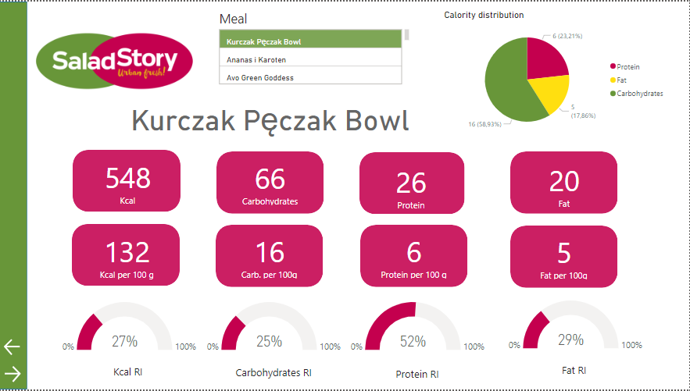

Third, fourth and fifth page show statistics about three main nutrients: carbohydrates, protein and fat.

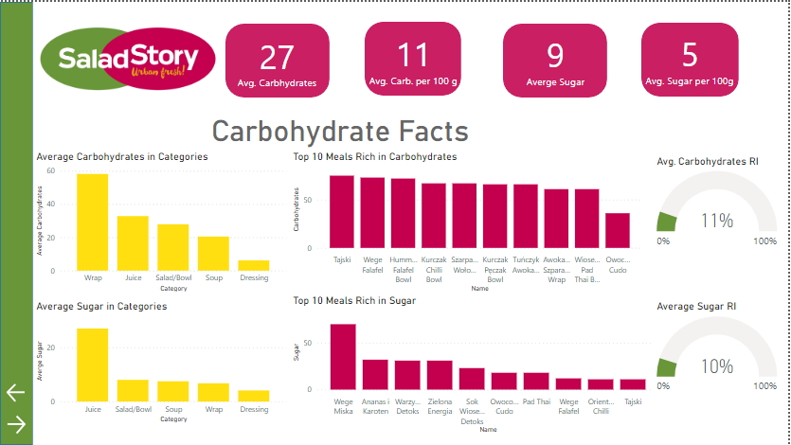

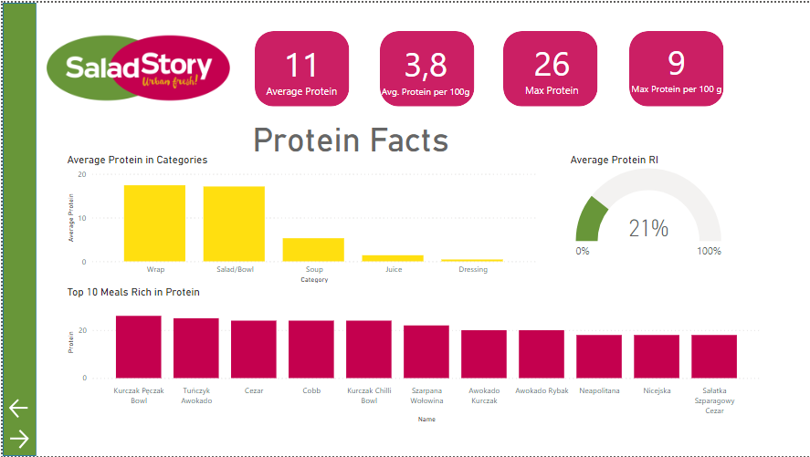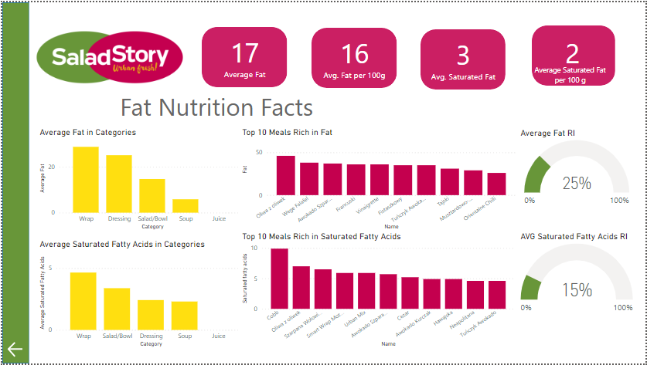

# Discussion

# Calories

Dietitians reccomend that meals should have different calorie content. Dinner should be the main meal covering 30% RI calories (600 kcal) [3] .

Average calories per meal in Salad Story is only 309 kcal (15% reference intake).

The most caloric category are wraps with average calories 563 kcal (28% kcal RI), but even this category fits to dieticians’ reccomendations.

If we consider eating meals from category salad/bowl (avg. 312 kcal) with dressing (avg. 249 kcal) it is still ok for our diet.

## Carbohydrates

Average carbohydrates content is only 27 g (11% RI) which is a good score according to that this is a macronutrient that we often eat too much.

## Protein

Average protein is 11 g (21% RI) which is a good score in 5 meals diet. Considering only Salad/Bowl and Wrap category which have both 17 g average protein (34-35% RI) is a very good score beacuse protein is a macronutrient that we often eat to little.

## Fat

Average fat content is 17 g (25%) which is high score. The richest category is Wraps (average 29 g / 41 % RI). However if you want to choose meal whith less fat content, you should consider sald/bowl (without dressing) – average fat content only 15 g / 21 % RI or soup – 6 g / 8% RI.

Average saturated fatty acids content is 3 g (15% RI) which is a good score.

# Conclusions

If you are concerned about your diet Salad Story is a good choice. You should only worry about fat content which is on average pretty high, but you can balance it with your other daily meals.

# Sources

[1] <https://www.saladstory.com/menu>, access 22.04.2024

[2] https://ncez.pzh.gov.pl/abc-zywienia/ile-poszczegolnych-skladnikow-powinnismy-jesc-dla-zachowania-zdrowia-rws/, access 30.04.2024

[3] https://dietly.pl/blog/dieta-2000-kcal-twoja-droga-do-zdrowego-stylu-zycia, access 30.04.2024