Data Preparation Report
Project: retail-analytics-eda
This report documents all data type conversions, data corrections, and structural changes made during the data preparation phase (file: 03_data_preparation.sql).

1. Summary of Changes
Table | Column | Change | Notes
sales_orders | order_date | nvarchar(50) to date | 598 rows with invalid date removed first
sales_orders | product_id | smallint to int | No issues found
sales_orders | unit_price | nvarchar to decimal(10,2) | No issues found
sales_orders | discount_pct | nvarchar to decimal(10,2) | 1039 rows with '%' sign cleaned first
products_mmmgmeum | base_price | nvarchar(50) to decimal(10,2) | No issues found
products_mmmgmeum | launch_date | nvarchar(50)  to date | 4 rows with invalid date removed first
inventory_mmmgkubv | (all columns) | No changes | stock_quantity checked — max value 567, smallint sufficient

2. sales_orders: Detailed Changes

2.1 order_date: nvarchar(50) to date

When attempting to convert order_date to date type, an error appeared indicating some values could not be converted. A check was performed to identify the invalid values:

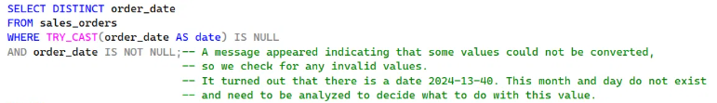

Result: invalid date '2024-13-40' found (month 13 and day 40 do not exist). Before deleting, the rows were investigated to check for patterns or links to other tables:
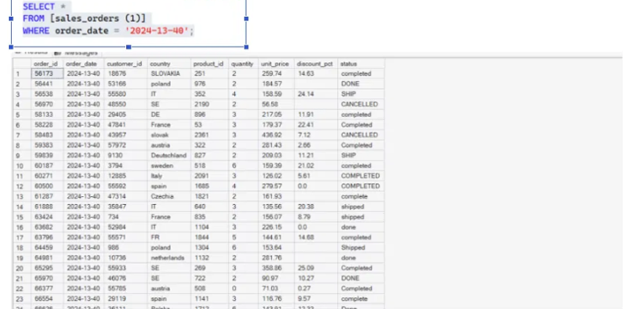

Investigation showed no systematic pattern. Rows represent random countries, products and order values. Data loss considered acceptable (0.23% of total rows).

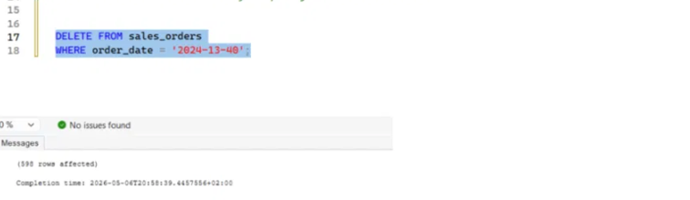

After removing invalid rows, the data type conversion was performed successfully:

2.2 product_id: smallint to int

Converted without any errors
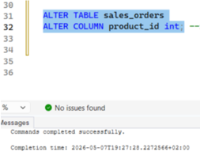

2.3 unit_price: nvarchar to decimal(10,2)
No problems here, conversion went through cleanly

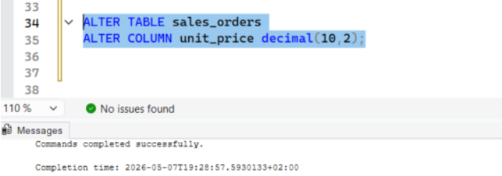

2.4 discount_pct: nvarchar to decimal(10,2)

When attempting conversion, an error appeared because some values were stored with a trailing '%' sign (e.g. '15%'), which cannot be cast to a number. The invalid values were identified first:
SELECT DISTINCT discount_pct FROM sales_orders
WHERE TRY_CAST(discount_pct AS decimal(10,2)) IS NULL AND discount_pct IS NOT NULL;

The '%' sign was removed using REPLACE, so the text could be converted to a number (1039 rows affected):

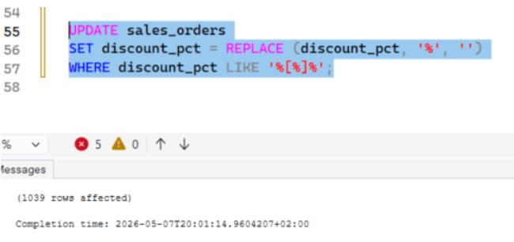
After cleaning, the data type conversion was performed successfully:

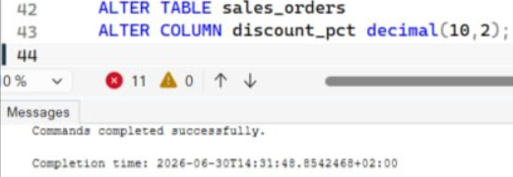

3. products_mmmgmeum: Detailed Changes

3.1 base_price: nvarchar(50) to decimal(10,2)

The base_price column was stored as text (nvarchar). During the earlier data quality check, no negative or zero prices were found and the value range was valid (min 31.23, max 409.97). The conversion to decimal(10,2) was straightforward and completed without errors:

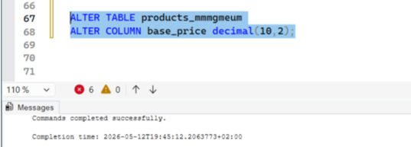

3.2 launch_date: nvarchar(50) to date

When attempting to convert launch_date to date type, the conversion failed with error Msg 241 ("Conversion failed when converting date and/or time from character string"), meaning at least one value could not be interpreted as a valid date:

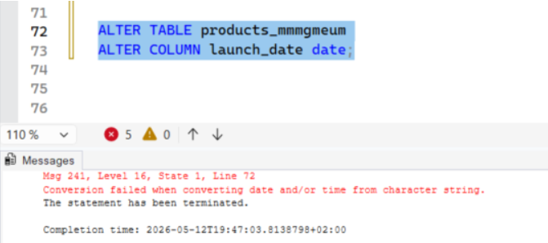

I used TRY_CAST here since it returns NULL instead of throwing an error, which made it easy to spot.

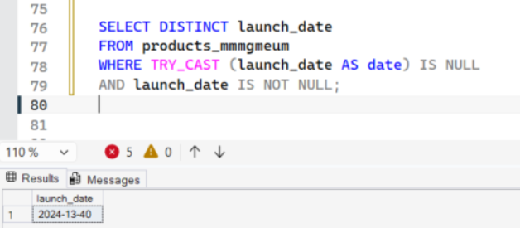

Result: the invalid date '2024-13-40' was found (month 13 and day 40 do not exist). This is the same impossible date that had already been identified and removed in the sales_orders table (see section 2.1).
Before deleting, the affected rows were investigated to check for any pattern or link to other data:
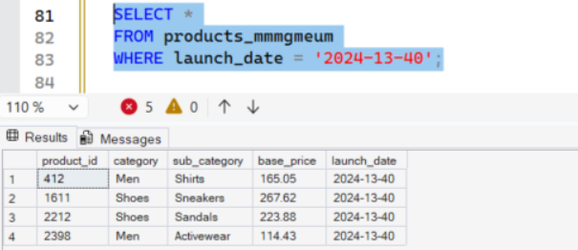

Four products were affected (product_id 412, 1611, 2212, 2398), spanning unrelated categories (Men/Shirts, Shoes/Sneakers, Shoes/Sandals, Men/Activewear) and a wide price range. No systematic pattern was found. These products did have related orders in sales_orders, but those orders had already been removed earlier during the sales_orders cleaning (the same '2024-13-40' deletion), so no orphaned orders remain.
The four rows were removed. Data loss is negligible (less than 0.1% of products):

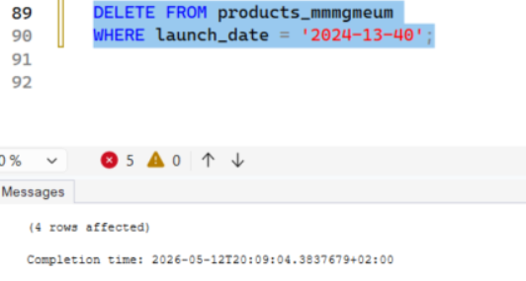

After removing the invalid rows, the data type conversion completed successfully:

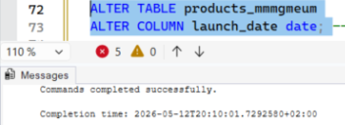

4. inventory_mmmgkubv: No Changes

All columns were reviewed. The only candidate for a type change was stock_quantity (smallint). The maximum value was checked to decide whether a wider int type was needed:

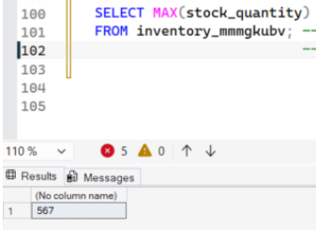

The maximum value was 567, well within the smallint range (32,767), so the column was left as smallint. No other changes were required:
- product_id - already int
- warehouse_country - nvarchar, correct for text data
- stock_quantity - kept as smallint (max value 567, smallint is sufficient)
- last_stock_update - already date

5. Joining Tables for Analysis
To answer the business questions, the tables had to be joined on product_id. The join logic was explored first, before building the final analytical views.

5.1 Initial join of all three tables
A first exploratory query joined all three tables together to see the combined result:

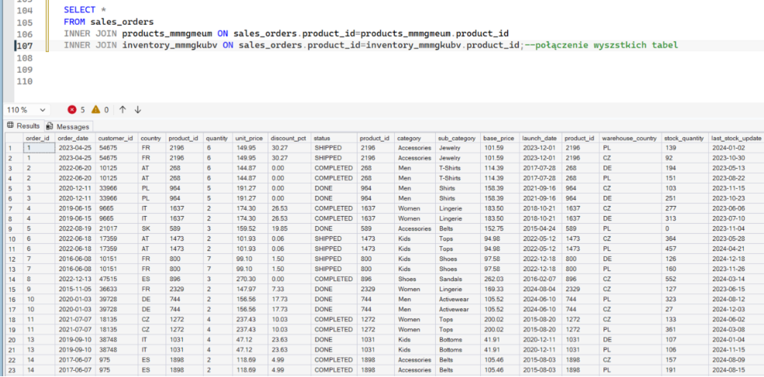

Observation: orders were duplicated because the same product is stored in more than one warehouse. Each product_id in inventory_mmmgkubv can match several warehouse rows, so a single order line fans out into multiple rows (e.g. order_id 1 appears for both the PL and CZ warehouse). This means a sales_orders + inventory join cannot reliably attribute an order to one specific warehouse, which limits the depth of inventory and logistics analysis (business questions Q3 and Q6).

5.2 Recommended data collection improvement
The most impactful future improvement would be to add a shipped_from_warehouse column to the sales_orders table, populated automatically when an order status changes to SHIPPED or COMPLETED, recording which warehouse fulfilled the order. This would enable:
- Accurate inventory analysis - knowing which warehouse stock was used for each order
- Overstocking detection by country - comparing actual shipments against stock levels per warehouse
- Logistics optimization and more actionable insights for management

To work around the limitation above, two focused VIEWs were created, each joining sales_orders with only one other table.

5.3 View for product analysis: seasonality_VS_margin

This view supports the product-related questions, starting with business question Q4 ("Does seasonality affect the margin?"). The sales_orders + products_mmmgmeum join was tested first, then saved as a view:

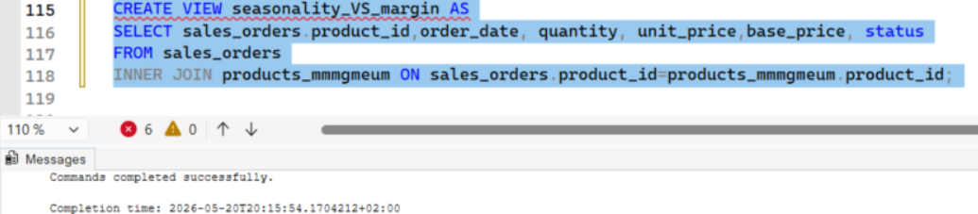

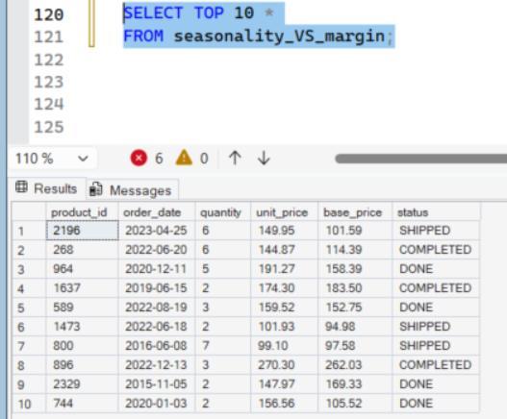

The view was then extended with ALTER VIEW: the discount_pct column was added because it was needed for business question Q5 ("Do promotions have a negative impact on profit?"), and a computed revenue column (unit_price * quantity) was added for the revenue analysis. Final definition:

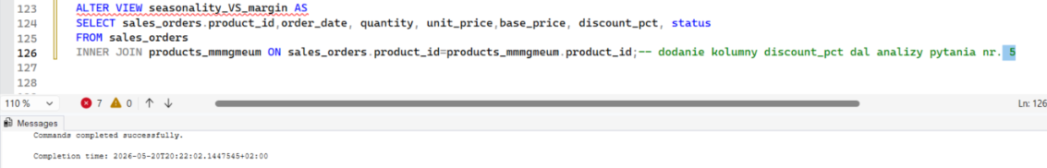

5.4 View for inventory analysis: sales_inventory
This view supports business questions Q3 ("Do we have an inventory problem?") and Q6 ("Which countries are overstocked?"). The sales_orders + inventory_mmmgkubv join was checked first, then saved as a view:

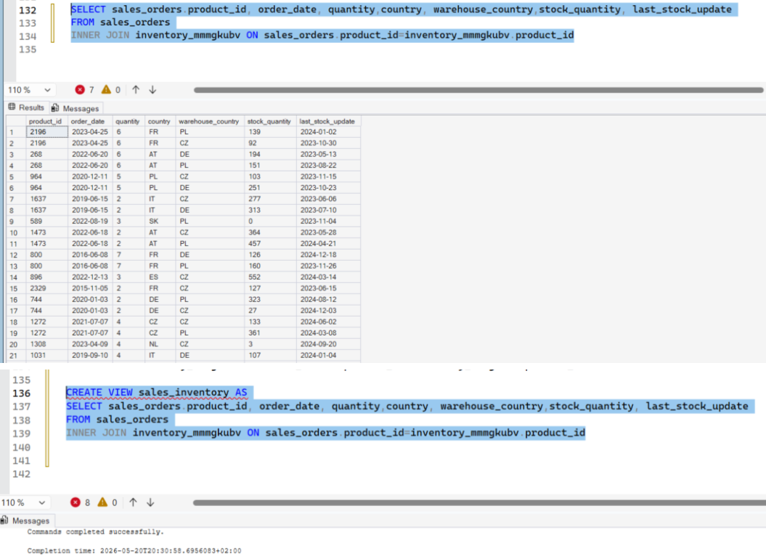
Preview of the raw join, tested before creating the view

Verified with a preview (note: subject to the warehouse duplication limitation described in 5.1 the same product appears once per warehouse):

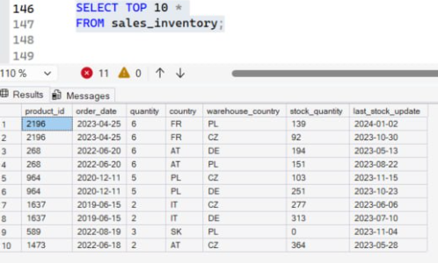

6. Analytical Queries Built on the Views (SQL)
The views above were then used to run the analytical SQL for the business questions. The key SQL-level findings are summarised below; they are developed further, with visualisations, in the analysis report (Power BI).

6.1 Q1: Are prices really growing? (YoY)
Average revenue per year was calculated from seasonality_VS_margin, grouped by YEAR(order_date).

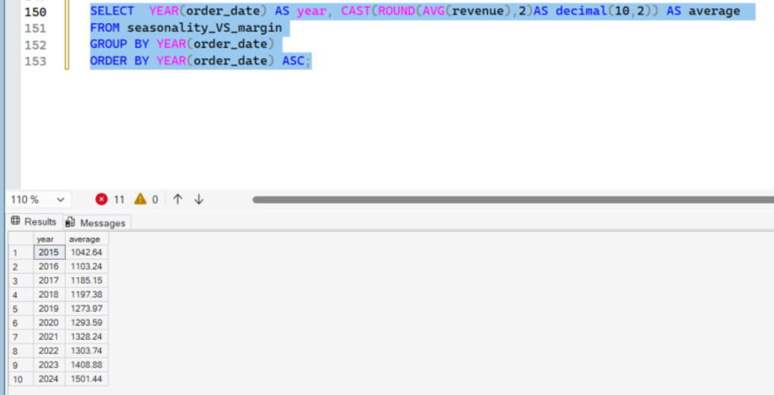

Finding: average revenue grows year over year, from roughly 1042 in 2015 to 1501 in 2024, with one exception a slight drop in 2022 compared to 2021.

6.2 Q2: Is revenue growth driven by volume or price?

Yearly total quantity and average unit price were compared, also from seasonality_VS_margin.
Finding: revenue growth is driven mainly by rising prices, not volume. Quantities stay fairly stable (roughly 161k to 174k per year), while the average price increases steadily from 155 in 2015 to 212 in 2024.

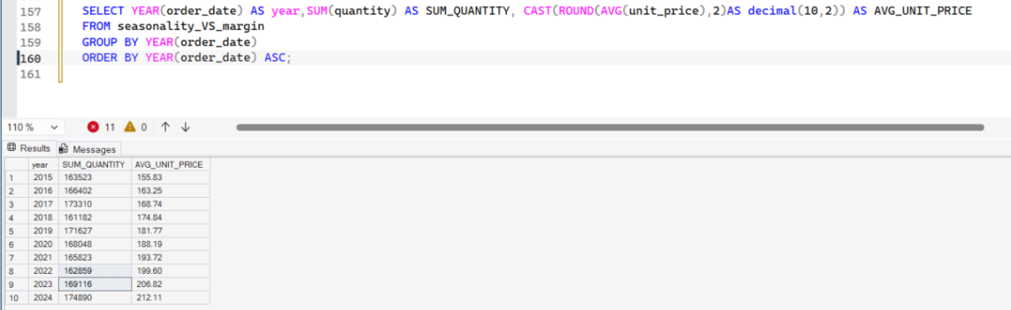

6.3 Q3: Do we have an inventory problem?
Quantities sold were compared with stock levels using sales_inventory, filtered to 2024.

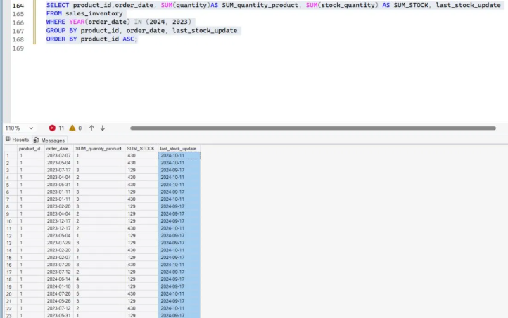

Finding: a fully reliable inventory analysis is not possible, because last_stock_update does not align with order_date (e.g. an order from 2024 but a stock update from 2023, or an order from 2022 with inventory levels from 2024). This makes it difficult to draw meaningful conclusions and is consistent with the warehouse limitation described in section 5.1.

6.4 Q4: Seasonality of sales
Quantity sold was aggregated by year and month (CONCAT of year and month) from seasonality_VS_margin to reveal seasonal patterns across all products.
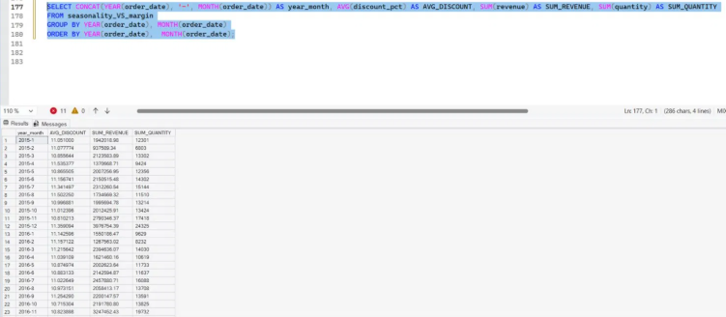

6.5 Q5: Do promotions have a negative impact on profit?
Average discount, total revenue and total quantity were aggregated by month from seasonality_VS_margin to look for a relationship between discounts and sales.
Finding: based on this data, the correlation between discount and sales is not clear. A Pearson correlation of −0.01 confirms effectively no linear relationship.
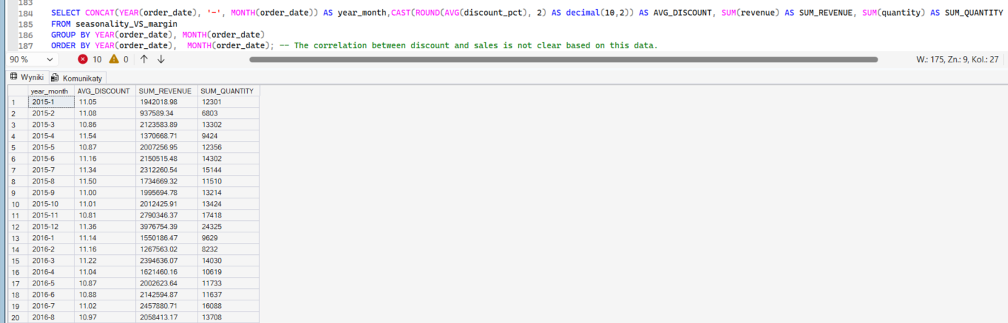

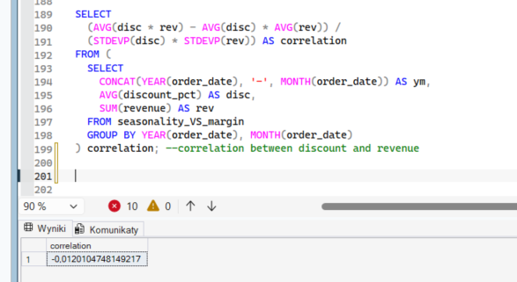

Note: a margin-level analysis (relevant to Q4) is limited by inconsistencies between unit_price, base_price and discount_pct identified earlier, so margin figures should be treated with caution. The findings above form the SQL basis for the analysis report, where they are expanded with Power BI visualisations.

