University of Caloocan City

College of Engineering
Electronics Engineering Department
Microprocessors, Microcontroller Systems and Design

Midterm Project # 1
ESP32-Based Smart Seedling Watering System with Automated Environmental Control

Submitted by:
Magdamit, Rovic B.
ECE - 3A

Submitted to:
Engr. Glenda C. Morales
September 15, 2026

Abstract
This project presents the design and development of an ESP32-based smart seedling watering system intended to reduce the repetitive manual work involved in watering young plants. The completed prototype combines an ESP32-C3 controller, a DHT22/AM2302 temperature and relative-humidity sensor, a DS3231 real-time clock, a relay and transistor driver stage, a DC solenoid valve, a regulated power section, a small seedling tray, tubing, and a manually assembled PVC support structure. The controller can execute daily watering schedules and configurable temperature/humidity rules through a locally hosted wireless web interface. Environmental rules can require a condition to remain true for a defined persistence period before watering and can apply a cooldown to reduce repeated triggering. Manual watering and a force-stop command are also provided. Timing for watering duration, sensor intervals, persistence, and cooldown is implemented with non-blocking millis()-based logic so the main control loop can continue servicing the web server and sensors. The DS3231 provides the time-of-day reference used for schedules and retains the clock when the controller itself is unpowered. Configuration is stored on the ESP32 using non-volatile storage so connected devices can retrieve the current schedule and rule settings. The final prototype evolved through several iterations, including an abandoned conveyor concept, a Bluetooth Low Energy communication attempt, and debugging of the RTC interface before the final Wi-Fi and RTC arrangement was stabilized. The resulting system demonstrates an integrated application of embedded programming, electronics, sensing, relay control, fluid delivery, and mechanical fabrication within a low-cost prototype.
Keywords: ESP32-C3, seedling watering, DHT22, DS3231 RTC, solenoid valve

Introduction

Background
Watering young seedlings is simple in principle but repetitive in practice. Seedling trays often require small and repeated watering events, and the consistency of those events can depend on whether a person is available to perform them at the correct time. The project began from this practical problem and from the observation that repeatedly watering plants can become tiring and easy to postpone. The design goal therefore shifted from simply opening a valve with a microcontroller to building a small, programmable controller that can repeat watering actions consistently and can be adjusted without rewiring the hardware.
The finished prototype uses the ESP32-C3 as the central controller. A DHT22/AM2302 provides temperature and relative-humidity measurements, while a DS3231 real-time clock supplies the time reference needed for daily schedules. The controller drives a solenoid valve through a transistor-and-relay interface. A local Wi-Fi access point and web interface allow a phone or laptop to configure schedules, environmental rules, manual watering duration, and automation state without requiring a cloud service or an external router. The ESP32 stores configuration in non-volatile storage so that the controller can retain its operating settings across restarts.

Project Requirement
The Microprocessors, Microcontroller Systems and Design project requirement was to create a project that is smart, helpful, marketable, and useful using an ESP32, relay, and solenoid valve. The present system addresses that requirement by combining a programmable embedded controller with a practical water-delivery application for seedlings. Rather than claiming a universal watering amount for every plant, the system emphasizes repeatable and user-configurable watering. This approach is consistent with the design notes developed during the project, which emphasize controlled watering and calibration rather than claiming that the controller can perfectly determine plant thirst.

Problem Statement
The project addresses the need for a compact and low-cost watering system that can perform repetitive seedling watering actions without requiring a person to activate the valve every time. The system must provide a dependable time reference for scheduled watering, sense environmental conditions, permit wireless configuration, control a solenoid valve safely, and allow manual intervention. It must also continue its timing and control logic without using long blocking delays that would prevent the controller from responding to other tasks.
Objectives
- To design and assemble an ESP32-C3-based controller capable of driving a DC solenoid valve through a relay and transistor driver stage.
- To implement daily watering schedules using a DS3231 real-time clock and user-defined watering durations.
- To implement temperature/humidity rules with configurable thresholds, persistence periods, optional second conditions, and cooldown periods.
- To provide a local Wi-Fi web interface for configuration, monitoring, manual watering, force stopping, and retrieval of the current controller configuration.
- To build a compact physical watering structure using PVC, tubing, a reservoir, a seedling tray, and an acrylic electronics enclosure.
- To evaluate the completed prototype through functional tests of sensing, timekeeping, wireless communication, configuration persistence, valve control, and physical water delivery.

Significance
The project demonstrates how a microcontroller can bridge several practical engineering disciplines in one system. Electrical design is required for power regulation, relay control, transistor driving, and inductive-load protection. Embedded programming is required for scheduling, sensor sampling, non-blocking timing, and web communication. Instrumentation is represented by environmental sensing and the RTC. Fluid handling is introduced through the reservoir, tubing, solenoid valve, and outlet. Finally, mechanical fabrication is required to support the reservoir and route the watering hardware. This integration makes the prototype relevant not only as a classroom microcontroller exercise but also as a small example of an automated nursery or seedling-management subsystem. The final system also required fluid-mechanics reasoning and structural consideration: gravity from the elevated reservoir provides the driving head for water movement, while the PVC frame and rope supports carry the reservoir load. This makes the project an integrated electromechanical and fluid-delivery system rather than an electronics-only prototype.

Methodology

Materials and Equipment
- ESP32-C3 SuperMini development board
- DHT22 / AM2302 temperature and relative-humidity sensor
- DS3231 real-time clock module
- 5 V relay (SRD-05VDC-SL-C) and PN2222A transistor drivers
- DC solenoid valve and clear fluid tubing
- 12 V DC adapter, LM7805 regulator, capacitors, resistors, flyback diodes, LED indicator, DC barrel jack, and terminal connections
- Custom PCB/perfboard implementation and connecting headers
- Blue PVC pipes and assorted elbow/tee fittings for the support frame
- Nylon rope for reservoir/support attachment
- Approximately 10-L plastic reservoir container and seedling tray
- Clear acrylic sheet for the electronics enclosure and acrylic adhesive
- Computer/phone for local web configuration, Arduino IDE, KiCad, and a digital multimeter

System Architecture
The final architecture places the ESP32-C3 at the center of the system. The DHT22 feeds environmental data to the controller, while the DS3231 supplies the time-of-day reference. User devices communicate with the ESP32 through its local Wi-Fi access point and HTTP interface. The controller decides when watering should occur and drives the relay/driver path connected to the solenoid valve. The electrical power section provides the external DC input and the regulated logic rail. The architecture therefore separates sensing, decision-making, actuation, and user configuration while keeping the entire system local.

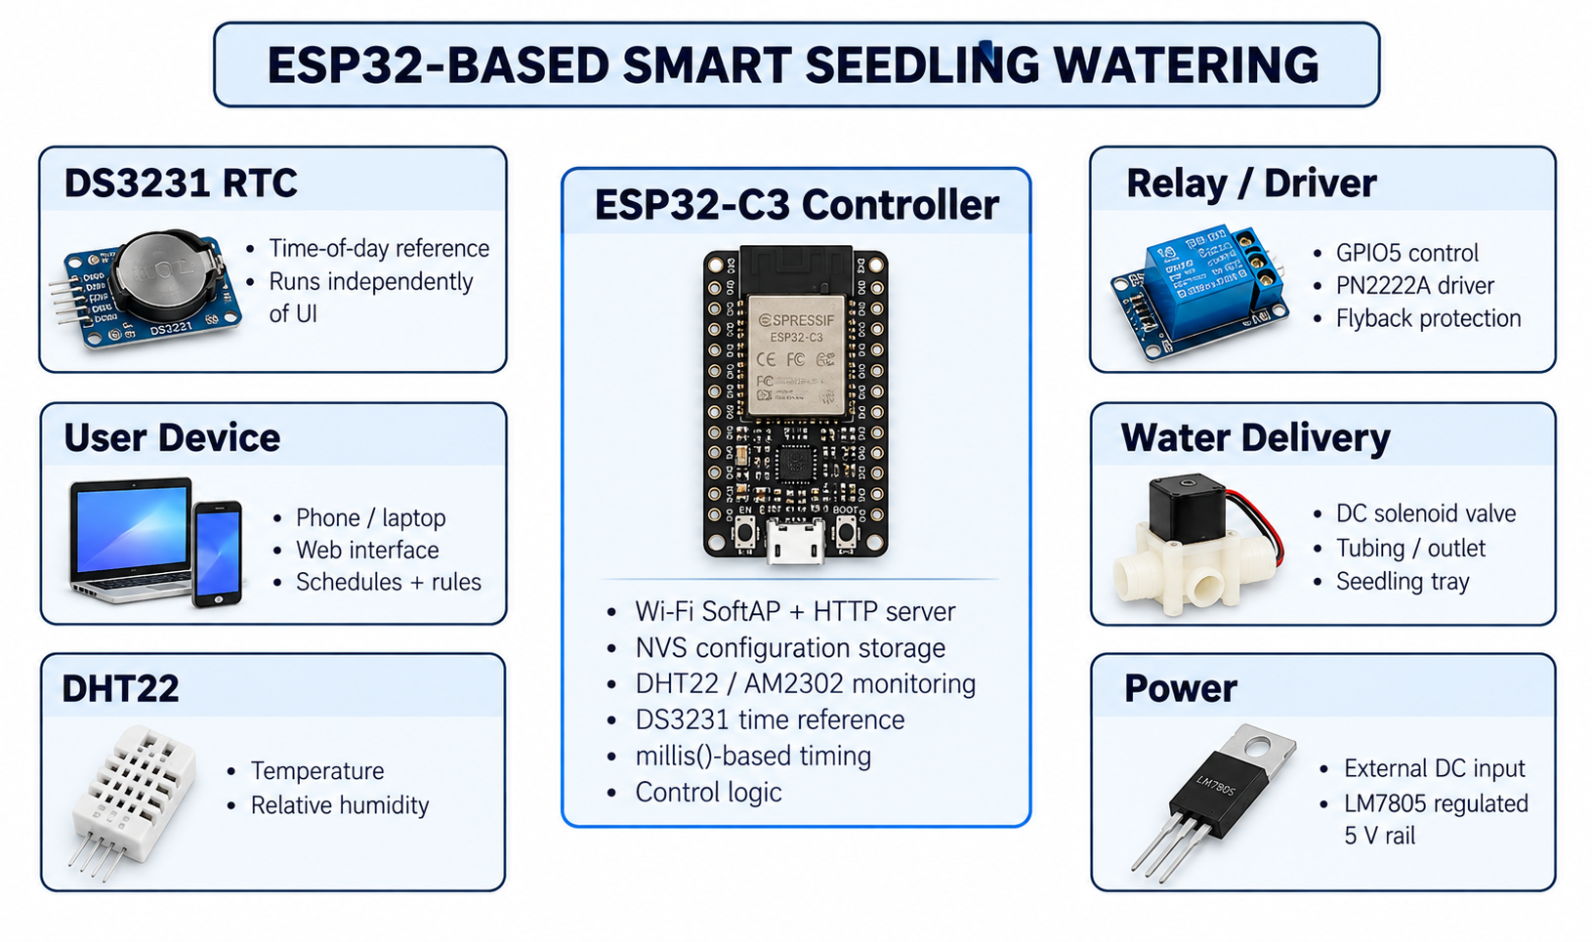
Figure 1. Functional architecture of the completed ESP32-based smart seedling watering system.

Electrical Design and PCB
The controller board was designed in KiCad and organized into functional groups for the relay and manual-switch path, power regulation, indicator circuit, and ESP32/RTC/DHT22 connections. The supplied PCB design uses a 1.6 mm board thickness and an outline of approximately 83.8 mm by 51.8 mm (8.38 cm by 5.18 cm) according to the KiCad board file. The ESP32-C3 uses GPIO5 for the watering control signal, GPIO6 for I2C SDA, GPIO7 for I2C SCL, and GPIO4 for the DHT22 data line. The relay coil uses a transistor driver and flyback diode, while the solenoid path includes a separate flyback diode for inductive-load protection. The relay and manual-water input share the actuation stage so that the same valve can be controlled by either the software command or the physical manual control.
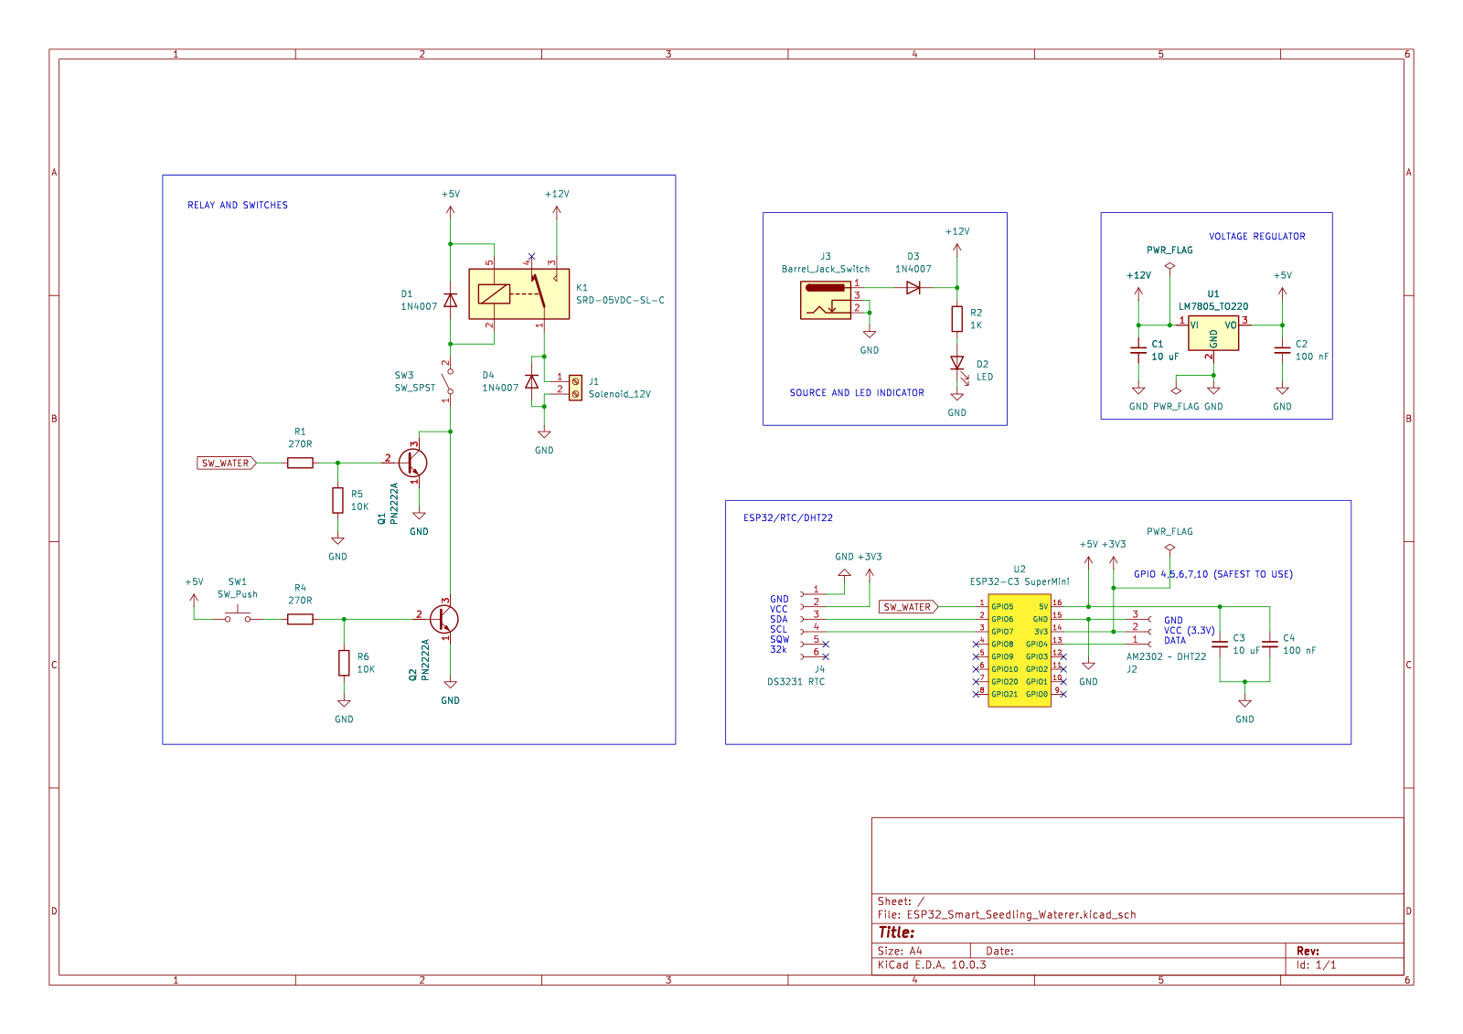
Figure 2. KiCad schematic/layout overview showing the relay, manual switch, power regulation, ESP32-C3, DHT22, and DS3231 connections.

Pin Assignment
Device / Function | ESP32-C3 connection | Purpose
DHT22 / AM2302 data | GPIO4 | Temperature and relative-humidity input
Water control | GPIO5 | Drives transistor/relay watering path
DS3231 SDA | GPIO6 | I2C data
DS3231 SCL | GPIO7 | I2C clock
Power | 5 V regulated rail / GND | Controller and peripherals
External supply | 12 V DC input | System power source before regulation

Software and Control Logic
The firmware is written for the ESP32-C3 using the Arduino environment. The main loop repeatedly services the HTTP server, samples the DHT22 at a defined interval, updates watering duration, and evaluates automation rules. Watering is deliberately implemented without long blocking delays. When watering begins, the firmware stores the start time using millis() and checks elapsed time on later loop iterations. The same non-blocking approach is used for environmental persistence, cooldown timing, and sensor polling. This allows the controller to continue responding to network requests while the solenoid is active.
The DS3231 is used for actual time-of-day scheduling. The browser can synchronize the current local time to the RTC through the local interface, after which the ESP32 reads the RTC independently of the phone. The DS3231 is also checked for a power-loss indication at startup. This is distinct from the volatile runtime timing performed with millis(): millis() measures elapsed intervals while the controller is running, whereas the DS3231 supplies calendar time for daily schedules and retains its time reference when the ESP32 is unpowered.
Configuration is maintained as a structured controller configuration containing automation state, manual duration, and up to ten events. Events can be scheduled watering events or environmental rules. Environmental rules can contain a first sensor condition, an optional second condition joined by AND or OR, a persistence interval, a watering duration, and a cooldown. The configuration is stored in ESP32 non-volatile storage using the Preferences library. The local browser also maintains a local copy for editing, while the ESP32 remains the authoritative stored configuration when devices connect.
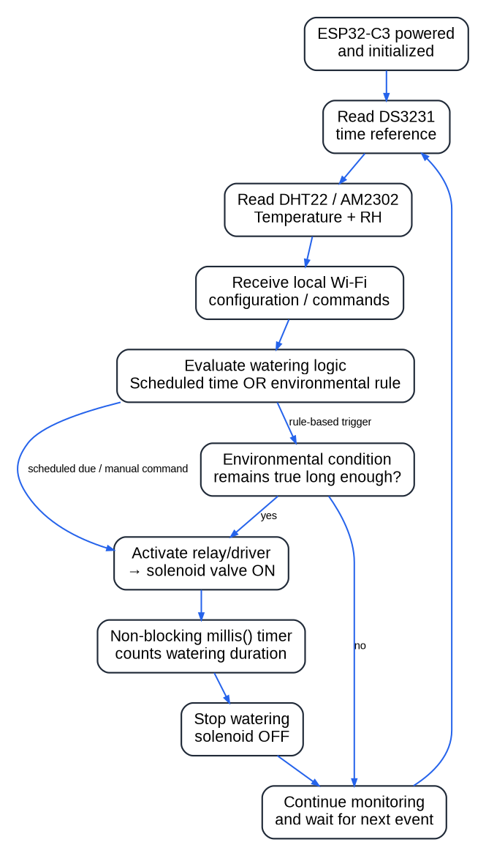
Figure 3. Control flow of the final firmware, showing RTC timekeeping, environmental sensing, rule evaluation, non-blocking watering timing, and return to monitoring.

Mechanical Construction
The physical watering frame was fabricated from blue PVC pipe with assorted elbow and tee fittings. The main square sections are approximately 9 inches per side, with additional short members, tees, and diagonal members used to support the reservoir, watering outlet, and seedling area. The repeated closed rectangular members provide a stable load path, while the additional bracing helps reduce sway when the reservoir is filled. The joints were assembled without additional sealant because the fitted prototype was already sufficiently rigid for the intended demonstration. Nylon rope was used at multiple attachment points to suspend and stabilize the reservoir and outlet assembly. For structural interpretation, the full reservoir load is approximately 10 kg of water before the bottle and fittings are added, corresponding to about 98 N of gravitational load. The actual tension in each rope segment depends on its attachment angle and how the load is distributed, so the prototype was treated as a low-cost demonstration structure rather than a rated lifting frame.
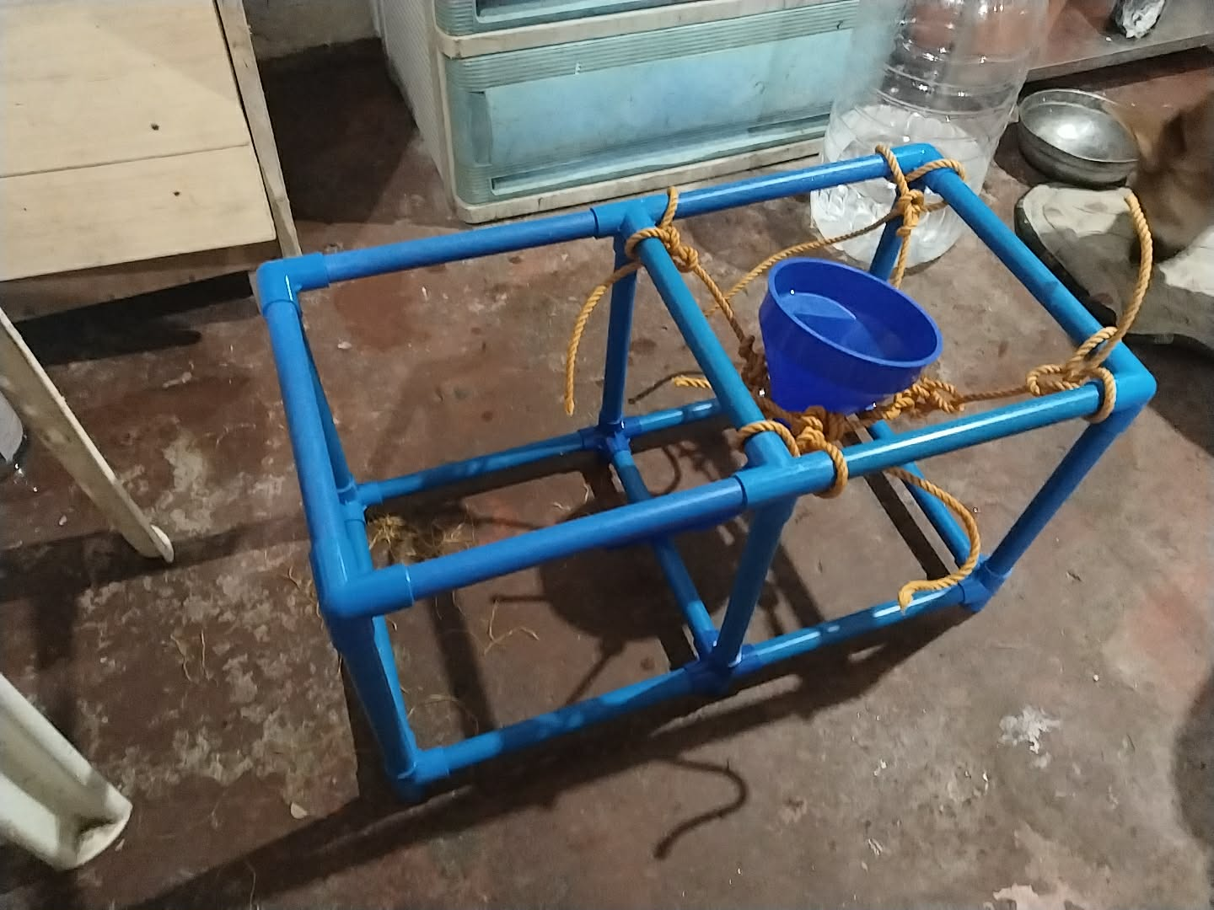
Figure 4. PVC structural frame and manually assembled watering outlet support.
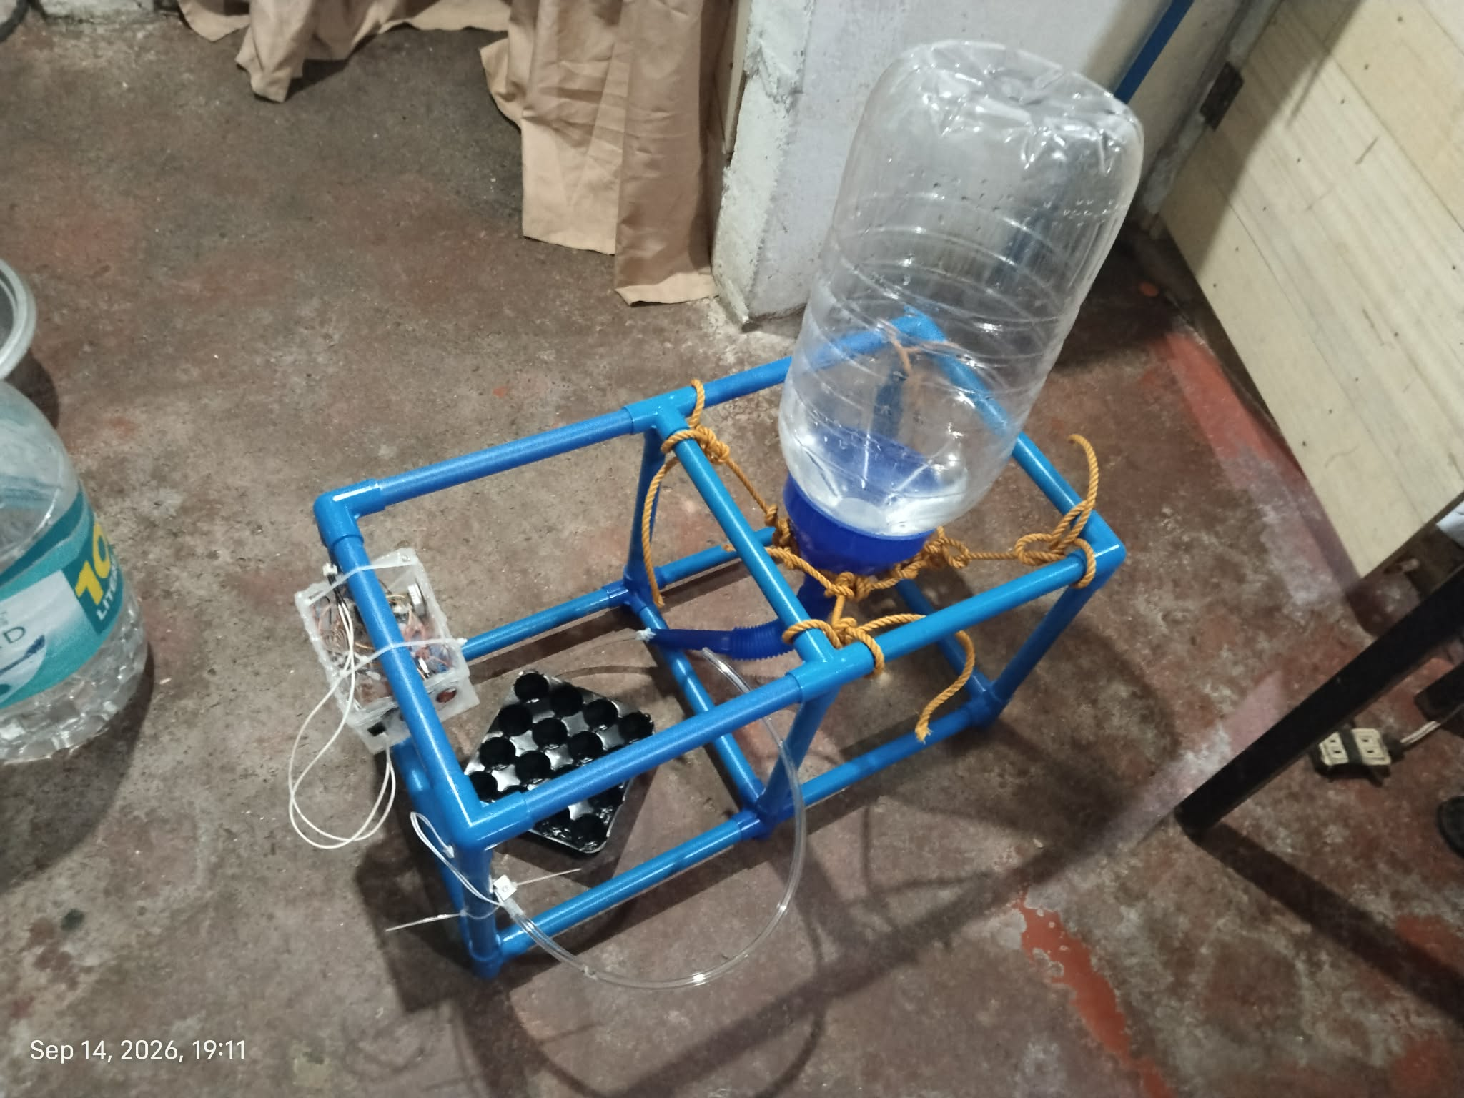

Figure 5. Final physical prototype with reservoir, watering frame, tubing, seedling tray, and controller enclosure.
Electronics Enclosure
The controller electronics were housed in a small clear acrylic enclosure cut and bonded during the prototype stage. The enclosure was designed to fit the controller board, wiring, power input, manual controls, relay, and valve connections while keeping the electronics visible for demonstration and troubleshooting. The prototype used adhesive bonding and improvised wire management with cable ties. The enclosure is functional rather than cosmetic, and the visible adhesive and exposed wiring reflect the rapid iterative construction process used to complete the project within the available time.
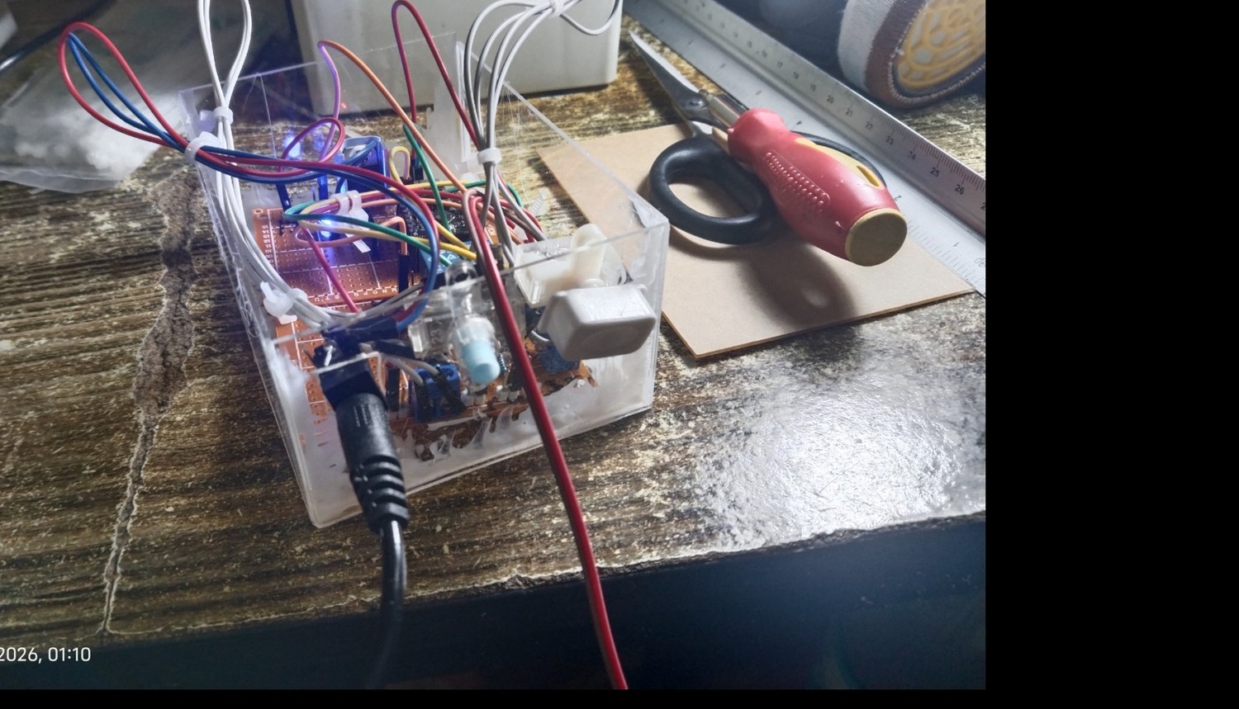
Figure 6. Acrylic enclosure containing the controller electronics, relay, wiring, and external connectors.
Procedure
1. Planning and requirement definition: The project was framed around a repetitive seedling-watering problem and the requirement to use an ESP32, relay, and solenoid valve. The initial concept included a conveyor or watering tunnel, but this was later reduced to a stationary tray system to keep the final prototype achievable with available materials and time.
2. Electrical prototyping: The ESP32-C3, DHT22, relay/driver circuit, manual control, regulator, and solenoid path were tested individually before being combined. Flyback protection and regulated power were incorporated into the controller design.
3. RTC integration: The DS3231 was connected through GPIO6/GPIO7. An initial detection problem was traced with an I2C scanner, which eventually confirmed devices at 0x57 and 0x68. A focused RTClib test then detected the DS3231 and returned a readable time, confirming that the hardware and I2C bus were operating correctly.
4. Wireless interface development: Bluetooth Low Energy was attempted first, but repeated connection and GATT service retrieval failures led to a Wi-Fi SoftAP design. The final controller creates a local Wi-Fi network and serves the web interface at 192.168.4.1 without requiring an external router.
5. Configuration and persistence development: The browser interface was built to edit schedules and environmental rules. The design was revised so the ESP32 non-volatile configuration is the shared source of truth; a newly connected device retrieves the stored configuration and reconstructs the same schedule and rule interface.
6. Physical construction: The PVC frame, reservoir support, tubing path, watering outlet, acrylic enclosure, and controller wiring were assembled and adjusted repeatedly until the final integrated layout could be demonstrated.
7. Functional verification: The completed system was checked for environmental sensing, RTC communication, local Wi-Fi operation, watering command execution, timed shutoff, manual control, force-stop behavior, configuration persistence, and physical water delivery.
Results and Discussion
System Integration Results
The final prototype successfully brought together the electrical controller, environmental sensor, RTC, wireless interface, relay and solenoid actuation path, water delivery hardware, and physical frame. The system is represented in the final photographs as a complete assembly rather than as separate bench tests. The controller enclosure contains the active electronics, while the external structure provides the reservoir support and gravity-fed water path. The 10-L reservoir provides a practical demonstration-scale water supply, and the approximately 9-inch frame geometry keeps the assembly compact while creating the elevation needed for gravity-assisted flow. This integration is the main result of the project because the required ESP32, relay, and solenoid operate as parts of one physical application.
Functional Verification
Test item | Observed result | Assessment
ESP32-C3 startup | Serial startup completed and local AP address reported as 192.168.4.1. | Pass
DHT22 / AM2302 | Temperature and relative-humidity values were read and responded to environmental changes during testing. | Pass
DS3231 I2C communication | I2C scan detected 0x57 and 0x68; focused RTClib test detected the DS3231 and returned a readable time. | Pass after wiring/initialization debugging
Scheduled watering | Firmware checks RTC time and triggers configured daily events without blocking the main loop. | Implemented / integrated
Environmental rules | Temperature/humidity thresholds, persistence, optional second condition, and cooldown are represented in the configuration and control logic. | Implemented / integrated
Manual watering | Web interface provides a user-defined watering duration. | Implemented / integrated
Force stop | Web command immediately stops watering through the same actuation path. | Implemented / integrated
Configuration persistence | Schedules and environmental rules are stored through Preferences/NVS and returned through the configuration endpoint. | Implemented / integrated
Non-blocking timing | Water duration, persistence, cooldown, and sensor interval use millis()-based elapsed-time checks. | Pass
Physical water delivery | Reservoir, tubing, valve, outlet, and seedling tray were assembled into the final frame. | Pass for prototype demonstration
Iterations and Failure Analysis
The project required repeated trial and error rather than a single build sequence. The earliest mechanical concept involved transporting a seedling tray through a watering zone with a conveyor. This concept was consistent with a miniature nursery tunnel, but its motor, guide, entry/exit sensing, and mechanical timing requirements increased the fabrication burden. The design was therefore simplified into a stationary seedling watering system while retaining the programmable watering and wireless-control ideas.
Communication development also required iteration. Bluetooth Low Energy initially appeared attractive because it would avoid dependence on a router, but the prototype repeatedly entered connect/disconnect cycles and browser GATT service retrieval failed. The design was changed to ESP32 SoftAP Wi-Fi, which fit the same local-device concept while making the browser interface easier to operate. The final firmware uses the ESP32 as the access point and web server.
The DS3231 also generated an early false-negative result. The main firmware first reported the RTC as not detected even though the wiring was ultimately correct. A dedicated I2C scanner identified 0x68, and a smaller RTClib sketch then detected the DS3231 and read its time. The issue therefore came from the initialization path in the larger program rather than from a failed RTC module. The final firmware explicitly starts the I2C bus on GPIO6 and GPIO7 and checks the 0x68 device before initializing RTClib.
The browser configuration interface required another round of debugging because schedules and environmental rules were initially not consistently repopulated across connected devices. The final design treats the ESP32 non-volatile configuration as the master copy, with the browser localStorage acting as a local editing copy. This change makes the configuration available to any device that connects to the ESP32 rather than tying the visible schedule to one browser alone.
Environmental and Fluid-System Considerations
The prototype intentionally avoids claiming that one fixed watering volume is correct for every seedling. Water demand depends on plant type, tray geometry, substrate, age, temperature, and humidity. The control strategy instead treats valve-open duration as a configurable quantity. In the physical prototype, water moves from an elevated reservoir through clear tubing and the solenoid valve to the outlet over the seedling tray, with no separate pump used in the final arrangement. The elevation of the water surface above the valve provides gravitational pressure (hydrostatic head), while losses in the tubing, fittings, and outlet reduce the pressure available at the discharge. For water, the pressure contribution from elevation can be approximated by P = rho g h. As a reference, a 9-inch vertical water head (0.2286 m) corresponds to approximately 2.24 kPa or 0.33 psi of hydrostatic gauge pressure. The actual head in the prototype changes with reservoir fill level and the exact relative height of the valve and outlet. Because the valve used in the prototype is intended for low/zero differential-pressure operation, the gravity-fed arrangement is practical without a pump; zero-differential solenoid valves are specifically designed to open without requiring a positive pressure differential (Parker Hannifin Corporation, 2025; SMC Corporation, 2025). The final flow rate still depends on head, tubing resistance, valve orifice, fittings, and outlet geometry, so future calibration should measure delivered water volume for several valve-open durations rather than assuming a universal flow rate.
Physical-System Reference Calculations
Parameter | Expression / Basis | Reference Result
Water mass in 10-L reservoir | m ≈ 10 L × 1 kg/L | ≈ 10 kg
Reservoir water weight | W = mg | ≈ 98.1 N
9-in vertical water head | h = 9 in = 0.2286 m; P = rho g h | ≈ 2.24 kPa ≈ 0.33 psi
Frame dimensions | Main square members ≈ 9 in per side | Prototype reference dimension
Note: the 9-inch head calculation is an illustrative reference based on elevation difference, not a measured pressure value for every reservoir fill condition. Rope tension was not directly measured.
Safety and Reliability Features
- The watering duration is constrained by a 30-minute software maximum.
- A dedicated force-stop command immediately turns the watering output off.
- Flyback diodes are included for the relay coil and solenoid inductive load.
- Transistor drivers separate the microcontroller output from the higher-current relay/actuator path.
- The DS3231 supplies an independent time reference instead of relying entirely on volatile ESP32 runtime time.
- Watering and rule timing use millis()-based elapsed-time checks rather than long blocking delays.
- Controller configuration is retained in ESP32 non-volatile storage so a power cycle does not automatically erase the saved schedules and rules.
The reservoir support was also kept mechanically simple: multiple rope attachment points share the hanging load, while the PVC frame provides distributed support through its rectangular and braced members. Because neither the rope grade nor structural joints were laboratory load-rated, the result is documented as a prototype support arrangement rather than a certified load-bearing structure.
Estimated Project Cost
The following estimate combines the recorded purchase prices with the approximate prices supplied during documentation. Reused female headers are treated as having no additional purchase cost. The three 2-pin terminal blocks are estimated at about PHP 10 each, while soldering lead, minor consumables, and other unpriced catch-up items are covered by a PHP 300 miscellaneous allowance. Several prototype parts were purchased in quantities larger than the final build required, so this table reflects documented project spending rather than an exact manufacturing cost per finished unit.
Item | Qty. | Unit / assumed cost (PHP) | Estimated total (PHP)
Nylon rope | 1 | 80 | 80
Blue PVC pipe/fittings order | 1 | 139 | 139
Acrylic enclosure material | 2 | ~40 | 80
12 V DC adapter | 1 | 43 | 43
DC solenoid valve | 1 | 71 | 71
Seedling tray | 2 | ~4.50 | 9
Clear tubing | 1 | 19 | 19
DHT22 / AM2302 module | 1 | 72 | 72
DS3231 RTC module | 1 | ~30 | 30
Relay SRD-05VDC-SL-C | 3 | ~19.67 | 59
ESP32-C3 SuperMini | 1 | 136 | 136
PCB pieces | 2 | 10 | 20
Acrylic glue sticks | 3 | 10 | 30
DC barrel jack | 1 | 10 | 10
Switches | 2 | 20 | 40
1N4007 diodes | 3 | 1 | 3
LED | 1 | 5 | 5
Resistors | 5 | 1 | 5
PN2222A transistors | 3 | 3 | 9
LM7805 regulator | 1 | 25 | 25
Capacitors | 4 | 5 | 20
2-pin terminal blocks | 3 | ~10 | 30
Miscellaneous / solder / reused small parts allowance | 1 | 300 | 300
Estimated project cost: PHP 1,235 (best-effort estimate; includes a PHP 300 miscellaneous/catch-up allowance and ~PHP 30 estimated terminal-block cost).
Conclusion
The ESP32-Based Smart Seedling Watering System with Automated Environmental Control met the central Microprocessors, Microcontroller Systems and Design requirement by combining an ESP32 controller with a relay and solenoid valve into a practical and programmable seedling-watering application. The completed prototype includes environmental sensing through the DHT22, calendar-time scheduling through the DS3231, local wireless configuration through the ESP32-C3 SoftAP and HTTP interface, non-volatile configuration storage, relay-based actuation, and a physical water-delivery structure fabricated from low-cost materials.
The project also demonstrated that integration was more demanding than any individual circuit. Electrical behavior, embedded timing, sensor behavior, real-time clock communication, water flow, structural support, enclosure fabrication, and user-interface persistence all had to work together. Several iterations were necessary before the final arrangement was stable, including simplification of the original conveyor concept, replacement of BLE with local Wi-Fi, and debugging of DS3231 initialization and configuration synchronization. These failures were useful engineering steps because they led to a simpler and more maintainable final system.
The final prototype should be considered a compact proof-of-concept rather than a production agricultural machine. Its strongest contribution is repeatable, configurable control of a small seedling watering process at low cost. Future refinement can improve the mechanical frame, enclosure finish, water distribution uniformity, reservoir mounting, calibration of delivered volume, and long-term environmental protection. Even in its current form, the system demonstrates a complete embedded engineering workflow from requirement definition and circuit design to fabrication, programming, debugging, and physical integration.
References
Adafruit Industries (2026). DHT11, DHT22 and AM2302 Sensors. https://learn.adafruit.com/dht
Adafruit Industries (2026). RTClib: RTC_DS3231 class reference. https://adafruit.github.io/RTClib/html/class_r_t_c___d_s3231.html
Espressif Systems (2026). Arduino-ESP32 Wi-Fi API. https://docs.espressif.com/projects/arduino-esp32/en/latest/api/wifi.html
Espressif Systems (2026). Preferences: Non-volatile storage for Arduino-ESP32. https://docs.espressif.com/projects/arduino-esp32/en/latest/tutorials/preferences.html
Espressif Systems (2026). SoftAP example and captive portal concepts. https://github.com/espressif/arduino-esp32/blob/master/libraries/DNSServer/examples/CaptivePortal/CaptivePortal.ino
OpenStax (2022). College Physics 2e: Fluids. https://openstax.org/details/books/college-physics-2e
Parker Hannifin Corporation (2025). General Purpose Solenoid Valves: Direct-lift models with zero-pressure opening capability. https://www.parker.com/content/dam/Parker-com/Literature/Fluid-Control-Division/Static-Files/fcd-fl0911/general_purpose_solenoid_valves_cat_fcdfl0911.pdf
SMC Corporation (2025). VXZ Series: 2 Port Solenoid Valve, Zero Pressure Differential Operation. https://content.smcetech.com/pdf/VXZ_EU.pdf
ASHRAE (2025). Chapter 22: Pipe and Tube Design. https://handbook.ashrae.org/Handbooks/F25/IP/F25_Ch22/F25_Ch22_ip.aspx
OpenStax (2020). Physics: Tension and Newton’s laws of motion. https://openstax.org/books/physics/pages/4-4-newtons-third-law-of-motion

AI-Assisted Development Disclosure
Artificial intelligence tools were used as development assistants during the project for brainstorming, software debugging, code review, documentation refinement, and troubleshooting. The final hardware assembly, testing, design decisions, implementation, and validation were performed by the author. AI-generated suggestions were reviewed, adapted, and tested against the actual prototype.
Appendix A. Final Firmware Pin Map
The following mapping is taken from the supplied final ESP32-C3 firmware. The current code defines the DHT22 on GPIO4, the watering control on GPIO5, and the DS3231 I2C interface on GPIO6 and GPIO7.
Pin / Interface | Assignment | Function
GPIO4 | DHT_PIN | DHT22 / AM2302 data
GPIO5 | WATER_PIN | Relay/transistor watering control
GPIO6 | RTC_SDA | DS3231 SDA
GPIO7 | RTC_SCL | DS3231 SCL
I2C address | 0x68 | DS3231 device address observed during debugging
Wi-Fi AP | 192.168.4.1 | Local HTTP configuration interface

Appendix B. Representative Firmware Logic
The firmware uses millis() - based elapsed-time checks to control watering duration, sensor polling, environmental persistence, and cooldown without long blocking delays. The complete source is maintained in the project repository referenced in Appendix C.

Appendix C. Complete Project Repository
The complete ESP32-C3 firmware, project resources, and supporting implementation files are available in the project repository: https://github.com/magdamit173/esp32_Smart_Seedling_Watering_System

Figure 7. QR code linking to the ESP32 Smart Seedling Watering System project repository.
Repository URL: https://github.com/magdamit173/esp32_Smart_Seedling_Watering_System

