FRONT END DESIGN AND TESTING
  - NAME: K MAGDIEL JAINSON
  - REG. NO: 24MIC0041

OUTPUT:

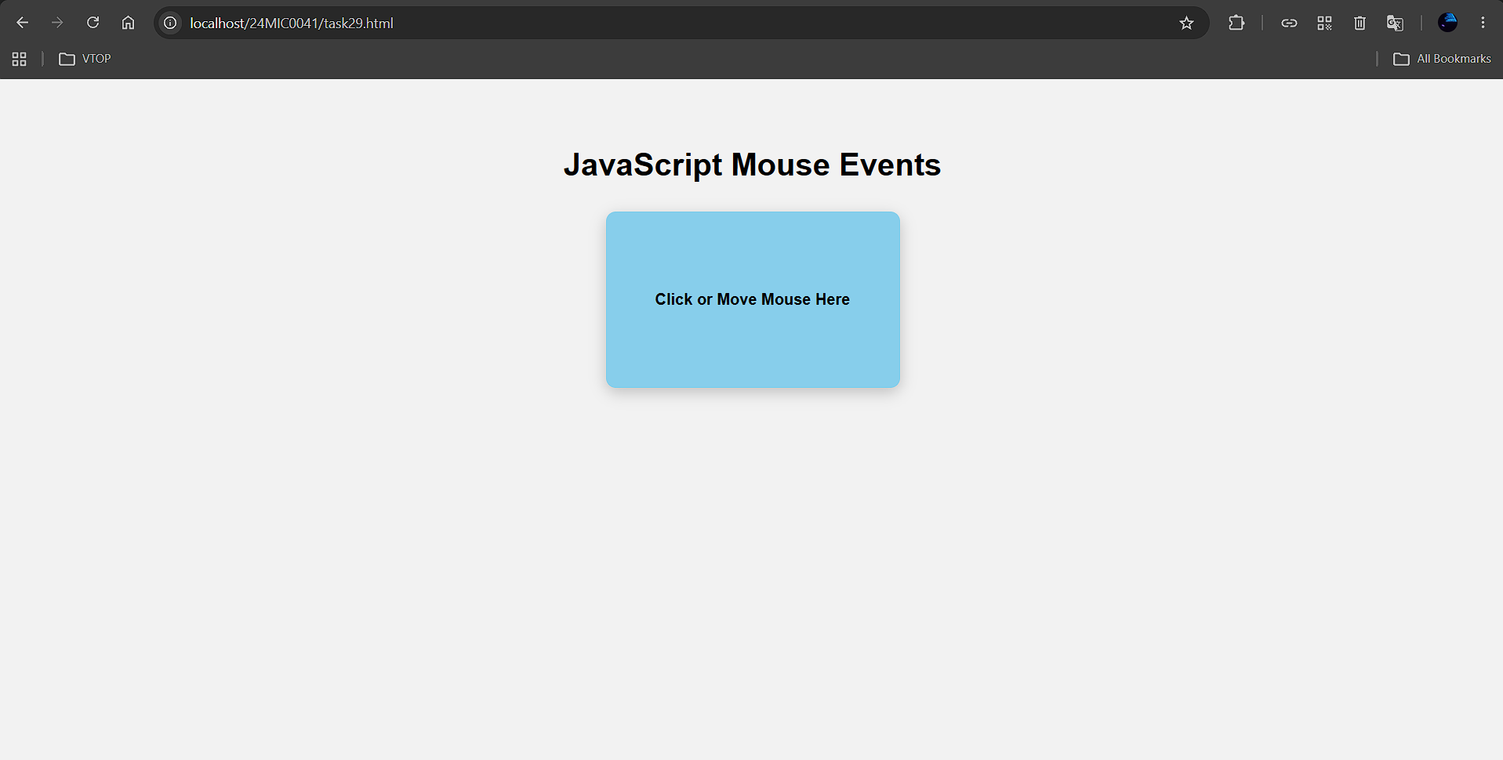
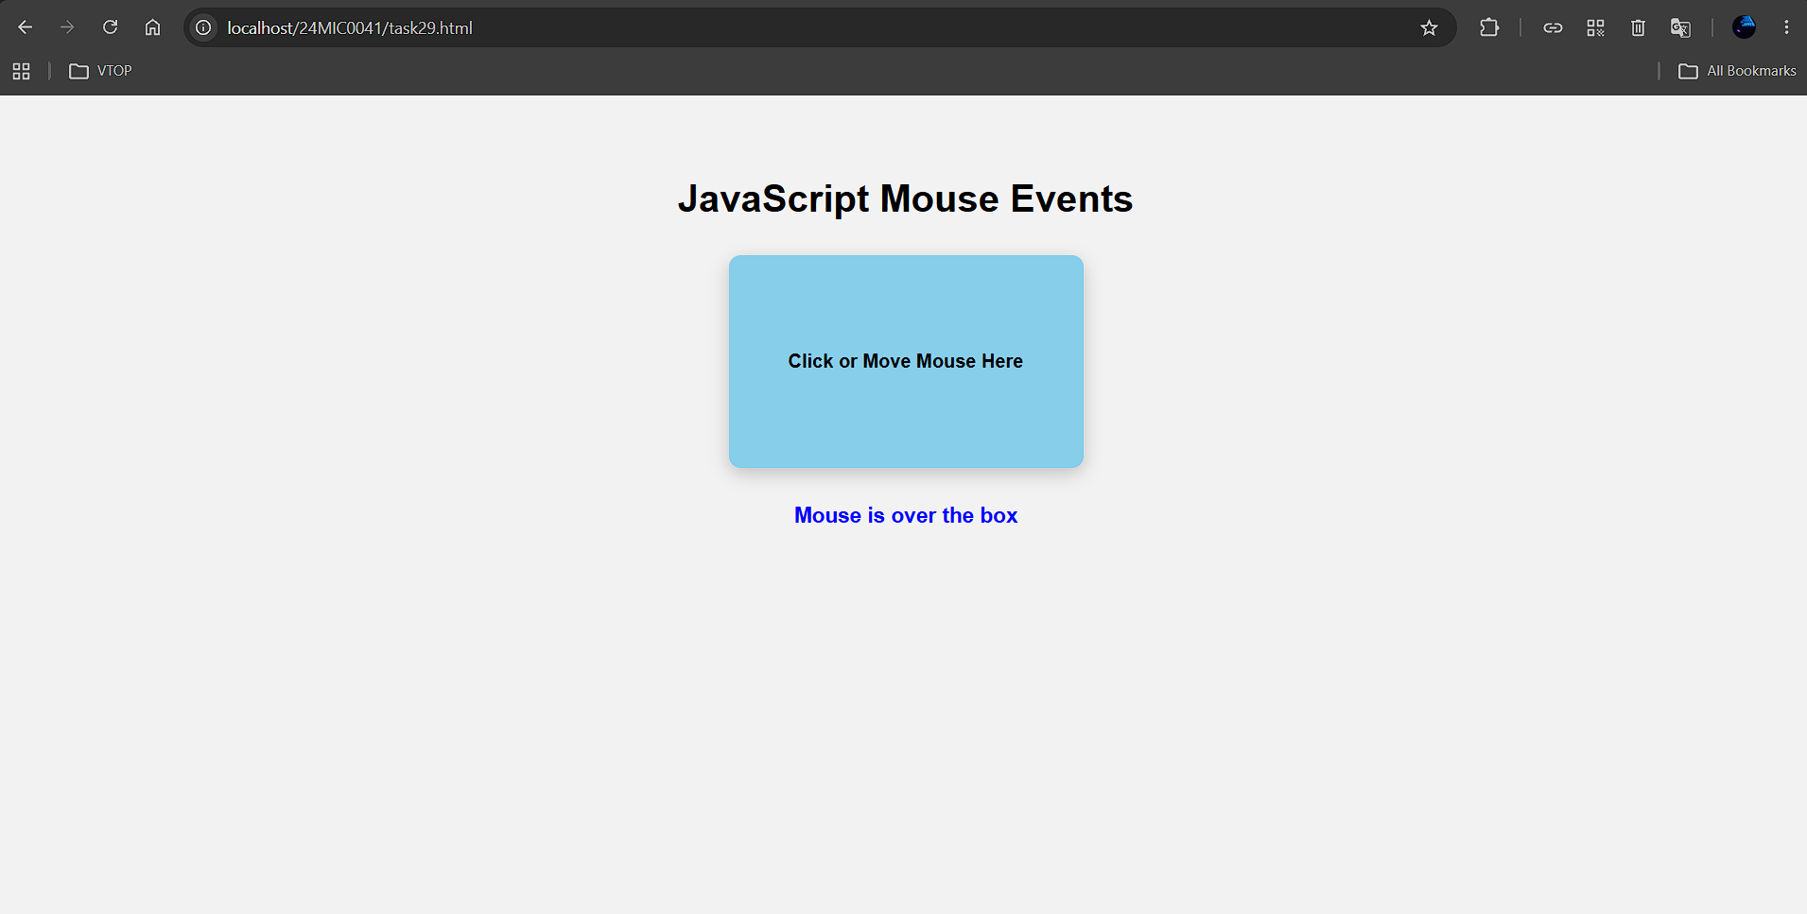

Onclick it changes from blue to lightgreen
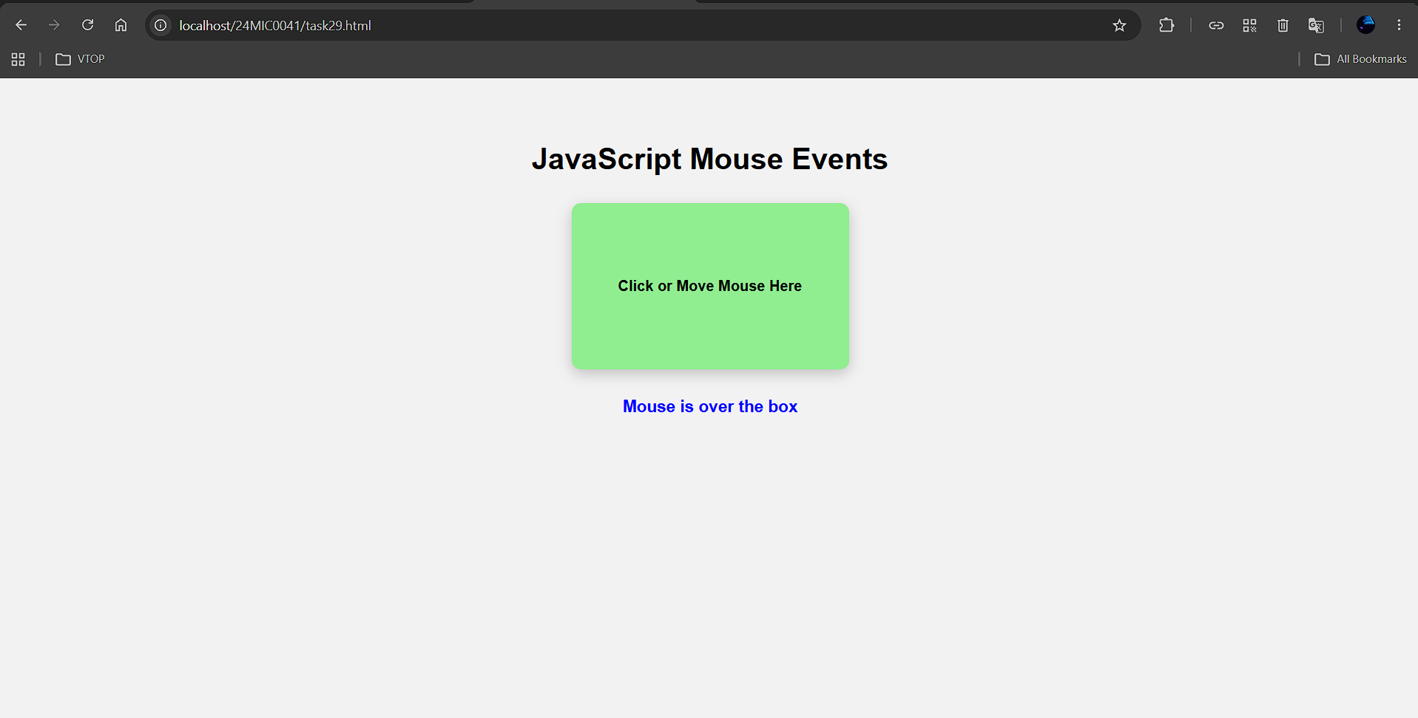
On the another click it changes from light green to yellow
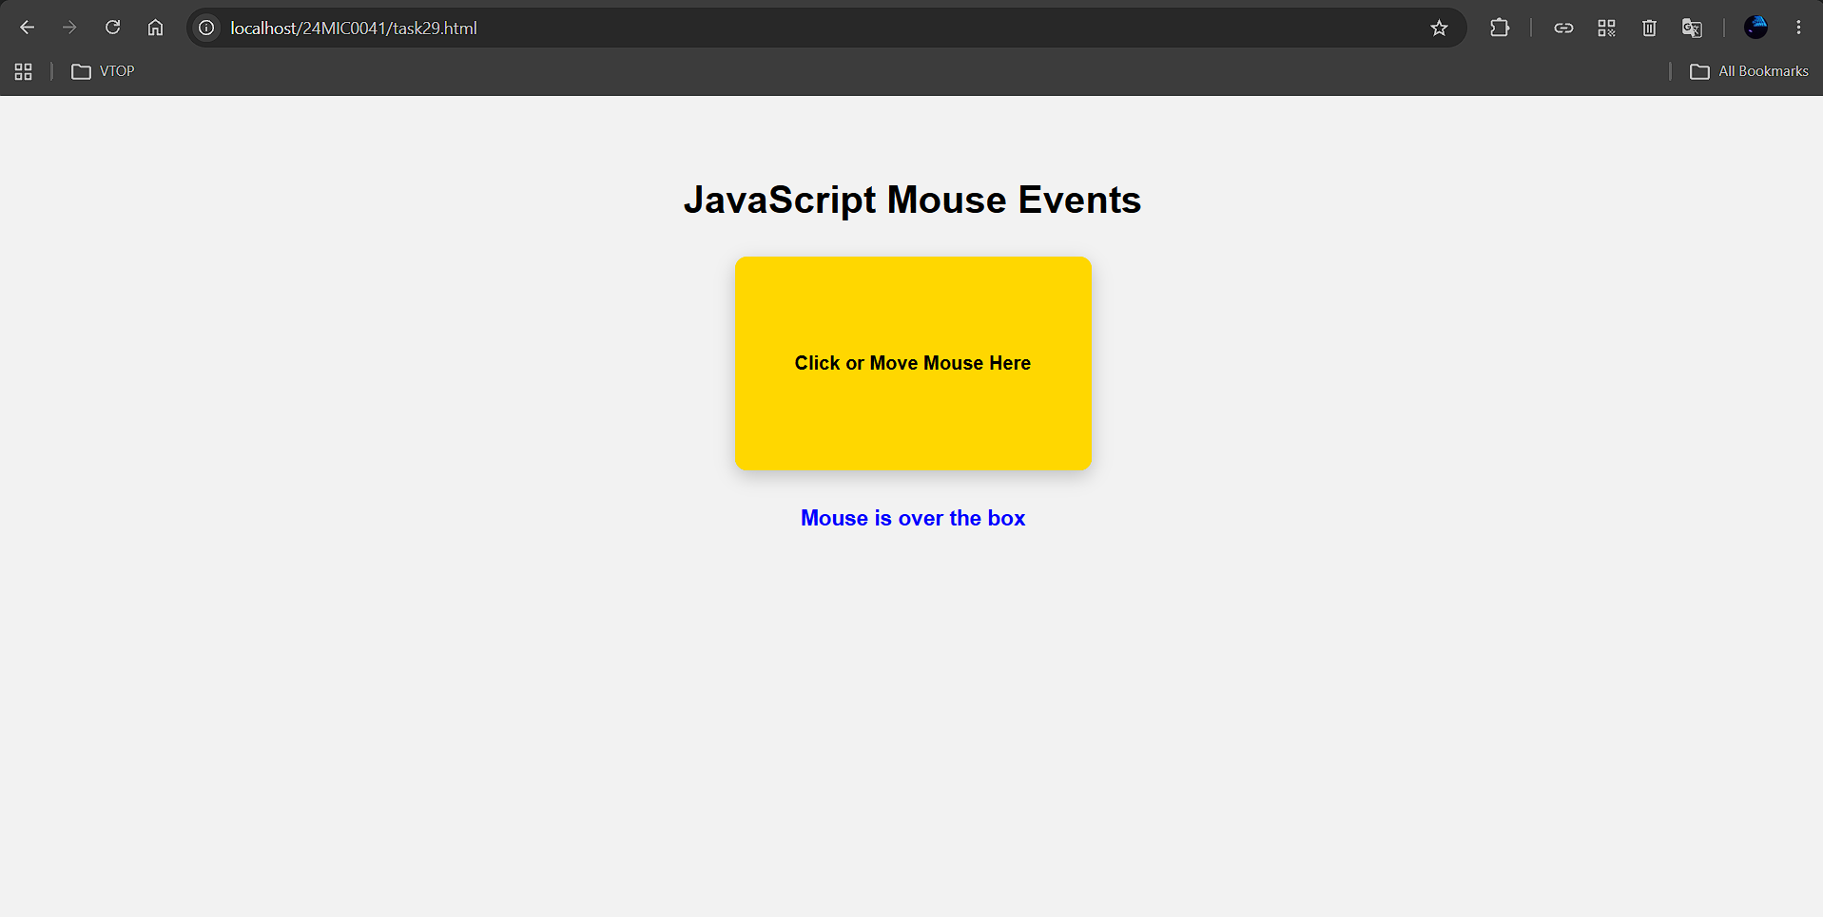

CODE:
