FRONT END DESIGN AND TESTING

NAME: K MAGDIEL JAINSON REG. NO: 24MIC0041

OUTPUT:

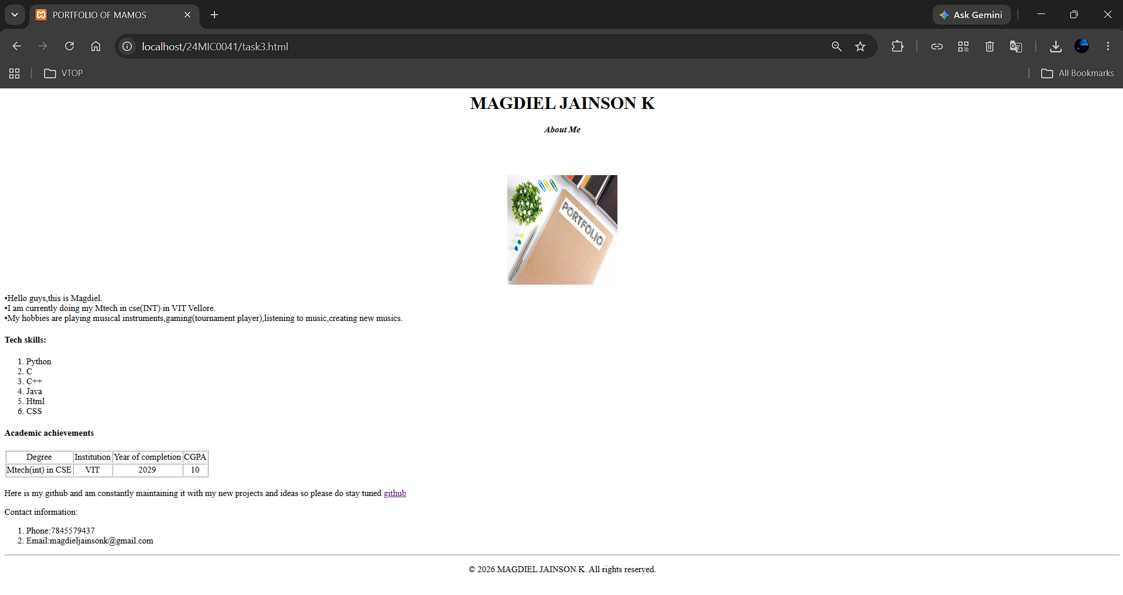

CODE:

