FRONT END DESIGN AND TESTING
  - NAME: K MAGDIEL JAINSON
  - REG. NO: 24MIC0041

OUTPUT:
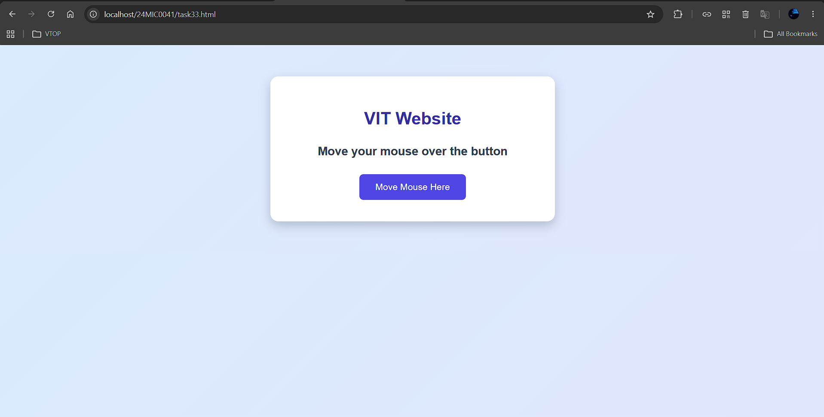
OnMouseOver
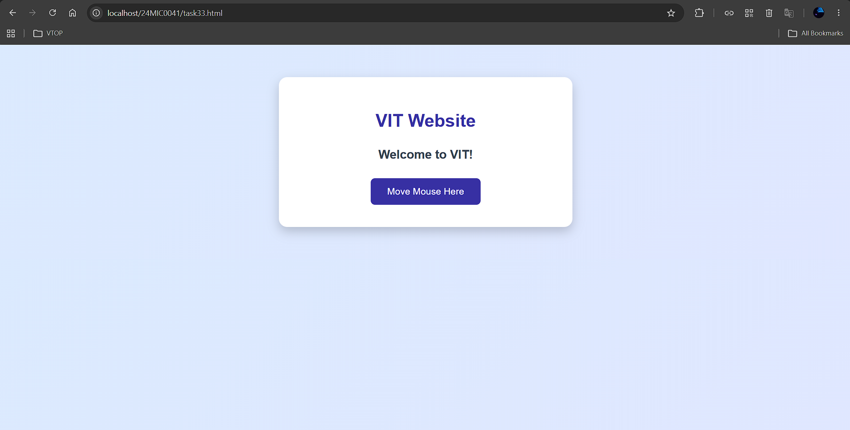

OnMouseOut
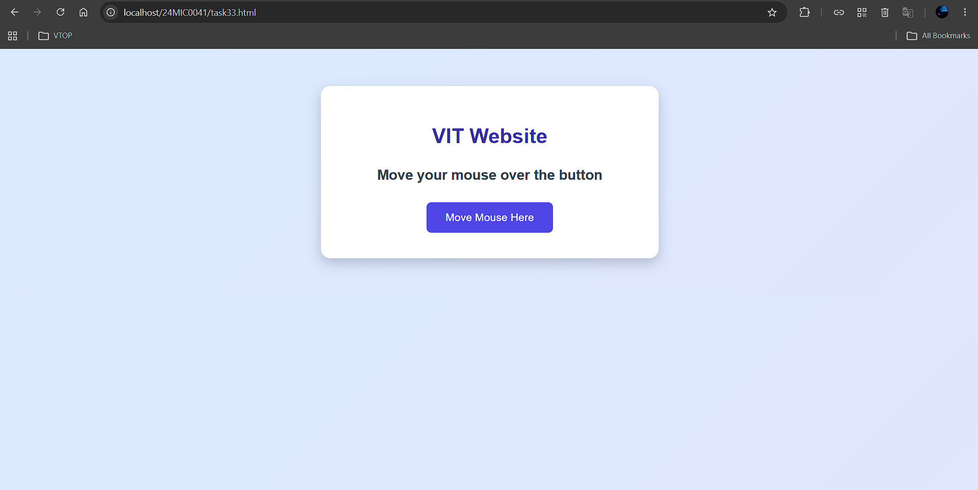

CODE:
