FRONT END DESIGN AND TESTING
  - NAME: K MAGDIEL JAINSON
  - REG. NO: 24MIC0041

OUTPUT:
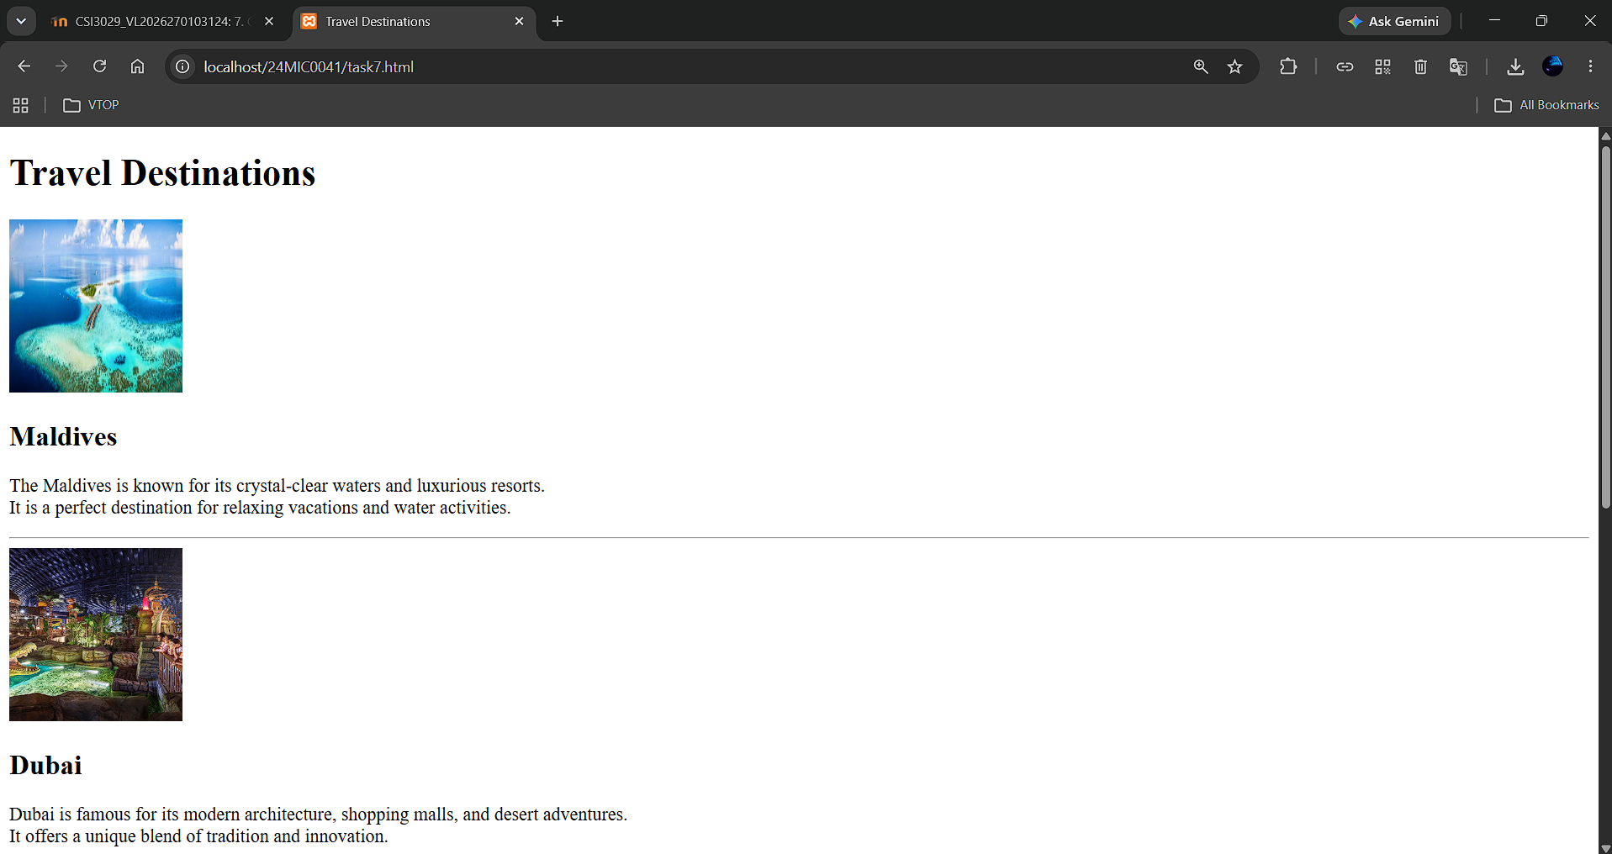

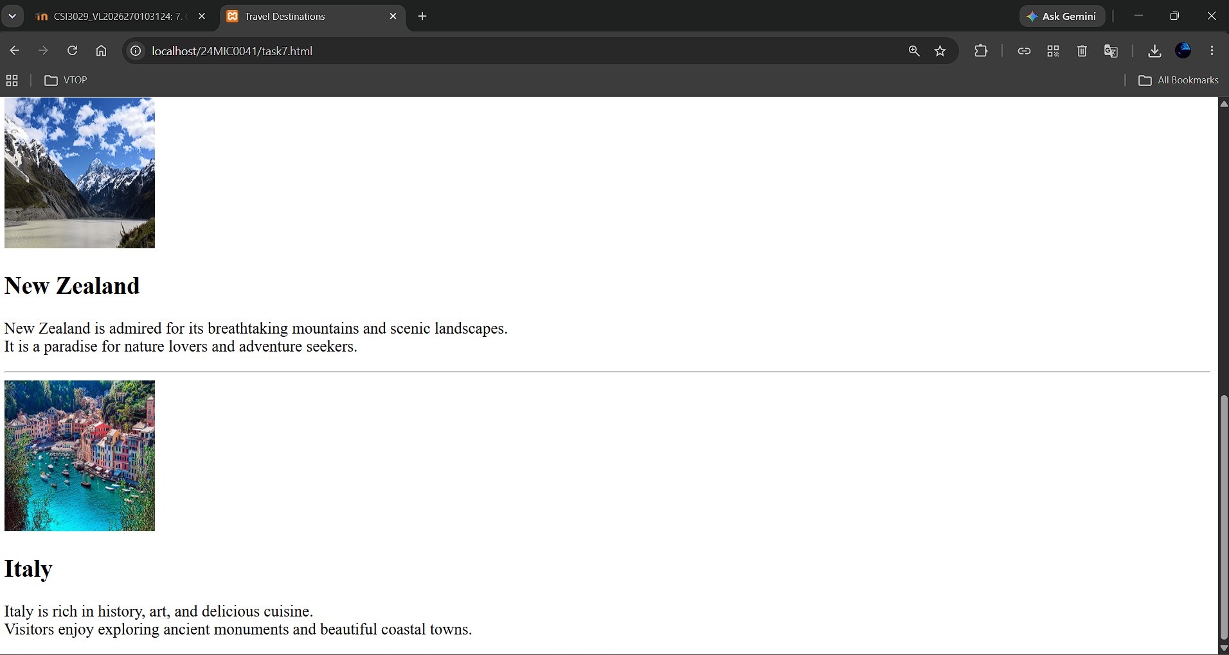

CODE:

