Merge sort

Quick sort

Insertion sort

Bubble sort

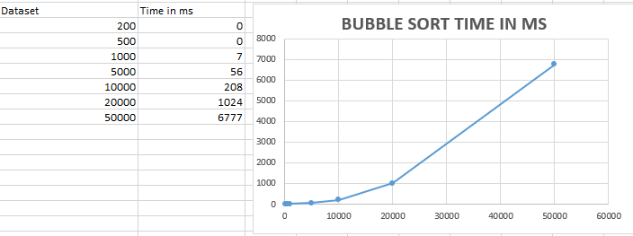

Selection sort

Shell Sort

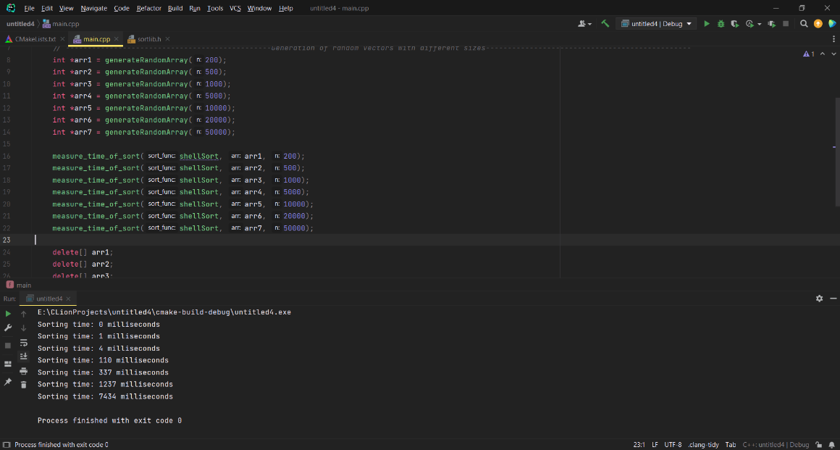

|  |  |
| --- | --- |
| **Array size** | **Sorting time (milliseconds)** |

|  |  |
| --- | --- |
| 200 | 0 |
| 500 | 1 |
| 1000 | 4 |
| 5000 | 110 |
| 10000 | 337 |
| 20000 | 1237 |
| 50000 | 7434 |

Count Sort

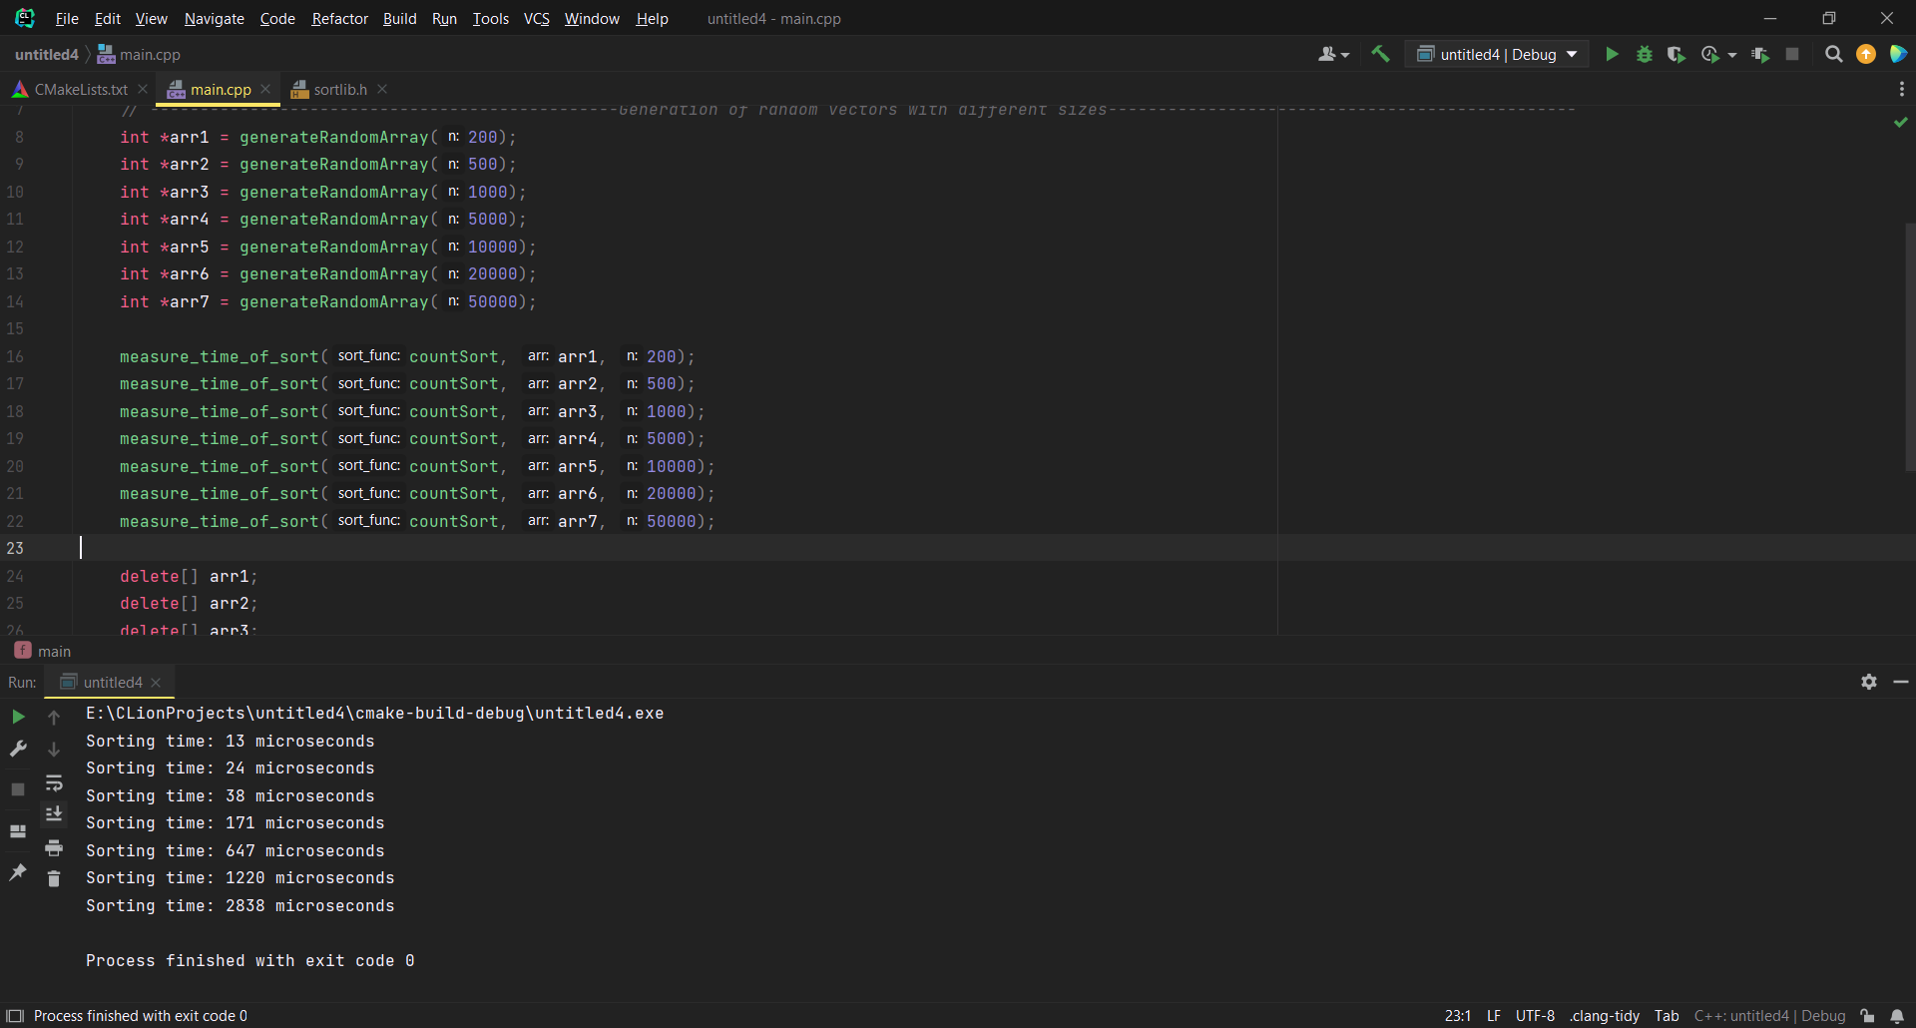

|  |  |
| --- | --- |
| **Array size** | **Sorting time (microseconds)** |

|  |  |
| --- | --- |
| 200 | 13 |
| 500 | 24 |
| 1000 | 38 |
| 5000 | 171 |
| 10000 | 647 |
| 20000 | 1228 |
| 50000 | 2838 |

*Note: count sort is measured in microseconds as it is faster than other algorithms