**Q1**

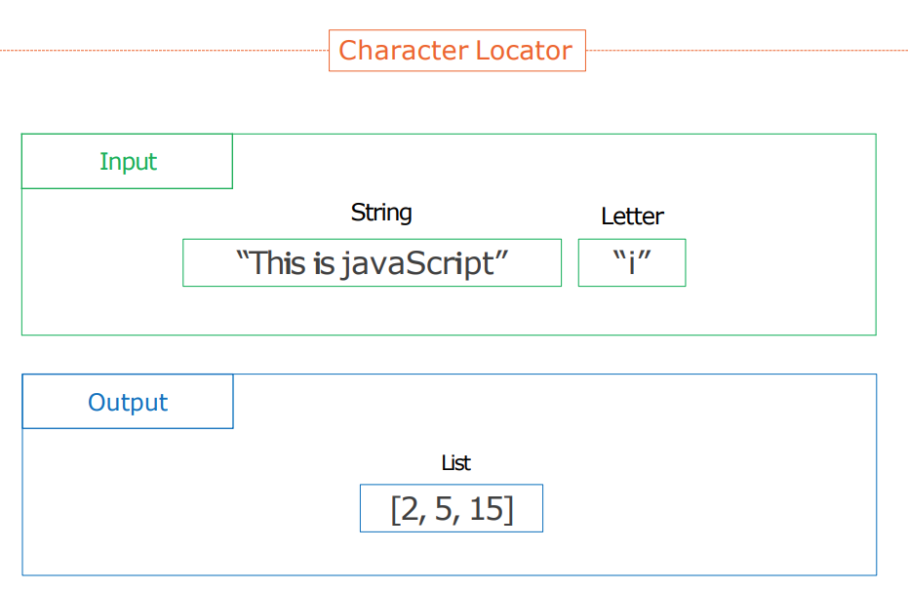

**Q2**

Write a Python script to concatenate following dictionaries to create a new one.

Sample Dictionary :  
dic1={1:10, 2:20}  
dic2={1:30, 4:40}  
dic3={2:50,6:60}