**PDM**

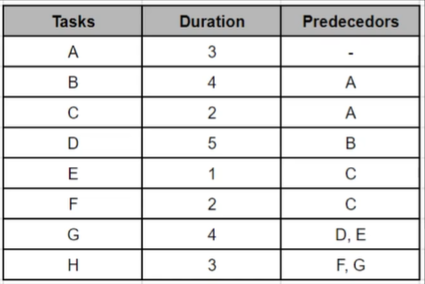

|  |  |  |
| --- | --- | --- |
| **1** | **3** | **3** |
| **TASK A** | | |
| **1** | **0** | **3** |

|  |  |  |
| --- | --- | --- |
| **8** | **5** | **12** |
| **TASK D** | | |
| **8** | **0** | **12** |

|  |  |  |
| --- | --- | --- |
| **4** | **2** | **5** |
| **TASK C** | | |
| **10** | **6** | **11** |

|  |  |  |
| --- | --- | --- |
| **4** | **4** | **7** |
| **TASK B** | | |
| **4** | **0** | **7** |

|  |  |  |
| --- | --- | --- |
| **6** | **1** | **6** |
| **TASK E** | | |
| **12** | **6** | **12** |

|  |  |  |
| --- | --- | --- |
| **6** | **2** | **7** |
| **TASK F** | | |
| **15** | **9** | **16** |

|  |  |  |
| --- | --- | --- |
| **13** | **4** | **16** |
| **TASK G** | | |
| **13** | **0** | **16** |

|  |  |  |
| --- | --- | --- |
| **17** | **3** | **19** |
| **TASK H** | | |
| **17** | **0** | **19** |

**Delivery date: After 19 days.**

**Tasks which can be delayed: C, E & F**