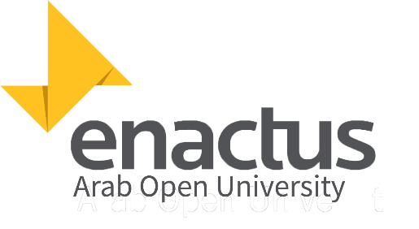

Enactus Arab Open University

Project Management committee

2016-2017 season plan

**______________________________________**

1. First Phase: - **Brainstorming and searching:**

(1: 25, Dec, 2016)

1.1 -Searching for promising projects’ ideas by prospecting for opportunities and problems which face all regions in Egypt nowadays.

(25:30, Dec, 2016)

1.2 -Submission of project charter to Enactus Egypt.

(1: 30, Dec, 2016)

1.3 -Submission of project paper for the strength / weakness of the 4 world cup finalists in coordination with presentation committee.

**______________________________________**

**(1: 25, Jan, 2017)**

**Block days for final exams**

**______________________________________**

2. Second Phase: - **Studying & Planning**

(25:30, Jan, 2017)

2.1- Free time before starting work again.

(1:10, Feb, 2017)

2.2 -Planning for implement the project and making full project analysis by all different suitable methods.

**______________________________________**

3. Final Phase: - **Implementing the projects**

(10, Feb: 30 Apr, 2017)

3.1 – Implementing projects’ tasks according to the project manager instructions and the given time plan

3.2 – All enactus AOU member help project management committee in implementing projects

**______________________________________**

Nada Muhammed Salah

Head of Project management

Enactus Arab Open University

[nadamuhammedsalah@yahoo.com](mailto:nadamuhammedsalah@yahoo.com)

01117241222