How to Check in the code to Github From Eclipse

Step 1: Create a Java Project

Step 2: Right Click on the project and Share the project – Team --> Share Project

Step 3: Create a github Local Directory
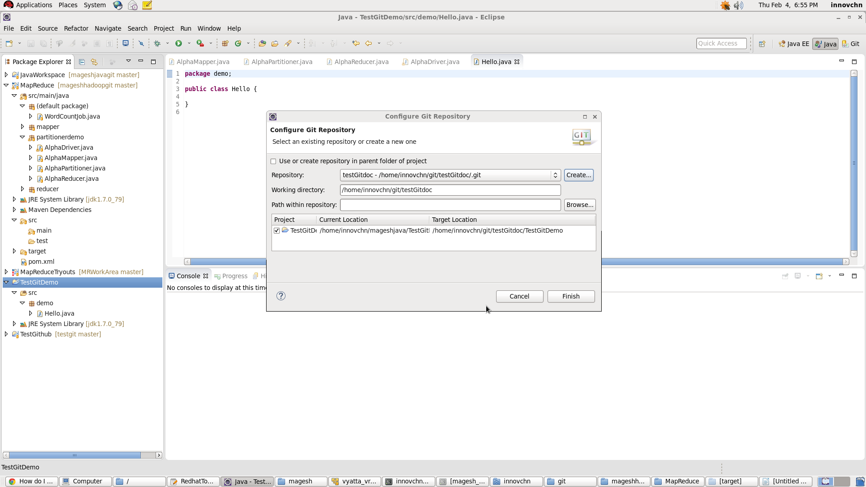

Step 4: Once u clicked Finish the code in the Local work space will moved to the Git hub Local Directory

Step 5: All the code will shown as outgoing mode >>> then right click on the project or code
Team --> Commit. This commit the code in the local reposotiry

Step 6:

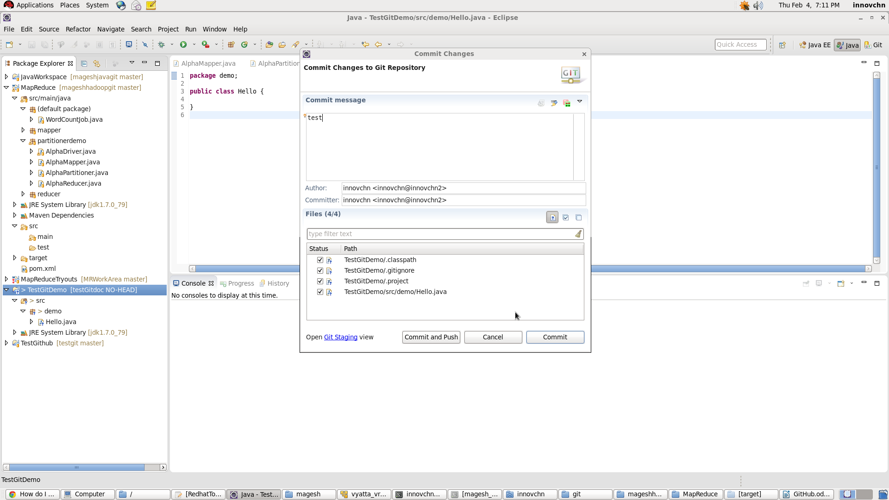
Step 6: Then right Click on the code and click push this will ask for the fill tthe details
