Setting Up Horizontal Pod Autoscaler (HPA) on Google Kubernetes Engine (GKE) Autopilot
GKE Autopilot is a fully managed Kubernetes solution where Google automatically manages node scaling, so you only focus on deploying your app and configuring HPA for pod-level scaling based on demand.

✅ Step 1: Set Up a GKE Autopilot Cluster
1️⃣ Login to Google Cloud Console
👉 GCP Console
2️⃣ Enable Kubernetes Engine API
Run this in Cloud Shell:
sh
CopyEdit
gcloud services enable container.googleapis.com
3️⃣ Create an Autopilot Cluster
sh
CopyEdit
gcloud container clusters create-auto my-autopilot-cluster \
--region us-central1 \
--project YOUR_PROJECT_ID
☑ Replace YOUR_PROJECT_ID with your actual Google Cloud project ID.

✅ Step 2: Deploy a Sample Application (Nginx)
We’ll deploy an Nginx web server as a sample workload.
1️⃣ Create a deployment with CPU requests/limits
yaml
CopyEdit
apiVersion: apps/v1
kind: Deployment
metadata:
name: nginx-deployment
spec:
replicas: 1
selector:
matchLabels:
app: nginx
template:
metadata:
labels:
app: nginx
spec:
containers:
- name: nginx
image: nginx
resources:
requests:
cpu: "100m"
limits:
cpu: "500m"
Save this as nginx-deployment.yaml and apply it:
sh
CopyEdit
kubectl apply -f nginx-deployment.yaml

✅ Step 3: Enable Metrics Server (Required for HPA)
GKE Autopilot comes with metrics-server pre-installed, so you don’t need to install it manually.
Verify it is running:
sh
CopyEdit
kubectl get deployment metrics-server -n kube-system
If it’s running, you're good to go! 🚀

✅ Step 4: Create an HPA (Horizontal Pod Autoscaler)
Now, create an HPA that scales based on CPU usage.
1️⃣ Apply HPA:
yaml
CopyEdit
apiVersion: autoscaling/v2
kind: HorizontalPodAutoscaler
metadata:
name: nginx-hpa
spec:
scaleTargetRef:
apiVersion: apps/v1
kind: Deployment
name: nginx-deployment
minReplicas: 2
maxReplicas: 10
metrics:
- type: Resource
resource:
name: cpu
target:
type: Utilization
averageUtilization: 50
Save this as nginx-hpa.yaml and apply it:
sh
CopyEdit
kubectl apply -f nginx-hpa.yaml
✅ This configures HPA to:
- Scale up/down between 2 to 10 replicas
- Trigger scaling if average CPU utilization > 50%

✅ Step 5: Test Auto-Scaling by Generating Load
1️⃣ Find the pod names
sh
CopyEdit
kubectl get pods
2️⃣ Run a load test using a busy loop
Replace nginx-pod-name with an actual pod name:
sh
CopyEdit
kubectl exec -it nginx-pod-name -- /bin/sh -c "while true; do :; done"
This simulates high CPU usage, triggering HPA.
3️⃣ Monitor Scaling Activity
sh
CopyEdit
kubectl get hpa -w
You should see replica count increasing as load increases.

✅ Step 6: Cleanup (Optional)
If you want to remove everything:
sh
CopyEdit
kubectl delete deployment nginx-deployment
kubectl delete hpa nginx-hpa
gcloud container clusters delete my-autopilot-cluster --region us-central1

🎯 Summary
✅ GKE Autopilot manages infrastructure → You focus on deploying applications
✅ HPA automatically scales pods based on CPU utilization
✅ You tested autoscaling by simulating CPU load
Would you like to extend this setup with custom metrics (e.g., RPS-based scaling)? 🚀
4o

O

Search
Reason
ChatGPT can make mistakes. Check important info.

---------------------------------------

What difference between minikube and kubectl

🔍 Difference Between Minikube and Kubectl
Feature | Minikube 🏗️ | Kubectl 📌
What It Is | A tool that runs a local Kubernetes cluster | A command-line tool to interact with Kubernetes clusters
Purpose | Helps developers test and learn Kubernetes locally | Used to manage Kubernetes resources (pods, deployments, services, etc.)
How It Works | Runs a single-node Kubernetes cluster inside a VM or container on your local machine | Sends commands to a remote Kubernetes API server
Installation | Requires VirtualBox, Docker, or KVM to create a local cluster | Requires only a Kubernetes cluster and config file (~/.kube/config)
Usage Example | minikube start (to create a local cluster) | kubectl get pods (to list running pods)
Scope | Limited to local testing and development | Used to manage both local and cloud-based Kubernetes clusters

🚀 Summary
- Minikube is for running Kubernetes locally (great for learning & testing).
- Kubectl is a CLI tool for interacting with any Kubernetes cluster (local or cloud).
- ✔ kubectl uses contexts to connect to different cloud clusters.
✔ Use kubectl config get-contexts to check available clusters.
✔ Use kubectl config use-context <context-name> to switch between Azure, GCP, or AWS clusters.
---------------------

Before you begin
You need to have a Kubernetes cluster, and the kubectl command-line tool must be configured to communicate with your cluster
----------------------------------\

What is a Pod in Kubernetes?
A Pod is the smallest and simplest unit in Kubernetes. It represents a single instance of a running application in a cluster.
This is the target of the autoscaling.
----------------------------------------

Service is a method for exposinnetwork application(Example : nginx web server) that runs as one opr multiple pods in the cluster.

---------------------------------------

Replica Set (RS)

Replica Set(RS) controls how many pods must be deployed in the cluster. Autoscaling adjust the desired pod count in RS to execute scale-up/down commands.

----------------------------------------

Monitor-analysis-plan-Execute (MAPE).

Horizontal Pod Autoscaler (HPA)

--------------------

What is INGRESS_HOST in Kubernetes?
INGRESS_HOST is a variable that represents the host/domain name used to access services via an Ingress Controller in Kubernetes. It is commonly used when configuring Ingress resources to expose services to external users.

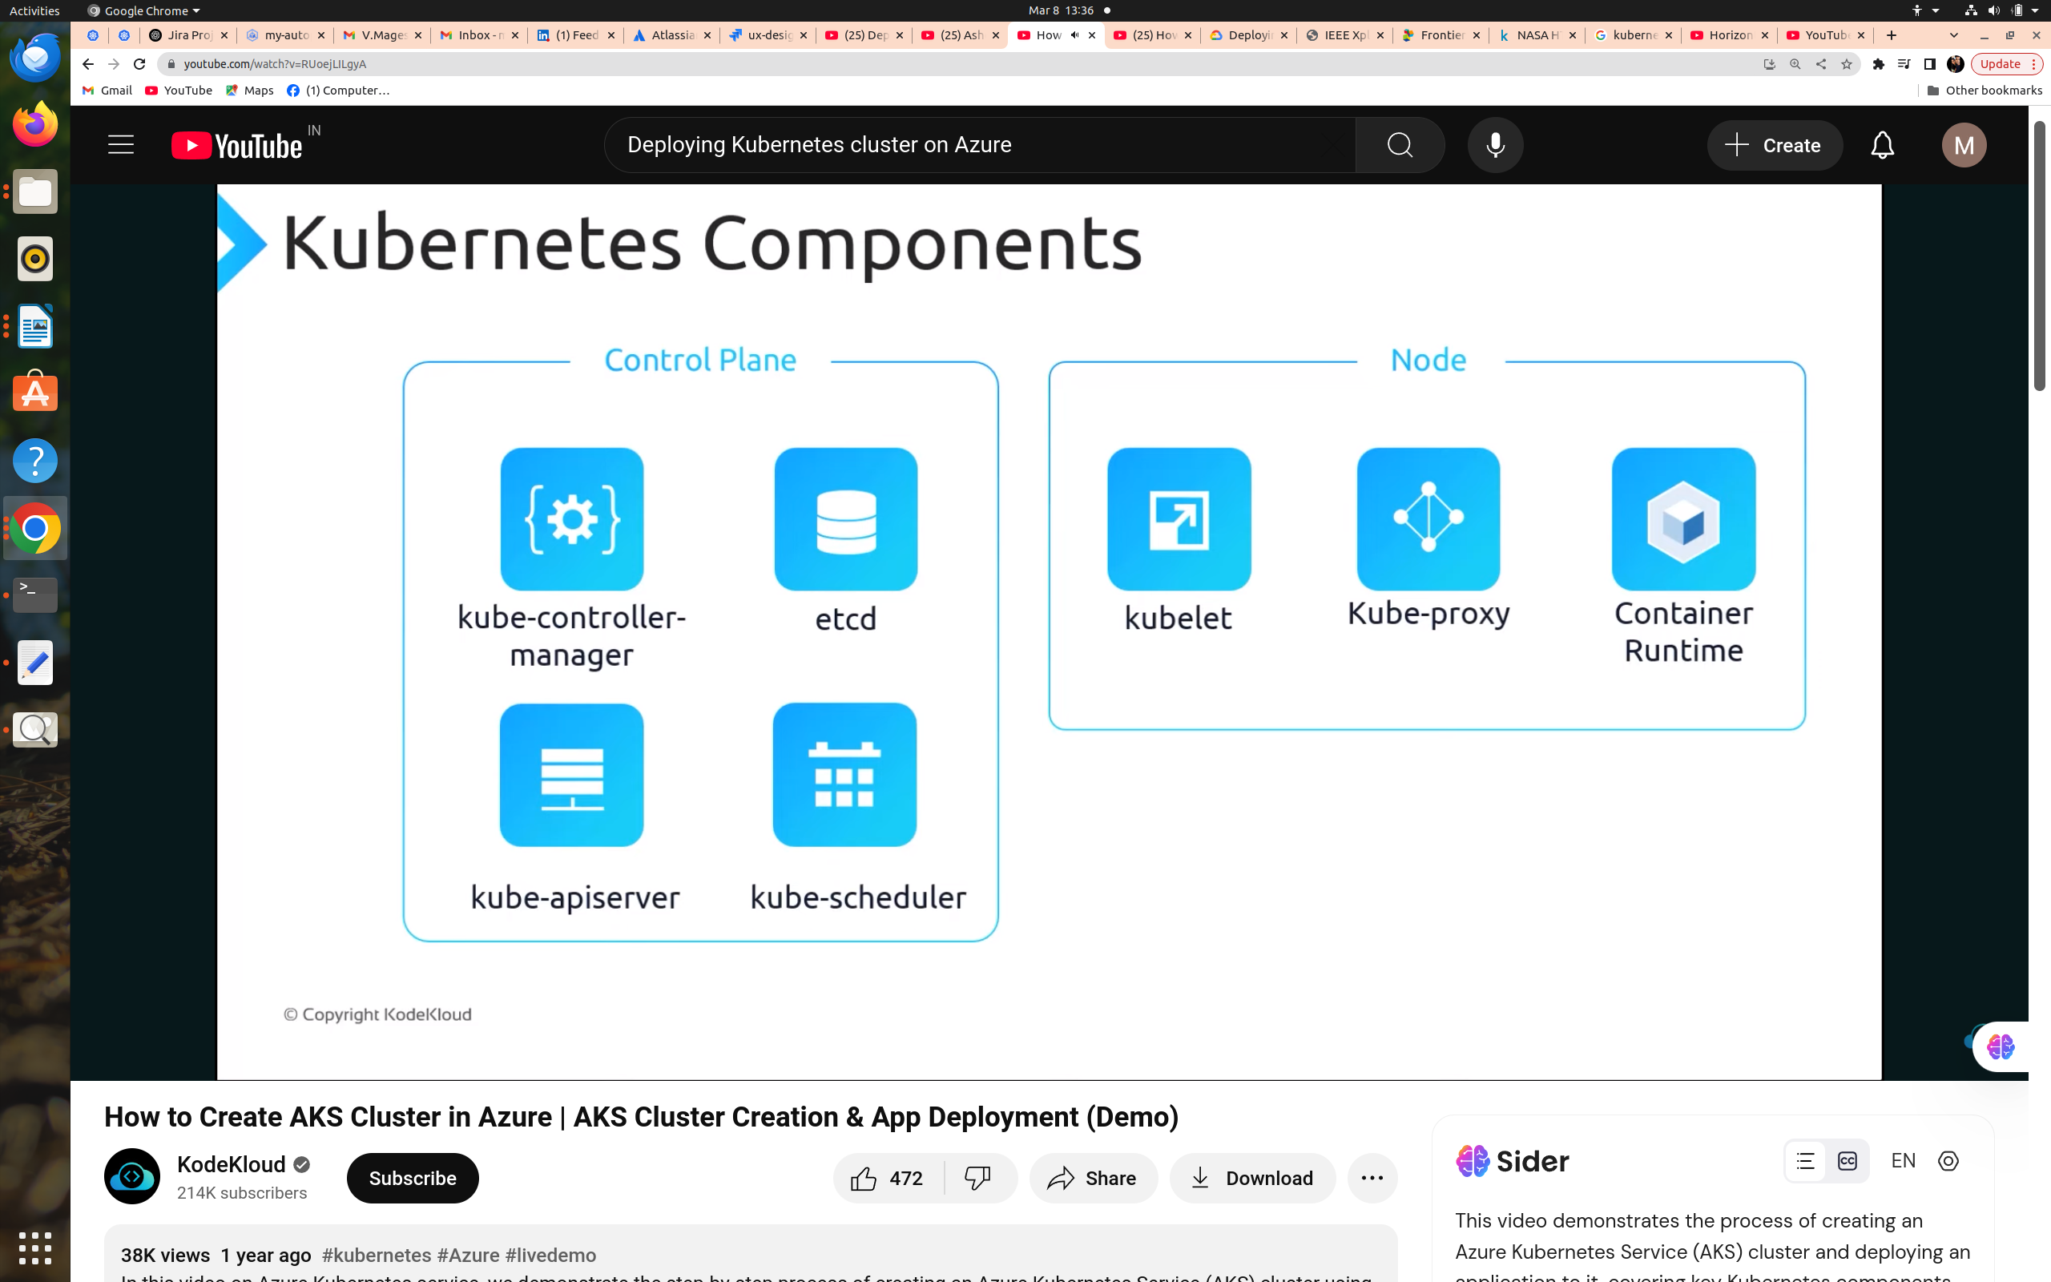
-----------------------

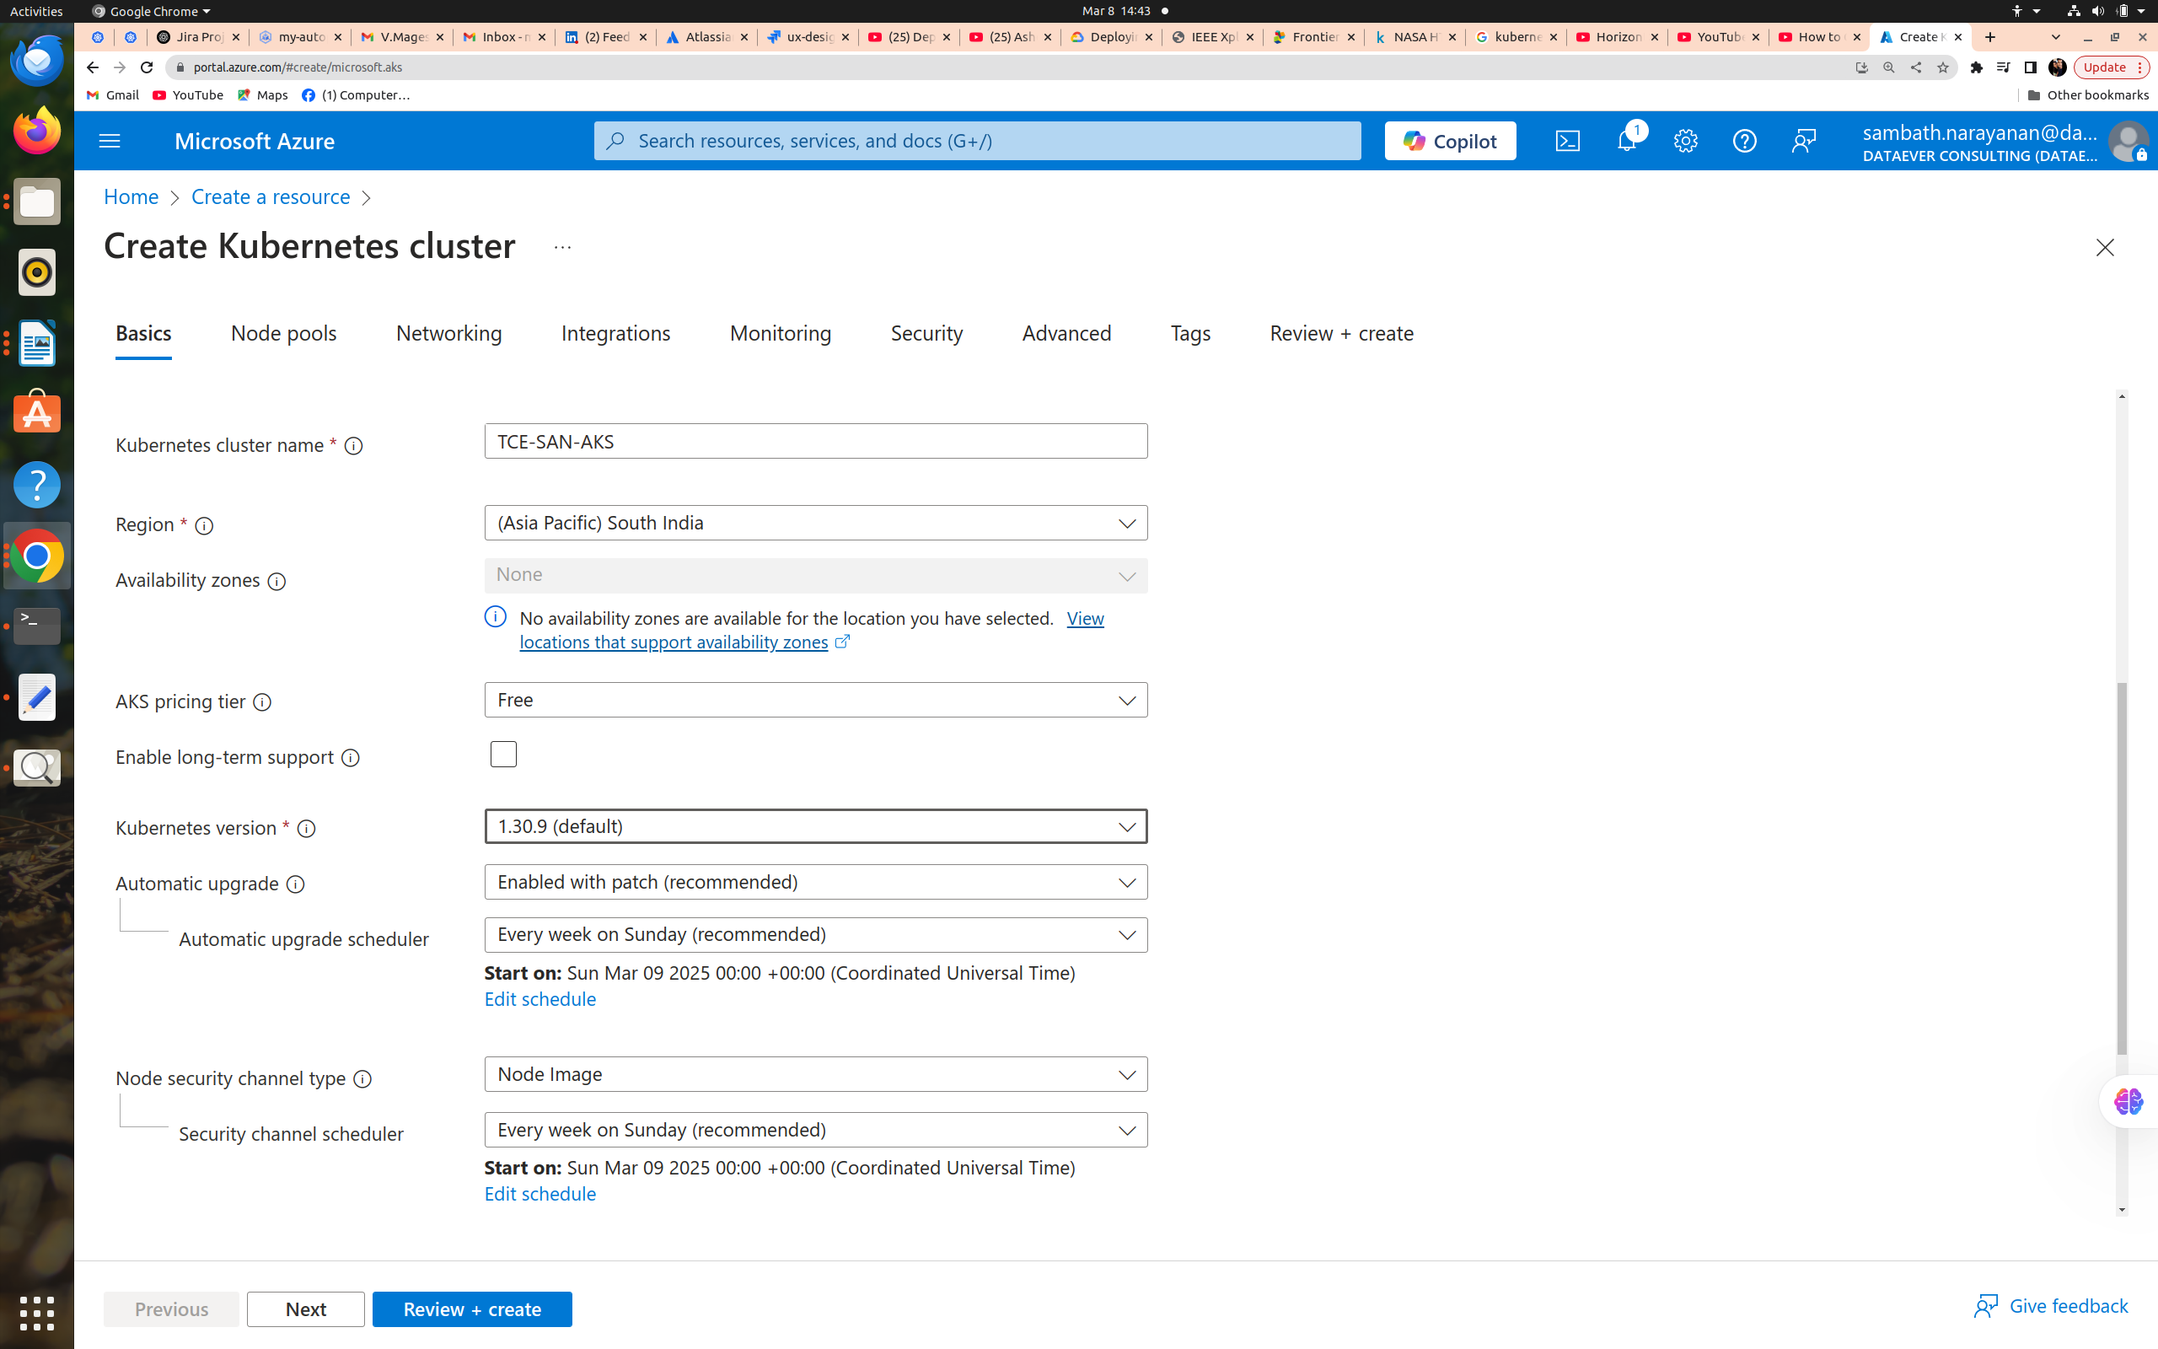
chchchg

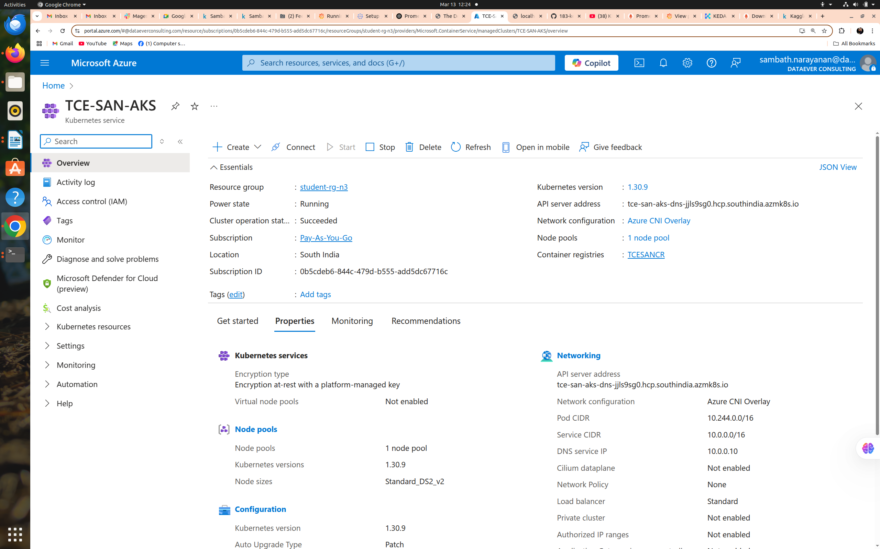

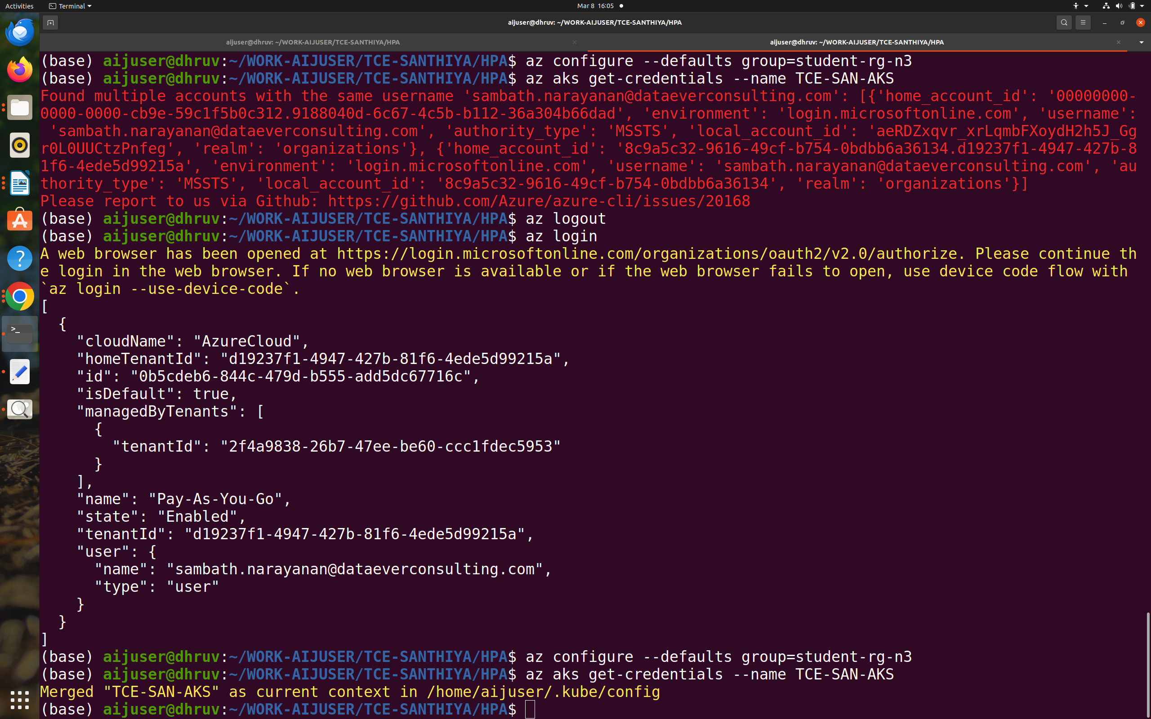

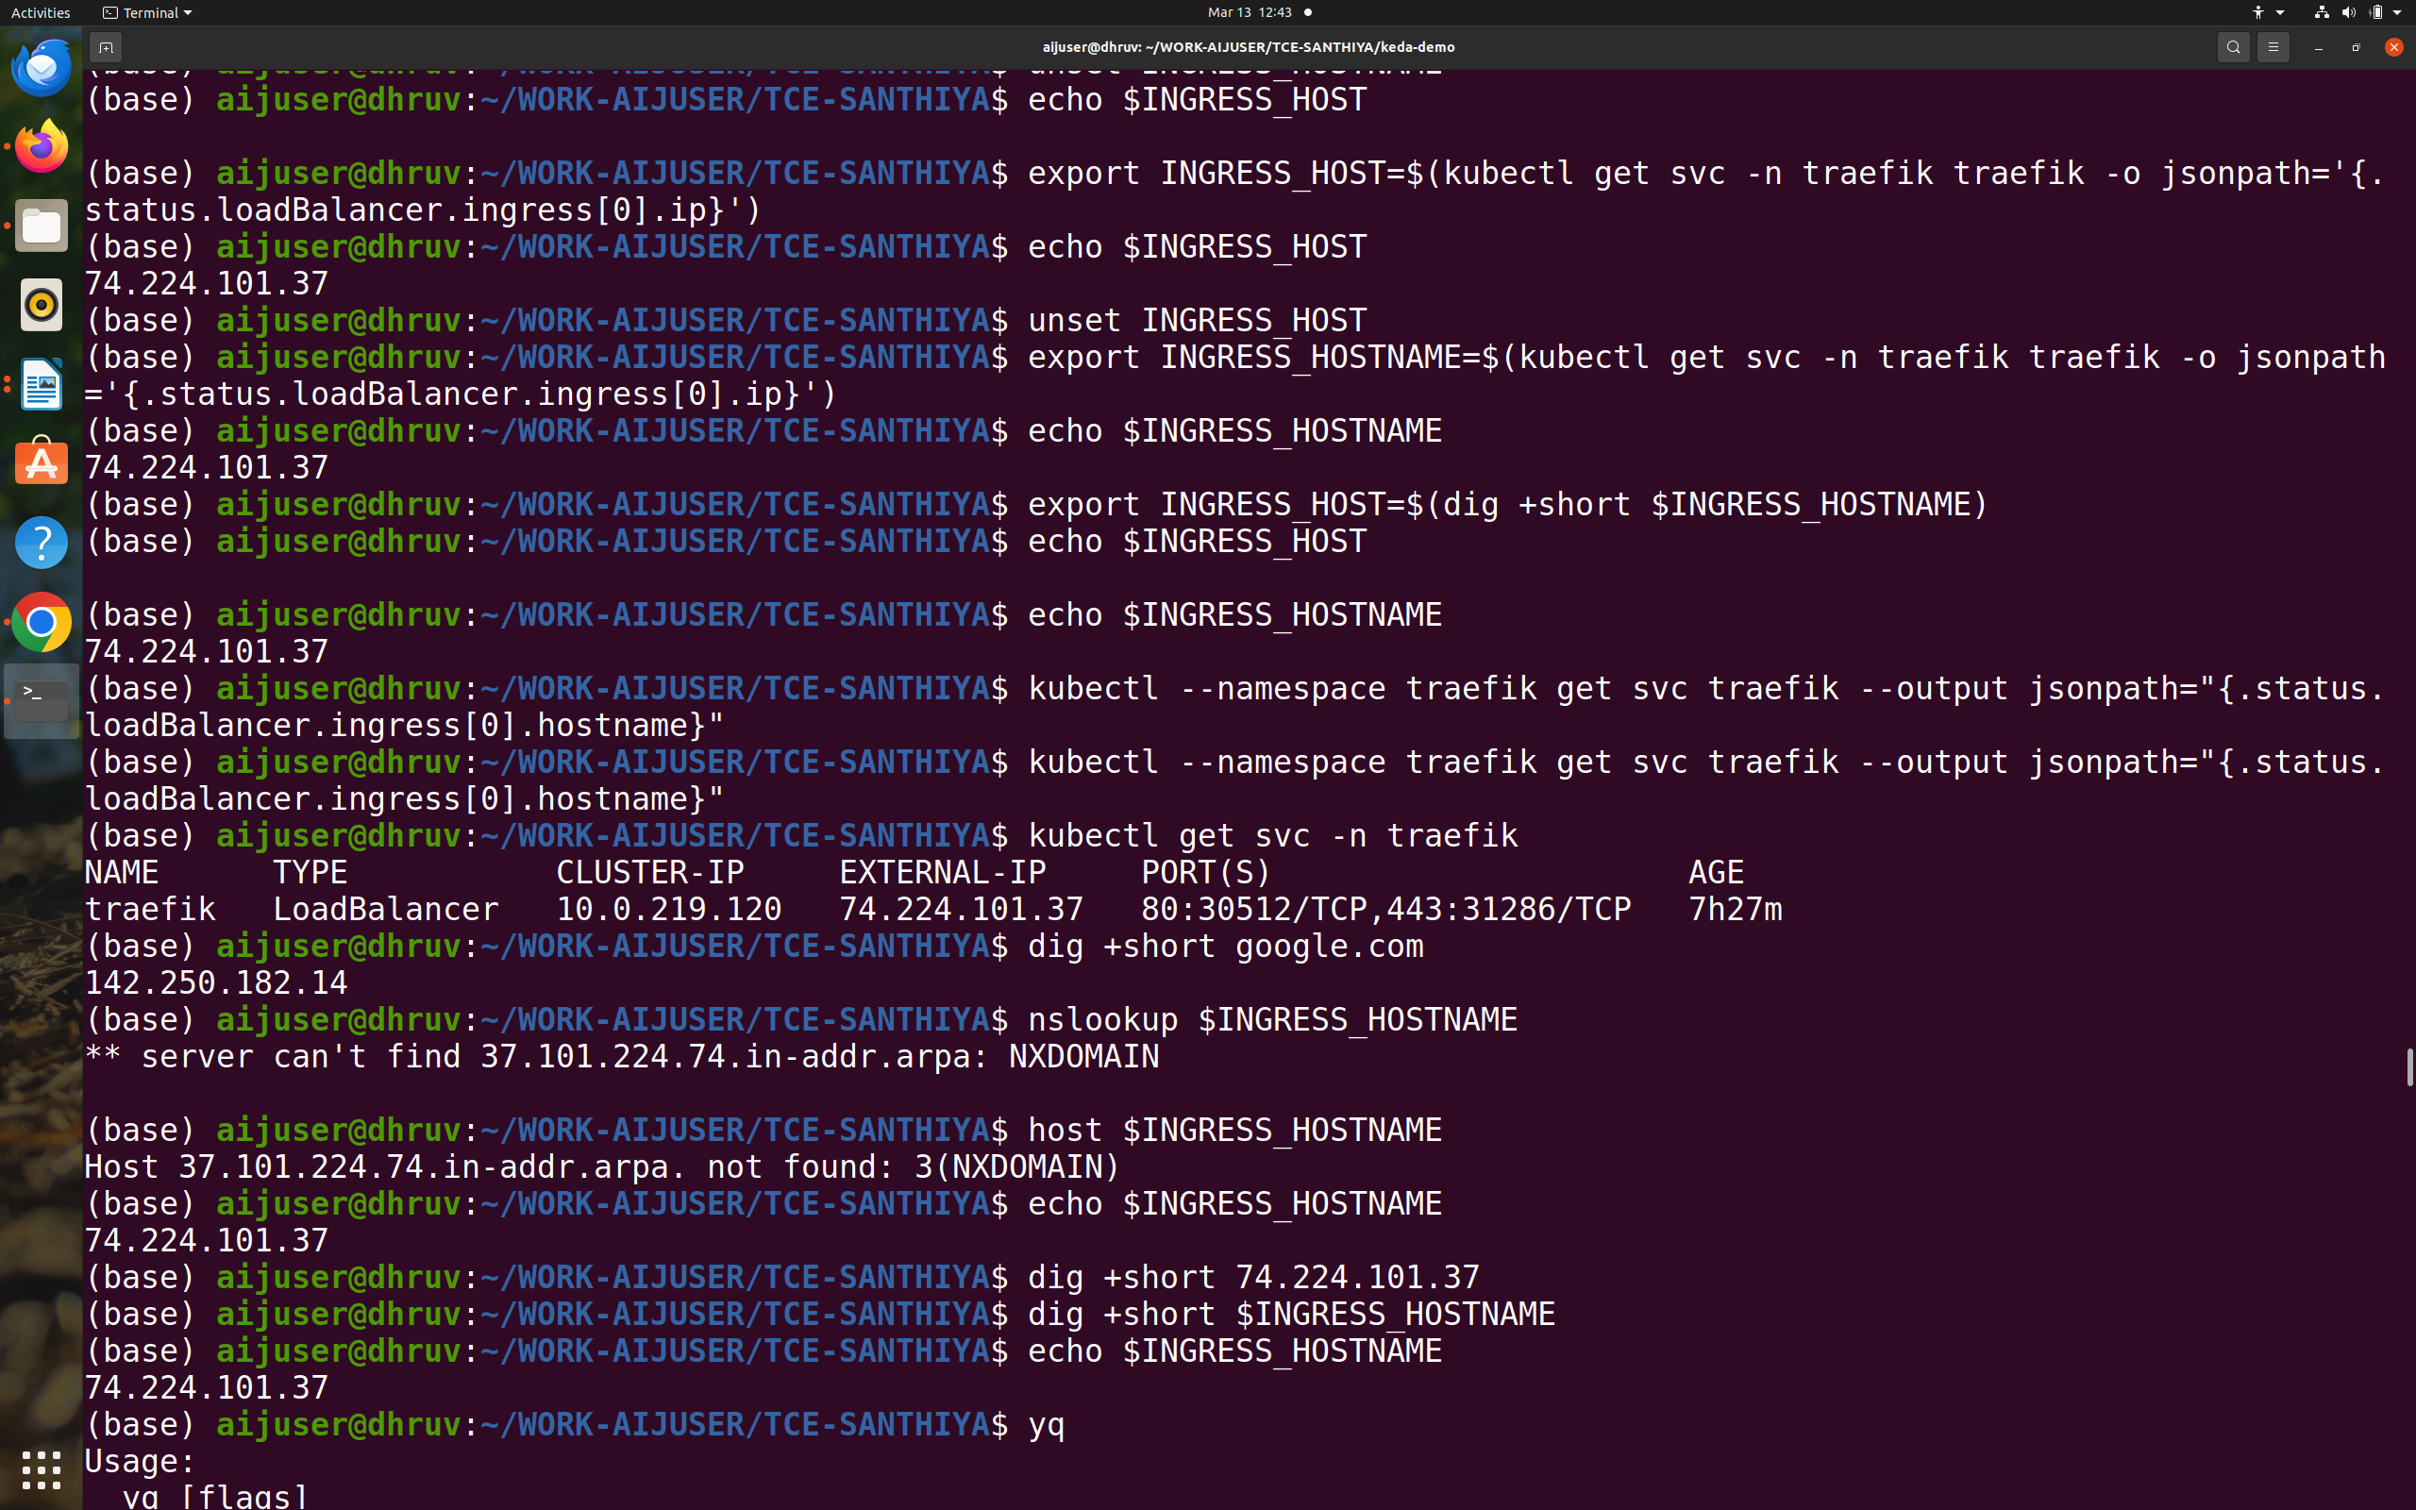
Commands :

- Login into azure cloud account

aijuser@dhruv:~/WORK-AIJUSER/TCE-SANTHIYA/HPA$ az login

- Configure the Azure Resoruce Group.

aijuser@dhruv:~/WORK-AIJUSER/TCE-SANTHIYA/HPA$ az configure --defaults group=student-rg-n3

- Give a Azure Kubernetes Cluster Credentials.

aijuser@dhruv:~/WORK-AIJUSER/TCE-SANTHIYA/HPA$ az aks get-credentials --name TCE-SAN-AKS

aijuser@dhruv:~/WORK-AIJUSER/TCE-SANTHIYA/HPA$ az acr login --name TCESANCR

Login Succeeded

/home/aijuser/WORK-AIJUSER/TCE-SANTHIYA$ helm repo add traefik https://helm.traefik.io/traefik

(base) aijuser@dhruv:~/WORK-AIJUSER/TCE-SANTHIYA$ helm repo update
Hang tight while we grab the latest from your chart repositories...
...Successfully got an update from the "kedacore" chart repository
...Successfully got an update from the "traefik" chart repository
...Successfully got an update from the "robusta" chart repository
...Successfully got an update from the "grafana" chart repository
...Successfully got an update from the "prometheus-community" chart repository
Update Complete. ⎈Happy Helming!⎈

(base) aijuser@dhruv:~/WORK-AIJUSER/TCE-SANTHIYA$ helm upgrade --install traefik traefik/traefik --namespace traefik --create-namespace --wait
Release "traefik" does not exist. Installing it now.
NAME: traefik
LAST DEPLOYED: Wed Mar 12 15:26:01 2025
NAMESPACE: traefik
STATUS: deployed
REVISION: 1
TEST SUITE: None
NOTES:
traefik with docker.io/traefik:v3.3.4 has been deployed successfully on traefik namespace !

- How to list namespace?

kubectl get namespace

- Check if Traefik is Exposing a LoadBalancer

kubectl --namespace traefik get svc traefik
NAME TYPE CLUSTER-IP EXTERNAL-IP PORT(S) AGE
traefik LoadBalancer 10.0.219.120 74.224.101.37 80:30512/TCP,443:31286/TCP 14m

aijuser@dhruv:~/WORK-AIJUSER/TCE-SANTHIYA/HPA/k8s_metrics_server$ ls

deploy README.md

git clone https://github.com/ashokitschool/k8s_metrics_server.git
520 ls
521 cd k8s_metrics_server/
522 ls
523 cd deploy/
533 cd 1.8+/
534 ls
536 kubectl apply -f .
537 ls
538 kubectl top nodes
539 kubectl top pods

aijuser@dhruv:~/WORK-AIJUSER/TCE-SANTHIYA/HPA$ pwd

/home/aijuser/WORK-AIJUSER/TCE-SANTHIYA/HPA

git clone https://github.com/ashokitschool/kubernetes_manifest_yml_files.git

571 ls
572 cd kubernetes_manifest_yml_files/
573 ls
574 cd 05-HPA/
575 kubectl apply -f 01_Deployment.yml
576 kubectl get deploy
577 kubectl apply -f 02_Service.yml
578 kubectl get deploy
579 kubectl get svc
580 kubectl apply -f 03_HPA.yml
581 kubectl get hpa
582 kubectl get pods
583 kubectl run -i --tty load-generator --rm --image=busybox --restart=Never -- /bin/sh -c "while sleep 0.01; do wget -q -o- http://hpa-demo-deployment; done"

use the following

kubectl run -i --tty load-generator --rm --image=busybox --restart=Never -- /bin/sh -c "while sleep 0.01; do wget --spider -q http://hpa-demo-deployment; done"

watch -n 1 "kubectl get pods"

To delete the load-generator pod, run:
bash
CopyEdit

kubectl delete pod load-generator
-----------------------------------------------

kubectl describe ingress example-ingress -n default

Name: example-ingress
Labels: <none>
Namespace: default
Address: 74.224.101.37
Ingress Class: traefik
Default backend: <default>
Rules:
Host Path Backends
---- ---- --------
example.com
/ example-service:80 (<error: endpoints "example-service" not found>)
Annotations: <none>
Events: <none>
---------------------------------------------------
echo "http://dot.$INGRESS_HOST.nip.io"
http://dot.74.224.101.37.nip.io
-----------------------------------------------------
kubectl apply -f ingress-basic.yaml
749 history | grep kubectl
750 kubectl get svc
751 kubectl get namespace
752 kubectl get pods -n default
753 kubectl get pods -n default
754 cat ingress-basic.yaml
755 kubectl get ingress -A
756 kubectl delete ingress nginx-ingress
757 kubectl get ingress -A
758 kubectl get pods -n default
759 kubectl get pods --all-namespaces
760 kubectl get svc --all-namespaces
761 echo "http://dot.$INGRESS_HOST.nip.io"
762 echo $INGRESS_HOST
763 unset INGRESS_HOST
764 export INGRESS_HOST=$(kubectl get svc -n ingress-nginx ingress-nginx-controller -o jsonpath='{.status.loadBalancer.ingress[0].ip}')
765 echo $INGRESS_HOST
766 kubectl delete svc ingress-nginx-controller
767 kubectl delete svc ingress-nginx-controller -n ingress-nginx
768 kubectl delete svc ingress-nginx-controller-admission -n ingress-nginx
769 kubectl get svc --all-namespaces
770 export INGRESS_HOST=$(kubectl get svc -n traefik traefik -o jsonpath='{.status.loadBalancer.ingress[0].ip}')
771 unset INGRESS_HOST
772 export INGRESS_HOST=$(kubectl get svc -n traefik traefik -o jsonpath='{.status.loadBalancer.ingress[0].ip}')
773 echo $INGRESS_HOST
774 history
775 echo "http://dot.$INGRESS_HOST.nip.io"
776 kubectl get ingress -A

echo $INGRESS_HOSTNAME
801 dig +short 74.224.101.37
802 dig +short $INGRESS_HOSTNAME
803 echo $INGRESS_HOSTNAME
804 yq
805 cd keda-demo
806 yq --inplace ".spec.rules[0].host = \"dot.$INGRESS_HOSTNAME.nip.io\"" k8s/ing.yaml
807 cat k6.js | sed -e "shistory | grep graf@http\.get.*@http\.get('http://dot.$INGRESS_HOSTNAME.nip.io');@g" | tee k6.js
808 cat k6-100.js | sed -e "s@http\.get.*@http\.get('http://dot.$INGRESS_HOSTNAME.nip.io');@g" | tee k6-100.js
809 (Yes) kubectl create namespace production
810 (Yes) kubectl --namespace production apply --filename k8s
811 cd k8s
812 vi ing.yaml
813 ls
814 vi service.yaml
815 vi ing.yaml.old
816 vi deployment.yaml
817 vi ing.yaml
818 kubectl --namespace production apply --filename k8s/deployment.yaml
819 kubectl --namespace production apply --filename deployment.yaml
820 kubectl --namespace production apply --filename service.yaml
821 kubectl --namespace production apply --filename ing.yaml
822 kubectl get all -n ingress-nginx
823 kubectl apply -f https://raw.githubusercontent.com/kubernetes/ingress-nginx/main/deploy/static/provider/cloud/deploy.yaml
824 kubectl --namespace production apply --filename ing.yaml
825 cd ..
826 (Yes) helm repo add kedacore https://kedacore.github.io/charts
827 (Yes) helm repo add prometheus-community https://prometheus-community.github.io/helm-charts
828 (Yes) helm repo update
829 (Yes) helm install keda kedacore/keda --namespace keda --create-namespace --wait
830 (Yes) helm upgrade --install prometheus prometheus-community/prometheus --namespace monitoring --create-namespace --wait
831 pip install -U robusta-cli --no-cache
832 robusta gen-config
833 helm upgrade --install robusta robusta/robusta --namespace monitoring --create-namespace --values generated_values.yaml --values robusta-values.yaml --set clusterName=dot –wait

(Yes) kubectl --namespace traefik get svc traefik

NAME TYPE CLUSTER-IP EXTERNAL-IP PORT(S) AGE
traefik LoadBalancer 10.0.48.117 52.172.6.24 80:32636/TCP,443:30124/TCP 154m

(Yes) export INGRESS_HOSTNAME=dot.52.172.6.24.nip.io

(Yes) echo $INGRESS_HOSTNAME
dot.52.172.6.24.nip.io

(Yes) echo "http://dot.$INGRESS_HOSTNAME.nip.io"
http://dot.dot.52.172.6.24.nip.io.nip.io

834 (Yes) echo "http://dot.$INGRESS_HOSTNAME.nip.io"
835 (Yes) kubectl --namespace production get pods
836 ls
837 cat keda-prom.yaml
838 cat keda-prom.yaml.old
839 ls
840 cp keda-prom.yaml tmp
841 cp keda-prom.yaml.ol keda-prom.yaml
842 cp keda-prom.yaml.old keda-prom.yaml
843 cat keda-prom.yaml
844 (Yes) kubectl --namespace production apply --filename keda-prom.yaml
845 k6 run k6.js
846 k6 run k6-100.js
847 ls
848 vi k6-100.js
849 ls -al
850 vi k6.js
851 cp k6.js k6-100.js
852 vi k6-100.js
853 k6 run k6-100.js

1️⃣ Watch all pods across all namespaces
kubectl get pods -A --watch
This will update live whenever pods change status.

2️⃣ Watch all nodes
kubectl get nodes --watch
This will show node status (Ready/NotReady), CPU, memory, etc., live.

3️⃣ Watch all HPA (Horizontal Pod Autoscalers)
kubectl get hpa -A --watch
This shows HPA metrics, current vs. desired replicas, and scaling events.

4️⃣ Combined view (using watch command in Linux)
If you want a single terminal split view, you can use watch with multiple commands:
watch -n 2 'kubectl get pods -A; echo ""; kubectl get nodes; echo ""; kubectl get hpa -A'

--------------------------------

For an already created Azure Kubernetes Service (AKS) cluster, you can find the associated Azure Container Registry (ACR) using the following Azure CLI command:

az acr list --query "[].{Name:name, ResourceGroup:resourceGroup}" --output table

az acr list --query "[].{Name:TCESANCR , ResourceGroup:student-rg-n3}" --output table
Output

Name ResourceGroup
-------- ---------------
TCESANCR student-rg-n3

---------------------------------------

FAQ

1. Where Will the Pods Be Installed?
By default, Kubernetes schedules pods on any available node that meets the requirements (like CPU/memory) — so you don't control which node/pod unless you explicitly set rules.

helm install keda kedacore/keda --namespace keda --create-namespace --wait
NAME: keda
LAST DEPLOYED: Tue Apr 15 13:33:11 2025
NAMESPACE: keda
STATUS: deployed
REVISION: 1
TEST SUITE: None
NOTES:
:::^. .::::^: ::::::::::::::: .:::::::::. .^.
7???~ .^7????~. 7??????????????. :?????????77!^. .7?7.
7???~ ^7???7~. ~!!!!!!!!!!!!!!. :????!!!!7????7~. .7???7.
7???~^7????~. :????: :~7???7. :7?????7.
7???7????!. ::::::::::::. :????: .7???! :7??77???7.
7????????7: 7???????????~ :????: :????: :???7?5????7.
7????!~????^ !77777777777^ :????: :????: ^???7?#P7????7.
7???~ ^????~ :????: :7???! ^???7J#@J7?????7.
7???~ :7???!. :????: .:~7???!. ~???7Y&@#7777????7.
7???~ .7???7: !!!!!!!!!!!!!!! :????7!!77????7^ ~??775@@@GJJYJ?????7.
7???~ .!????^ 7?????????????7. :?????????7!~: !????G@@@@@@@@5??????7:
::::. ::::: ::::::::::::::: .::::::::.. .::::JGGGB@@@&7:::::::::
?@@#~
P@B^
:&G:
!5.
.Kubernetes Event-driven Autoscaling (KEDA) - Application autoscaling made simple.

Get started by deploying Scaled Objects to your cluster:
- Information about Scaled Objects : https://keda.sh/docs/latest/concepts/
- Samples: https://github.com/kedacore/samples

Get information about the deployed ScaledObjects:
kubectl get scaledobject [--namespace <namespace>]

Get details about a deployed ScaledObject:
kubectl describe scaledobject <scaled-object-name> [--namespace <namespace>]

Get information about the deployed ScaledObjects:
kubectl get triggerauthentication [--namespace <namespace>]

Get details about a deployed ScaledObject:
kubectl describe triggerauthentication <trigger-authentication-name> [--namespace <namespace>]

Get an overview of the Horizontal Pod Autoscalers (HPA) that KEDA is using behind the scenes:
kubectl get hpa [--all-namespaces] [--namespace <namespace>]

Learn more about KEDA:
- Documentation: https://keda.sh/
- Support: https://keda.sh/support/
- File an issue: https://github.com/kedacore/keda/issues/new/choose

helm upgrade --install prometheus prometheus-community/prometheus --namespace monitoring --create-namespace --wait
Release "prometheus" does not exist. Installing it now.
NAME: prometheus
LAST DEPLOYED: Tue Apr 15 13:35:03 2025
NAMESPACE: monitoring
STATUS: deployed
REVISION: 1
TEST SUITE: None
NOTES:
The Prometheus server can be accessed via port 80 on the following DNS name from within your cluster:
prometheus-server.monitoring.svc.cluster.local

Get the Prometheus server URL by running these commands in the same shell:
export POD_NAME=$(kubectl get pods --namespace monitoring -l "app.kubernetes.io/name=prometheus,app.kubernetes.io/instance=prometheus" -o jsonpath="{.items[0].metadata.name}")
kubectl --namespace monitoring port-forward $POD_NAME 9090

The Prometheus alertmanager can be accessed via port 9093 on the following DNS name from within your cluster:
prometheus-alertmanager.monitoring.svc.cluster.local

Get the Alertmanager URL by running these commands in the same shell:
export POD_NAME=$(kubectl get pods --namespace monitoring -l "app.kubernetes.io/name=alertmanager,app.kubernetes.io/instance=prometheus" -o jsonpath="{.items[0].metadata.name}")
kubectl --namespace monitoring port-forward $POD_NAME 9093
#################################################################################
###### WARNING: Pod Security Policy has been disabled by default since #####
###### it deprecated after k8s 1.25+. use #####
###### (index .Values "prometheus-node-exporter" "rbac" #####
###### . "pspEnabled") with (index .Values #####
###### "prometheus-node-exporter" "rbac" "pspAnnotations") #####
###### in case you still need it. #####
#################################################################################

The Prometheus PushGateway can be accessed via port 9091 on the following DNS name from within your cluster:
prometheus-prometheus-pushgateway.monitoring.svc.cluster.local

Get the PushGateway URL by running these commands in the same shell:
export POD_NAME=$(kubectl get pods --namespace monitoring -l "app=prometheus-pushgateway,component=pushgateway" -o jsonpath="{.items[0].metadata.name}")
kubectl --namespace monitoring port-forward $POD_NAME 9091

For more information on running Prometheus, visit:
https://prometheus.io/

Reference :

Youtube link : https://youtu.be/c-tsJrcB50I?si=ItqDxevpBM1EQhZ1

youtube link : https://youtu.be/RUoejLILgyA?si=yh2_02SM8Th9ZwdJ

Git Hub link : https://github.com/ashokitschool/k8s_metrics_server

Git Hub link : https://github.com/ashokitschool/kubernetes_manifest_yml_files

https://www.frontiersin.org/journals/computer-science/articles/10.3389/fcomp.2025.1509165/full

Youtube link : https://youtu.be/lt3ZvspGkIo?si=gpLGW06PQCnICleb

1st Kubernetes manifest file.

