Azure AKS + Kubernetes Setup Steps
Explain this ppt first
TCE-SANTHIYA/AI-BASED-RESOURCE-MGMT/Lecture-9-Keda-Autoscaling [Autosaved].pptx
Then Explain the following steps

Steps | Actions | Notes/scripts
 | Using Azure Console
 | Go to Azure console and create Kubernetes Cluster
Click Basics and fill
- Subscription
- Resource Group Name
- Kubernetes cluster name
- Region

 | Click Node pool and fill  Add Node pool  - Node pool name = agentpool  - OS = Ubuntu  - Node size Standard DS2 v2  - Scale method = Auto Scale  - Min Node count = 2  - Max Node count = 5  - Max pods per node is default = 110 | Automatically adjusts the no of nodes in a nodepool based on the resource demand of your workloads
 | Click integrations tab  Azure Container Registry  Click Create new  - Registry Name = TCESANCR  Click Review + Create | This is Azure Container Registry not Docker Container
 | Using Azure CLI
1 | az login | Logs into Azure account via browser authentication. Enables CLI access to subscriptions.
2 | az configure --defaults group=student-rg-n3 | Sets default resource group to avoid specifying it in every command.
3 | az aks get-credentials --name TCE-SAN-AKS | Downloads kubeconfig and connects kubectl to AKS cluster.
4 | az acr login --name TCESANCR | Authenticates to Azure Container Registry to push/pull container images.
5 | sudo git clone https://github.com/vfarcic/keda-demo | aijuser@dhruv:~$  In this directory to clone the keda-demo
6 | cd keda-demo | Go to keda-demo directory.
7 | helm repo add traefik https://helm.traefik.io/traefik | Adds the Traefik Helm chart repository to your local Helm client. You can now install Traefik using Helm.
8 | helm repo update | Downloads the latest list of charts from all repositories.
9 | helm upgrade --install traefik traefik/traefik --namespace traefik --create-namespace --wait | Install the Traefik Ingress Controller in the cluster.
10 | export INGRESS_HOST=$(kubectl --namespace traefik get svc traefik --output jsonpath="{.status.loadBalancer.ingress[0].ip}") | Gets the external IP address of the Traefik service and stores it in a variable.  Save the LoadBalancer IP into a variable.  External IP of Traefik service
11 | echo $INGRESS_HOST | Displays the external IP stored in the variable.  Show the public IP.  Output : 20.41.253.128
13 | sudo yq --inplace ".spec.rules[0].host = \"dot.$INGRESS_HOST.nip.io\"" k8s/ing.yaml | Modifies the ing.yaml file automatically.  Update the domain name in the Ingress file using the external IP.
14 | sudo vi k6.js  sudo vi k6-100.js | Edit Load Testing Scripts ip in k6.js and k6-100.js file.  Ip 20.41.253.128
15 | kubectl create namespace production | Create a separate namespace called production for application deployment  Output: namespace/production created
16 | kubectl --namespace production apply --filename k8s/ | Deploy the application into Kubernetes.  Output: deployment.apps/devops-toolkit created  ingress.networking.k8s.io/devops-toolkit created  service/devops-toolkit created
17 | helm repo add kedacore https://kedacore.github.io/charts | Register KEDA charts in Helm
18 | helm repo add prometheus-community https://prometheus-community.github.io/helm-charts | Adds the Prometheus chart repository.  Register Prometheus charts.
19 | helm repo update | Get latest versions of charts.
20 | helm install keda kedacore/keda --namespace keda --create-namespace --wait | Installs KEDA into the cluster.  Install autoscaling applications with keda.
21 | helm upgrade --install prometheus prometheus-community/prometheus --namespace monitoring --create-namespace --wait | Installs Prometheus monitoring system.  Install metrics collection system.
22 | echo "http://dot.$INGRESS_HOST.nip.io" | Show the application link.  Output: http://dot.20.41.253.128.nip.io
23 | kubectl --namespace production get pods | Displays running pods in the production namespace.  Output : NAME READY STATUS RESTARTS AGE  devops-toolkit-7c76f8859f-wdndc 1/1 Running 0 5m11s
24 | kubectl --namespace production apply --filename keda-prom.yaml | Enable autoscaling rules.  Output: scaledobject.keda.sh/devops-toolkit created
25 | k6 run k6.js | Generate user requests.
26 | k6 run k6-100.js | Stress test the application.
27 | kubectl --namespace production get pods,hpa,scaledobjects | Monitor scaling behavior.  Output: NAME READY STATUS RESTARTS AGE  pod/devops-toolkit-7c76f8859f-6xcm4 1/1 Running 0 4m21s  pod/devops-toolkit-7c76f8859f-bgjrh 1/1 Running 0 4m36s  pod/devops-toolkit-7c76f8859f-csnh4 1/1 Running 0 4m6s  pod/devops-toolkit-7c76f8859f-fjsbm 1/1 Running 0 4m21s  pod/devops-toolkit-7c76f8859f-kfsd5 1/1 Running 0 4m36s  pod/devops-toolkit-7c76f8859f-mhc9v 1/1 Running 0 4m21s  pod/devops-toolkit-7c76f8859f-wdndc 1/1 Running 0 12m  pod/devops-toolkit-7c76f8859f-xj6qx 1/1 Running 0 4m21s  pod/devops-toolkit-7c76f8859f-z4rxj 1/1 Running 0 4m36s  NAME REFERENCE TARGETS MINPODS MAXPODS REPLICAS AGE  horizontalpodautoscaler.autoscaling/keda-hpa-devops-toolkit Deployment/devops-toolkit 0/10 (avg) 1 10 9 6m52s  NAME SCALETARGETKIND SCALETARGETNAME MIN MAX READY ACTIVE FALLBACK PAUSED TRIGGERS AUTHENTICATIONS AGE  scaledobject.keda.sh/devops-toolkit apps/v1.Deployment devops-toolkit 1 10 True False False False prometheus 6m52s

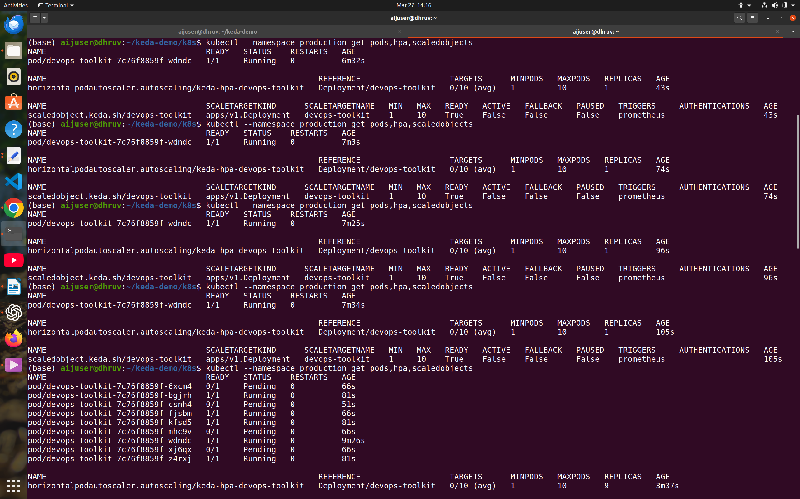

Reference:
Commands : https://gist.github.com/vfarcic/2dad051fe41bd2bbcf94eda74386ce49#file-183-keda-sh
Youtube : https://youtu.be/3lcaawKAv6s?si=Bfrsb0gq5evmv9s2

