* Operating on database through DB clients- connectors. Database used - mysql

**Name : Mageshwar HM**

**Register no : 2021506044**

**Platform Engineering**

**Assignment-2**

Programming language used – python Question:

To perform functions- create ,update ,select ,delete

* 1. Auto create query for insert ,update ,delete
  2. Auto create query for bulk insertion
  3. To run a procedure

Mysql db:

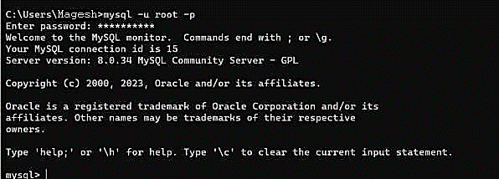

mysql and python versions:

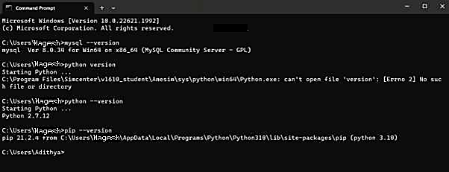

Downloading python connector in command prompt:

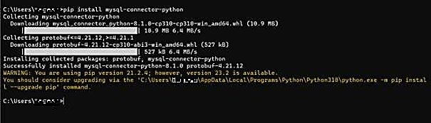

Databases present in mysql:

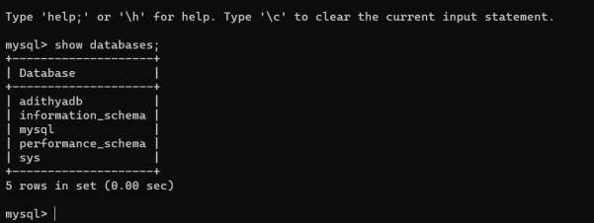

Python code to establish connection between mysql and python to perform CRUD operations:

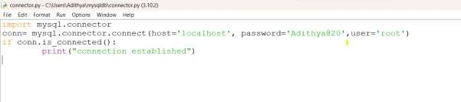

After connection:

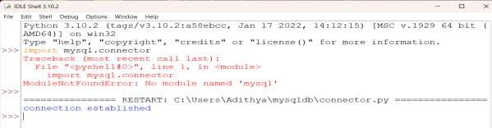

Creating table:

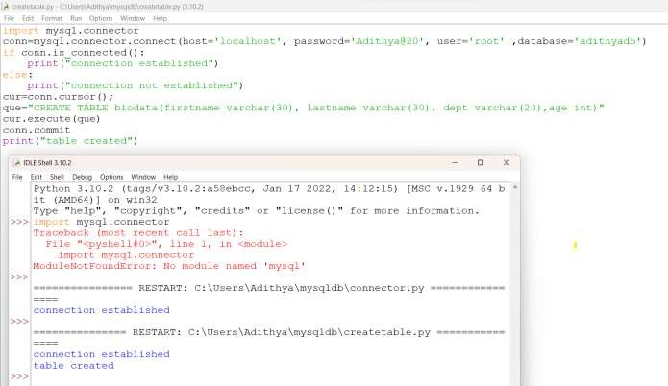

After creating table:

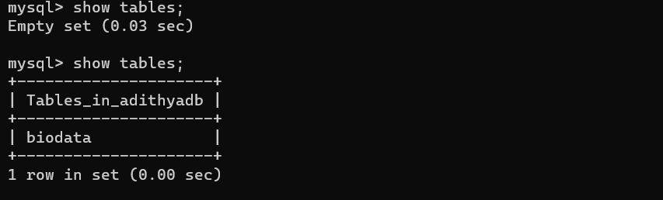

Inserting data in the table: py code:

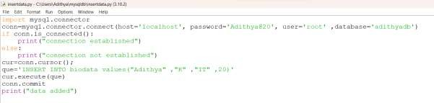



Database being updated:

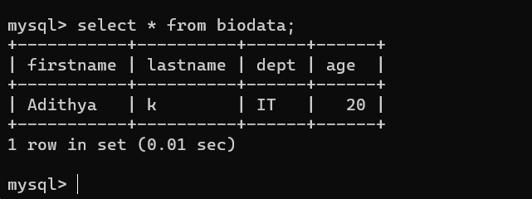

Adding bulk values to table:

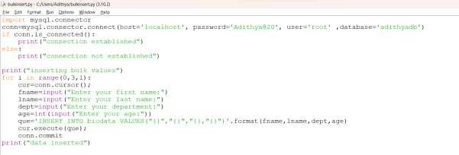

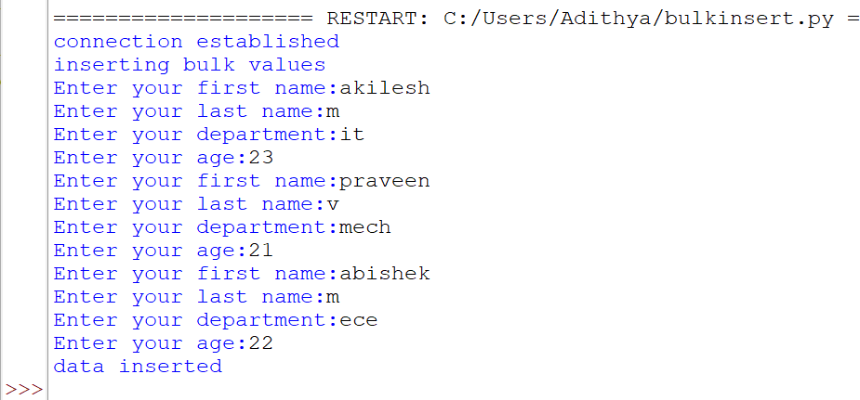

Database after inserting:

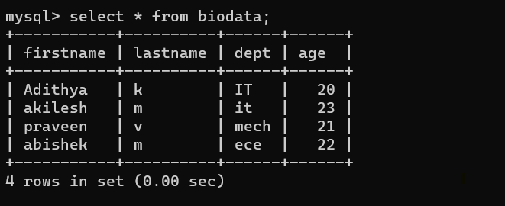

Updating values:

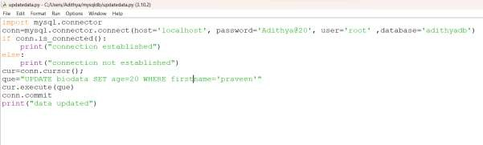

Database after updation:

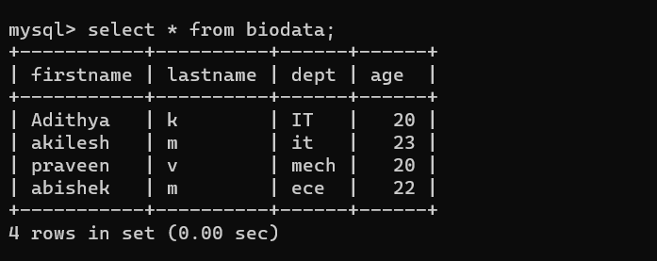

Deleting values:

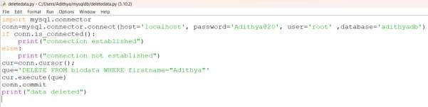

Database after deletion:

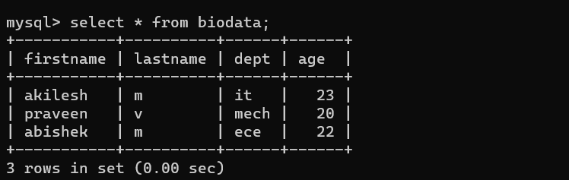

PROCEDURE:

Procedure to retrieve student age above 20:

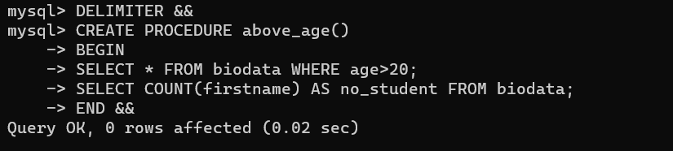

Calling the procedure:

