*CHATBOT DEPLOYMENT WITH IBM CLOUD USING WATSON ASSISTANT*

**Team members:**

1. *AKSHAYA - 311521106006*
2. *HARINI.B-311521106033*
3. *JAYASHRREE PRIYA .L - 311521106043*
4. *MAGESWARI.M- 311521106057*

**Project Title:** *Chatbot Deployment with IBM Cloud using Watson Assistant –* ***Tourism-Based Chatbot***

**Phase 3:** Development Part I

**Topic:** Start building the chatbot using IBM Cloud Watson Assistant

*TOURISM*

***Introduction:***

A tourism-based chatbot using IBM Cloud and Watson Assistant is a computer program that can simulate conversation with humans, specifically about travels and tourism . It can be used to provide information about locations, such as common places, information, and other recommendations. It can also be used to take food orders and make reservations.

To build a tourism-based chatbot using IBM Cloud and Watson Assistant, you will need to:

A tourism-based chatbot using IBM Cloud and Watson Assistant can be a valuable tool for tourism businesses of all sizes. It can help to improve customer service, increase engagement, and generate leads and sales.

Improved customer service: A chatbot can provide 24/7 customer support, answering questions about destinations, attractions, events, and more. It can also help customers to book travel arrangements, purchase tickets, and make reservations.

Increased engagement: A chatbot can help to increase engagement with tourists by providing them with personalized recommendations, sharing interesting facts about the destination, and running contests and promotions.

Generated leads and sales: A chatbot can help to generate leads and sales by collecting contact information from potential customers and qualifying them for sales calls or email marketing campaigns.

Here are some examples of how a tourism-based chatbot could be used:

* A chatbot could help tourists to plan their trip by providing them with information about different destinations, attractions, and events. It could also help them to book travel arrangements, purchase tickets, and make reservations.
* A chatbot could help tourists to get around their destination by providing them with information about public transportation, maps, and directions. It could also help them to find restaurants, shops, and other businesses.
* A chatbot could help tourists to learn about the culture and history of their destination by providing them with information about local attractions, museums, and historical sites. It could also recommend activities and events that are relevant to their interests.
* Overall, a tourism-based chatbot using IBM Cloud and Watson Assistant can be a valuable tool for tourism businesses of all sizes. It can help to improve customer service, increase engagement, and generate leads and sales.

.

***Development: Part 1***

Task 1: Create the Assistant service

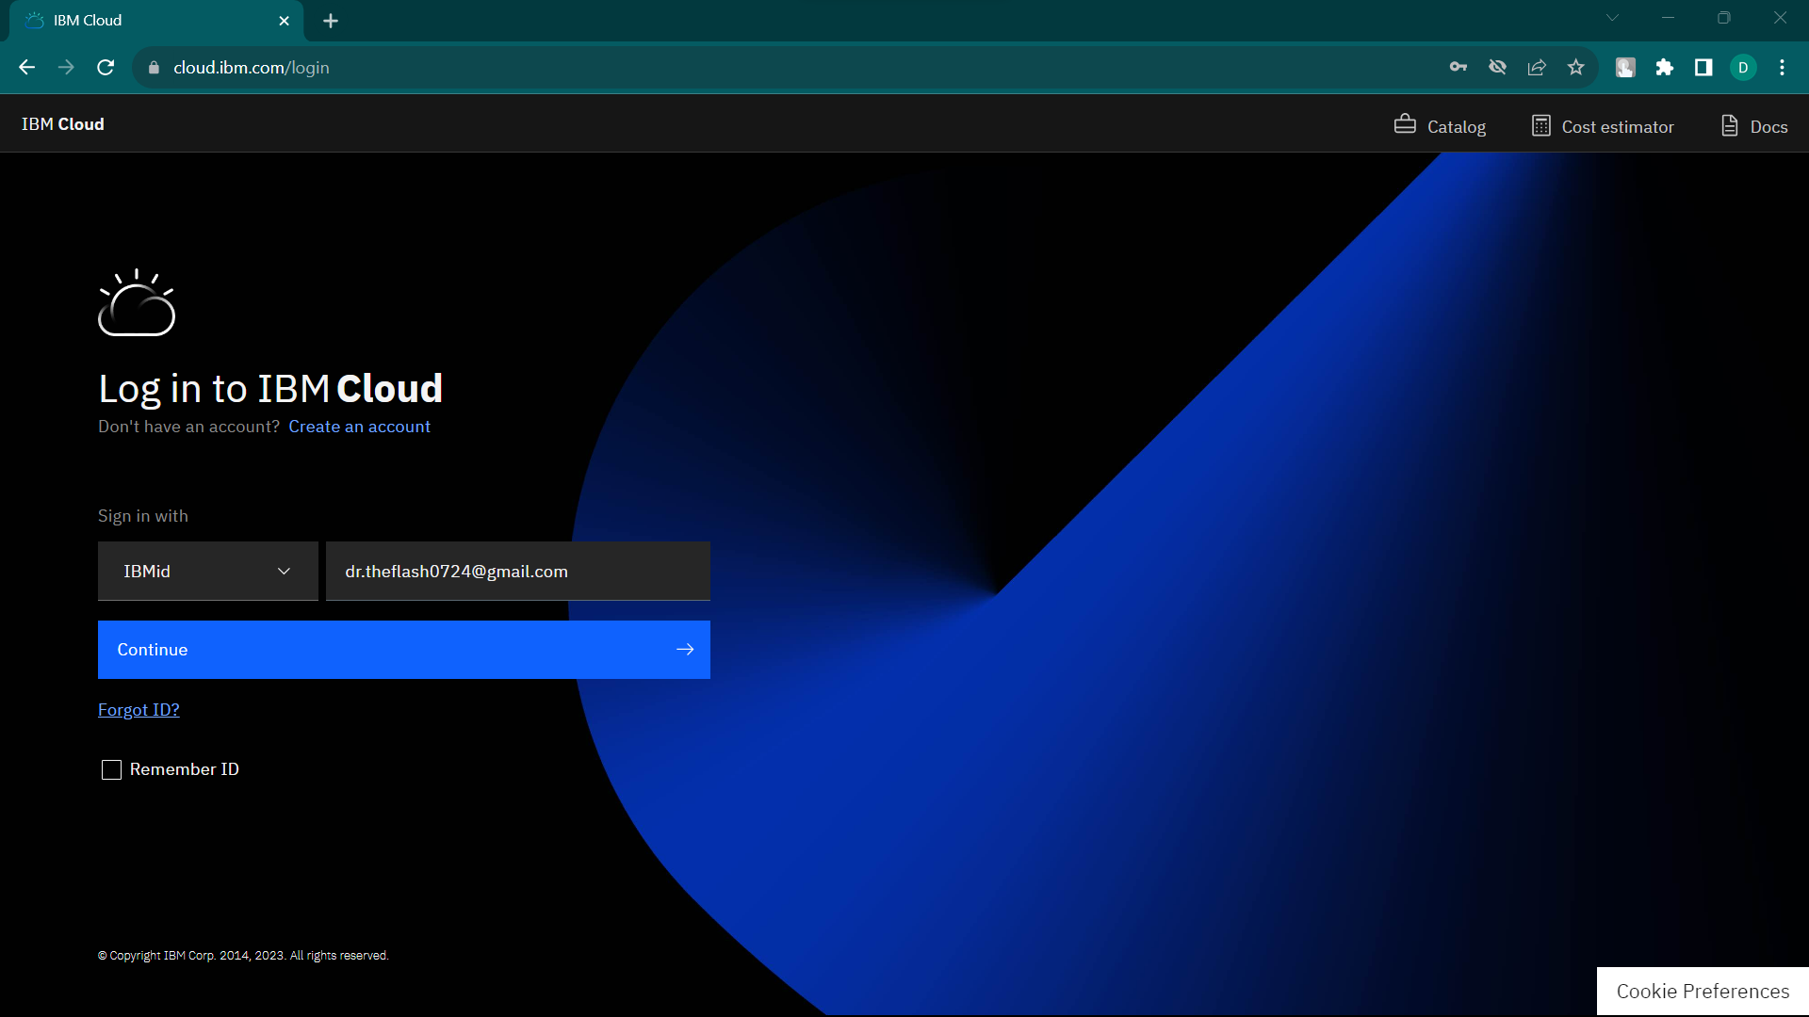

1. The first task is to create an instance of Watson Assistant on IBM Cloud.
2. Make sure that you are logged in to your IBM Cloud account. Click Catalog and then click Services > Watson > Assistant.

IBM Cloud Watson Services

1. For the service name, type **TOURISM**. Click Create. Assistant Service will be displayed.

1. Click the Launch tool to open the Watson Assistant workspace.

Task 2: Create a workspace

1. In the Workspaces section, click Create. A workspace will be created.

1. Type a name for the workspace., the workspace name is **TOURISM AND TRAVELS**.

Task 3: Create Intents

Add intents. An intent is a group of examples of things that a user might say to communicate a specific goal or idea. To identify intents, start with something that a user might want and then list the ways that the user might describe it. For each intent, think of the various ways that a user might express his or her desire—those are the examples. Examples can be developed by using a crowdsourcing approach.

For example, in a discussion with the user, we might gather this set of standard questions that support received from users:

* **Which region are you from?**
* **Phone number**
* **Gmail id**
* **Name if needed.**

Each of those questions is documented as a frequently asked question in the support team's document repository. Some solutions persist in a relational database in the form of application > problem > solution.

Based on the questions, you can extract these intents:

* **Explain about this chatbot to a 5-year-old.**
* **Common locations and Common places.**
* **Why is this chatbot?**

Add those intents to the workspace: From the Build page, click Intents and click Create New.

Intents

For the intent name, type applicationAccess after the number sign (#).

Questions

For each intent, add examples to train the conversation for intent recognition.

To get the IT support demonstration intents, click the Import link on the Intents page to import the Intents.csv file from the GitHub repository.

Task 4: Test the intent

Next, test your conversations.

1. As soon as you create an intent, you can test it by clicking Ask Watson icon in the top, right-hand side of the conversation editor.

Ask Watson

1. Enter one of the examples. You should get the #greetings intent identified by Watson. Enter other greetings to test the #greetings intent.
2. Test a few of the other intents that you imported from the .csv file.

***Conclusion***

Tourism -based chatbots using IBM Watson Assistant can be a valuable tool for both businesses and consumers. They can help businesses to improve customer service, increase sales, and reduce costs. They can also help consumers to save time and money and make easier choices.

Some of the benefits of using IBM Watson Assistant to build a Tourism-based chatbot:

1. **Scalability:** IBM Watson Assistant can scale to meet the needs of businesses of all sizes. This means that your chatbot can handle a large number of users without any performance issues.
2. **Reliability:** IBM Watson Assistant is a highly reliable platform. This means that your chatbot will be available to users when they need it.
3. **Security:** IBM Watson Assistant offers a variety of security features to protect your chatbot and your users' data.
4. **AI capabilities:** IBM Watson Assistant provides a variety of AI capabilities that can be used to make your chatbot more intelligent and conversational. For example, IBM Watson Assistant can be used to generate natural language responses, understand user intent, and learn from user interactions.

Design your chatbot's conversation flow. This includes identifying the different intents that your chatbot will be able to handle and the entities that it will need to understand.

Train your chatbot using the training data that you have collected. This data should include examples of the different types of conversations that you want your chatbot to be able to handle.

To Deploy your chatbot and make it available to your customers. You can deploy your chatbot to a variety of channels, such as your website, social media pages, and messaging apps.

Once your chatbot is deployed, you can monitor its performance and make adjustments as needed. You can also collect feedback from your customers to improve the chatbot's experience.