WEEK 4

DATA SCIENCE TOOL MASTERY PROJECT
Data Science Tool Mastery and Retail Analytics
Dataset: Online Retail Dataset
Programming Language: Python
Libraries: Pandas, NumPy, Matplotlib, Seaborn
Prepared as a practical data science portfolio project

1. Introduction
The Data Science Tool Mastery Project develops practical skills in industry-standard Python tools and libraries. The Online Retail dataset was used to demonstrate a complete workflow involving dataset inspection, data-quality assessment, cleaning, statistical analysis, visualization, validation, and export of reusable results.

2. Objectives
- Develop practical knowledge of commonly used data science tools.
- Use Pandas for data loading, cleaning, transformation, grouping, and export.
- Use NumPy for statistical calculations.
- Create visualizations with Matplotlib and Seaborn.
- Identify duplicate, missing, cancelled, and invalid transaction records.
- Generate portfolio evidence and business insights from a real-world dataset.

3. Tools and Technologies
Tool | Use in the project
Python | Main programming language
Pandas | Excel import, data inspection, cleaning, filtering, grouping, CSV export
NumPy | Mean, median, standard deviation, and percentile calculations
Matplotlib | Monthly sales and country-wise sales charts
Seaborn | Distribution visualization
VS Code | Python development environment
PowerShell | Script execution and output verification

4. Dataset Description
The Online Retail dataset contains 541,909 transaction rows and eight columns: InvoiceNo, StockCode, Description, Quantity, InvoiceDate, UnitPrice, CustomerID, and Country. It records product-level retail transactions across multiple countries.

5. Data Cleaning and Preprocessing
Exact duplicate rows were removed. Missing product descriptions were replaced with 'Unknown product'. Records with missing CustomerID values were retained because they can still contribute to sales calculations. Cancelled invoices (invoice numbers beginning with C), negative or zero quantities, invalid dates, and zero, negative, or missing unit prices were excluded from positive-sales calculations.
The exclusion categories can overlap. For example, a cancelled invoice may also contain a negative quantity. Therefore, their counts should not be added to derive the number of unique excluded rows.

6. Data Cleaning Results
Measure | Result
Original records | 541,909
Exact duplicate rows removed | 5,268
Rows after duplicate removal | 536,641
Valid positive-sales records | 524,878
Rows excluded from positive-sales analysis | 11,763
Missing CustomerID in valid sales | 132,186
Missing descriptions in valid sales | 0
Transaction checks (categories may overlap):
Condition | Rows
Invalid dates | 0
Cancelled invoice rows | 9,251
Negative quantity rows | 10,587
Zero quantity rows | 0
Missing or invalid quantities | 0
Zero, negative, or missing unit prices | 2,512

7. Statistical Analysis Using NumPy
Statistic | Result
Mean line value | 20.2754 (approximately 20.28)
Median line value | 9.92
Standard deviation | 271.6933 (approximately 271.69)
25th percentile | 3.90
75th percentile | 17.70
The mean is greater than the median, indicating that some relatively large transaction line values influence the average. The standard deviation indicates substantial variation in line values.

8. Verified Sales Summary
Measure | Result
Total calculated line value | 10,642,110.80
Total units sold | 5,572,420
Unique invoices | 19,960
Unique products | 3,922
Countries represented | 38
Identified customers | 4,338
The total line value is calculated as Quantity multiplied by UnitPrice for the retained positive-sales records. It should be described as a calculated line value, not audited net revenue, because the project does not reconcile all accounting adjustments, taxes, or refunds.

9. Country-wise Sales Analysis
Country | Calculated line value
United Kingdom | 9,001,744.09
Netherlands | 285,446.34
EIRE | 283,140.52
Germany | 228,678.40
France | 209,625.37
Australia | 138,453.81
Spain | 61,558.56
Switzerland | 57,067.60
Belgium | 41,196.34
Sweden | 38,367.83
The United Kingdom contributed approximately 84.59% of the total calculated line value and was the largest market in the cleaned dataset.

10. Monthly Sales Analysis
Month | Calculated line value
December 2010 | 821,452.73
January 2011 | 689,811.61
February 2011 | 522,545.56
March 2011 | 716,215.26
April 2011 | 536,968.49
May 2011 | 769,296.61
June 2011 | 760,547.01
July 2011 | 718,076.12
August 2011 | 757,841.38
September 2011 | 1,056,435.19
October 2011 | 1,151,263.73
November 2011 | 1,503,866.78
December 2011 | 637,790.33
November 2011 recorded the highest monthly value (1,503,866.78), while February 2011 recorded the lowest (522,545.56) among the months shown.

11. Data Visualizations and Evidence
The improved script generated three charts. Insert the actual PNG files produced by the script in the spaces below before submitting the report.

11.1 Monthly Sales Trend
Evidence file: outputs/charts/cleaned_monthly_sales.png
Shows changes in calculated line value across months and highlights the November 2011 peak.
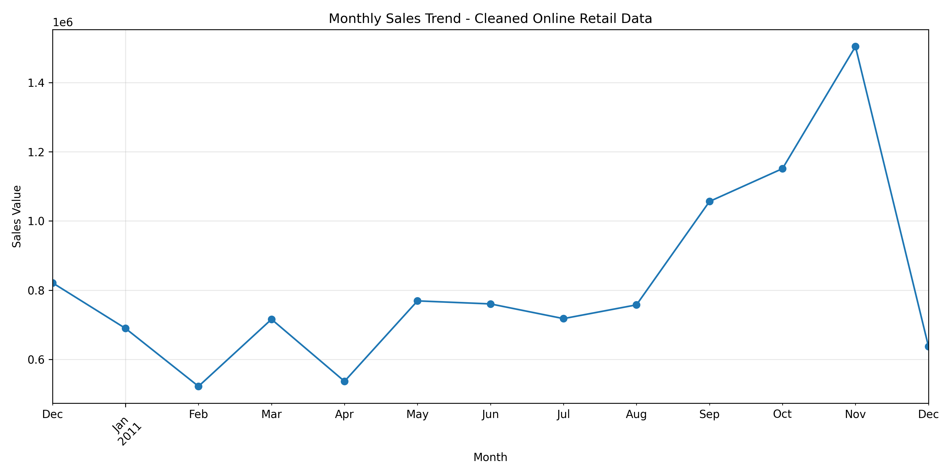

11.2 Top 10 Countries by Sales
Evidence file: outputs/charts/cleaned_top_10_countries.png
Compares the ten leading countries and shows the United Kingdom as the largest market.
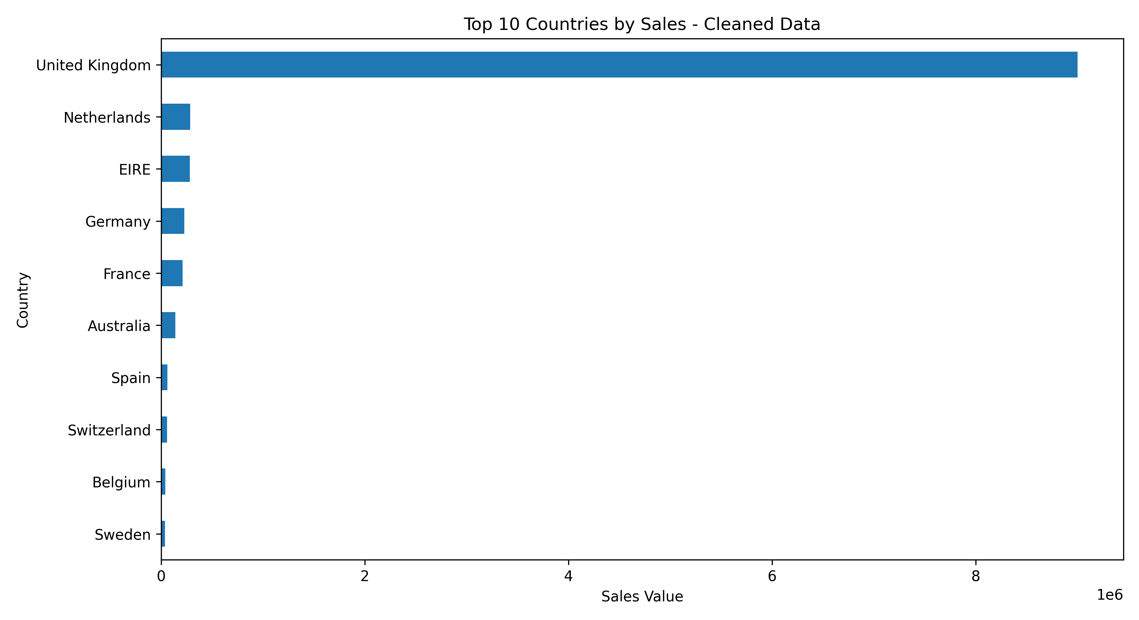

11.3 Sales Line-Value Distribution
Evidence file: outputs/charts/cleaned_sales_distribution.png
Shows the distribution of positive transaction line values and the variation in transaction sizes.
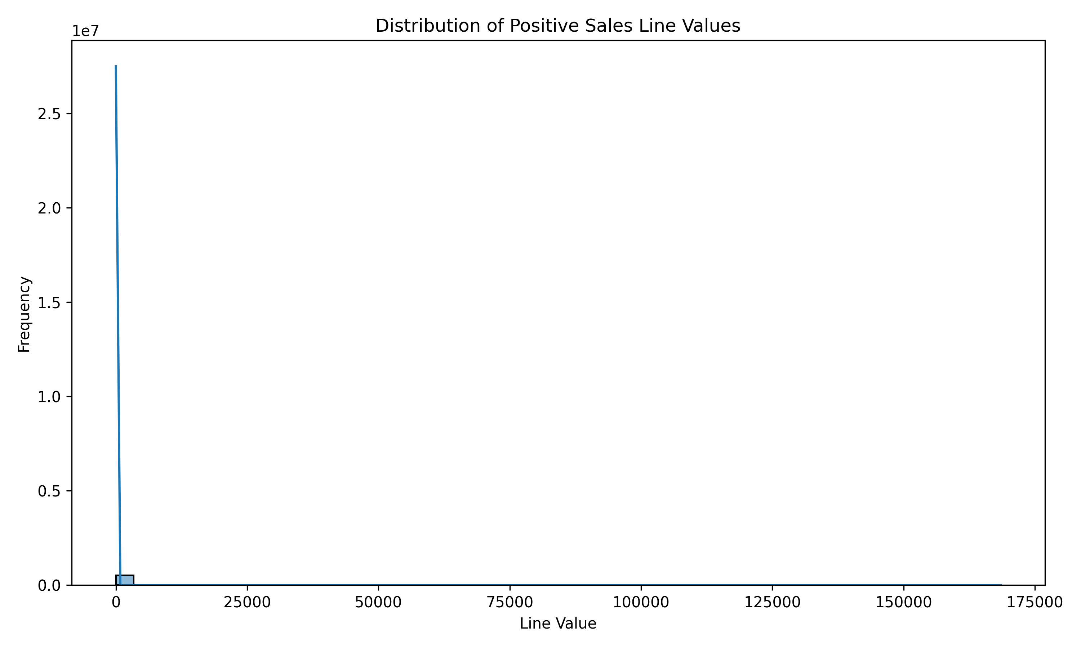

12. Project Outputs
- initial_data_quality.csv
- transaction_exclusion_summary.csv
- cleaned_data_quality_report.csv
- cleaned_online_retail.csv
- top_10_country_sales_cleaned.csv
- monthly_sales_cleaned.csv
- top_10_products_cleaned.csv
- numpy_statistics.csv
- charts/cleaned_monthly_sales.png
- charts/cleaned_top_10_countries.png
- charts/cleaned_sales_distribution.png

13. Skills Gained
- Importing and inspecting large Excel datasets.
- Handling missing values and duplicate records.
- Filtering transactions using business rules.
- Using NumPy for statistical summaries.
- Grouping and aggregating data for business analysis.
- Creating charts with Matplotlib and Seaborn.
- Exporting cleaned datasets and reproducible CSV outputs.
- Organizing a data science project into data, source, outputs, and evidence folders.

14. Limitations and Future Improvements
A substantial number of valid sales rows have missing CustomerID values, limiting customer-level analysis. The current workflow excludes negative quantities and cancelled invoices from positive-sales analysis rather than performing a separate refund and returns reconciliation. The calculated line value is not an audited accounting revenue figure. Further work could include returns analysis, customer segmentation, product-level trend analysis, sales forecasting, and an interactive dashboard.

15. Conclusion
The project demonstrated how Python and its major data science libraries can be combined to process a real-world retail dataset. Pandas supported data loading, cleaning, transformation, and aggregation; NumPy supported statistical calculations; and Matplotlib and Seaborn supported visual analysis. The improved workflow removed exact duplicates, applied transparent transaction filters, validated key conditions, and produced reusable CSV reports and charts. The analysis identified the United Kingdom as the largest market and November 2011 as the strongest month in the observed period. Overall, the project strengthened practical skills in data preparation, analysis, visualization, and project documentation.

Appendix: Reproducibility and Submission Evidence
The analysis can be reproduced from the project root by running: python src\tool_mastery.py
Keep the original Online Retail.xlsx dataset, the original preliminary CSV outputs, the cleaned CSV outputs, the Python source file, and the generated chart images together in the project folder. Capture and add a screenshot of the successful terminal execution and the project folder structure.

16. Additional Data Visualizations

16.1 Original Monthly Sales Visualization
This chart provides an additional view of the monthly sales pattern before the improved cleaning workflow.
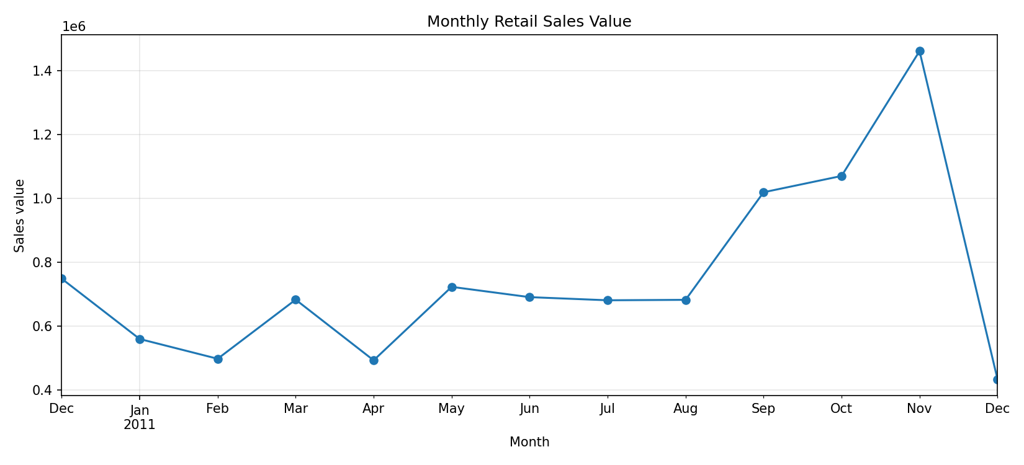

16.2 Quantity versus Unit Price
This visualization examines the relationship between transaction quantity and unit price.
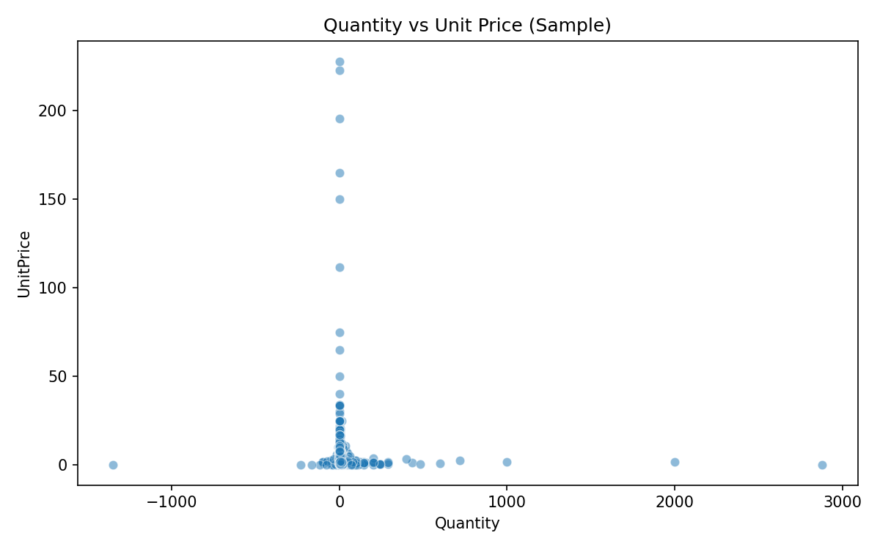

17. Execution Evidence
This section provides visual evidence of project execution. The screenshots demonstrate the generated analysis outputs and successful execution of the Python workflow.

17.1 Successful Terminal Execution
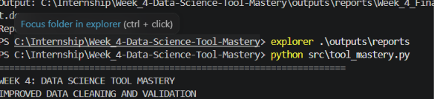

18. Project Evidence Inventory
Evidence File | Availability
cleaned_data_quality_report.csv | Available
initial_data_quality.csv | Available
transaction_exclusion_summary.csv | Available
monthly_sales_cleaned.csv | Available
top_10_country_sales_cleaned.csv | Available
top_10_products_cleaned.csv | Available
numpy_statistics.csv | Available
cleaned_online_retail.csv | Available

