WEEK 5 PROJECT REPORT

Analytics Report
and Business Insights
Online Retail Sales Dataset

Internship Assessment: Data Science
Project: Week 5 – Analytics Report and Insights
Dataset: UCI Online Retail
Analysis Period: December 2010 – December 2011

Prepared as a practical business analytics study

1. Executive Summary
This project analyses cleaned online retail transaction data to understand sales performance, monthly trends, country contribution, product performance and data quality. The analysis contains 524,878 valid sales records, representing 5,572,420 units across 19,960 invoices, 3,922 product descriptions and 38 countries. The calculated total line value is £10,642,110.80. This value is calculated as Quantity multiplied by UnitPrice; it should not be interpreted as profit because product costs and operating expenses are not included.
The United Kingdom contributes approximately 84.59% of the calculated total. November 2011 is the strongest month in the period, with £1,503,866.78, while February 2011 is the lowest at £522,545.56. The validation checks passed, including checks for duplicate records, valid dates, positive quantities and prices, line-value calculations, and reconciliation of monthly, country and product totals. A key limitation is that 132,186 valid sales rows do not contain a CustomerID, which restricts customer-level analysis.

2. Introduction
Business analytics converts transaction data into useful information for decision-making. Retail businesses can use sales analysis to identify high-performing periods, understand where sales originate, monitor product demand and plan inventory or marketing activities. This project uses the Online Retail dataset to prepare a structured analytics report supported by summary tables, validation results and visualizations.

3. Project Objectives
- Summarize the cleaned retail dataset using key business performance indicators.
- Analyse monthly sales trends and identify high- and low-performing months.
- Compare sales contribution across countries.
- Identify product descriptions with the highest calculated sales values.
- Examine transaction-line value statistics and communicate their meaning.
- Validate the analytical outputs and provide practical business recommendations.

4. Dataset Description
The project uses the UCI Online Retail transactional dataset. The analysis was performed on the cleaned data prepared in the earlier internship work. The final analytical dataset contains 524,878 valid records and 10 columns, including the original transaction fields and derived analysis fields. The main fields used in this report are InvoiceNo, StockCode, Description, Quantity, InvoiceDate, UnitPrice, CustomerID, Country and the calculated line value.
Dataset measure | Result
Valid sales records | 524,878
Units sold | 5,572,420
Unique invoices | 19,960
Unique product descriptions / codes counted | 3,922
Countries | 38
Identified customers | 4,338
Rows with missing CustomerID | 132,186

5. Tools and Technologies
Tool / Library | Purpose
Python | Main programming language for data analysis and report preparation.
Pandas | Data loading, filtering, grouping, aggregation and tabular summaries.
NumPy | Numerical calculations and descriptive statistics.
Matplotlib | Charts for monthly, country-wise and product-wise analysis.
Visual Studio Code | Development environment used to run and manage the project.

6. Methodology
- Load the cleaned Online Retail dataset and inspect its dimensions and columns.
- Check required fields and verify that transaction dates, quantities and unit prices are valid.
- Calculate each transaction line value as Quantity × UnitPrice.
- Generate overall KPIs and descriptive statistics.
- Group records by month, country and product description to calculate sales totals.
- Compare grouped totals with the overall total to validate aggregation consistency.
- Create charts and summarize the findings as business insights and recommendations.

7. Data Validation and Quality Checks
The validation report recorded PASS for all checks performed. These checks help ensure that the reported summaries are internally consistent and based on valid sales rows.
Validation check | Result
Required columns present | PASS
Duplicate rows | None found / PASS
Invalid dates | None found / PASS
Quantity values | All positive / PASS
Unit price values | All positive / PASS
Calculated line values | Non-negative / PASS
Quantity × UnitPrice formula | Matched / PASS
Monthly totals reconcile to overall total | PASS
Country totals reconcile to overall total | PASS
Product totals reconcile to overall total | PASS

Missing CustomerID values remain in 132,186 rows. These rows are included in the overall sales analysis because the sales values are available, but they cannot be reliably assigned to a known customer for customer-level segmentation.

8. Business KPI Analysis
KPI | Value | Interpretation
Calculated total line value | £10,642,110.80 | Total of Quantity × UnitPrice across valid sales lines.
Total units sold | 5,572,420 | Combined quantity across valid sales records.
Unique invoices | 19,960 | Distinct invoice identifiers in the analysed data.
Product descriptions / codes | 3,922 | Distinct product count used in the analysis.
Countries | 38 | Geographic coverage represented in the data.
Identified customers | 4,338 | Distinct non-missing CustomerID values.
Missing CustomerID rows | 132,186 | Limits customer-level analysis.

The average transaction-line value is £20.28 and the median is £9.92. The mean is higher than the median, indicating that a smaller number of high-value lines increase the average. The standard deviation is £271.69, showing substantial variation in line values. The 25th percentile is £3.90 and the 75th percentile is £17.70.

9. Monthly Sales Analysis
Monthly sales were calculated by grouping transaction lines by invoice month and summing their calculated line values. The trend shows fluctuations during the period, followed by a strong increase in September, October and November 2011.
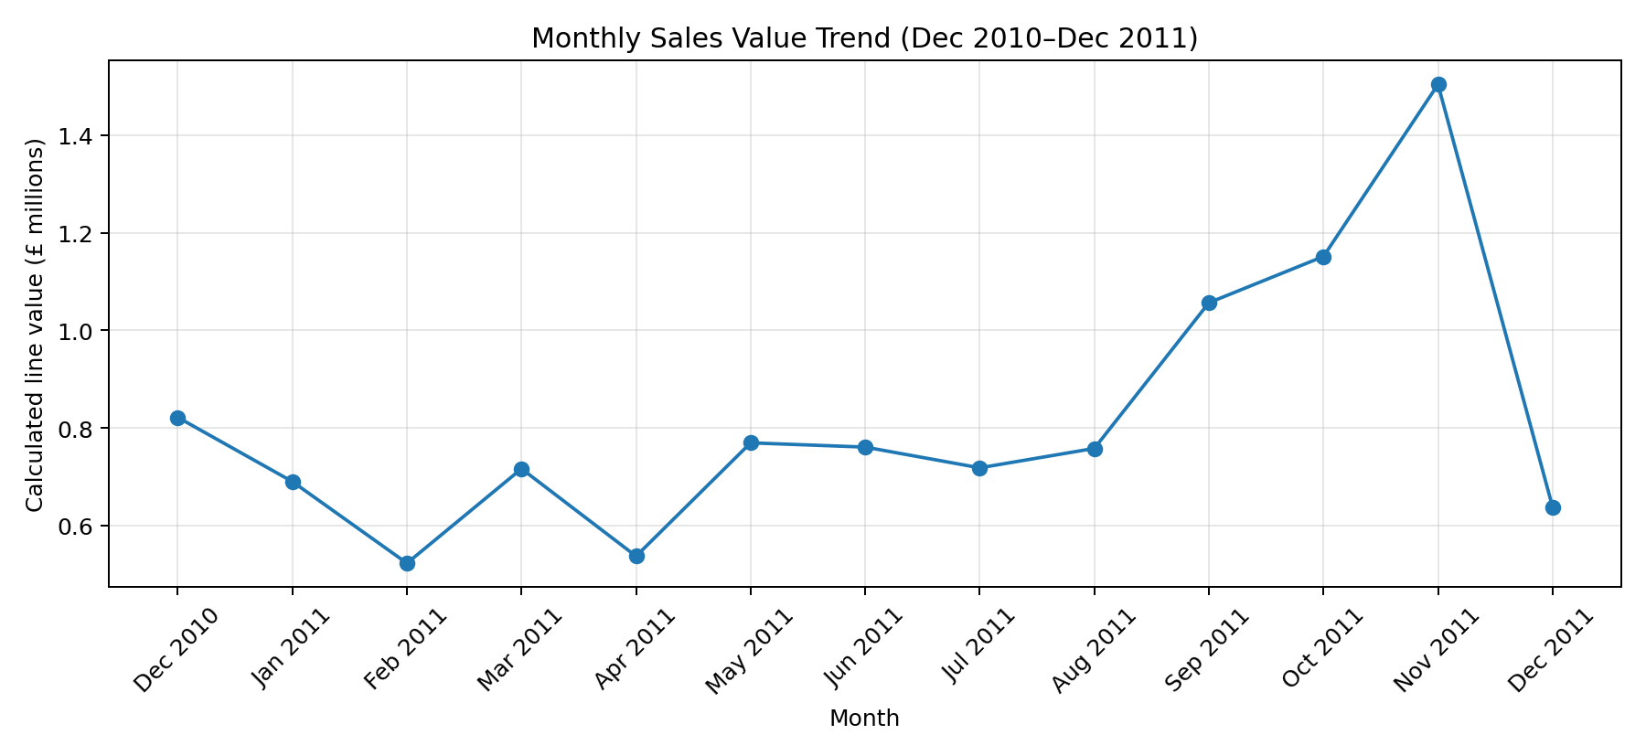
Month | Calculated line value
Dec 2010 | £821,452.73
Jan 2011 | £689,811.61
Feb 2011 | £522,545.56
Mar 2011 | £716,215.26
Apr 2011 | £536,968.49
May 2011 | £769,296.61
Jun 2011 | £760,547.01
Jul 2011 | £718,076.12
Aug 2011 | £757,841.38
Sep 2011 | £1,056,435.19
Oct 2011 | £1,151,263.73
Nov 2011 | £1,503,866.78
Dec 2011 | £637,790.33

November 2011 recorded the highest monthly value at £1,503,866.78. February 2011 recorded the lowest at £522,545.56. The business could investigate the drivers of the late-year increase, including seasonal demand, promotions and changes in order volume. The analysis alone does not prove which factor caused the increase.

10. Country-wise Sales Analysis
The country analysis indicates a strong concentration of sales in the United Kingdom. Its calculated line value is £9,001,744.09, approximately 84.59% of the overall total. The remaining countries contribute a much smaller share individually.
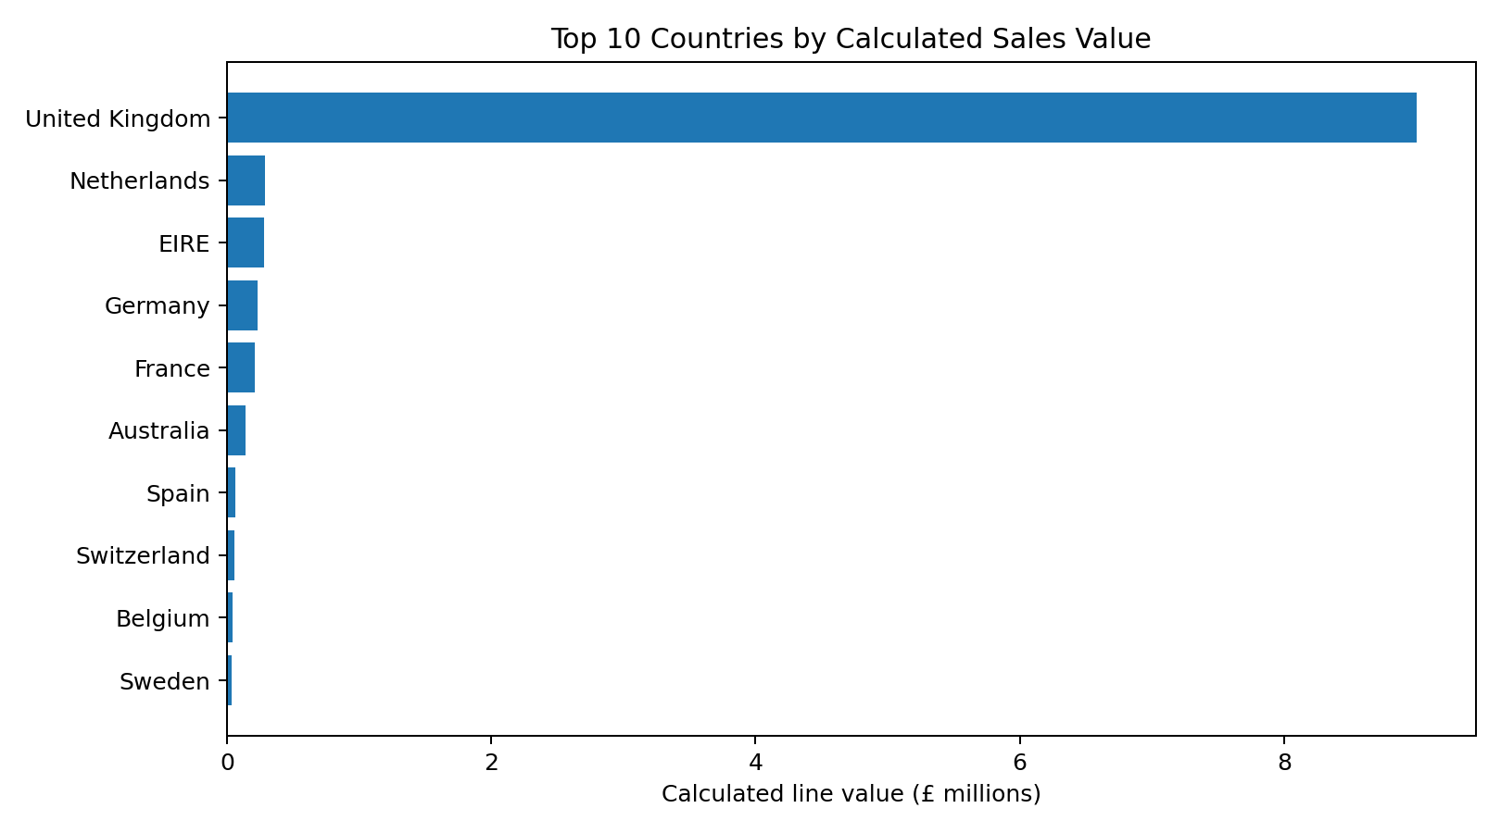
Country | Calculated line value
United Kingdom | £9,001,744.09
Netherlands | £285,446.34
EIRE | £283,140.52
Germany | £228,678.40
France | £209,625.37
Australia | £138,453.81
Spain | £61,558.56
Switzerland | £57,067.60
Belgium | £41,196.34
Sweden | £38,367.83

The Netherlands and EIRE are the next largest contributors, followed by Germany and France. The business may protect its established UK market while exploring opportunities to grow in other countries. Any expansion decision should also consider shipping costs, taxes, demand and local market conditions, which are not available in this dataset.

11. Product-wise Sales Analysis
Product performance was assessed by summing calculated line values for each product description. The following table lists the ten highest-value product descriptions in the analysis.
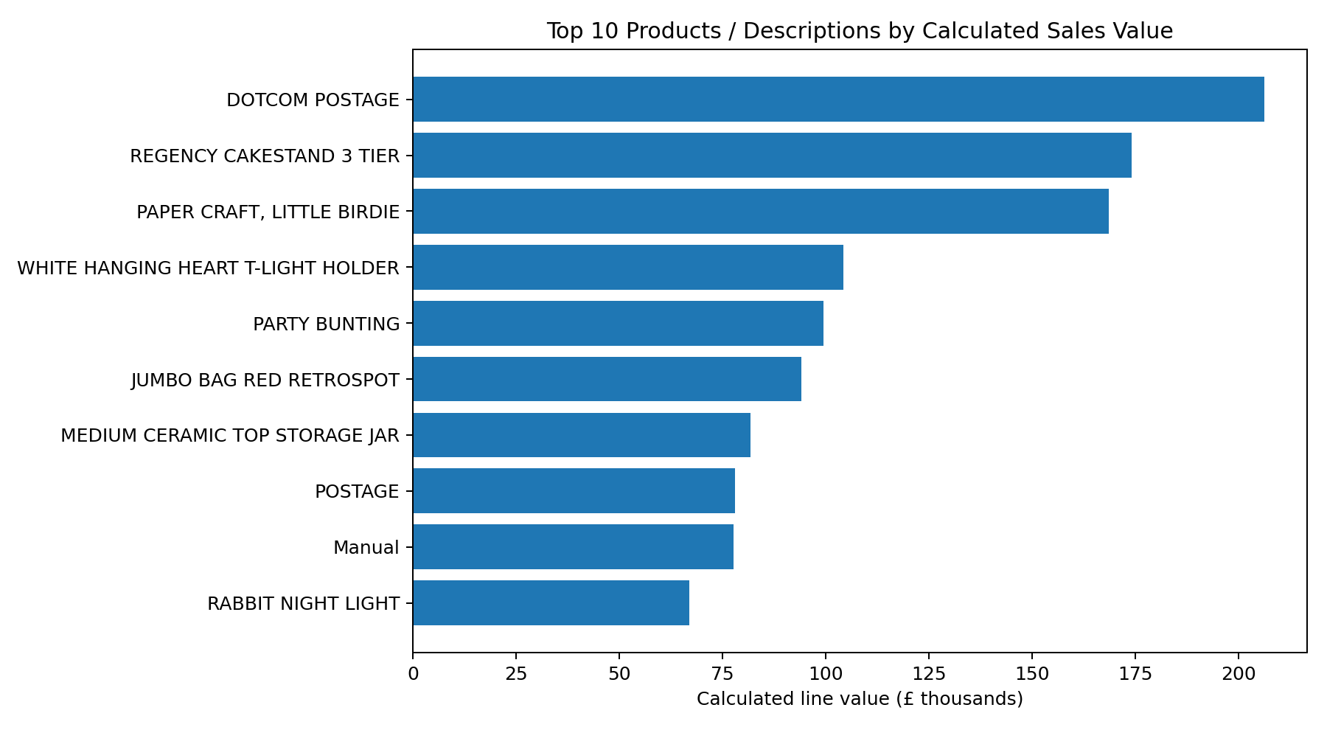
Product description | Units | Sales lines | Calculated line value
DOTCOM POSTAGE | 706 | 706 | £206,248.77
REGENCY CAKESTAND 3 TIER | 13,851 | 2,007 | £174,156.54
PAPER CRAFT, LITTLE BIRDIE | 80,995 | 1 | £168,469.60
WHITE HANGING HEART T-LIGHT HOLDER | 37,580 | 2,244 | £104,284.24
PARTY BUNTING | 18,283 | 1,699 | £99,445.23
JUMBO BAG RED RETROSPOT | 48,371 | 2,109 | £94,159.81
MEDIUM CERAMIC TOP STORAGE JAR | 78,033 | 250 | £81,700.92
POSTAGE | 3,150 | 1,126 | £78,101.88
Manual | 6,984 | 316 | £77,750.27
RABBIT NIGHT LIGHT | 30,739 | 1,017 | £66,870.03

DOTCOM POSTAGE has the highest calculated line value in this ranking. A notable data point is PAPER CRAFT, LITTLE BIRDIE: it records 80,995 units but only one sales line. This unusual combination should be checked against the original source record before making inventory or product decisions based on it.

12. Transaction-Line Value Distribution
The descriptive statistics show that the distribution of line values is uneven. The median (£9.92) is below the mean (£20.28), and the standard deviation (£271.69) is large relative to the median. This suggests that many line values are comparatively small while a smaller number of large values affect the average. The percentile values provide additional context: 25% of line values are at or below £3.90, and 75% are at or below £17.70.
A raw transaction-level histogram is not reproduced in this document because the underlying individual line-value observations were not supplied to the report-generation step. The interpretation above is based only on the verified summary statistics.

13. Key Business Insights
- The analysed dataset contains more than half a million valid sales lines and a calculated total line value of £10.64 million.
- The United Kingdom accounts for approximately 84.59% of calculated sales value, indicating strong geographic concentration.
- November 2011 is the strongest month in the analysed period, while February 2011 is the weakest.
- The difference between mean and median line value indicates a right-skewed pattern with some comparatively high-value lines.
- A significant number of valid sales rows lack CustomerID, limiting customer-level analysis.
- The unusually high unit count associated with PAPER CRAFT, LITTLE BIRDIE and one sales line merits source-data verification.

14. Business Recommendations
- Investigate the November 2011 sales increase by reviewing promotions, seasonal demand, product mix and order volume.
- Maintain strong service and stock availability in the United Kingdom, the largest market in this dataset.
- Study the Netherlands, EIRE, Germany and France to identify realistic opportunities for international growth.
- Use product-level sales values together with stock availability and margin data before making replenishment decisions.
- Improve CustomerID capture during checkout so that repeat-purchase and customer-retention analysis becomes more reliable.
- Review unusual product records, especially PAPER CRAFT, LITTLE BIRDIE, against the source dataset.
- Add product cost, shipping cost, discount and return information in future analysis to estimate profitability rather than sales value alone.

15. Project Limitations
- The dataset does not provide product cost or operating expenses, so profit and profit margin cannot be calculated.
- 132,186 valid sales rows have missing CustomerID values, limiting customer-level conclusions.
- The analysis describes patterns in the available period and does not establish the causes of sales changes.
- An unusual product aggregation was identified and requires source-level verification.
- The report focuses on sales value and does not include a complete analysis of returns, marketing spend or inventory levels.

16. Conclusion
The Week 5 Analytics Report and Insights project demonstrates how cleaned retail transaction data can be converted into useful business information. The analysis summarizes more than 524,000 valid sales records, identifies the leading month, compares country contributions and highlights the top product descriptions by calculated line value. Validation checks passed, supporting the consistency of the reported aggregations. The results show that sales are heavily concentrated in the United Kingdom and that November 2011 is the strongest month in the period. The project also identifies limitations, especially missing customer identifiers and the absence of cost data. Overall, the work provides a clear foundation for retail performance monitoring and for more detailed future analysis.

17. Project Deliverables
Deliverable | Description
Python analysis script | analytics_report.py
Validation report | analytics_validation_report.csv
Business insights | business_insights.csv
KPI summary | business_kpi_summary.csv
Monthly analysis | monthly_sales_analysis.csv
Country analysis | country_sales_analysis.csv
Product analysis | product_sales_analysis.csv
Recommendations | recommendations.csv
Visualizations | Monthly trend, country sales and top product charts included in this report.

Appendix: Interpretation Note
Throughout this report, the term “calculated line value” refers to Quantity × UnitPrice summed across the relevant transaction lines. It is a sales-value measure derived from the supplied fields, not an independently verified accounting revenue or profit measure. Figures are rounded to two decimal places for presentation; some source aggregations contain additional decimal places.

