GLOBAL RETAIL SALES
INTELLIGENCE
FINAL DATA SCIENCE CAPSTONE PROJECT

Retail Business Analytics | Customer Segmentation |
Weekly Sales Forecasting

Dataset: Online Retail
Tools: Python, Pandas, NumPy, Matplotlib, Scikit-learn and Streamlit
Project Report | 2026

1. Executive Summary
This capstone project presents an end-to-end retail data science workflow using a cleaned Online Retail transaction dataset. The work combines business performance analysis, product and country analysis, customer segmentation using RFM features and K-Means clustering, and weekly sales forecasting.
The analysis covered 19,960 invoices and 5,572,420 units, with total recorded sales value of 10,642,110.80. It identified 4,338 customers with available customer identifiers.
Four customer groups were identified through unsupervised clustering. Three forecasting approaches were compared using a chronological holdout test set. The Naive baseline achieved the lowest test MAE among the evaluated approaches.

Project Objectives
- Analyze overall retail sales and business performance.
- Identify high-performing products and countries.
- Segment identified customers using Recency, Frequency and Monetary value.
- Compare weekly sales forecasting methods using a time-ordered test set.
- Present the results through an interactive Streamlit dashboard.

2. Dataset Description and Validation
The project uses the cleaned Online Retail transaction dataset. Each row represents a transaction line. The processed dataset contains 524,878 records and 10 columns, including invoice, product, quantity, date, customer, country and calculated sales-value fields.
Dataset characteristic | Result
Processed records | 524,878
Columns | 10
Duplicate rows | 0
Invalid invoice dates | 0
Non-positive quantities | 0
Non-positive unit prices | 0
Missing CustomerID | 132,186
Identified customers | 4,338
Unique invoices | 19,960
Unique products | 3,922
Countries | 38
Date range | 01-Dec-2010 to 09-Dec-2011

Rows without CustomerID were retained for overall sales analysis but could not be assigned to individual customers during RFM segmentation. The RFM analysis therefore uses the 4,338 identified customers.

3. Business Performance Analysis
Business KPI | Value
Total Sales | 10,642,110.80
Total Units Sold | 5,572,420
Total Invoices | 19,960
Unique Products | 3,922
Countries | 38
Identified Customers | 4,338
Average Transaction Line Value | 20.28

Average Transaction Line Value is calculated at the transaction-line level. It should not be interpreted as average invoice value or average order value.

Monthly Sales Trend
Monthly aggregation provides a view of changes in recorded sales over the dataset period. The chart below presents the monthly sales pattern.
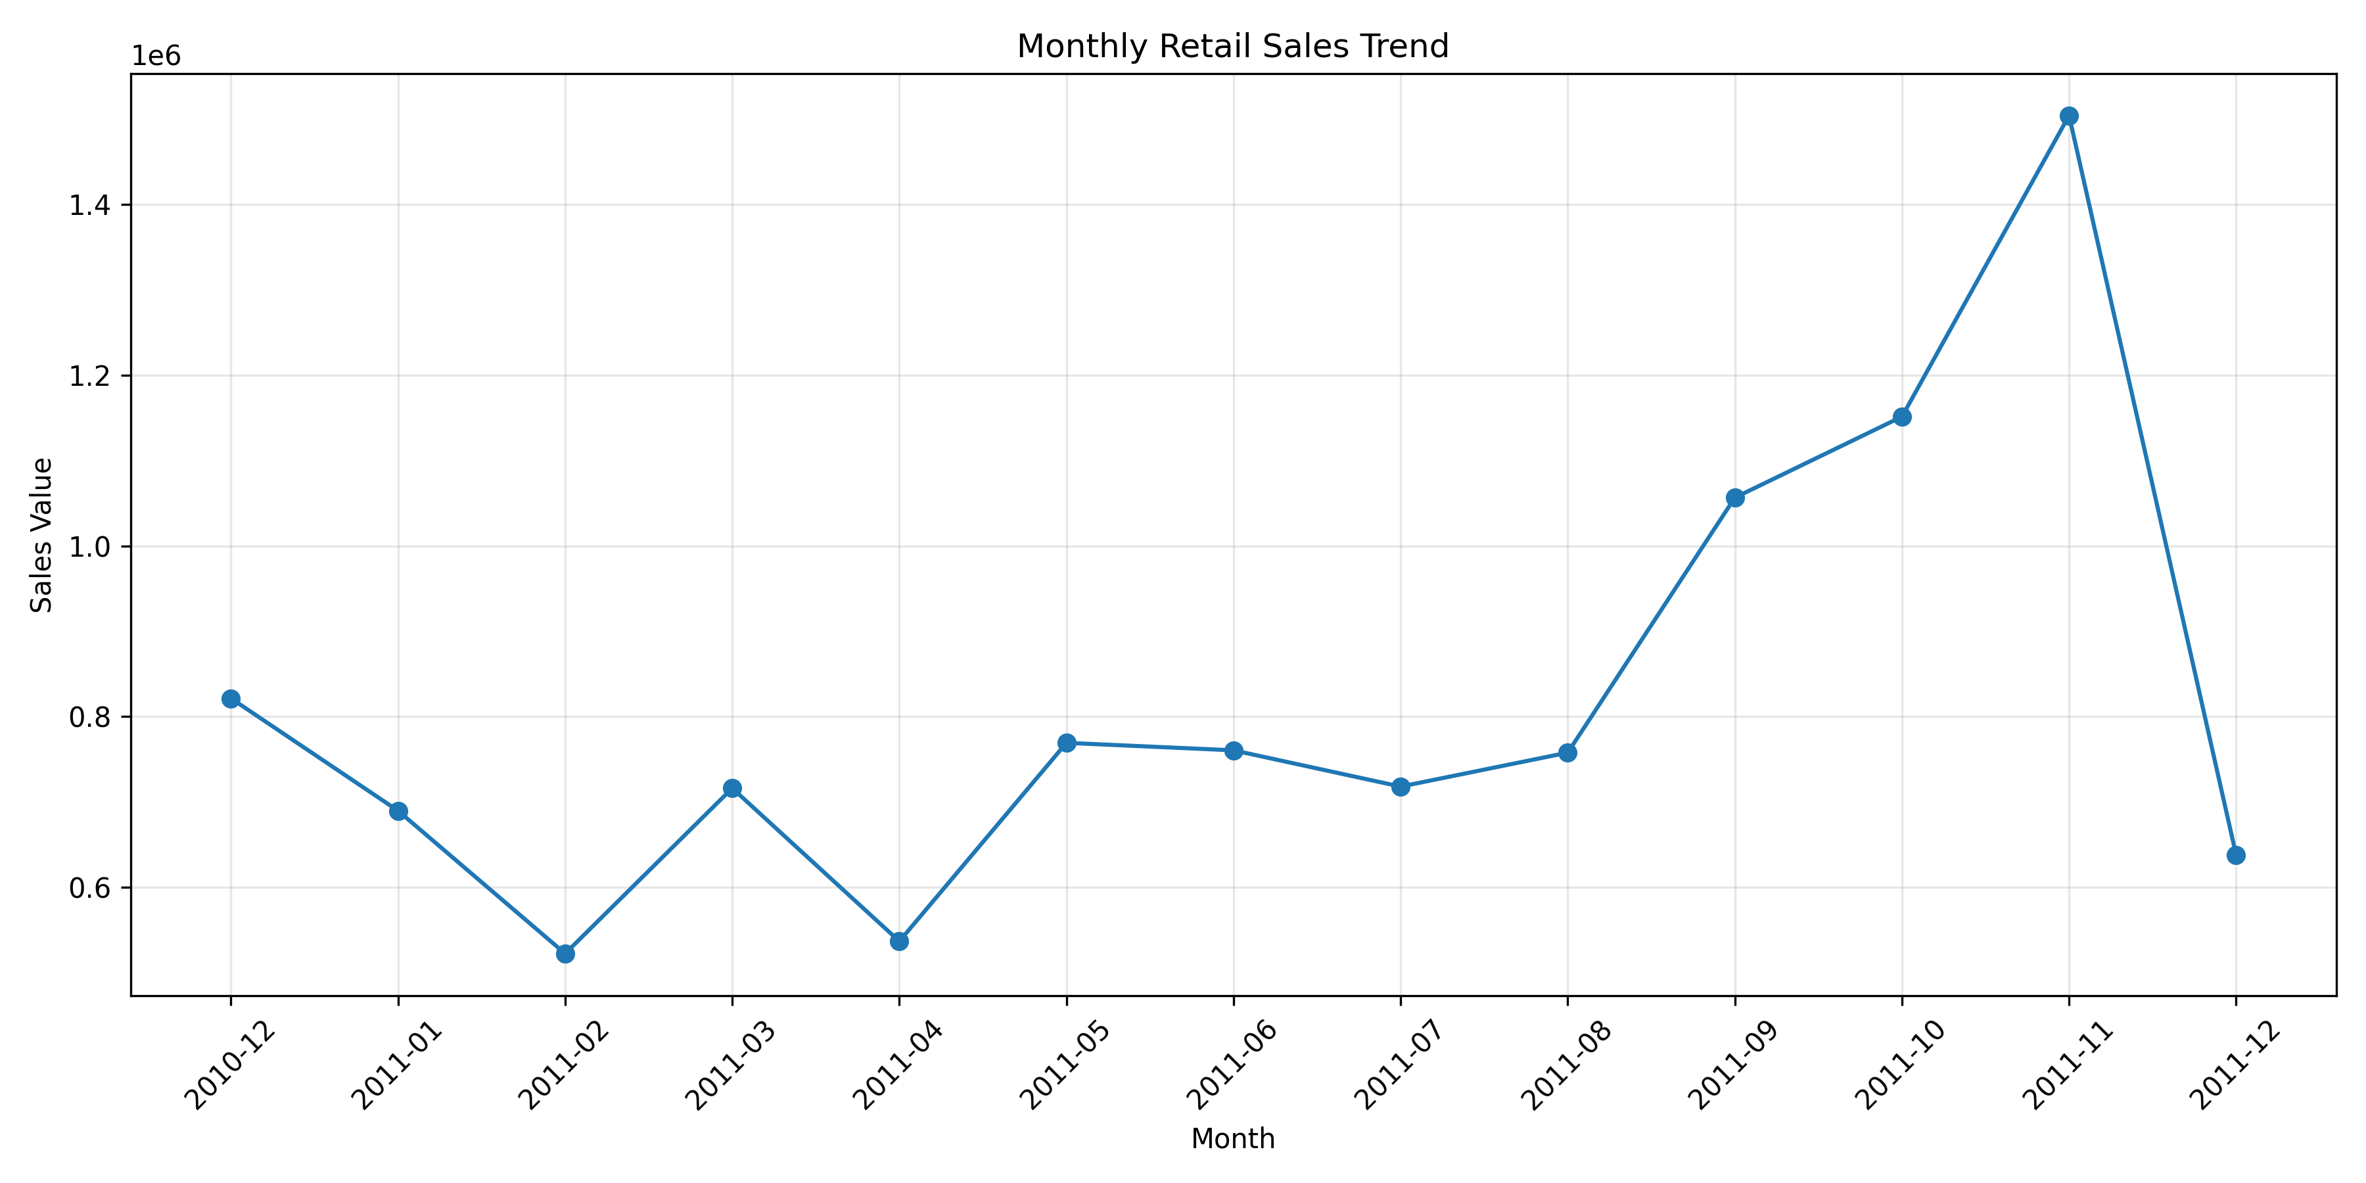
Figure 1. Monthly retail sales trend

Weekly Sales Trend
Weekly sales were aggregated into Sunday-ending calendar weeks. The incomplete first and last weekly buckets were excluded before forecasting, leaving 52 complete weekly observations.
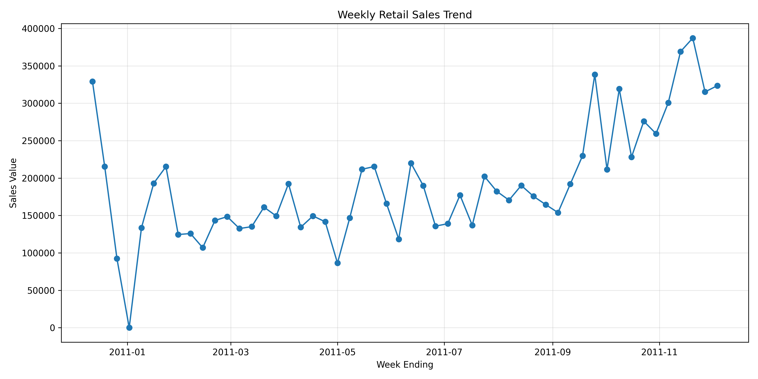
Figure 2. Weekly retail sales trend

4. Product Performance Analysis
Product-level sales were aggregated to identify products contributing the highest recorded sales value. The following table shows the top five products in the processed analysis.
Product | Sales Value | Units Sold
DOTCOM POSTAGE | 206,248.77 | 706
REGENCY CAKESTAND 3 TIER | 174,156.54 | 13,851
PAPER CRAFT , LITTLE BIRDIE | 168,469.60 | 80,995
WHITE HANGING HEART T-LIGHT HOLDER | 106,236.72 | 37,872
PARTY BUNTING | 99,445.23 | 18,283

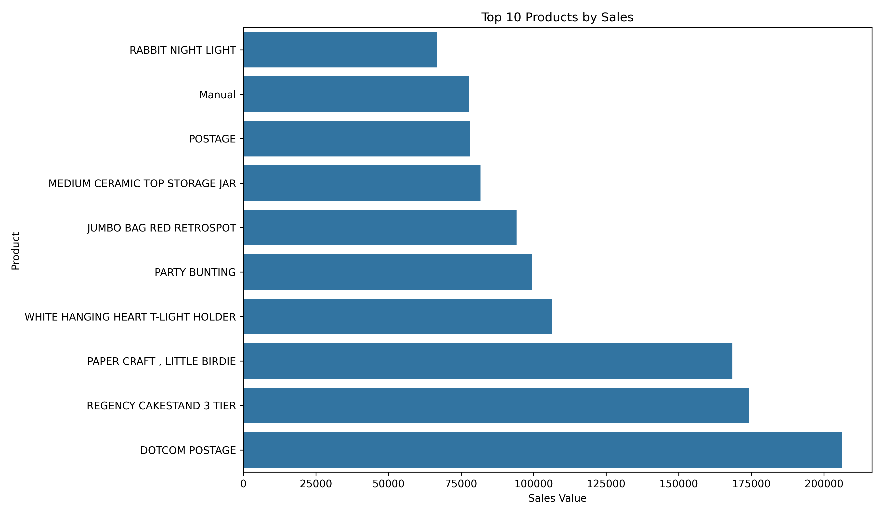
Figure 3. Top 10 products by sales

5. Country-wise Sales Analysis
Country-level aggregation was used to compare recorded sales across the countries represented in the dataset. The United Kingdom accounts for the largest sales value in the analysis.
Country | Sales Value | Units Sold | Invoices
United Kingdom | 9,001,744.09 | 4,646,906 | 18,019
Netherlands | 285,446.34 | 200,361 | 94
EIRE | 283,140.52 | 147,007 | 288
Germany | 228,678.40 | 119,154 | 457
France | 209,625.37 | 112,060 | 392
Australia | 138,453.81 | 83,891 | 57
Spain | 61,558.56 | 27,933 | 90
Switzerland | 57,067.60 | 30,617 | 54
Belgium | 41,196.34 | 23,237 | 98
Sweden | 38,367.83 | 36,078 | 36

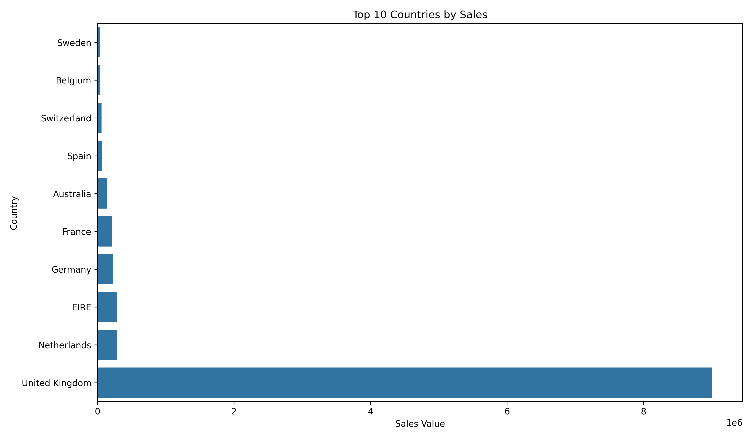
Figure 4. Top 10 countries by sales

6. Customer Segmentation Using RFM and K-Means
RFM analysis represents customer purchasing behaviour using three features: Recency (time since the most recent purchase), Frequency (number of distinct invoices) and Monetary value (total recorded customer sales). The features were log-transformed using log1p and standardized before applying K-Means clustering with four clusters.
The cluster numbers are algorithmic identifiers. The business labels below are interpretations based on the observed cluster averages.
Cluster | Interpretation | Customers | Avg Recency (days) | Avg Frequency | Avg Monetary | Total Revenue
0 | High-Value Loyal Customers | 713 | 12.17 | 13.75 | 8,088.02 | 5,766,757.07
1 | Inactive Low-Value Customers | 1,622 | 181.51 | 1.32 | 341.00 | 553,099.77
2 | Recent Occasional Customers | 837 | 17.70 | 2.19 | 557.32 | 466,479.03
3 | Regular Customers | 1,166 | 71.64 | 4.08 | 1,801.78 | 2,100,873.02

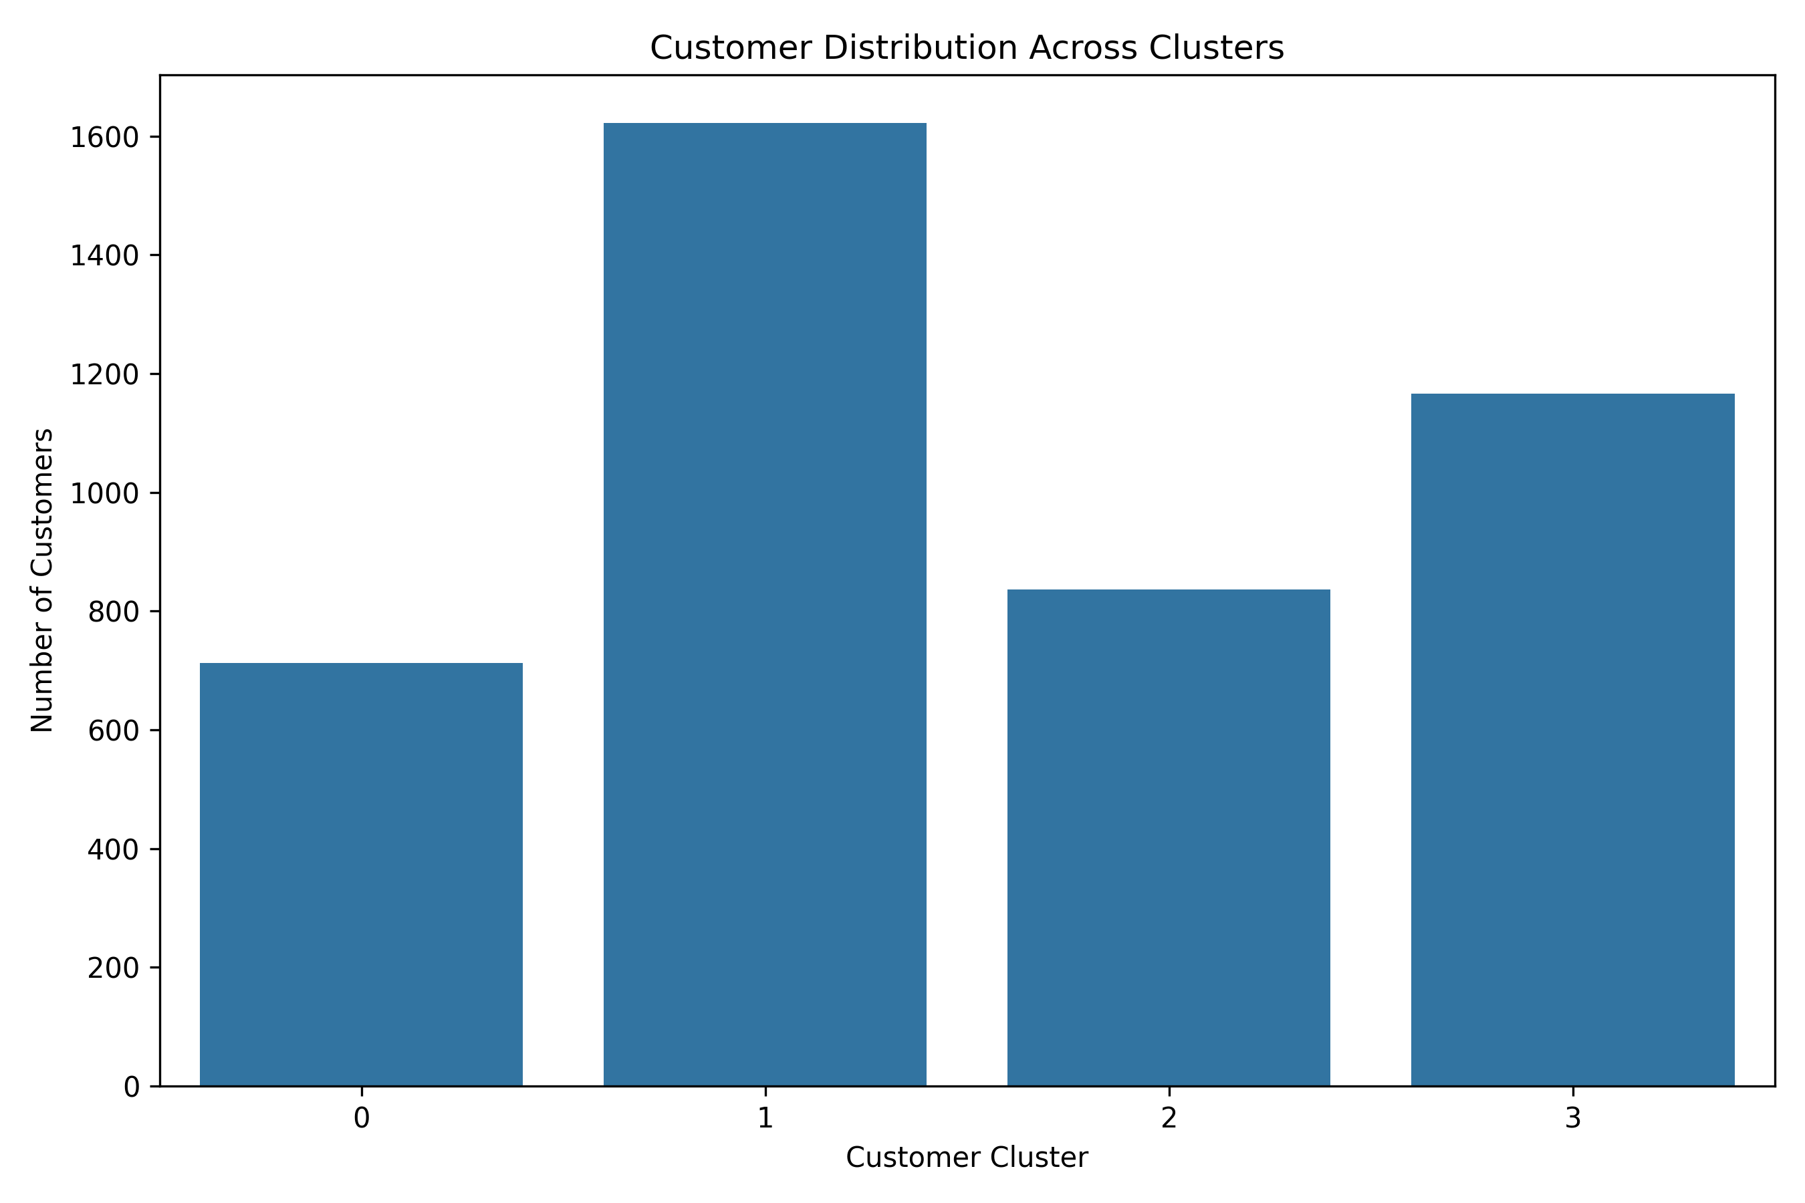
Figure 5. Customer distribution across RFM clusters

Customer Segment Interpretation
- Cluster 0: High average frequency and monetary value, with low average recency. This group represents the strongest high-value and loyal customer segment.
- Cluster 1: High average recency, low frequency and low monetary value. These customers may be suitable for re-engagement campaigns.
- Cluster 2: Low average recency but relatively low frequency and monetary value. These are recent, occasional purchasers.
- Cluster 3: Intermediate recency, frequency and monetary value. This group represents regular customers with potential for further engagement.

7. Weekly Sales Forecasting
Weekly forecasting was performed using 52 complete weekly observations. The first 44 observations were used for training and the final eight observations were reserved for testing. This chronological split preserves time order and avoids randomly mixing future observations into the training set.

Forecasting Methods
- Naive baseline: predicts each test week using the most recent available actual weekly sales value.
- Moving Average: uses a recursive four-week moving average.
- Random Forest Regressor: uses lagged weekly sales features and rolling statistics.

Model Evaluation
Models were compared using Mean Absolute Error (MAE), Root Mean Squared Error (RMSE) and Weighted Absolute Percentage Error (WAPE). Lower values indicate lower forecast error for these metrics.
Model | MAE | RMSE | WAPE
Naive | 42,319.02 | 51,488.05 | 13.77%
Moving Average | 43,938.81 | 55,219.94 | 14.30%
Random Forest | 55,312.74 | 68,666.53 | 18.00%

The selected model was Naive, with a test MAE of 42,319.02, RMSE of 51,488.05 and WAPE of 13.77%.
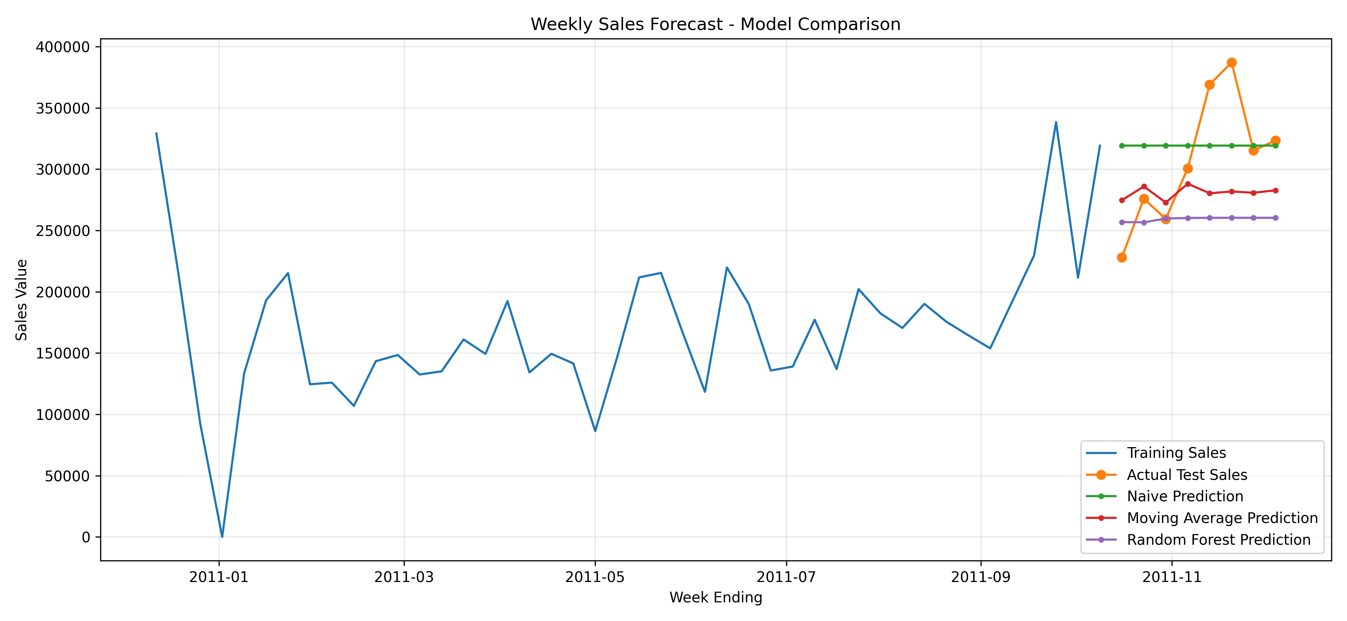
Figure 6. Forecast model comparison

Actual vs Predicted Test Results
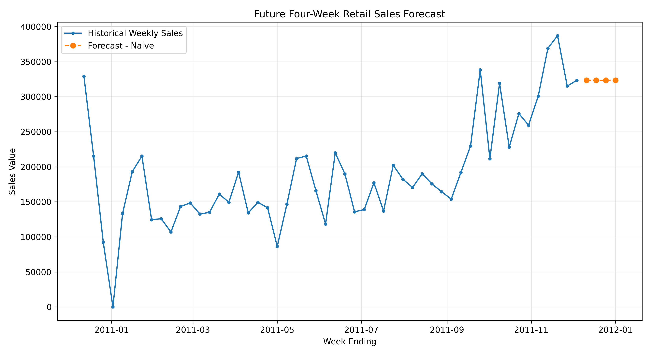
Figure 7. Four-week future weekly sales forecast

Future Four-week Forecast
Week Ending | Predicted Sales | Selected Model
2011-12-11 | 323,398.70 | Naive
2011-12-18 | 323,398.70 | Naive
2011-12-25 | 323,398.70 | Naive
2012-01-01 | 323,398.70 | Naive

The selected Naive model repeats the latest observed weekly sales value for each future week. Therefore, the identical forecast values are an expected property of this baseline model. They should not be interpreted as evidence that future sales will remain constant.

8. Key Business Insights
The United Kingdom contributes approximately 84.59% of the recorded sales value in the country-level analysis.
The RFM analysis indicates that customer value is concentrated in different purchasing behaviour groups. The high-value loyal segment has the highest average monetary value and frequency among the four clusters.
The Naive baseline outperformed the Moving Average and Random Forest models on the selected test MAE metric. This demonstrates that a simple benchmark can be competitive on a limited historical time series.

9. Business Recommendations
- Prioritize retention programmes for high-value loyal customers through relevant offers and customer engagement.
- Consider targeted reactivation campaigns for inactive customers, while evaluating campaign cost and response.
- Encourage recent occasional customers to make repeat purchases through product recommendations and follow-up communication.
- Monitor country-level sales concentration and investigate opportunities to diversify market contribution.
- Review top-performing products for inventory planning and availability management.
- Collect and maintain customer identifiers more consistently to improve customer-level analytics.
- Continue comparing forecasting models as more weekly observations become available, including seasonal and trend-aware approaches.
- Use forecast uncertainty and business judgement when planning inventory, staffing and purchasing.

10. Limitations
- The dataset covers a historical period from December 2010 to December 2011 and may not represent current retail behaviour.
- A substantial number of transaction rows have missing CustomerID values and cannot be included in customer-level RFM analysis.
- K-Means cluster labels are interpretations of unsupervised groups and may change with different preprocessing choices or cluster settings.
- Only 52 complete weekly observations were available for forecasting, with eight observations used for testing.
- The Naive model does not explicitly capture seasonality, long-term trends, promotions or external business factors.
- The forecast is an estimate based on historical observations and should not be treated as a guaranteed outcome.

11. Interactive Dashboard
A Streamlit dashboard was developed to make the project results accessible through a navigable interface. It includes business overview KPIs, sales trends, product analysis, country analysis, customer segmentation and weekly sales forecasting.
The dashboard reads the processed project outputs and prediction files, allowing users to inspect the results without rerunning the full analysis pipeline.

12. Conclusion
This project demonstrates an end-to-end data science workflow using retail transaction data. It combines data validation, business KPI analysis, product and country performance analysis, unsupervised customer segmentation, forecasting model evaluation and an interactive dashboard.
The analysis identified four customer groups and compared three weekly forecasting approaches. The Naive baseline achieved the lowest test MAE among the evaluated models. The resulting insights and dashboard provide a foundation for understanding historical retail performance and supporting further business analysis.

