Title: Dream Museum

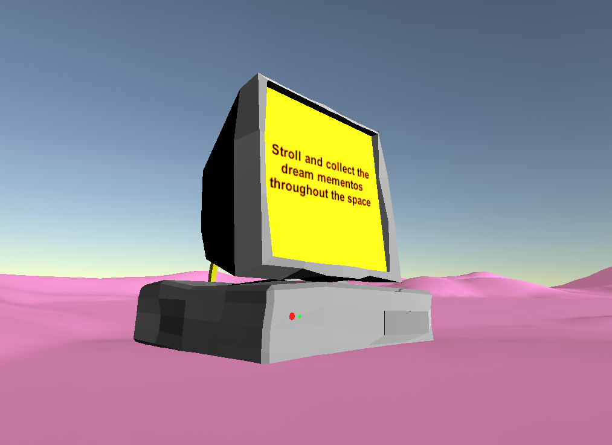

Prepared for: Burke Jam, Adjunct Lecturer, Creative Computation, Division of Art, Southern Methodist University

Meadows School of the Arts, Creative Computation, Capstone 5301

Prepared by: Maggie Cruse

Date: March 19, 2021

Proposal number: 4

Margaret Cruse is a digital technician working with code and new media to develop interactive experiences, looking at themes of embodiment, technology, and simulacra. She is currently working on "Dream Museum" which curates dreams into a walking simulator, examining the ideas of intimacy and philosophies tied to dreaming.

# Project summary

## Description:

## A walking simulator based on crowd sourced dreams.

## I will stage vignettes of dream scenarios in a larger space for the viewer to explore in an open world setting. Looking at games like ART SQOOL and LSD: Dream Emulator, I seek to have a place to house representations of these dreams to be marveled or at least seen by a viewer in a way that is engaging.

## The act of sharing dreams can be incredibly intimate. By soliciting dreams from strangers, I am breaching that intimacy in a public way. With that, there are many ideas on dream analysis and meaning that I could incorporate in my work.

## Objective:

* Expand my understanding of Unity
  + Coding in an engine
  + Utilizing larger spaces
* Better myself as a storyteller
  + Curating multiple stories in one space
  + Maintaining an aesthetic

## Goals:

* Experiment with coding and game mechanics
  + Playing with intrinsic motivation
  + Possible interaction with dreams
* Maybe explore ideas in dream analysis, i.e, Jung and Freud (maybe vaguely ironically)
* Examine ideas of intimacy attached to dreams

## Project Outline

Meadows School of the Arts, Creative Computation, Capstone 5301

* What: walking simulator
* Where: online hopefully, maybe through itch.io
* How: using unity
* Who: me
* Parts/Components: system to solicit dreams, dream vignettes, motivation for seeing all the dreams

# Project Time Frame

## Notes or relevant timeline information:

Meadows School of the Arts, Creative Computation, Capstone 5301

This is tentative

| Project Deliverables and Research Areas | Phase 1 Date | Mid Term Date | Showcase Date |
| --- | --- | --- | --- |
| Component or Area: google form | Feb 17 |  |  |
| Component or Area: assembly | On-going | 3/19 |  |
| Component or Area: inventory | 3/24 |  |  |
| Component or Area: |  |  |  |
| *Add Rows as Needed |  |  |  |