# hw01

## Quick Biography

**My name is Maggie Rivera**. I grew up in Chicago, IL with my mom and sister. *Sometimes* I like to write science fiction stories and watching horror movies.If you have any good recommendations, let me know! I’ve always been more of a cat person.

* Some of the items on my bucket list include:
  + Learning Tagalog and Spanish
  + Learning to dance
  + Writing a book

### Some Accompanying Visuals :P

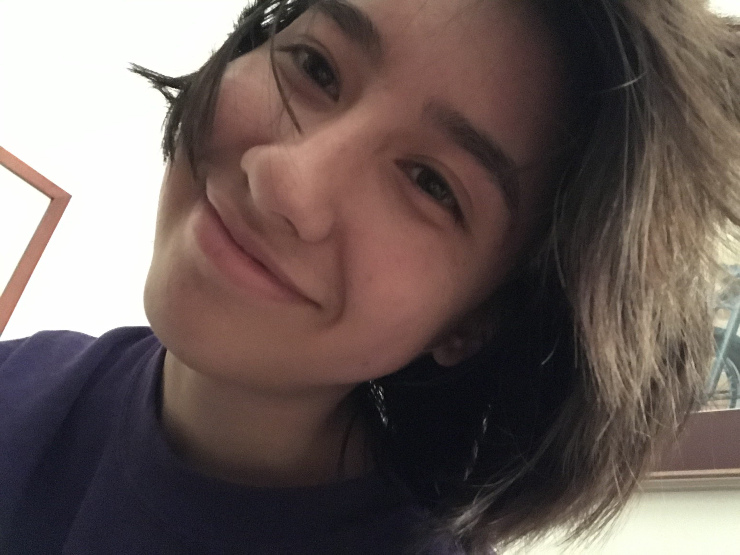

Hi there!

[Instagram Profile](https://www.instagram.com/magpie_riv/?hl=en)