**图像配准**

**一．手动标点：**

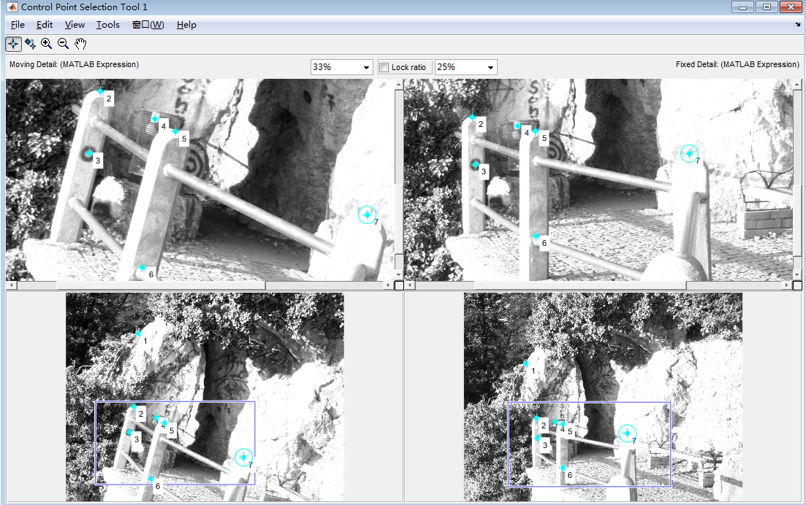

**二．输出两幅图中对应点的坐标：**

fixedPoints3 =

810.500000000000 926.500000000000

954.500000000000 1646.50000000000

970.500000000000 1902.50000000000

1194.50000000000 1690.50000000000

1298.50000000000 1722.50000000000

1310.50000000000 2302.50000000000

2142.50000000000 1858.50000000000

movingPoints3 =

735.685344827586 410.196120689655

687.662356321839 1142.54669540230

639.639367816092 1394.66738505747

909.768678160919 1247.59698275862

984.804597701149 1295.61997126437

855.742816091954 1862.89152298851

1789.18965517241 1655.79238505747

**三．计算转换矩阵：**

计算转换矩阵H可利用MATLAB中的相应函数进行计算。

H=[0.957393062119832,-0.258682674848429,0;

0.263188452704986,0.968134768588880,0;

-1.546779069831634,7.193176030000051e+02,1]

**四．输出转换之后的图像：**

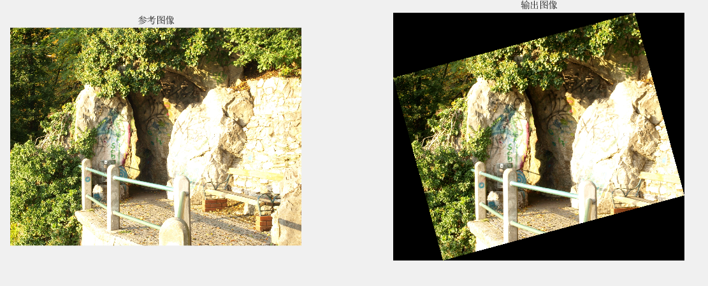

**五．代码示例：**

close all;clear all;clc;

I1=imread('Image A.jpg');

X1=rgb2gray(I1);

I2=imread('Image B.jpg');

X2=rgb2gray(I2);

cpselect(I2,I1);

tform = cp2tform(movingPoints,fixedPoints,'affine');

I_out = imtransform(I2,tform);

figure

subplot(1,2,1)

imshow(I1);

title('参考图像');

subplot(1,2,2)

imshow(I_out);

title('输出图像');

**六．心得体会：**

这次图像配准的实现让我对仿射变换及相关matlab指令有了更深的了解，点的选取和H矩阵的计算让我对数字图像处理产生了浓郁的兴趣。