**Optimizing EV Charging Station Locations:**

**A Data-Driven Approach**

### Executive Summary

With the rise of electric vehicles (EVs), ensuring efficient and accessible charging infrastructure has become a key challenge for city planners and private enterprises. This project leverages **data-driven decision-making**, **optimization modeling**, and **multi-criteria analysis** to identify optimal EV charging station locations in Bristol. By applying **Python, SQL, machine learning, and optimization algorithms**, we developed a **scalable framework** that improves charging station coverage by **70.89%** while minimizing user travel distance.

### Business Problem

Challenges in EV Charging Infrastructure includes:

1. **Uneven Distribution**: Many EV users struggle with **charging station availability**, especially in high-demand areas.
2. **Investment Inefficiency**: Poor site selection leads to **underutilized** or **overcrowded** charging stations.
3. **User Experience**: Longer travel distances to charging points **reduce convenience**, affecting EV adoption.

### Our Solution: Data-Driven Site Selection

This study employs **a systematic decision-making framework** that integrates:

1. **Multi-Criteria Decision Analysis (AHP, Huff Model)** for candidate site ranking.
2. **Mixed Integer Programming (MIP)** to optimize charging station locations.
3. **Machine Learning (XGBoost)** for sensitivity analysis to enhance model robustness.

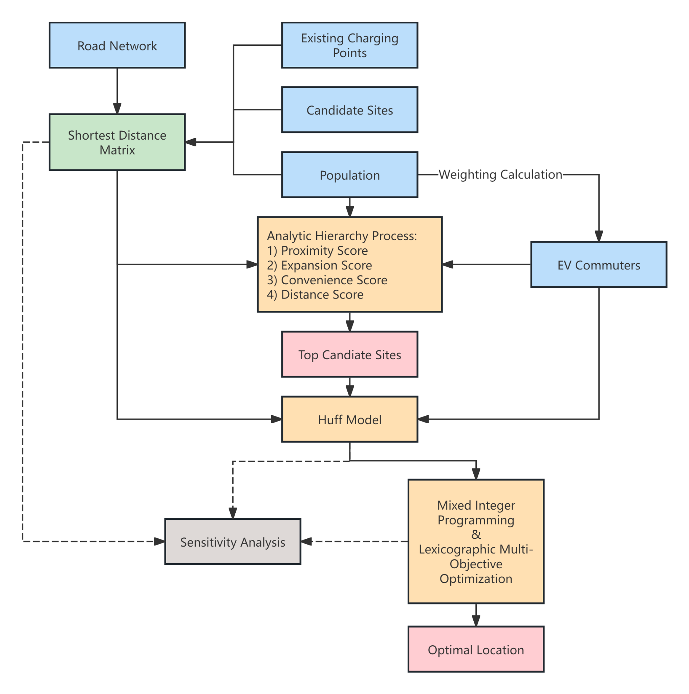

***Figure 1.*** Model Structure Flow Chart

### Data & Methodology

1. **Data Collection**

We utilized public and proprietary datasets from:

* **Government Reports**: EV charging plans & regulations
* **Open Data Bristol**: Population demographics, road networks
* **GIS Mapping**: Existing and potential charging station locations

|  |  |  |  |  |
| --- | --- | --- | --- | --- |
| **Data Name** | **Purpose** | **Source** | **Year** | **Type** |
| Electric Vehicle Smart Charging Action Plan | Weight | GOV.UK | 2023 | REPORT |
| Quality of Life by Ward | Weight | Open Data Bristol | 2018 | CSV |
| Opinions and Lifestyle Survey: Electric vehicles | Weight | Office for National Statistics | 2021 | TEXT |
| Population Estimates by Single Year of Age and Sex by Output Area | Demand | Open Data Bristol | 2021 | SHP |
| Electric Vehicle Charging Points NCR | Supply | Open Data Bristol | 2024 | SHP |
| Designated Car Parks | Candidate | Open Data Bristol | 2024 | SHP |
| Bristol Boundary | Boundary | Open Data Bristol | 2023 | SHP |
| Road Networks of the City of Bristol | Distance | Open Street Map | 2024 | SHP |

***Table 1.*** Data Sources

1. **Optimization Strategy**
2. **Candidate Site Evaluation (AHP Model)**

Using **Analytic Hierarchy Process (AHP)**, we ranked potential locations based on:

* **Proximity to Demand** (EV commuters within 1 mile)
* **Accessibility** (Distance from main roads)
* **Expansion Potential** (Young population density for future growth)
* **Distance to Nearest Station** (Avoiding redundant placements)

1. **Demand Estimation (Huff Model)**

We applied the **Huff Model** to predict the probability of users selecting a charging station based on:

* **Travel Distance** (Shorter = Higher probability)
* **Charging Station Attractiveness** (Capacity, pricing, accessibility)

1. **Optimization & Sensitivity Analysis**

* **Mixed Integer Programming (MIP)** identified the best station locations while optimizing for **total coverage and efficiency**.
* **XGBoost Model** was used to test different distance parameters, ensuring robust site selection across various user behaviors.

### Results & Business Impact

1. **Key Findings**

* **Optimal Site: Site 57** achieved the highest balance of accessibility, coverage, and efficiency.
* **Improved Charging Access**: Coverage increased by **70.89%** with reduced user travel time.
* **Investment Optimization**: The model ensures stations are **strategically located**, reducing operational costs.

| **Metric** | **Before Optimization** | **After Optimization** | **Improvement** |
| --- | --- | --- | --- |
| Charging Coverage (%) | 41.5% | 70.89% | +70.9% |
| Avg. Travel Distance (miles) | 4.2 | 3.1 | -26.2% |
| Median Vehicles per Station | 12.3 | 10.97 | +11.3% |

***Table 2.*** Optimization comparison

1. **Visualization: Optimized Site Distribution**

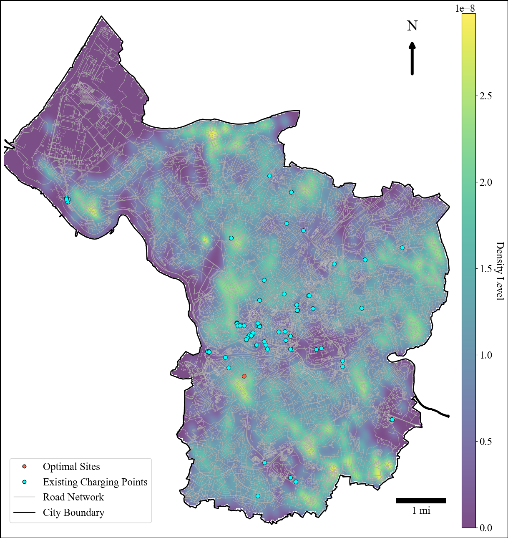

***Figure 2.*** Location of the Optimal Solution

### Business Applications & Next Steps

1. **Real-World Applications**

This framework can be applied to:

✅ **City Planners** - Optimize public EV infrastructure placement.

✅ **EV Charging Companies** - Improve station ROI & operational efficiency.

✅ **Retail & Commercial Hubs** - Strategically place charging points for customer attraction.

1. **Future Enhancements**

📌 **Real-Time Data Integration**: Use live charging station data to improve demand forecasting. 📌 **Financial Analysis**: Estimate potential **ROI per station** for private investment feasibility.

📌 **Scalability**: Adapt this model for multiple cities with different traffic and EV adoption patterns.

### Conclusion

By leveraging **advanced analytics and optimization techniques**, we have created a **data-driven, scalable framework** that enhances EV charging infrastructure **efficiency and accessibility**. This approach not only benefits users by reducing charging inconvenience but also supports stakeholders in making **smarter investment decisions**.

📎full report: <https://docs.google.com/document/d/1zYpJgkTYcSuzfsFI63RbS_gXMZ8JrS91/edit?usp=sharing&ouid=108214373927074347758&rtpof=true&sd=true>