**BOOK A SESH SYSTEM**

**WIREFRAMES**

**SIGN UP**

This will be used by the student to create an account in order to be able to be identified and thus book an appointment.

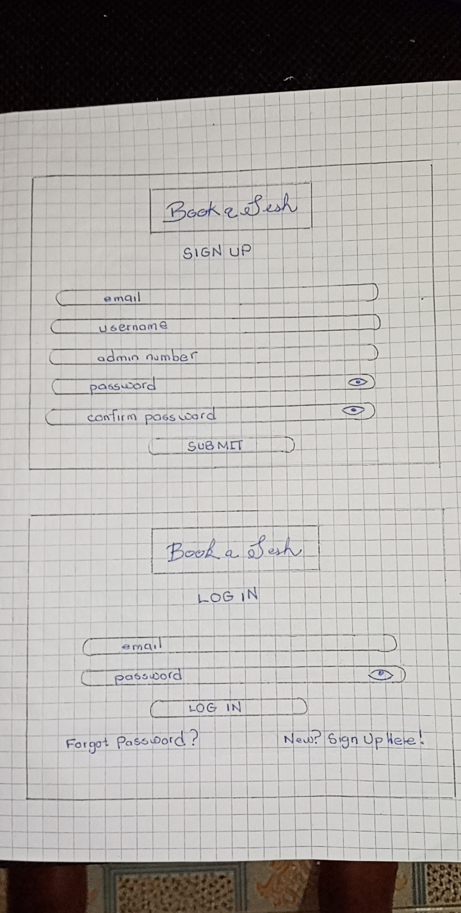

**LOG IN**

This will be used by both the student and the counsellor or life coach to log into the system and access respective functionalities.



**BOOKING AN APPOINTMENT**

This will be used by the student to book an appointment in the time slot of their choice with the counsellor or life coach of their choice.

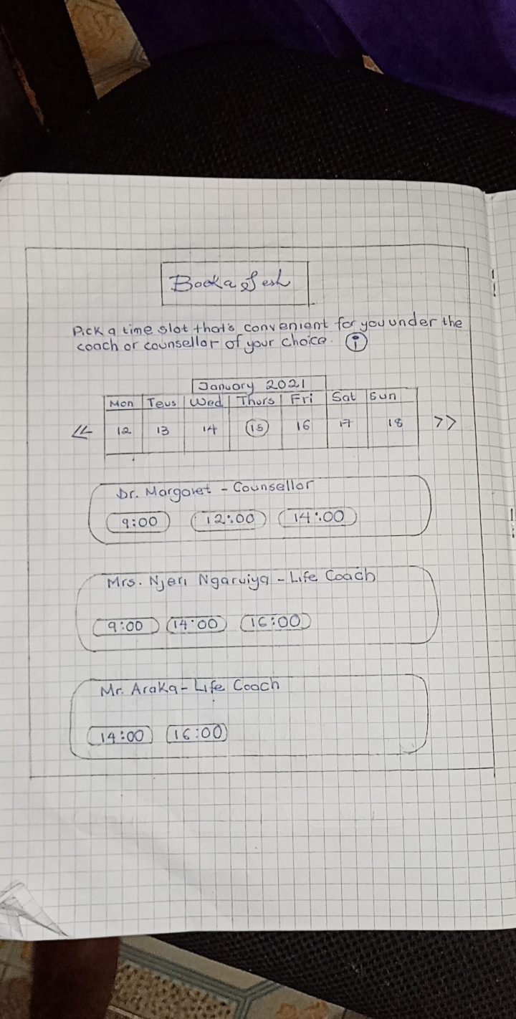

**DASHBOARD**

This is where the counsellor or life coach is directed to once signing in where they can choose the action they want to take.

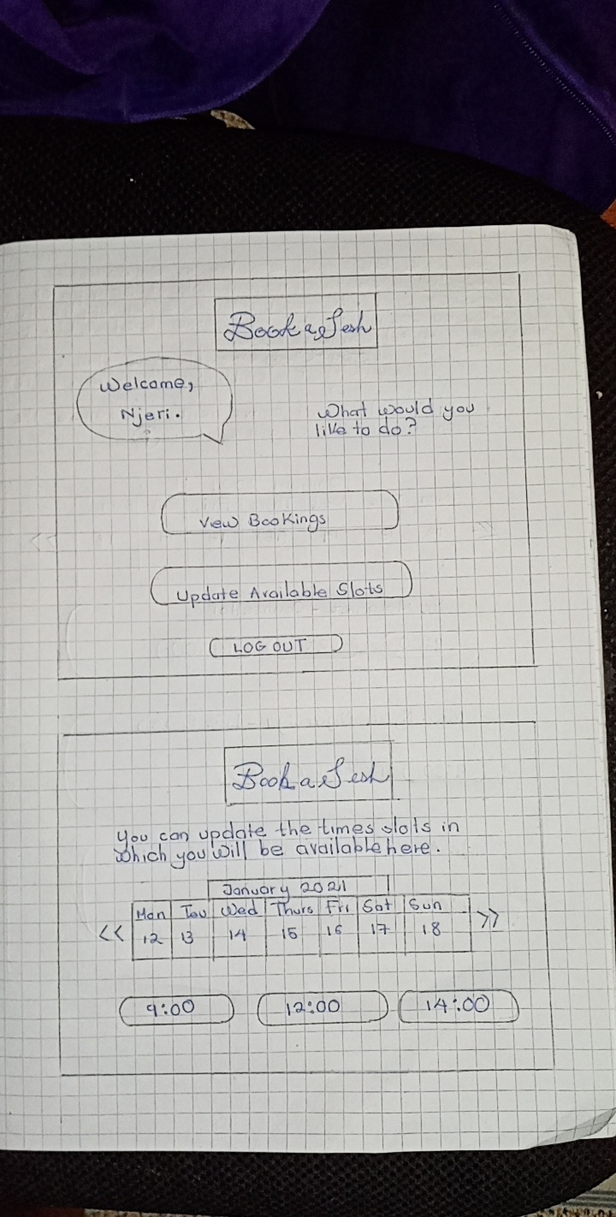

**UPDATING AVAILABLE TIMES**

This is where the counsellor or life coach will be able to update the time slots in which they are available to be booked.



**VIEWING BOOKED APPONTMENTS**

This is where the counsellor or life coach will be able to view the time slots for which they have been booked for and the related information.

