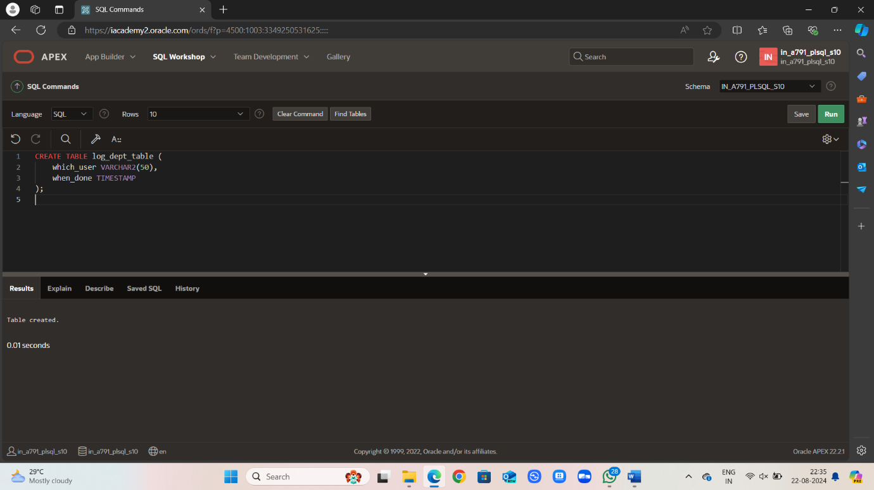

CREATE TABLE log_dept_table (

which_user VARCHAR2(50),

when_done TIMESTAMP

);

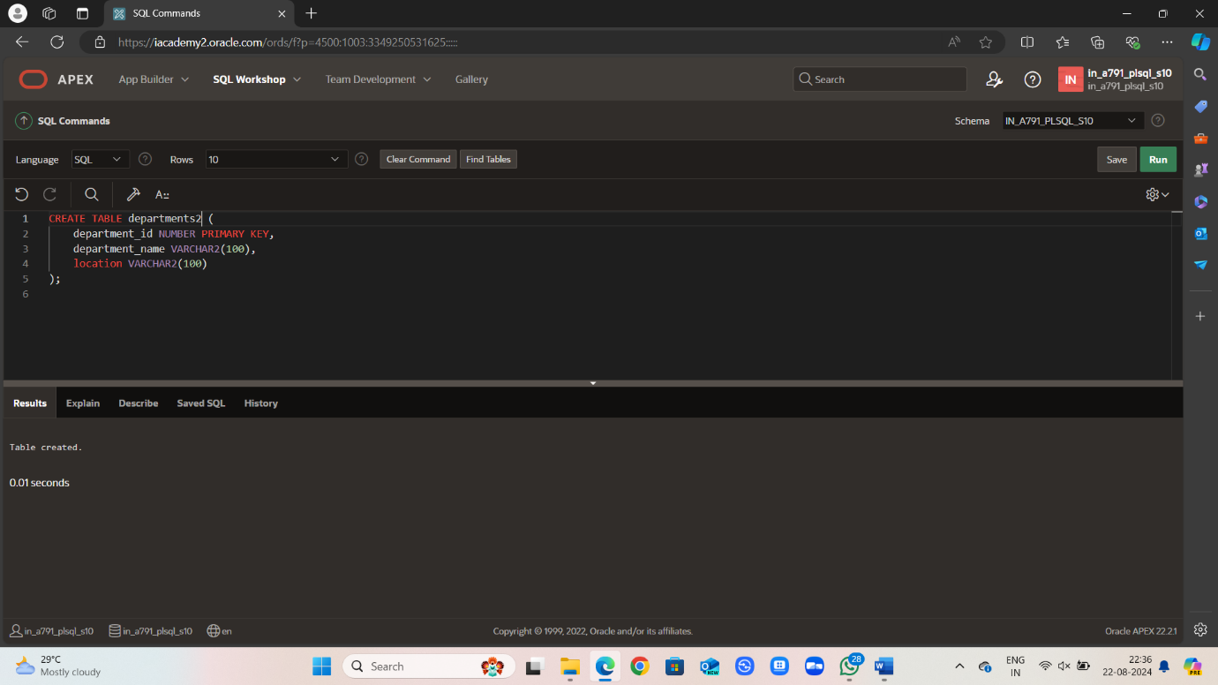

CREATE TABLE departments2 (

department_id NUMBER PRIMARY KEY,

department_name VARCHAR2(100),

location VARCHAR2(100)

);

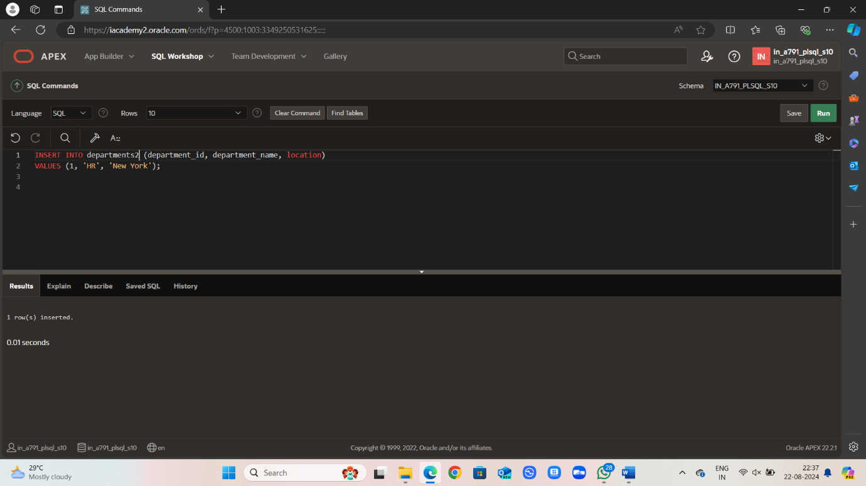

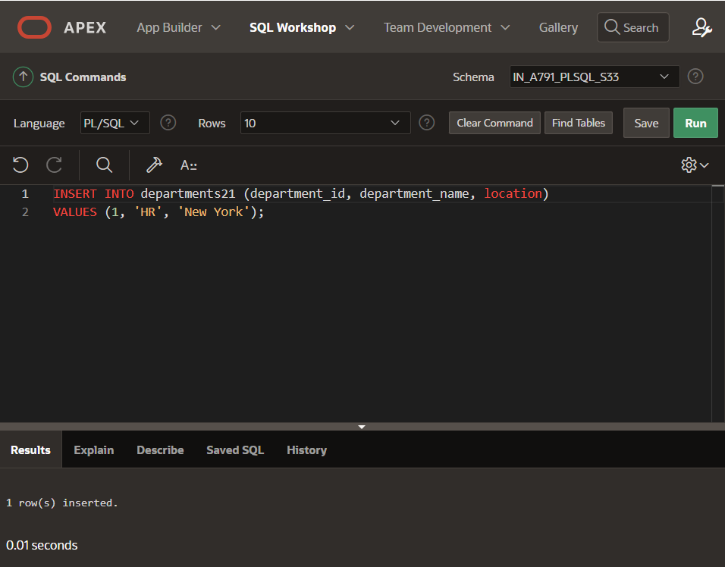INSERT INTO departments2 (department_id, department_name, location)

VALUES (1, 'HR', 'New York');

VALUES (2, 'Finance', 'San Francisco');

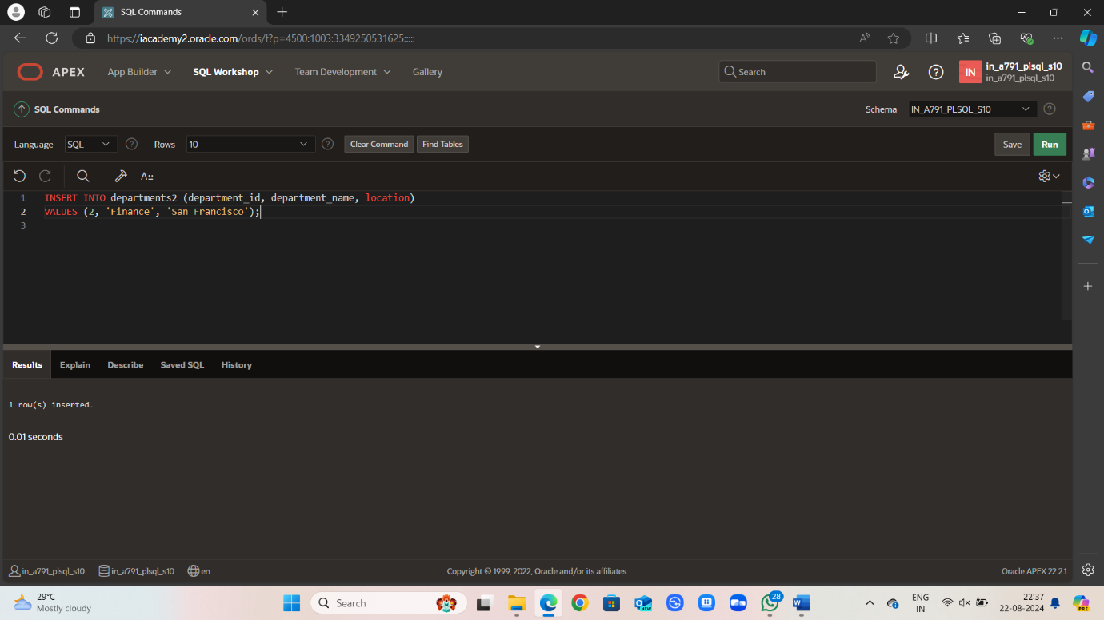

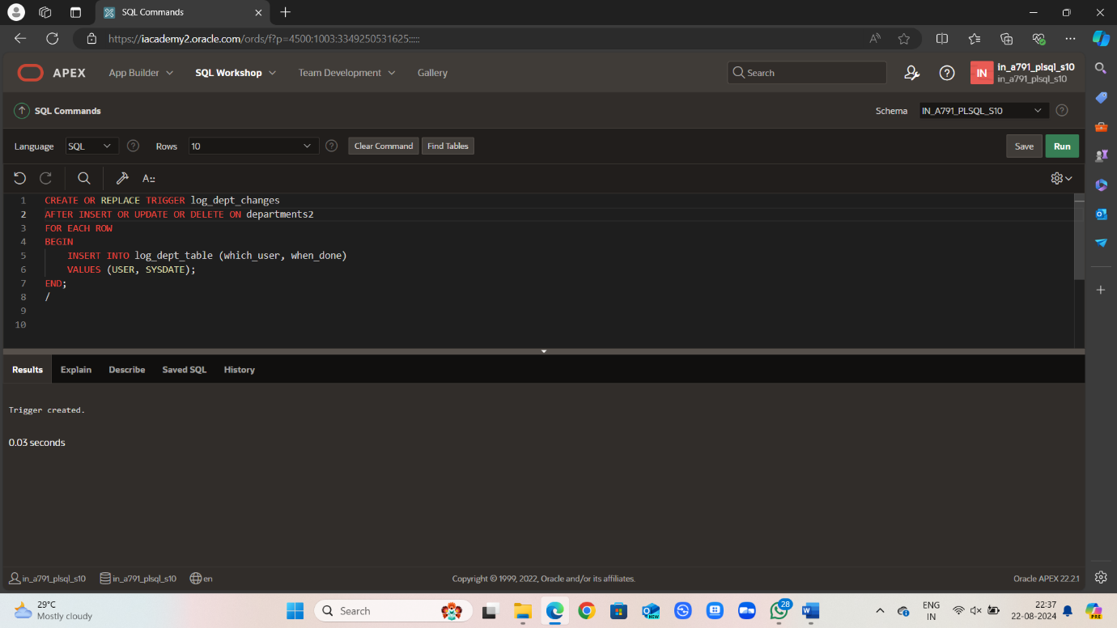

CREATE OR REPLACE TRIGGER log_dept_changes

AFTER INSERT OR UPDATE OR DELETE ON departments2

FOR EACH ROW

BEGIN

INSERT INTO log_dept_table (which_user, when_done)

VALUES (USER, SYSDATE);

END;

/

