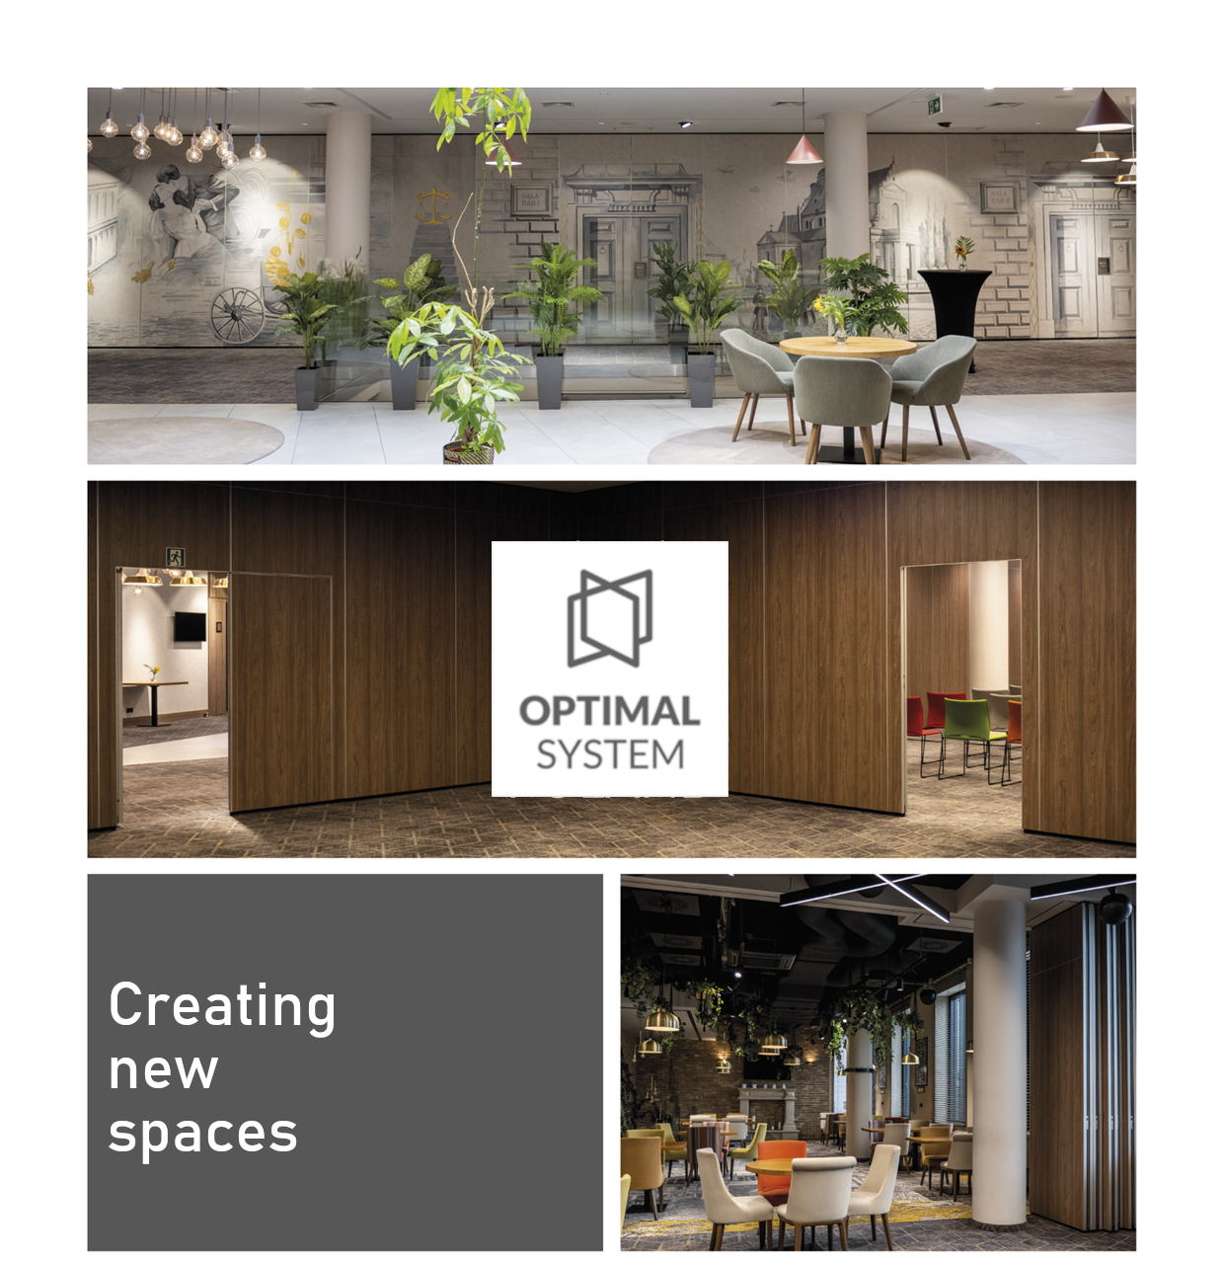
OFFER no 123-MM-26 dated: 02.02.2026r.

Offer prepared by:


Michał Magala (+48 690 371 355 e-mail: m.magala@optimalpoland.com.pl)

