Electricity Price Forecasting

# Margaret Toohey

## Capstone Project Report

## Udacity Machine Learning Nanodegree, Nov 2020

# Definition

## Overview

Electricity price forecasting (EPF) is concerned with the prediction of the price of wholesale electricity, for a region or energy market. The energy market is a highly deregulated and controlled market, and many of the markets across Europe, the USA and Australia trade under strict market rules using spot and derivative contracts. For this reason, in order for participants in the markets to successfully win those contracts, accurate EPF is crucial. [1]. According to Weron et al, accurate price prediction is fundamental for energy companies’ decision making mechanisms. [2]

### Factors Effecting the Electricity Market

Like any commodity, accurate price prediction is crucial for energy companies and suppliers to be able to bid into and participate in the energy market. Unlike other commodities, the stability of power systems is bound by a constant balance between production and consumption, and excess electricity on the system cannot be stored. Another unique feature of the electricity market is the high variability in the demand, based on weather (temperature, wind-speed, sunlight), time of the day (on-peak vs. off-peak) and more long term seasonal effects (winter, summer, weekends, holidays). [1] The variability caused by these factors leads to a market unlike other commodities markets, exhibiting both seasonal trends and unanticipated price spikes or drops.

Another major factor in the EPF is the amount of Renewable Energy Sources (RES) that are available to the market. RES (e.g. Wind [3], solar and hydro [4] etc. electricity sources) have an impact on the price of electricity, and generally the generation of RES leads to a decrease in the wholesale price of electricity [5], since the RES marginal costs are close to zero. The drawback, however, is that the amount of RES available to the power system is not constant, and is variable over a number of factors, such as weather.

### Statistical Methods

Traditionally, statistical methods have been used for EPF, methods such as time series and regression models have been used with good effect, but due to the complexity of the markets, predictions from these models do not give accurate long term EPF. Advanced statistical methods such as bootstrapping, distribution-based probabilistic forecasts and quantile regression averaging. The bootstrap method was developed by Efron et al in 1979 [6] which solved the problem of estimating the sampling distribution of some random variable on the basis of observed data. This method has been successfully applied to EPF for short term predictions on high density forecasts, but begins to suffer in accuracy after longer prediction time periods. [7]. Distribution-based forecasts can be used not only to predict the price of electricity, but for forecasting wind power, like in Wu et al. [8] Quantile regression averaging (QRA) is a method by which quantile regression is applied to the point forecasts of a number of forecasting models, introduced by Weron et al [1] particularly for the application of EPF. QRA and has been extended by various methods to automate the model selection, such as using Principle Component Analysis (PCA) [9] for use prediction spot prices of electricity. This approach can also be used to investigate the effect of various exogenous variables on the market, such as the impact of (RES) on electricity price. [10]. The main issue with statistical methods for EPF is the accuracy over longer term forecasts. [11]

### Machine Learning Methods

The recent computational advancements have led to an increase in popularity in Machine Learning (ML) methods. Artificial neural networks (ANN) have been used for short term EPF [12], [13]. Deep neural networks (DNN) have been used frequently for prediction of day ahead electricity prices [14] [11]. Hybrid models have also been used, such as in [15] when the authors combined a wavelet transform, ARMA and kernel based machine learning for day-ahead EPF. Radial basis function neural networks (RBFN) have also been used in combination with hybrid methods for day-ahead EPF. [16] Recurrent neural networks (RNN) are natural choices of algorithm for the EPF problem due to their temporal nature. Unlike other feedforward neural networks, RNN maintain an internal state, and so makes them applicable to prediction of time series and temporal data. RNN have been used to model many electricity markets, such as the Turkish market [17] and the European Power Exchange [18]. As indicated in the review paper of Lago et al [11], a common issue throughout publications on ML techniques for EPF is the testing periods are to short to yield statistically significant results, and in some cases only used test datasets of one week periods. The issue with short time periods like this is that there is a strong seasonal component to electricity prices, and also “special days” such as holidays etc are not accounted for in these timelines.

After extensive literature review, the group recommend using deep learning methods as the optimal ML approach for ELF, and this recommendation formed the basis of the problem statement for this project.

### Personal Motivation

There were a number of reasons I chose the domain of EPF for the capstone project. I have always had an interest in renewable and sustainable energy sources, and personally I feel strongly that society as a whole should be maximizing the RES in the energy market. As seen from the literature, RES plays a large role in the day-ahead price. An increase in EPF accuracy could lead more market participants to use RES, and will also encourage government bodies to promote investment in renewable schemes [19].

From a pragmatic perspective, as a software engineer, I wanted to use the capstone project to work on an area I wouldn’t normally get to study, like financial models and market predictions, so combining these reasons led me to choose Electricity Price Forecasting as the topic of my project.

## Problem Statement

As mentioned above, after extensive literature review, Lago et al recommended using deep learning methods for the problem of electricity price forecasting [11] and also recommended using at least 4 years of data for training and testing. EPF (like any forecasting problem) is a time-series, prediction problem. Given historical data on how a variable changes over a time-series, the goal of a forecasting problem is to accurately predict the value of the variable for the next time step. Given the historical data, we can frame this prediction problem as a supervised machine learning problem, giving a time series as an input, and the following variable value as the label.

The goal of this project is to use 6 years of historical electricity price data, for the Scandinavian region from the NordPool energy group, train a DeepAR model, which could be used by energy companies for day-ahead price forecasting and hence successful bidding into an energy market.

## Metrics

Initially, when creating a project proposal, I planned on using the Mean Average Percentage Error (MAPE) and the relative Mean Absolute Error (rMAE) and the Root Mean Squared Error (RMSE) to calculate the accuracy of my model, since MAPE, MAE and RMSE are commonly used to quantify the error of forecasting models [20].

However, upon review of my project proposal, the reviewer recommended some reading material about best practice for forecasting problems [21] in which the author states that the MAPE metric is only sensible if yt >> 0. This is not the case for the NordPool data, as seen in Figure 2, in the next section, the data is not much greater than zero and sometimes the price drops below zero. Factoring this into the design of the project, and after reading up the best practices for using the DeepAR algorithm [22], the metrics used to determine the accuracy were the RMSE and the mean quantile loss.

### RMSE

The root mean square error is calculated by taking the square root of the sum of the square of the difference between the predicted value and the actual value, see below. RMSE is appropriate for calculating errors between the prediction and the actual value, rather than comparing across different datasets, so it is suitable for the problem described here.

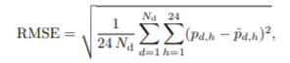

### The Quantile Regression Function

The quantile regression loss function is the maximum value of product of the quantile and the difference between the predicted and actual value, and the product of the quantile less one and the difference between predicted and actual values, see below. For a set of predictions, the loss will be the average quantile loss. [23]

$$L\left(y_{i}^{p},y_{i}\right)=max⁡[q\left(y_{i}^{p}-y_{i}\right), (q-1)\left(y_{i}^{p}-y_{i}\right)$$

# Analysis

## Data Exploration

The data used in this project is from the openly available historical price data from the NordPool group at <https://www.nordpoolgroup.com/historical-market-data/>. This dataset contains:

* The day-ahead price of electricity – unit Euros/MWh
* The day-ahead load forecast (the total amount of power being consumed from the electrical power grid) – unit MWh
* The day-ahead wind generation forecast – unit MWh

The data is give in hourly increments, starting in January 2013 (the first data point is 2013-01-01 00:00:00) up until Dec 2018 (2018-12-24 23:00:00) and there are no data points missing from the dataset.

## Data Visualization

The three variables are plot as a function of time in Figure 1, and it can be seen from the graph that the data in each series is of vastly different scale. In fact, the values of the load data (Exogenous 1) and the wind generation (Exogenous 2) are so much larger than the price that it’s hardly visible on the plot.

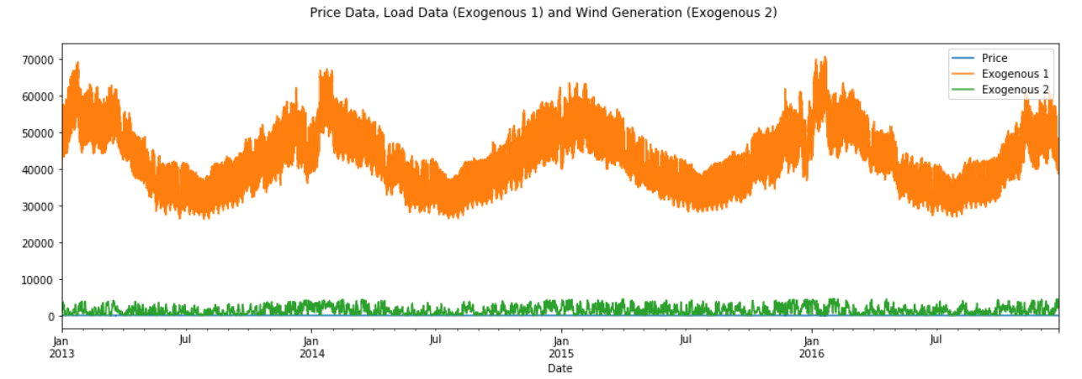

Figure Time series representing the price, load and wind generation of the NordPool group from Jan 2013 to Dec 2018.

In order to better understand the price fluctuation (as that is the variable of interest, and the one we are trying to predict) the price data is plotted by itself in Figure 1.

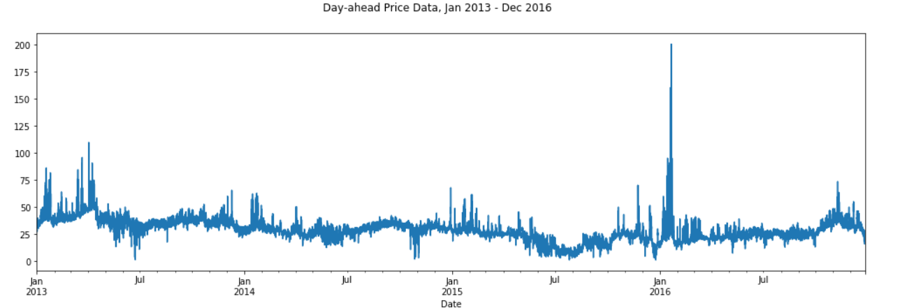Figure The price of electricity in the NordPool group market, from Jan 2013 to Dec 2018

As can be seen in Figure 2, the price of electricity in the Nordic region is almost always positive, zero prices are rare and price spikes happen infrequently.

## Algorithms and Techniques

The model chosen to predict the price of electricity is the DeepAR model from Amazon SageMaker. Lago et al conclude that deep learning methods are the best for forecasting the price of electricity, and many other papers had success with RNNs for prediction [18], [17]. DeepAR is a supervised learning algorithm for forecasting scalar time series [24]. In our case, we want to forecast the day-ahead price of electricity, so DeepAR is a suitable choice of model.

Since the value needed is the day-ahead price prediction, we will use a context length of 72 hours, and a prediction length of 24 hours, for the time series in our dataset.

## Benchmark

The model used to benchmark the DeepAR model is the open source DNN model in the EPF toolbox, from Lago et al [25], which has been specifically created for benchmarking of deep learning models. The DNN model provided is specifically tailored to electricity price forecasting, and the features and hyperparameters have already been optimized for the task. This package also contains a method for evaluating the accuracy of the predictions from the trained model, and this includes a method for RMSE. This allows a direct comparison to the DeepAR model.

# Methodology

## Data Preprocessing

The data is a complete dataset, and has no missing values, so contains all 6 years of hourly data. Since this leads to a huge number of data points, only the day-ahead price forecast data will be used for the model.

The first task is to divide the data into time-series, of a certain “context_length”. This is the number of data points we’e instructing the model to take into consideration when making a prediction. According to [22] the context length shouldn’t be too long, as if the context length is too long, the training job will be very slow. The context length for this project was chosen as 72 hours.

The next step is to decide how long should the prediction be, or the “prediction_length”, and in our case, we are making a prediction on the day-ahead price of electricity, so the prediction length was chosen as 24 hours.

Before splitting the data into training and test datasets, the total dataset is saved as a series of pandas Series objects.

### Training Data:

As mentioned previously, we are making a prediction of 24 hours, so we will leave out the last 24 data points in each section of the data we generated in the previous step, and just use the first part of the data for training.

### Test Data:

The test set contains the full range of each

Implementation

Refinement

Results

Model Evaluation and Validation

Justification

Visualisation

Conclusion

# Bibliography

|  |  |
| --- | --- |
| [1] | R. Weron, "Electricity price forecasting: A review of the state-of-the-art with a look into the future,," *International Journal of Forecasting,* vol. 30, no. 4, pp. 1030-1081, 2014. |
| [2] | R. W. Jakub Nowotarski, "Recent advances in electricity price forecasting: A review of probabilistic forecasting," *Renewable and Sustainable Energy Reviews,* vol. 81, pp. 1548-1568, 2018. |
| [3] | G. B. B.-M. H. Carlo Brancucci Martinez-Anido, "The impact of wind power on electricity prices," *\Renewable Energy,* vol. 94, pp. 474-487, 2016. |
| [4] | L. P. M. P. Angelica Gianfreda, "The Impact of RES in the Italian Day–Ahead and Balancing Markets," *The Energy Journal,* vol. 37, pp. 161-184, 2016. |
| [5] | F. y. Luigi Grossi, "Robust forecasting of electricity prices: Simulations, models and the impact of renewable sources," *Technological Forecasting and Social Change,* vol. 141, pp. 305-318, 2019. |
| [6] | B. Efron, "Bootstrap Methods: Another Look at the Jackknife," *Annual Statistics,* pp. 1-26, 1979. |
| [7] | R. S. Florian Ziel, "Probabilistic mid- and long-term electricity price forecasting," *Renewable and Sustainable Energy reviews,* pp. 251-266, 2018. |
| [8] | B. Z. H. L. Z. L. Y. C. X. M. Junli Wu, "Statistical distribution for wind power forecast error and its application to determine optimal size of energy storage system," *Int. Journal of Electrical Power and Energy Systems,* pp. 100-107, 2014. |
| [9] | J. N. R. W. Katarzyna Maciejowska, "Probabilistic forecasting of electricity spot prices using Factor Quantile Regression Averaging," *International Journal of Forecasting,* pp. 957-965, 2016. |
| [10] | l. Maciejowska, "Assessing the impact of renewable energy sources on the electricity price level and variability – A quantile regression approach," *Energy Economica,* p. 85, 2020. |
| [11] | G. M. B. D. S. R. W. Jesus Lagoa, "Forecasting day-ahead electricity prices: A review of state-of-the-art algorithms, best practices and an open-access benchmark," *Renewable and Sustainable Energy Reviews,* 2020. |
| [12] | S. H. S. T. Nitin Singh, "A PSO-Based ANN Model for Short-Term Electricity Price Forecasting," *Ambient Communications and Computer Systems,* pp. 553-563, 2018. |
| [13] | G. X. Yi Da, "An improved PSO-based ANN with simulated annealing technique," *Neurocomputing,* vol. 63, pp. 527-533, 2005. |
| [14] | S. J. P. T. H. A. S. N. P. R. Radhakrishnan Angamuthu Chinnathambi, "Deep Neural Networks (DNN) for Day-Ahead Electricity Price Markets," in *IEEE Electrical Power and Energy Conference*, Toronto, 2018. |
| [15] | L. C. L. L. Zhang Yang, "Electricity price forecasting by a hybrid model, combining wavelet transform, ARMA and kernel-based extreme learning machine methods,," *Applied Energy,* vol. 190, pp. 291-305, 2017. |
| [16] | M. M. A. N. S. M. H. H. Javad Olamaee, "Day‐ahead price forecasting based on hybrid prediction model," *Complexity,* vol. 21, no. 52, pp. 156-164, 2016. |
| [17] | I. O. O. T. Umut Ugurlu, "Electricity Price Forecasting Using Recurrent Neural Networks," *Energies,* vol. 11, no. 5, p. 1255, 2018. |
| [18] | Y. W. J. M. Q. J. Yiyan Chen, "BRIM: An Accurate Electricity Spot Price Prediction Scheme-Based Bidirectional Recurrent Neural Network and Integrated Market," *Energies,* vol. 12, no. 12, p. 2241, 2019. |
| [19] | G. Wilkins, "Renewable Energy Support Mechanisms – An Irish Perspective," 22 07 2020. [Online]. Available: https://www.capspire.com/renewable-energy-support-mechanisms-an-irish-perspective-by-graham-wilkins/. [Accessed 11 21 2020]. |
| [20] | Y. W. Shuman Luo, "A two-stage supervised learning approach for electricity price forecasting by leveraging different data sources,," *Applied Energy,* vol. 42, pp. 1497-1512, 2019. |
| [21] | R. J. Hyndman, Forecasting: Principles & Practice, Western Australia: UWA, 2014. |
| [22] | "Best Practices for Using the DeepAR Algorithm," AWS, 2020. [Online]. Available: https://docs.aws.amazon.com/sagemaker/latest/dg/deepar.html#deepar_best_practices. [Accessed 22 11 2020]. |
| [23] | J. Circle, "Quantile Loss Function for Machine Learning," Evergreen Innovations, 2020. [Online]. Available: https://www.evergreeninnovations.co/blog-quantile-loss-function-for-machine-learning. [Accessed 21 11 2020]. |
| [24] | "DeepAR Forecasting Algorithm," AWS, 2020. [Online]. Available: https://docs.aws.amazon.com/sagemaker/latest/dg/deepar.html. [Accessed 22 11 2020]. |
| [25] | F. N. Luigi Grossi, "Robust forecasting of electricity prices: Simulations, models and the impact of renewable sources,," *Technological Forecasting and Social Change,* pp. 305-318, 2019. |
| [26] | *https://www.nordpoolgroup.com/historical-market-data/,* 2020. |