Methodology
Project Methodology–Course Registration System Project
Selected Methodology:
- Agile Development: the system is built in short sprints, and each sprint delivers a working module.
Reasons:
- Advisor Feedback: credit limits and student-status rules are refined with feedback from academic advisors.
- Modular System: Student Management, Course Management, Rules Engine, and Reports Panel can be delivered one by one.
- Team Communication: a team of four members working face to face.
Sprint Plan (Implementation phase, 3 sprints of 14 days):
- Sprint 1: Student Management and Course Management.
- Sprint 2: Rules Engine: prerequisite verification, credit limits by GPA and student status, and schedule check.
- Sprint 3: Reports Panel, load testing for registration week, and advisor training.

Case Study
Case Study–Course Registration System
Background:
The university relies on manual review of prerequisites and manual calculation of minimum and maximum credit hours during each semester registration period.
Problems Identified:
- Human Errors: manual record checking causes prerequisite and credit-hour errors.
- Long Queues: students crowd student affairs at the start of each semester.
- No Seat Information: available seats cannot be seen in real time.
- Scheduling Conflicts: conflicts between lectures or final exams are found late.
- Administrative Burden: advisors spend registration week on manual paper-checking.
Project Objectives:
- Prerequisite Verification: prevent registration in a course without its prerequisite.
- Credit Limits: apply minimum and maximum credit hours by GPA and student status.
- Schedule Check: detect conflicts before the schedule is confirmed.
- Real-Time Seats: show available seats for each section.
- Reports: give the administration enrollment reports per course.
Development Plan (SDLC):
- Planning: goals, feasibility, and resources.
- Analysis: requirements from students, advisors, and administrators.
- Design: data model, rules engine, and interface.
- Implementation: build, test, deploy, and train advisors.
Question:
Which SDLC methodology is most suitable for this project?
Answer:
Agile Development. The rules engine is refined with advisor feedback, and working modules are delivered in sprints before the registration week.

Time Estimation
Phase | Percentage | Estimated Time (days)
Planning | 15% | 21
Analysis | 20% | 28
Design | 35% | 49
Implementation | 30% | 42
Total | 100% | 140 (20 weeks)

- Planning Time: 21 days, the minimum duration of the planning activities (see PERT Chart).
- Total Project Time: 21 ÷ 0.15 = 140 days.

PERT Chart
Activity | Description | Predecessors | Duration (days)
A | System Request | - | 3
B | Feasibility Study | - | 7
C | Methodology | B | 3
D | Time Estimation | A, C | 2
E | Task Identification | C | 3
F | PERT Chart | C | 7
G | Gantt Chart | D, E, F | 4
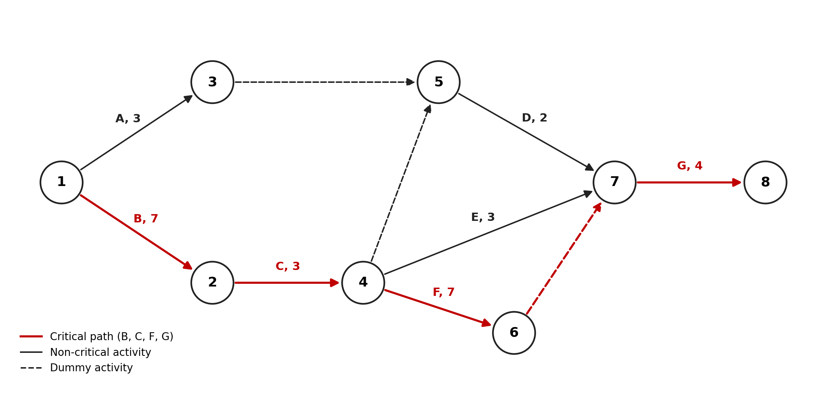
- Critical Path: B, C, F, G.
- Minimum Duration: 7 + 3 + 7 + 4 = 21 days.

Gantt Chart
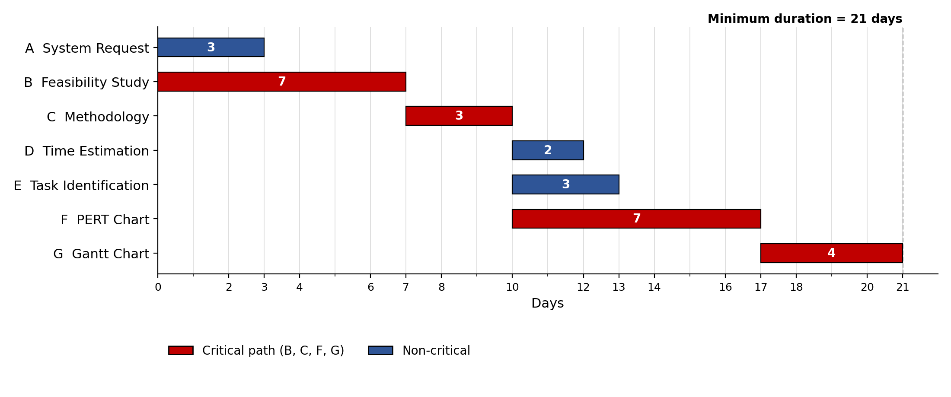
- Critical Path: B, C, F, G.
- Minimum Duration: 21 days.

