

**MFundPlus Software Functional Specification Document**

**FSD06- End of Day Process**

**UTT ASSET MANAGEMENT AND INVESTOR SERVICES PLC**

13-06-2025

# Disclaimer

The material contained in this Document represents proprietary, confidential information pertaining to Azentio Software Private Limited’s products, services and methods.  By accepting this document, the reader hereby agrees that the information in this Document shall not be disclosed outside of Angel One Mutual Fund and shall not be duplicated, used, or disclosed for any purpose other than to evaluate this Document.

# Version History

|  |  |  |  |
| --- | --- | --- | --- |
| Version No. | Release Date | Prepared by | Remarks |
| 1.0 |  | Anson Xavior | Initial Version |

# Contents

Disclaimer 2

Version History 2

Contents 3

Introduction 4

Income Distribution Calendar 4

Income Distribution Calendar upload 5

Income Distribution Scheduler 6

Income Distribution Authorisation 7

About Azentio Software 8

Head Office 8

# 

# Introduction

This document explains about the Income Distribution (also called as Dividend Distribution) in the MFund Plus Product. This module will allow the users to input the Income Distributions (Cash and Reinvestment) into the system based on the frequency opted by the investor.

# Income Distribution Calendar

**Path:** Operations🡪Income Distribution🡪 Income Distribution Calendar

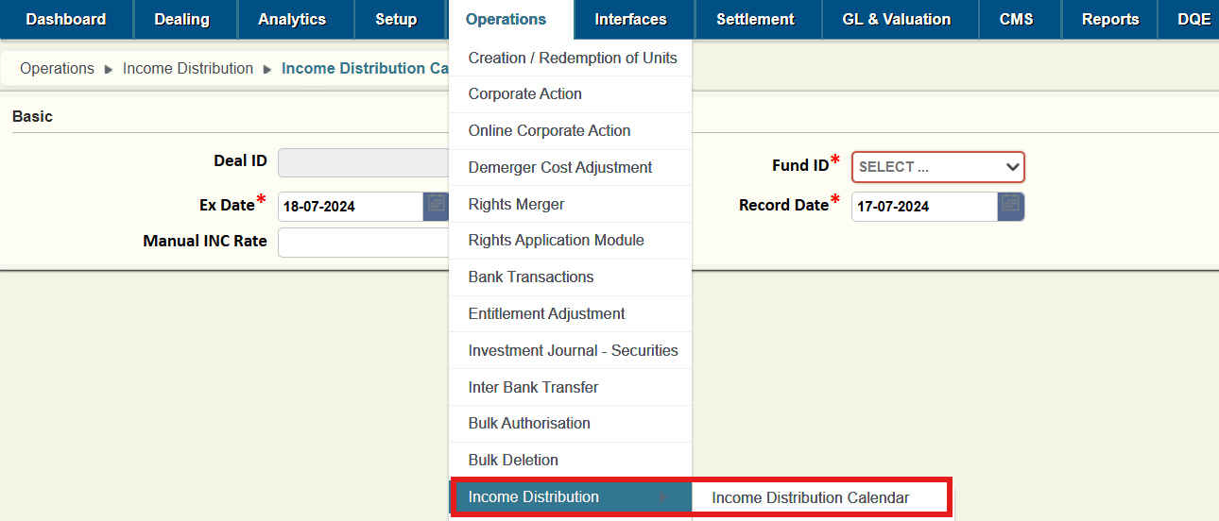

This is the first step wherein the user will input the below details:

**Fund Id (Mandatory):** Select the fund which offers Income Distribution

**Ex- Date (Mandatory):** Date on which the Income Distribution is to be booked.

**Record Date (Mandatory):** Date on which Ex Nav will be calculated based on which the income Distribution will be distributed among investors. Record Date will always be Ex Date-1(exception if the date falls on holiday).

**Manual INC Rate (Not Mandatory):** This will include the per-unit income distribution rate, if available at the time. Leave the header blank if the rate is not available at the time.

After entering and submitting the above details, another user must authorize the action using one of the following two methods

* Users can approve by going to **Operations🡪Bulk Authorisation**, select the count under the screen name **Dividend Distribution - Dividend Distribution Calendar** and approve theapprove the data uploaded

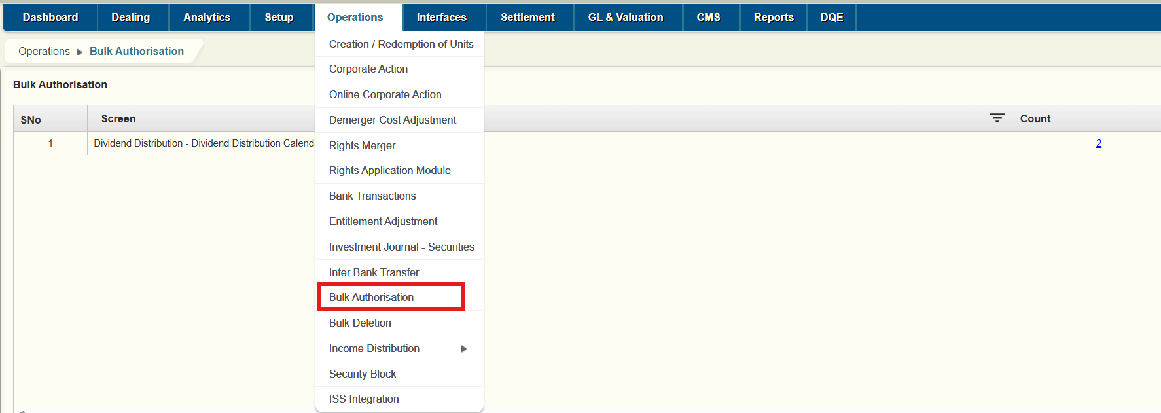

* Go to the path **Operations🡪Income Distribution🡪 Income Distribution Calendar,** click on Search on the right top corner and select unapproved and click on search approve the relevant records.

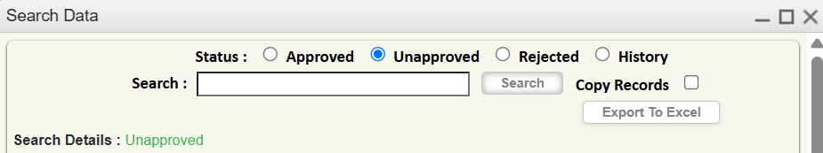

# Income Distribution Calendar upload

If the users have the dealing calendar and have the dates on when the Income Distribution is to be made or they have multiple schemes wherein the Calendar is to be updated or both. Users can use the upload file from the below path.

**Path:** Interface🡪Uploads

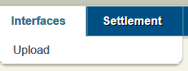

**Module Name:** DIVCAL

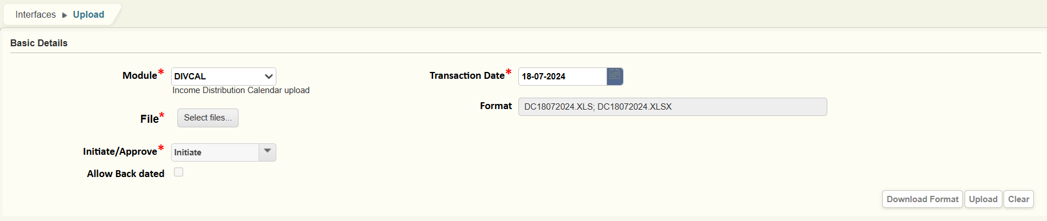

Users can download the .xls format file by clicking on download format. The format in the file looks like below

|  |  |  |  |
| --- | --- | --- | --- |
| Fund ID | Ex Date | Record Date | Div Rate |
|  |  |  |  |

Once the data is successfully submitted another user must authorize these entries by following the same steps mentioned above.

# Income Distribution Scheduler

**Path:** Operations🡪Income Distribution🡪 Income Distribution Scheduler

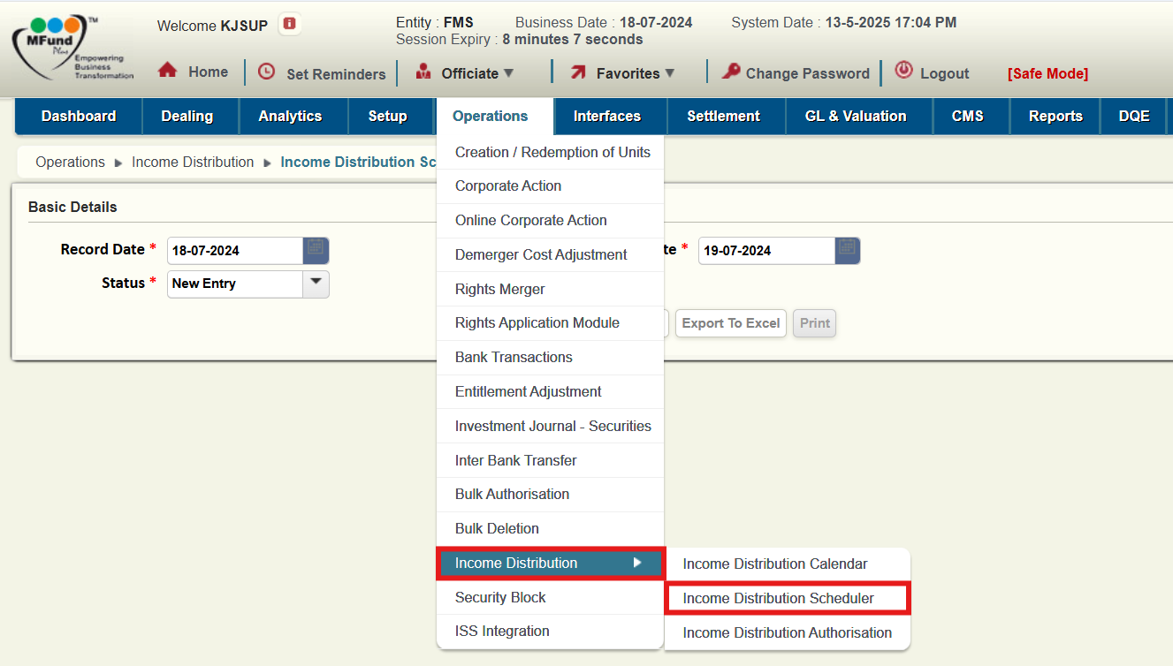

This module will be used on Record date. Within this module, users can view the status of income distribution. The following headers will appear in Status upon selecting the 'Scheduler' option

* **Record Date (Mandatory):** Date on which Ex Nav will be calculated
* **Ex- Date (Mandatory):** Date on which the Income Distribution is to be booked.
* **Status (Mandatory):** The following flowchart illustrates the process to facilitate a better understanding

**New Entry🡪 Saved🡪 Approved**

* + **All**: This field will show all the records.
  + **Approved**: Once the entry is approved in Saved screen it is visible in the Approved screen.
  + **New Entry:** Once the records are approved in Income Distribution Calendar, the entry will be visible on this screen where the user can input income Distribution/Unit if not given in the earlier and select the NAV.
  + **Saved:** The deal will be visible in Saved screen once the data is submitted in new entry screen, another user will have to check and approve the same.

# Income Distribution Authorisation

**Path:** Operations àIncome Distribution àIncome Distribution Authorisation

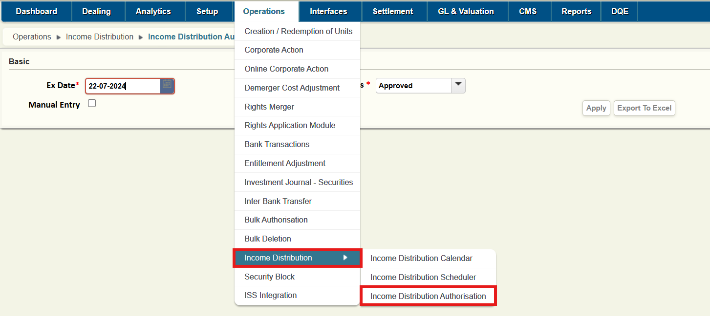

On the Ex-date, the user will access the Income Distribution Authorisation entry. By taking the status as Approved, all the approved records from the scheduler module with the ex-date will get displayed on the screen and it will also showcase the total units outstanding in that scheme and based on the per unit income distribution rate, system will compute the total dividend payable amount as well.

The following headers will appear in Status upon selecting the 'Authorisation' option.

* **Ex- Date (Mandatory):** Date on which the Income Distribution is booked.
* **Status (Mandatory):**

The following flowchart illustrates the process to facilitate a better understanding

**Approved🡪Processed🡪Authorised**

* + **All:** This field will show all the records.
  + **Approved:** The approved records in Income Distribution Scheduler, will be visible in the Approved screen, here the user can see the No of units, Total payout valueand other important details**.** The user can verify the details and submit the record
  + **Authorised:** Once the record is approved in the processed screen by a checker, these can be seen in the authorised screen.
  + **Processed:** Once the maker submits the record from the Approved screen, the record can be seen in Processed screen, here a checker can the details and action accordingly.
  + **Reverse Unauthorised:**

On authorisation of the entries, the accounting entries will be posted in the application as below

Income Distribution Expense………. Dr

Income Distribution Payable………. Cr

The accounting entries can be viewed in the path: Dashboard🡪Enquires🡪Accounting Entries.

# About Azentio Software

Headquartered in Singapore, Azentio Software Private Limited brings deep domain expertise with a suite of software products spanning across banking insurance, asset management and ERP verticals. Its flagship products include Kastle™ (Universal Banking Solution), Premia Astra™ (Core Insurance Solution), AMLOCK™ (Financial Crime Detection and Management Solution), MFund Plus™ (Wealth & Asset Management Solution) and Orion™ (Enterprise Resource Planning Solution).

Azentio provides core software to BFSI customers and ERP solutions to SMB enterprises primarily across Middle East and Africa, Asia Pacific and India. Azentio has over 700 customers in more than 58 countries. It has offices in 9 countries with a strong team of over 1,600 employees. Azentio is committed to partner with its customers globally to transform their business operations through continuous focus on innovation and best-in-class customer service.

Azentio Software Private Limited is wholly owned by Funds advised by Apax.

Head Office

38 Beach Road, #29-11 South Beach Tower, Singapore 189767  
Regional Office

International Infotech Park, Tower No. 5, 5th to 6th Floor, Vashi Railway Station Complex, Vashi,  
Navi Mumbai - 500703, India   
T: (+91) 22 7123 8000