

**MFundPlus Software Functional Specification Document**

**User Admin Masters- FSD02**

**UTT ASSET MANAGEMENT AND INVESTOR SERVICES PLC**

13-06-2025

# Disclaimer

The material contained in this Document represents proprietary, confidential information pertaining to Azentio Software Private Limited’s products, services and methods.  By accepting this document, the reader hereby agrees that the information in this Document shall not be disclosed outside of **CHOICE** Asset Management, and shall not be duplicated, used, or disclosed for any purpose other than to evaluate this Document.

# Version History

|  |  |  |  |
| --- | --- | --- | --- |
| Version No. | Release Date | Prepared by | Remarks |
| 1.0 |  | Anson Xavior | Initial Version |

# 



**Contents**

Disclaimer 2

Version History 2

1. Requirement Description – User Admin Masters 3

1.1. USER MASTER SCREEN 5

1.2. Officiate User 6

1.3. ROLE AND ACCESS PERMISSION 8

1.4. Access Master 10

1.5. USER UNLOCK AND RESET PASSWORD 14

1.6. RESET USER STATUS 16

About Azentio Software 18

Head Office 18

1. Requirement Description – User Admin Masters

This feature explains about the various users who can login only when user creates the user master here.

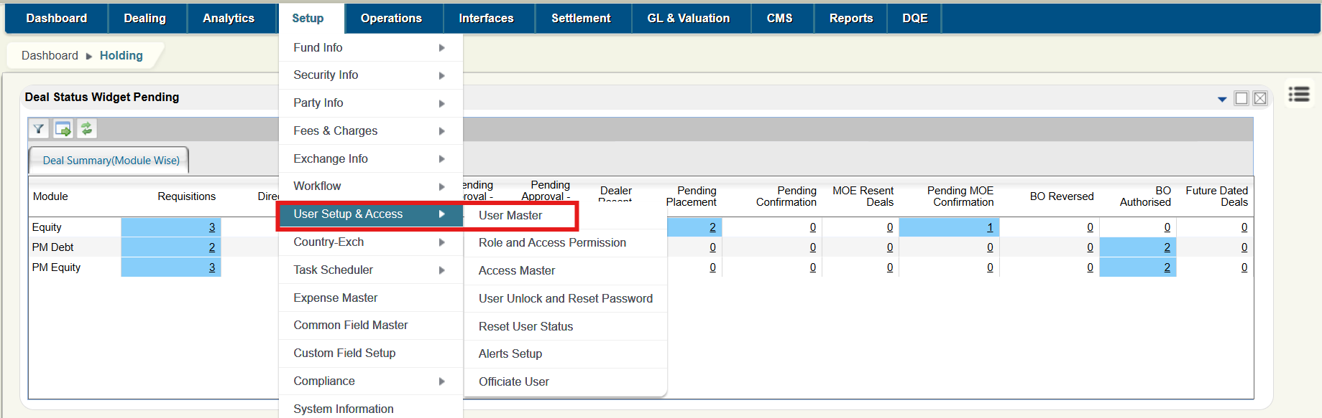

## 

## USER MASTER SCREEN

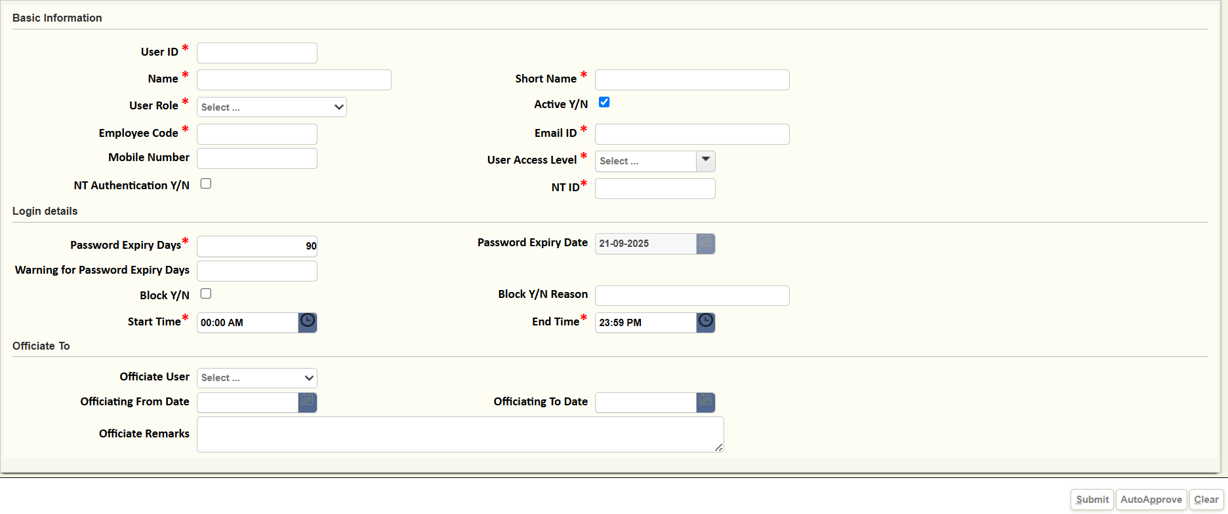

**Basic information**

* **User ID (Mandatory):** This field indicates unique user id.
* **Name** (**Mandatory):** This field indicates User’s name.
* **Short name** (**Mandatory)**: This column is to specify the short name of the user.
* **User Role** (**Mandatory**): This is to specify the role of user. Select an option from the dropdown list. for ex- Supervisor, Equity Fund Manager etc
* **Active Y/N**: This flag indicates if the user is active or not, this checkbox is selected by default. Incase User is inactive he will not be able to log into application.
* **Employee code:** This field indicates the Employee code of the user.
* **Email id** (**Mandatory**)**:** This flag indicates the user mail id to set the password. Once user creates the User master, User will receive the mail to set the password.
* **Mobile Number**: This field indicates the user mobile number.
* **User Access level** (**Mandatory**)**:** This column displays the user access level.
  + **Fund Level:** User will have the right to access with whatever fund he has permission to access.
  + **Fund Level:** Selecting this option, User will have the rights to access with all the funds.

**Login Details**

**Password expiry frequency (Mandatory):** This flag indicates how password frequently wants to get expiry. Ex- M0101, Weekly or Daily.

**Password expiry date**: This column will be automatically filled once the password frequency is set.

**Warning for password expiry days:** This is to specify warning alert prior to password expiry day.

**Block Y/N:** This field indicates if user is blocked or not. To block the user select the check box. Blocked user cannot log into application.

**Block Y/N Reason:** This filed should be filled incase user click on Block Y/N check box.

**Start time** **(Mandatory):** This column is to specify the start time of the user.

**End time** **(Mandatory):** This column is to specify the end time of the user. Once End time is over User cannot log into application. System will throw the validation.

## Officiate User

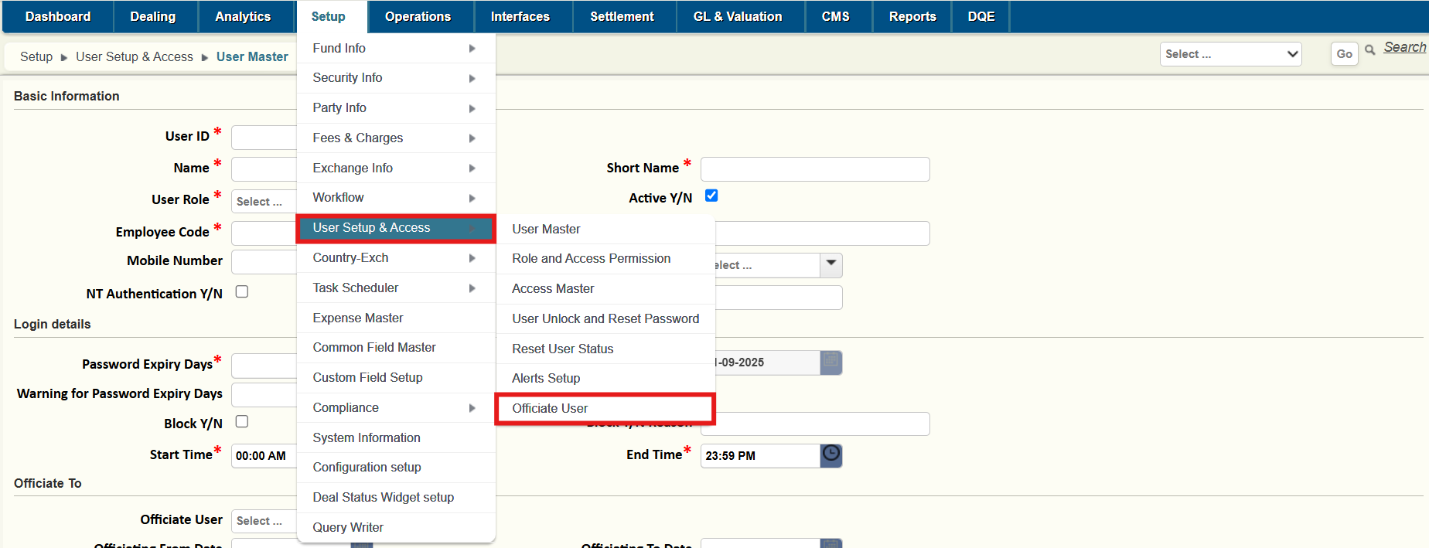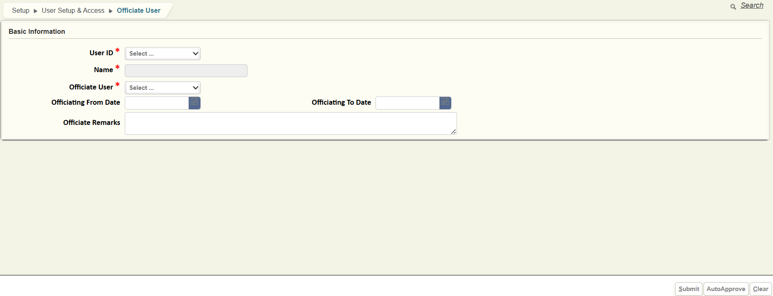

**Officiate User**: This Field indicates the officiate user. Users need to select the user id from the dropdown to whom the access is to be given. Once this selection is done. User selected in this column will get access of the main user who officiated access. For e.g. EQFM1 is going on leave then EQFM2 can be selected in Officiate User. EQFM2 will get all the access of EQFM1. Once EQFM2 logs into system with own ID using the officiate selection at the top screen EQFM2 will be able to navigate to screen of EQFM1

**Officiating from date:** This is to specify the officiating from date. Officiating access will start from date. This will be the calendar date

**Officiating end date:** This is to specify the officiating end date. Officiating access will get expired after the end date. This will be the calendar date

**Officiate Remarks:** Here the user should mention remarks on why the user gives the officiating access to the mentioned user.

## ROLE AND ACCESS PERMISSION

This feature defines how the user role and access permission are setting up for the users. This functionality is as follows.

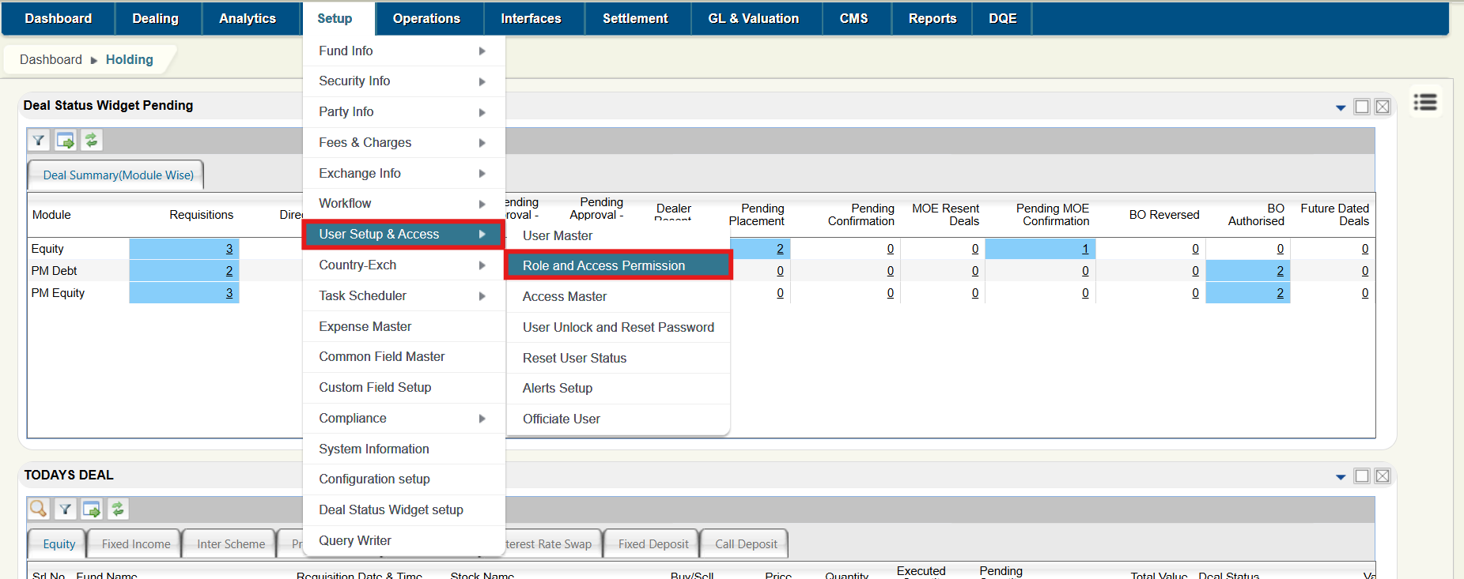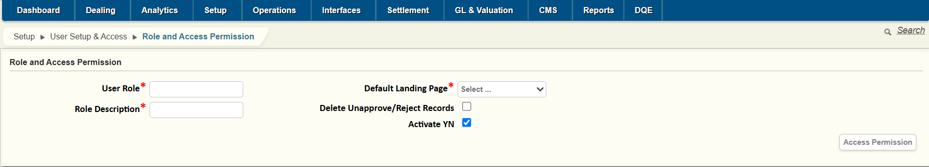

**Role and Access permission**

**User Role (Mandatory):** This indicates the user for whom to give access permission.

**Default Landing Page** (**Mandatory):** This indicates the defaulting landing page. Select an option from the dropdown menu.

**Role Description** (**Mandatory):** This flag indicates the description of the user role. Ex. Supervisor, Fund Manager, Dealer.

**Access Permission:** Clicking on this Button Will show the detailed view of application screens for the user. Users can select the access to be provided according to user role.

Back Office Modules have access as Initiate, Approve, Reverse, Delete, Auto Approve and View. Based on the accesses given to the users, only the users in that user role can perform those actions. For Front office modules, the access is set as Access YN. The users in the user role with Access YN will have access to that screen and can enter transactions, but taking the transaction through would be decided by the workflow setup.

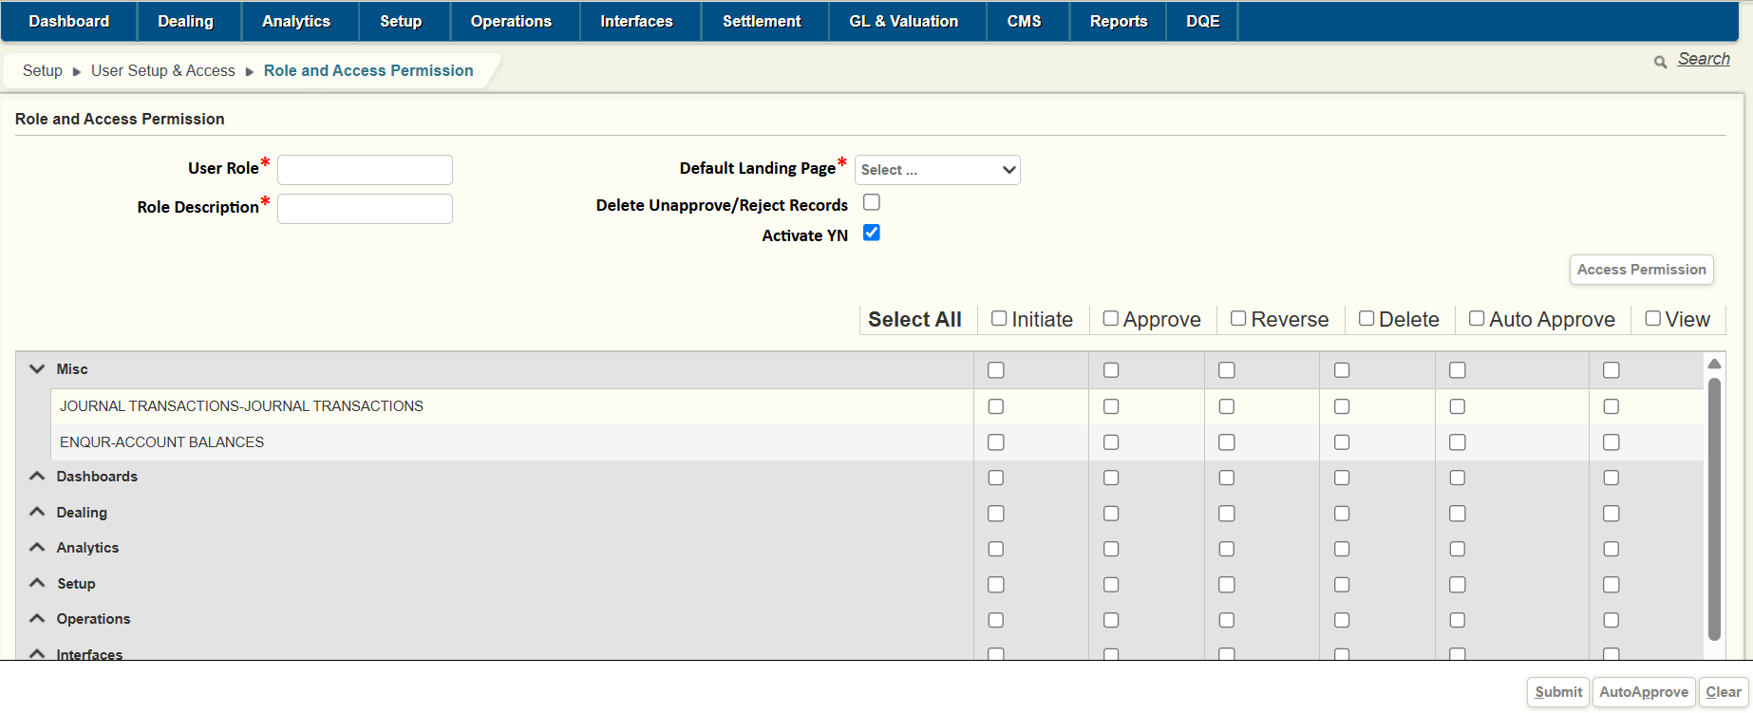

## Access Master

This Master defines to give access for the master based on the user id. This master functionality is given below.

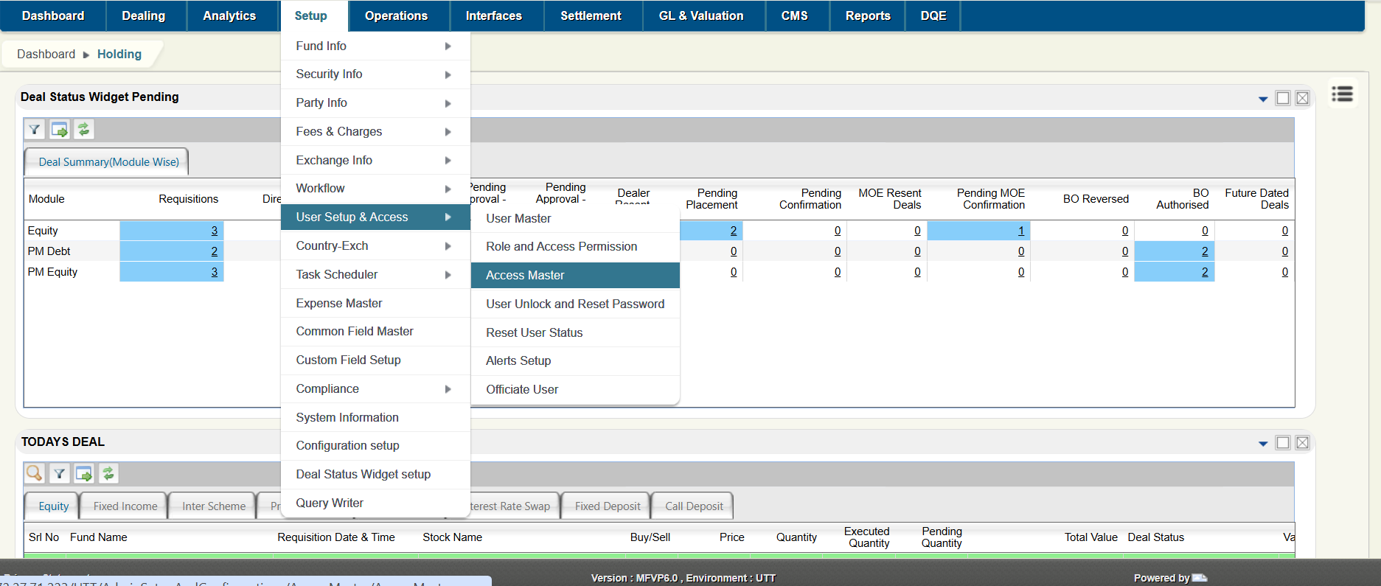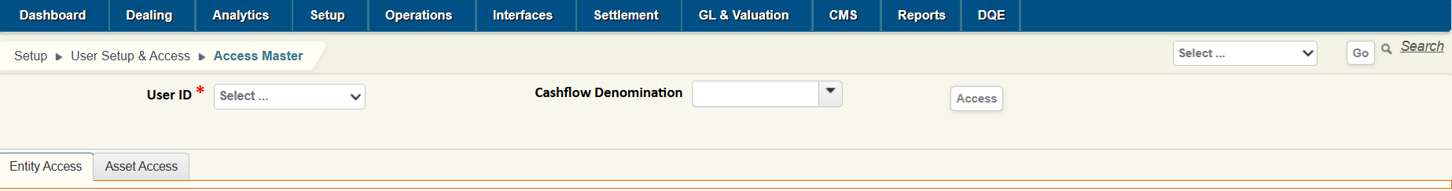

**User Id (Mandatory):** This field indicates user which is already created. Select the User from the dropdown list.

**Access Button:** Clicking on Access Button Will display the Entity/Fund Access and Asset Access details.

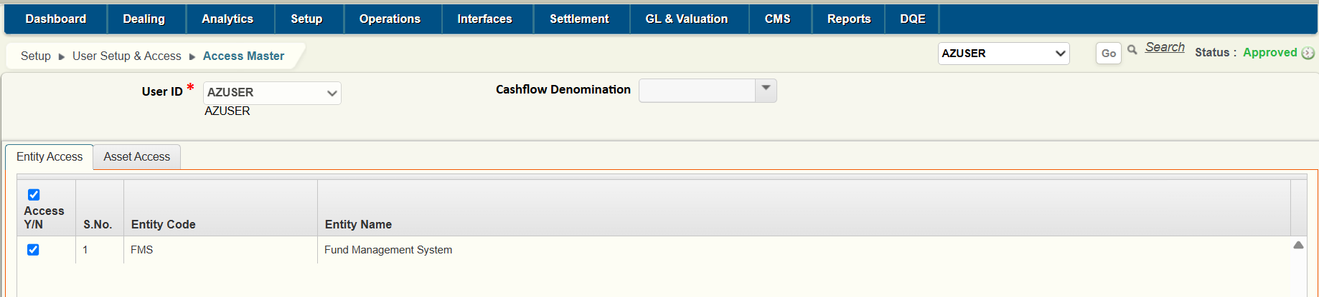

**Access Y/N:** This field indicates whether the Entity level access is applicable or not for the users. This option is applicable if Entity Access is selected in User master. In case Fund Access is selected in User master then individual funds can be selected

**Entity Code:** This column shows the entity code**.**

**Entity Name:** This column shows the entity name**.**

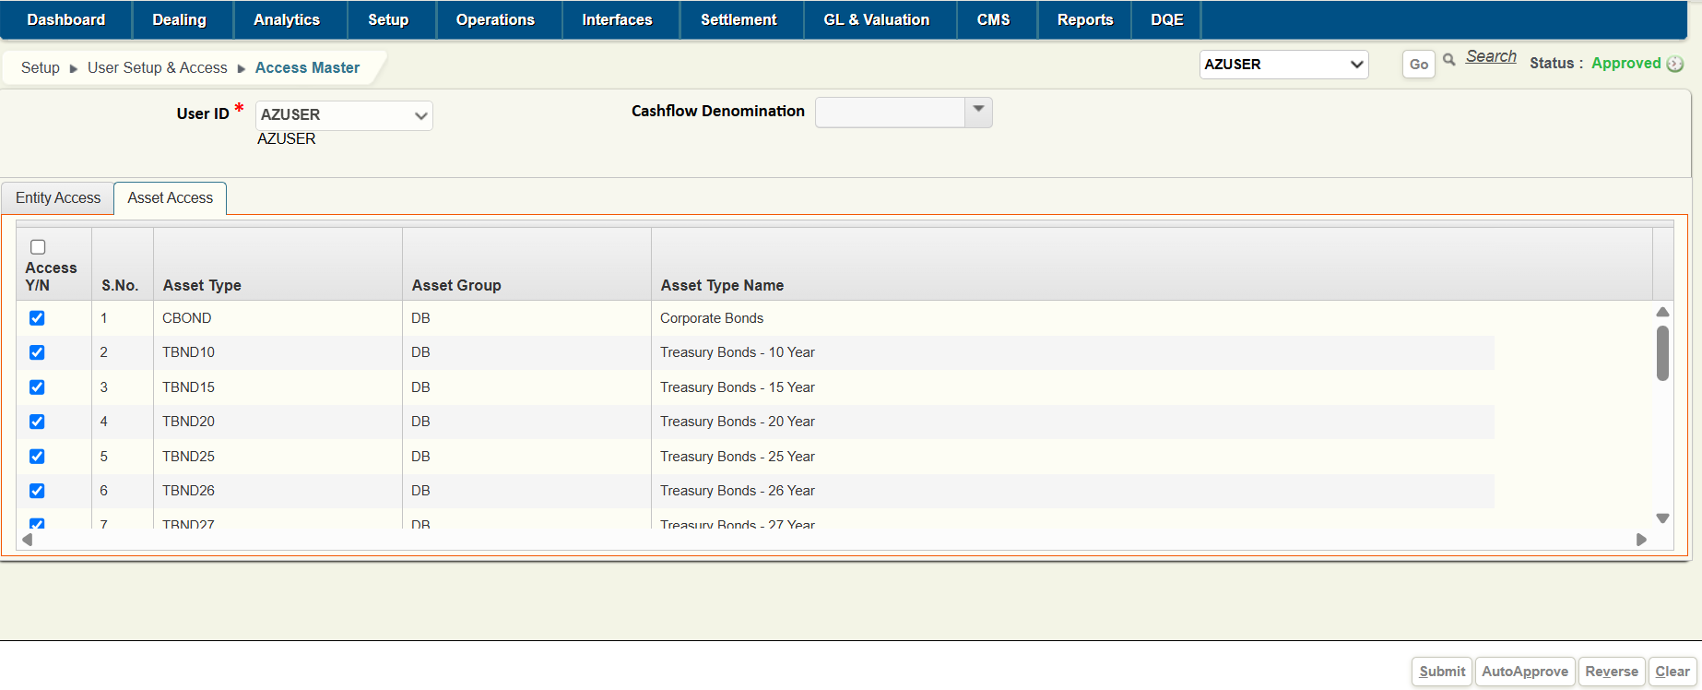

**Access Y/N:** This field indicates whether the Asset type wise access is applicable or not for the users.

**Asset Type:** This field indicates to which Asset type that needs to give access for this user.

**Asset Group:** This field indicates to which Asset Group that needs to give access for this user.

**Asset Type Name**: This field indicates the Asset type name.

## USER UNLOCK AND RESET PASSWORD

This Master explains about the user resetting the password when the user is locked or not able to login. This functionality is given as below.

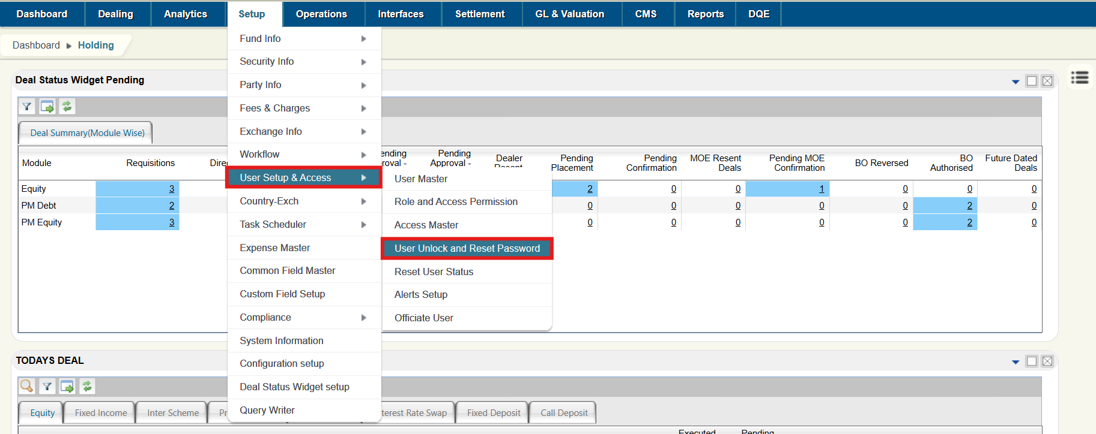

**SCREEN**

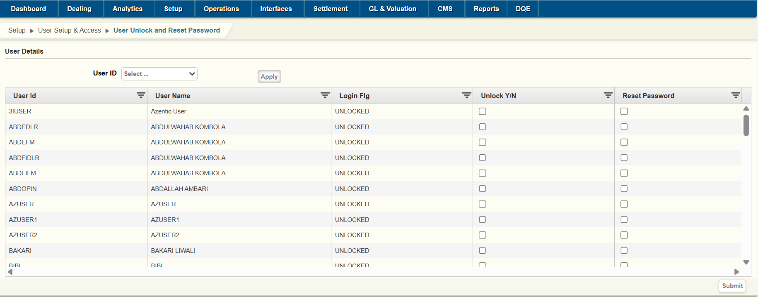

**User id:** This field Show all the user id which are available. This can be done through even the Filter menu.

**User name:** This will display the user name for user id that we have selected for. This can be done through even the filtering menu.

**Login Flag:** This will show the user login status. If the user is locked it will show as **locked**. It means that user cannot login to the Application.

**Unlock Y/N:** This option isto specify the user unlock status is Yes or No. Incase User locked Select this Option to unlock the user and on submit the respective user session gets unlocked.

**Reset Password:** This option isto specify the user reset password status check box. If the check box is checked it means the reset password is successfully done. User will receive the mail to reset the password. This can be done even through the filtering menu.

## RESET USER STATUS

This Master explains about the user reset status. That means User can logout other user from the system.

**Ex**. Incase user want to run End of the Day user have to reset the entire users using this screen.

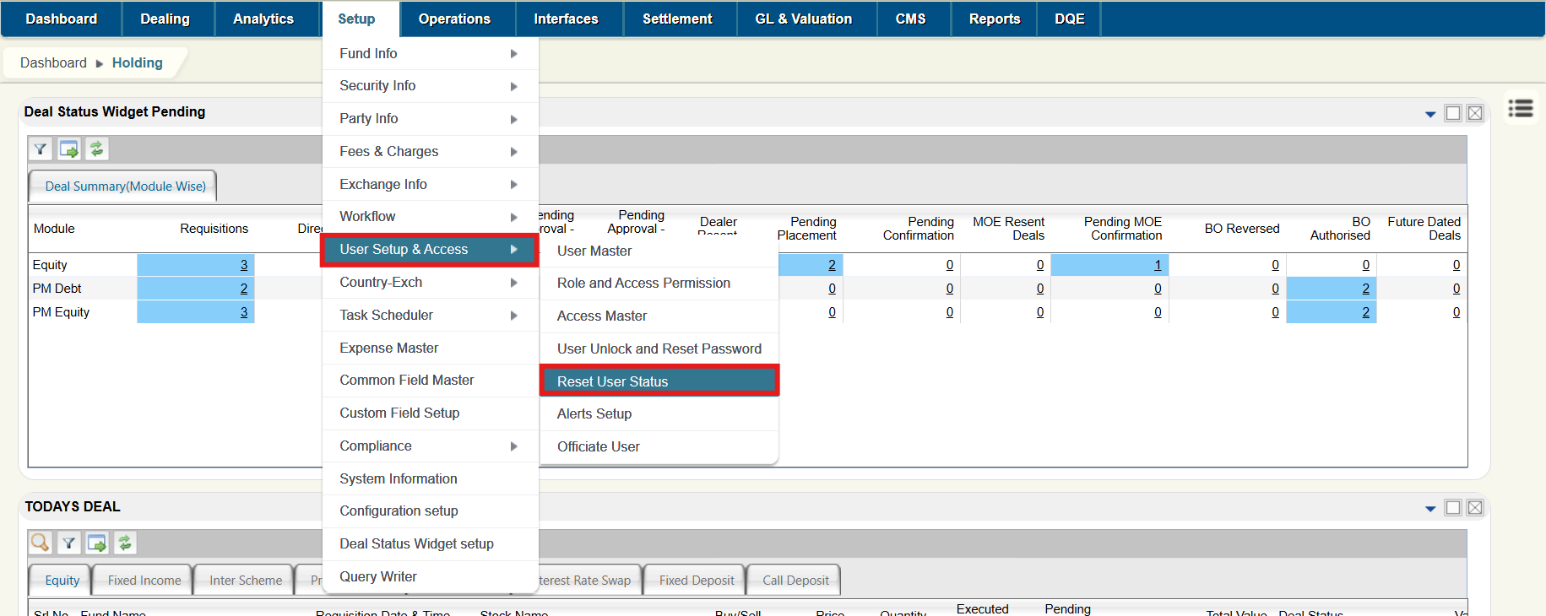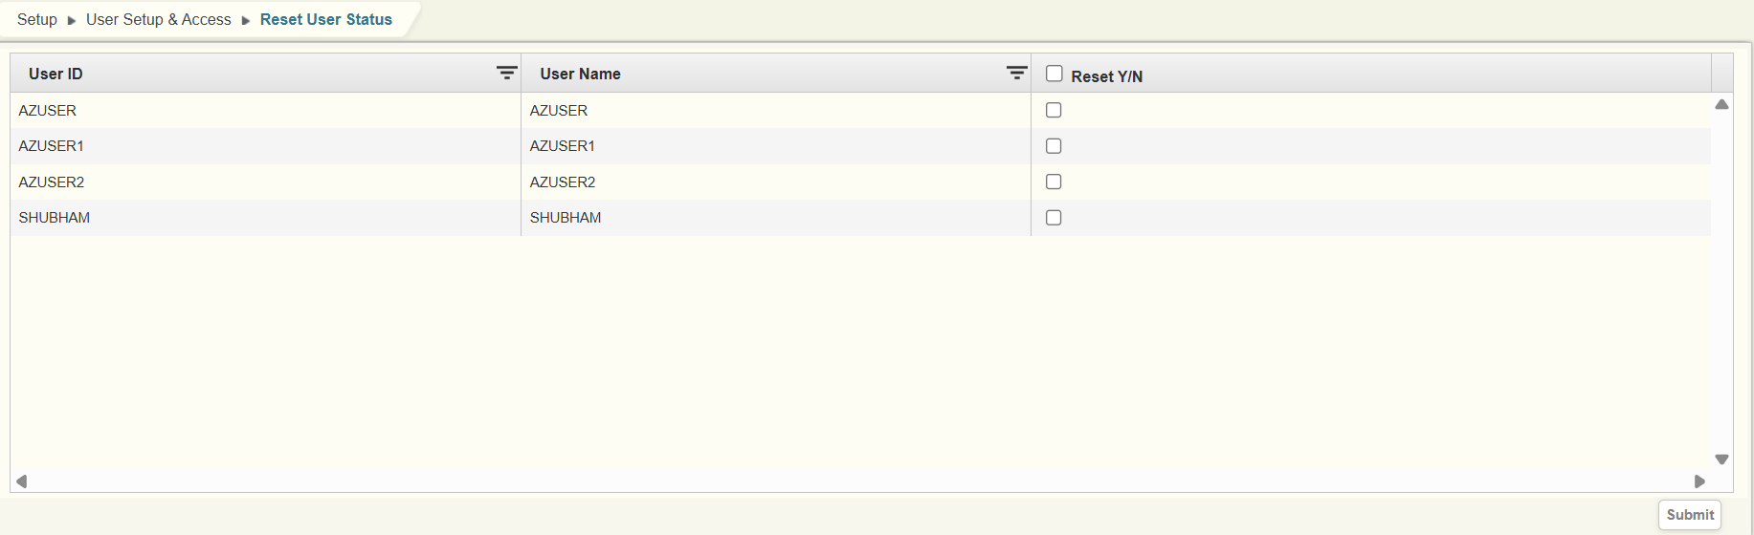

**User id:** This field displays the user id whoever has logged into this application. Users can select the user id using the filter option.

**User name:** This will display the name of the user for selected user id.

**Reset Y/N:** This will display the user Reset is done for user or not. Clicking on Check box that leads to User to logout from the application.

**Submit Button:** Submitting the records will lead to user to logout from the application.

**About Azentio Software**

Headquartered in Singapore, Azentio Software Private Limited brings deep domain expertise with a suite of software products spanning across banking insurance, asset management and ERP verticals. Its flagship products include Kastle™ (Universal Banking Solution), Premia Astra™ (Core Insurance Solution), AMLOCK™ (Financial Crime Detection and Management Solution), MFund Plus™ (Wealth & Asset Management Solution) and Orion™ (Enterprise Resource Planning Solution).

Azentio provides core software to BFSI customers and ERP solutions to SMB enterprises primarily across Middle East and Africa, Asia Pacific and India. Azentio has over 700 customers in more than 58 countries. It has offices in 9 countries with a strong team of over 1,600 employees. Azentio is committed to partner with its customers globally to transform their business operations through continuous focus on innovation and best-in-class customer service.

Azentio Software Private Limited is wholly owned by Funds advised by Apax.

### Head Office

38 Beach Road, #29-11 South Beach Tower, Singapore 189767  
Regional Office

International Infotech Park, Tower No. 5, 5th to 6th Floor, Vashi Railway Station Complex, Vashi,  
Navi Mumbai - 500703, India   
T: (+91) 22 7123 8000