D:\jkober\templates\TU_d_line_P1_full_color.emf **­Research Engineer Vacancy Announcement**

**Cognitive Robotics**

The Cognitive Robotics Department (CoR) at the Delft University of Technology, the Netherlands, announces a vacancy for a research engineer position on:

**Large-scale Fleet Routing in Urban Mobility Systems**

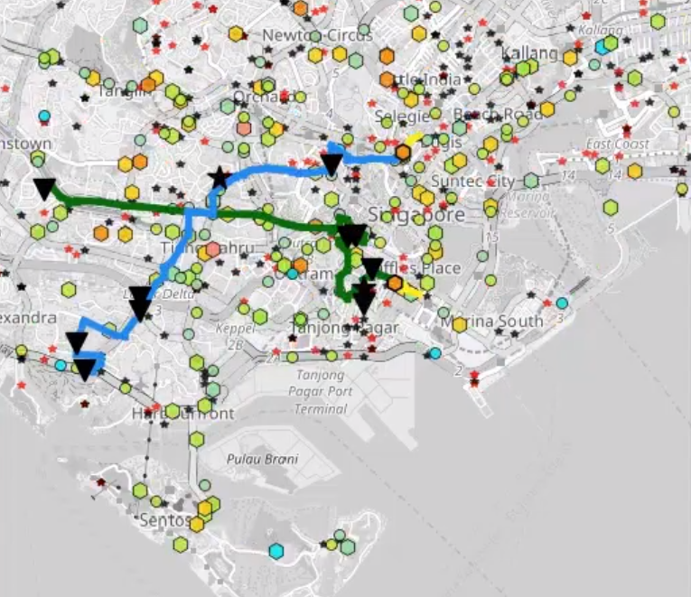**Project description**

Within this project, we develop methods and tools for dynamically routing of a fleet of autonomous vehicles in urban environments. The methods are further used to study the potential of autonomous taxis to provide mobility-on-demand with ride pooling, i.e. ride-sharing, in the cities such as Amsterdam or New York.

The researcher will be supervised by **Prof. Javier Alonso-Mora** from CoR and work in collaboration with the Amsterdam Institute for Advanced Metropolitan Solutions (AMS) and MIT. For a glimpse of our research visit [www.alonsomora.com](http://www.alonsomora.com/).

**What do we ask?**

We are looking for a student or a graduate in systems and control, robotics, operations research, applied mathematics, artificial intelligence, machine learning, or a related subject. The candidate should have experience with implementing algorithms in C++ and with data processing in Python. A very good command of the English language is also needed.

**What do we offer?**

With this 3-6 month internship, we offer the opportunity to get involved in ground-breaking research in the area of future urban transportation. As an employee of the university you will receive a competitive salary. Salary and benefits are in accordance with the Collective Labour Agreement for Dutch Universities. The position is available immediately.

**How to apply?**

Please submit your application by email to Prof. Alonso-Mora ([J.AlonsoMora@tudelft.nl)](mailto:J.AlonsoMora@tudelft.nl)). Applications will be reviewed until the position is filled. Include a detailed curriculum vitae, a motivation letter stating why the proposed research topic interests you, links to examples of code that you have written, the names and addresses of two reference persons, and any other information that might be relevant to your application.

**About 3mE and TU Delft**

The 3mE Faculty trains committed engineering students, PhD candidates and post-doctoral researchers in ground-breaking scientific research in the fields of mechanical, maritime and materials engineering. 3mE is the epitome of a dynamic, innovative faculty, with a European scope that contributes demonstrable economic and social benefits. TU Delft consistently ranks among the top universities in the engineering field.