Beverage Delivery App-
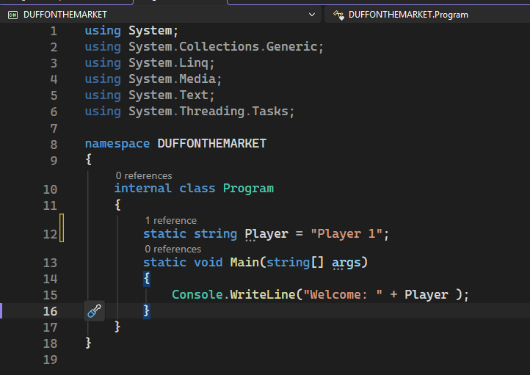
User opens app

<ButtonContent=”ClickMe”
Click=Button_Click”>

