T1-00

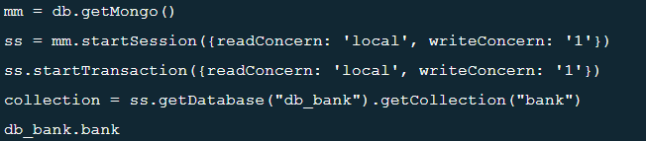

T2-00

T1-01

collection.aggregate([ {$match: {balance: {$gt: 900000}}}, { $group: {_id: null, count: {$sum: 1}}}])

{

_id: null,

count: 99961

}

T2.02

collection.aggregate([ {$match: {balance: {$gt: 900000}}}, { $group: {_id: null, count: {$sum: 1}}}])

{

_id: null,

count: 99961

}

T2-03

collection.updateOne({'_id': ObjectId('64a958a37db95684b99cf2b1')}, {'$set': {'balance': 100}})

{

acknowledged: true,

insertedId: null,

matchedCount: 1,

modifiedCount: 1,

upsertedCount: 0

}

T2-04

ss.commitTransaction()

{

ok: 1,

'$clusterTime': {

clusterTime: Timestamp({ t: 1688823116, i: 9 }),

signature: {

hash: Binary(Buffer.from("0000000000000000000000000000000000000000", "hex"), 0),

keyId: 0

}

},

operationTime: Timestamp({ t: 1688823116, i: 9 }),

recoveryToken: { recoveryShardId: 'rs-shard-01' }

}

T1-05

collection.aggregate([ {$match: {balance: {$gt: 900000}}}, { $group: {_id: null, count: {$sum: 1}}}])

{

_id: null,

count: 99961

}

T1-06

ss.commitTransaction()

{

ok: 1,

'$clusterTime': {

clusterTime: Timestamp({ t: 1688823116, i: 9 }),

signature: {

hash: Binary(Buffer.from("0000000000000000000000000000000000000000", "hex"), 0),

keyId: 0

}

},

operationTime: Timestamp({ t: 1688823116, i: 9 }),

recoveryToken: { recoveryShardId: 'rs-shard-01' }

}